Android Development

02 Practical (a) Interactive UI

# App Overview

The HelloToast app consists of two Button elements and one TextView. When the user taps the first Button, it displays a short message (a Toast) on the screen. Tapping the second Button increases a "click" counter displayed in the TextView, which starts at zero.

Here's what the finished app looks like:

# Create the Project

A few things to consider here.

When you open the IDE and select New project you will be presented with an application wizard presenting a number of possible starter templates:

* No Activity
* Empty Activity
* Basix Views Activity
* Bottom Navigation Views Activity
* Empty Views Activity
* Navigation Drawer Views Activity
* Responsive Views Activity
* Game Activity (C++)
* Native C++

For our initial coding sessions we will always use the Empty Views Activity. This builds a single Activity ‘Hello World’ Application coded (default) in Java. You can easily expand this template to include all of the functionality present in the other starter templates but, initially, we want to keep things simple.

The other templates include things that we will cover later in the course but which initially add confusion to understanding the Android basics.

* Fragments
* Floating action buttons
* Graph based navigation
* Navigation drawers
* Bottom navigation tabs
* UI data binding
* …

Initially, therefore, you can follow the instructions in section 2.1 or simply open the starter project I’ve zipped up in Moodle.

## Start Android Studio and create a new project with the following parameters:

|  |  |
| --- | --- |
| Attribute | Value |
| Application Name | Hello Toast |
| Company Name | com.example.android (or your own domain) |
| Phone and Tablet Minimum SDK | Use default |
| Template | Empty Views Activity |
| Generate Layout file box | Selected |
| Backwards Compatibility box Run App in AVD Select **Run > Run app** or click the **Run icon**Run Icon in the toolbar to build and execute the app on the emulator or your device. Explore the layout editor Android Studio provides the layout editor for quickly building an app's layout of user interface (UI) elements. It lets you drag elements to a visual design and blueprint view, position them in the layout, add constraints, and set attributes. Constraints determine the position of a UI element within the layout. A constraint represents a connection or alignment to another view, the parent layout, or an invisible guideline.  Explore the layout editor, and refer to the figure below as you follow the numbered steps: | Selected |

1. In the **app > res > layout** folder in the **Project > Android** pane, double-click the **activity_main.xml** file to open it, if it is not already open.
2. Click the **Design** tab if it is not already selected. You use the **Design** tab to manipulate elements and the layout, and the **Text** tab to edit the XML code for the layout.
3. The **Palettes** pane shows UI elements that you can use in your app's layout.
4. The **Component tree** pane shows the view hierarchy of UI elements. View elements are organized into a tree hierarchy of parents and children, in which a child inherits the attributes of its parent. In the figure above, the TextView is a child of the ConstraintLayout. You will learn about these elements later in this lesson.
5. The design and blueprint panes of the layout editor showing the UI elements in the layout. In the figure above, the layout shows only one element: a TextView that displays "Hello World".
6. The **Attributes** tab displays the **Attributes** pane for setting properties for a UI element.

NOTE: The GUI for Android Studio has changed slightly here. XML/Visual editors used to be tabbed at the bottom of the layout editor. Now there is a selection control top right of the main window when you are using layout editor that swaps between visual, XML or both.

# Add View elements in the layout editor

Here you create the UI layout for the HelloToast app in the layout editor using the ConstraintLayout features. You can create the constraints manually, as shown later, or automatically using the **Autoconnect** tool.

## **Examine the element constraints**

Follow these steps:

1. Open activity_main.xml from the **Project > Android** pane if it is not already open. If the **Design** tab is not already selected, click it.

If there is no blueprint, click the **Select Design Surface** button  in the toolbar and choose **Design + Blueprint**.

1. The **Autoconnect** tool  is also located in the toolbar. It is enabled by default. For this step, ensure that the tool is not disabled.
2. Click the zoom in Zoom in or out button to zoom into the design and blueprint panes for a close-up look.
3. Select **TextView** in the Component Tree pane. The "Hello World" TextView is highlighted in the design and blueprint panes and the constraints for the element are visible.
4. Refer to the animated figure below for this step. Click the circular handle on the right side of the TextView to delete the horizontal constraint that binds the view to the right side of the layout. The TextView jumps to the left side because it is no longer constrained to the right side. To add back the horizontal constraint, click the same handle and drag a line to the right side of the layout.

In the blueprint or design panes, the following handles appear on the TextView element:

**Constraint handle**: To create a constraint as shown in the animated figure above, click a constraint handle, shown as a circle on the side of an element. Then drag the handle to another constraint handle, or to a parent boundary. A zigzag line represents the constraint.

Constraint handle

**Resizing handle**: To resize the element, drag the square resizing handles. The handle changes to an angled corner while you are dragging it.



## Add a button to the layout

When enabled, the **Autoconnect** tool automatically creates two or more constraints for a UI element to the parent layout. After you drag the element to the layout, it creates constraints based on the element's position.

Follow these steps to add a Button:

1. Start with a clean slate. The TextView element is not needed, so while it is still selected, press the **Delete** key or choose **Edit > Delete**. You now have a completely blank layout.
2. Drag a **Button** from the **Palette** pane to any position in the layout. If you drop the Button in the top middle area of the layout, constraints may automatically appear. If not, you can drag constraints to the top, left side, and right side of the layout.

## Add a second button to the bottom of the layout

1. Drag another **Button** from the **Palette** pane to the middle of the layout as shown in the animated figure below. Autoconnect may provide the horizontal constraints for you (if not, you can drag them yourself).
2. Drag a vertical constraint to the bottom of the layout (refer to the figure below).

You can remove constraints from an element by selecting the element and hovering your pointer over it to show the Clear Constraints  button. Click this button to remove *all* constraints on the selected element. To clear a single constraint, click the specific handle that sets the constraint.

To clear all constraints in the entire layout, click the **Clear All Constraints** tool in the toolbar. This tool is useful if you want to redo all the constraints in your layout.

# Change the UI element attributes

The **Attributes** pane offers access to all of the XML attributes you can assign to a UI element. You can find the attributes (known as *properties*) common to all views in the [View class documentation](http://developer.android.com/reference/android/view/View.html).

Here you enter new values and change values for important Button attributes, which are applicable to most View types.

## Change the Button size

The layout editor offers resizing handles on all four corners of a View so you can resize the View quickly. You can drag the handles on each corner of the View to resize it but doing so hardcodes the width and height dimensions. Avoid hardcoding sizes for most View elements, because hardcoded dimensions can't adapt to different content and screen sizes.

Instead, use the **Attributes** pane on the right side of the layout editor to select a sizing mode that doesn't use hardcoded dimensions. The **Attributes** pane includes a square sizing panel called the *view inspector* at the top. The symbols inside the square represent the height and width settings as follows:

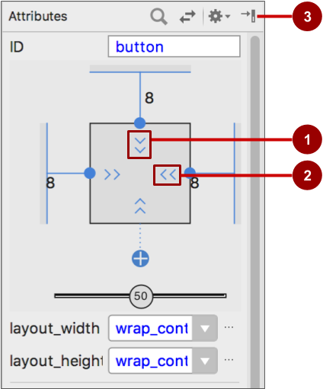

In the figure above:

1. **Height control**. This control specifies the layout_height attribute and appears in two segments on the top and bottom sides of the square. The angles indicate that this control is set to wrap_content, which means the View will expand vertically as needed to fit its contents. The "8" indicates a standard margin set to 8dp.
2. **Width control**. This control specifies the layout_width and appears in two segments on the left and right sides of the square. The angles indicate that this control is set to wrap_content, which means the View will expand horizontally as needed to fit its contents, up to a margin of 8dp.
3. **Attributes** pane close button. Click to close the pane.

Follow these steps:

1. Select the top Button in the **Component Tree** pane.
2. Click the **Attributes** tab on the right side of the layout editor window.

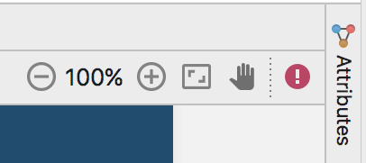

1. Click the width control twice—the first click changes it to **Fixed** with straight lines, and the second click changes it to **Match Constraints** with spring coils, as shown in the animated figure below.

As a result of changing the width control, the layout_width attribute in the **Attributes** pane shows the value match_constraint and the Button element stretches horizontally to fill the space between the left and right sides of the layout.

1. Select the second Button, and make the same changes to the layout_width

As shown in the previous steps, the layout_width and layout_height attributes in the **Attributes** pane change as you change the height and width controls in the inspector. These attributes can take one of three values for the layout, which is a ConstraintLayout:

* The match_constraint setting expands the View element to fill its parent by width or height—up to a margin, if one is set. The parent in this case is the ConstraintLayout. You learn more about ConstraintLayout in the next task.
* The wrap_content setting shrinks the View element's dimensions so it is just big enough to enclose its content. If there is no content, the View element becomes invisible.
* To specify a fixed size that adjusts for the screen size of the device, use a fixed number of [density-independent pixels](https://developer.android.com/training/multiscreen/screendensities.html) (dp units). For example, 16dp means 16 density-independent pixels.

## Change the button attributes

To identify each View uniquely within an Activity layout, each View or View subclass (such as Button) needs a unique ID. And to be of any use, the Button elements need text. View elements can also have backgrounds that can be colours or images.

The **Attributes** pane offers access to all of the attributes you can assign to a View element. You can enter values for each attribute, such as the android:id, background, textColor, and text attributes.

1. After selecting the first Button, edit the ID field at the top of the **Attributes** pane to **button_toast** for the android:id attribute, which is used to identify the element in the layout.
2. Set the background attribute to **@color/colorPrimary**. (As you enter **@c**, choices appear for easy selection.)
3. Set the textColor attribute to **@android:color/white**.
4. Edit the text attribute to **Toast**.
5. Perform the same attribute changes for the second Button, using **button_count** as the ID, **Count** for the text attribute, and the same colours for the background and text as the previous steps.

The colorPrimary is the primary color of the theme, one of the predefined theme base colours defined in the colors.xml resource file. It is used for the app bar. Using the base colours for other UI elements creates a uniform UI.

# Add a TextEdit and set its attributes

One of the benefits of [ConstraintLayout](https://developer.android.com/reference/android/support/constraint/ConstraintLayout.html) is the ability to align or otherwise constrain elements relative to other elements. In this task you will add a TextView in the middle of the layout and constrain it horizontally to the margins and vertically to the two Button elements. You will then change the attributes for the TextView in the **Attributes** pane.

## **Add a TextView and constraints**

1. Drag a TextView from the **Palette** pane to the upper part of the layout and drag a constraint from the top of the TextView to the handle on the bottom of the **Toast**Button. This constrains the TextView to be underneath the Button.
2. Drag a constraint from the bottom of the TextView to the handle on the top of the **Count**Button, and from the sides of the TextView to the sides of the layout. This constrains the TextView to be in the middle of the layout between the two Button elements.

## **Set the TextView attributes**

With the TextView selected, open the **Attributes** pane, if it is not already open. Set attributes for the TextView:

1. Set the ID to **show_count**.
2. Set the text to **0**.
3. Set the textSize to **160sp**.
4. Set the textStyle to **B** (bold) and the textAlignment to ALIGNCENTER (center the paragraph).
5. Change the horizontal and vertical view size controls (layout_width and layout_height) to **match_constraint**.
6. Set the textColor to **@color/colorPrimary**.
7. Scroll down the pane and click **View all attributes**, scroll down the second page of attributes to background, and then enter **#FFFF00** for a shade of yellow.
8. Scroll down to gravity, expand gravity, and select **center_ver** (for center-vertical).

Note*

* textSize: The text size of the TextView. For this lesson, the size is set to 160sp. The sp stands for *scale-independent pixel*, and like dp, is a unit that scales with the screen density and user's font size preference. Use dp units when you specify font sizes so that the sizes are adjusted for both the screen density and the user's preference.
* textStyle and textAlignment: The text style, set to **B** (bold) in this lesson, and the text alignment, set to ALIGNCENTER (center the paragraph).
* gravity: The gravity attribute specifies how a View is aligned within its *parent*View or ViewGroup. In this step, you center the TextView to be centred vertically within the parent ConstraintLayout.

# Edit the layout in XML

The Hello Toast app layout is nearly finished! However, an exclamation point appears next to each UI element in the Component Tree. Hover your pointer over these exclamation points to see warning messages, as shown below. The same warning appears for all three elements: hardcoded strings should use resources.

The easiest way to fix layout problems is to edit the layout in XML. While the layout editor is a powerful tool, some changes are easier to make directly in the XML source code.

## **Open the XML code for the layout**

Open the activity_main.xml file if it is not already open, and click the **Text** tab Switch from Design to Text (XML editing) at the bottom of the layout editor.

The XML editor appears, replacing the design and blueprint panes. As you can see in the figure below, which shows part of the XML code for the layout, the warnings are highlighted—the hardcoded strings "Toast" and "Count". (The hardcoded "0" is also highlighted but not shown in the figure.) Hover your pointer over the hardcoded string "Toast" to see the warning message.

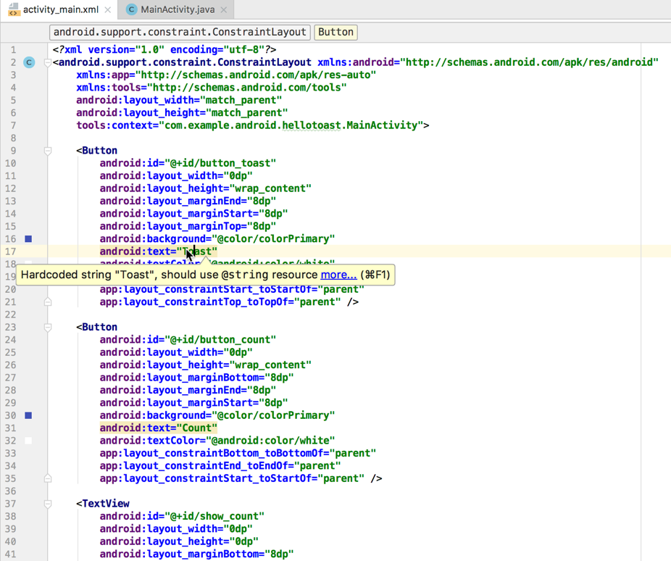

## **Extract string resources**

Instead of hard-coding strings, it is a best practice to use string resources, which represent the strings. Having the strings in a separate file makes it easier to manage them, especially if you use these strings more than once. Also, string resources are mandatory for translating and localizing your app, because you need to create a string resource file for each language.

1. Click once on the word "Toast" (the first highlighted warning).
2. Press **Alt-Enter** in Windows or **Option-Enter** in macOS and choose **Extract string resource** from the popup menu.
3. Enter **button_label_toast** for the **Resource name**.
4. Click **OK**. A string resource is created in the values/res/string.xml file, and the string in your code is replaced with a reference to the resource: @string/button_label_toast
5. Extract the remaining strings: button_label_count for "Count", and count_initial_value for "0".
6. In the Project > Android pane, expand values within res, and then double-click strings.xml to see your string resources in the strings.xml file:

<resources>

<string name="app_name">Hello Toast</string>

<string name="button_label_toast">Toast</string>

<string name="button_label_count">Count</string>

<string name="count_initial_value">0</string>

</resources>

1. You need another string to use in a subsequent task that displays a message. Add to the strings.xml file another string resource named toast_message for the phrase "Hello Toast!":

<resources>

<string name="app_name">Hello Toast</string>

<string name="button_label_toast">Toast</string>

<string name="button_label_count">Count</string>

<string name="count_initial_value">0</string>

<string name="toast_message">Hello Toast!</string>

</resources>

# Add onClick handlers for the buttons

Now add a Java method for each Button in MainActivity that executes when the user taps the Button.

## Add the onClick **attribute and handler to each Button**

A *click handler* is a method that is invoked when the user clicks or taps on a clickable UI element. In Android Studio you can specify the name of the method in the onClick field in the **Design** tab's **Attributes** pane. You can also specify the name of the handler method in the XML editor by adding the android:onClick property to the Button. You will use the latter method because you haven't yet created the handler methods, and the XML editor provides an automatic way to create those methods.

1. With the XML editor open (the Text tab), find the Button with the android:id set to button_toast:

<Button

android:id="@+id/button_toast"

android:layout_width="0dp"

...

app:layout_constraintStart_toStartOf="parent"

app:layout_constraintTop_toTopOf="parent" />

1. Add the android:onClick attribute to the end of the button_toast element after the last attribute and before the /> end indicator:

android:onClick="showToast" />

1. Click the red bulb icon that appears next to attribute. Select **Create click handler**, choose **MainActivity**, and click **OK**.

If the red bulb icon doesn't appear, click the method name ("showToast"). Press **Alt-Enter** (**Option-Enter** on the Mac), select **Create 'showToast(view)' in MainActivity**, and click **OK**.

This action creates a placeholder method stub for the showToast() method in MainActivity, as shown at the end of these steps.

1. Repeat the last two steps with the button_count Button: Add the android:onClick attribute to the end, and add the click handler:

android:onClick="countUp" />

The XML code for the UI elements within the ConstraintLayout now looks like this:

<Button

android:id="@+id/button_toast"

android:layout_width="0dp"

android:layout_height="wrap_content"

android:layout_marginEnd="8dp"

android:layout_marginStart="8dp"

android:layout_marginTop="8dp"

android:background="@color/colorPrimary"

android:text="@string/button_label_toast"

android:textColor="@android:color/white"

app:layout_constraintEnd_toEndOf="parent"

app:layout_constraintStart_toStartOf="parent"

app:layout_constraintTop_toTopOf="parent"

android:onClick="showToast"/>

<Button

android:id="@+id/button_count"

android:layout_width="0dp"

android:layout_height="wrap_content"

android:layout_marginBottom="8dp"

android:layout_marginEnd="8dp"

android:layout_marginStart="8dp"

android:background="@color/colorPrimary"

android:text="@string/button_label_count"

android:textColor="@android:color/white"

app:layout_constraintBottom_toBottomOf="parent"

app:layout_constraintEnd_toEndOf="parent"

app:layout_constraintStart_toStartOf="parent"

android:onClick="countUp" />

<TextView

android:id="@+id/show_count"

android:layout_width="0dp"

android:layout_height="0dp"

android:layout_marginBottom="8dp"

android:layout_marginEnd="8dp"

android:layout_marginStart="8dp"

android:layout_marginTop="8dp"

android:background="#FFFF00"

android:gravity="center_vertical"

android:text="@string/count_initial_value"

android:textAlignment="center"

android:textColor="@color/colorPrimary"

android:textSize="160sp"

android:textStyle="bold"

app:layout_constraintBottom_toTopOf="@+id/button_count"

app:layout_constraintEnd_toEndOf="parent"

app:layout_constraintStart_toStartOf="parent"

app:layout_constraintTop_toBottomOf="@+id/button_toast" />

1. If MainActivity.java is not already open, expand **java**in the Project > Android view, expand **com.example.android.hellotoast**, and then double-click **MainActivity**. The code editor appears with the code in MainActivity:

package com.example.android.hellotoast;

import android.support.v7.app.AppCompatActivity;

import android.os.Bundle;

import android.view.View;

public class MainActivity extends AppCompatActivity {

@Override

protected void onCreate(Bundle savedInstanceState) {

super.onCreate(savedInstanceState);

setContentView(R.layout.activity_main);

}

public void showToast(View view) {

}

public void countUp(View view) {

}

}

## Edit the Toast Button handler

Now edit the showToast() method—the Toast Button click handler in MainActivity—so that it shows a message. A [Toast](https://developer.android.com/reference/android/widget/Toast.html) provides a way to show a simple message in a small popup window. It fills only the amount of space required for the message. The current activity remains visible and interactive. A Toast can be useful for testing interactivity in your app—add a Toast message to show the result of tapping a Button or performing an action.

Follow these steps to edit the Toast Button click handler:

1. Locate the newly created showToast() method.

public void showToast(View view) {

}

1. To create an instance of a Toast, call the [makeText()](https://developer.android.com/reference/android/widget/Toast.html#makeText(android.content.Context,%20int,%20int)) factory method on the Toast class.

This statement is incomplete until you finish all of the steps.

1. Supply the [context](https://developer.android.com/reference/android/content/Context.html) of the app Activity. Because a Toast displays on top of the Activity UI, the system needs information about the current Activity. When you are already within the context of the Activity whose context you need, use this as a shortcut.

Toast toast = Toast.makeText(this,

1. Supply the message to display, such as a string resource (the toast_message you created in a previous step). The string resource toast_message is identified by R.string.

Toast toast = Toast.makeText(this, R.string.toast_message,

1. Supply a duration for the display. For example, [Toast.LENGTH_SHORT](https://developer.android.com/reference/android/widget/Toast.html#LENGTH_SHORT) displays the toast for a relatively short time.

Toast toast = Toast.makeText(this, R.string.toast_message,

Toast.LENGTH_SHORT);

The duration of a Toast display can be either Toast.LENGTH_LONG or Toast.LENGTH_SHORT. The actual lengths are about 3.5 seconds for the long Toast and 2 seconds for the short Toast.

1. Show the Toast by calling [show()](https://developer.android.com/reference/android/widget/Toast.html#show()). The following is the entire showToast() method:

public void showToast(View view) {

Toast toast = Toast.makeText(this, R.string.toast_message,

Toast.LENGTH_SHORT);

toast.show();

}

Run the app and verify that the Toast message appears when the **Toast** button is tapped.

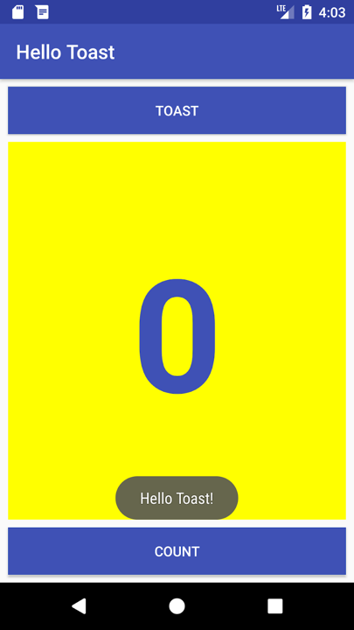

## **Edit the Count Button handler**

Now edit the countUp() method—the Count Button click handler in MainActivity—so that it displays the current count after **Count** is tapped. Each tap increases the count by one.

The code for the handler must:

* Keep track of the count as it changes.
* Send the updated count to the TextView to display it.

Follow these steps to edit the Count Button click handler:

Follow these steps to edit the **Count**Button click handler:

1. Locate the newly created countUp() method.

public void countUp(View view) {

}

1. To keep track of the count, you need a private member variable. Each tap of the Count button increases the value of this variable. Enter the following, which will be highlighted in red and show a red bulb icon:

public void countUp(View view) {

mCount++;

}

If the red bulb icon doesn't appear, select the mCount++ expression. The red bulb eventually appears.

1. Click the red bulb icon and choose **Create field 'mCount'** from the popup menu. This creates a private member variable at the top of MainActivity, and Android Studio assumes that you want it to be an integer (int):

public class MainActivity extends AppCompatActivity {

private int mCount;

1. Change the private member variable statement to initialize the variable to zero:

public class MainActivity extends AppCompatActivity {

private int mCount = 0;

1. Along with the variable above, you also need a private member variable for the reference of the show_count TextView, which you will add to the click handler. Call this variable mShowCount:

public class MainActivity extends AppCompatActivity {

private int mCount = 0;

private TextView mShowCount;

1. Now that you have mShowCount, you can get a reference to the TextView using the ID you set in the layout file. In order to get this reference only once, specify it in the onCreate() method. As you learn in another lesson, the [onCreate()](https://developer.android.com/reference/android/app/Activity.html#onCreate(android.os.Bundle)) method is used to *inflate the layout*, which means to set the content view of the screen to the XML layout. You can also use it to get references to other UI elements in the layout, such as the TextView. Locate the onCreate() method in MainActivity:

@Override

protected void onCreate(Bundle savedInstanceState) {

super.onCreate(savedInstanceState);

setContentView(R.layout.activity_main);

}

1. Add the [findViewById](https://developer.android.com/reference/android/view/View.html#findViewById(int)) statement to the end of the method:

@Override

protected void onCreate(Bundle savedInstanceState) {

super.onCreate(savedInstanceState);

setContentView(R.layout.activity_main);

mShowCount = (TextView) findViewById(R.id.show_count);

}

A [View](https://developer.android.com/reference/android/view/View.html), like a string, is a resource that can have an id. The [findViewById](https://developer.android.com/reference/android/view/View.html) call takes the ID of a view as its parameter and returns the View. Because the method returns a View, you have to cast the result to the view type you expect, in this case (TextView).

1. Now that you have assigned to mShowCount the TextView, you can use the variable to set the text in the TextView to the value of the mCount variable. Add the following to the countUp() method:

if (mShowCount != null)

mShowCount.setText(Integer.toString(mCount));

The entire countUp() method now looks like this:

public void countUp(View view) {

++mCount;

if (mShowCount != null)

mShowCount.setText(Integer.toString(mCount));

}

1. Run the app to verify that the count increases when you tap the **Count** button.

