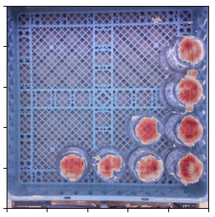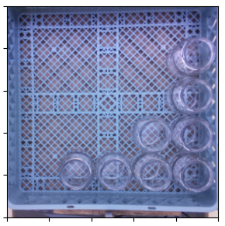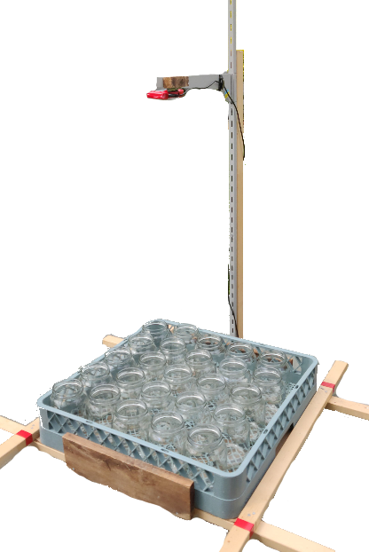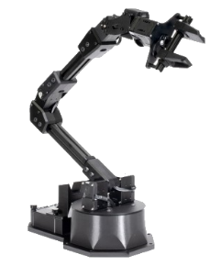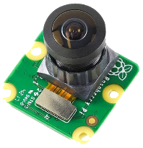

Using a frame, a camera and Raspberry Pi is mounted above a tray full of jars.

Data was collected and manually labelled using a custom-made program.

A convolutional neural network was trained using powerful computers with the collected dataset.

Industrial automation systems thrive on consistency.

When jars placed in a tray and passed through a dishwasher, their positions change, thus losing consistency.

A computer vision system may be employed to discern the positions of the now-displaced jars to inform a robot’s actions.

L. Akkerman and A. Hunter

Camera Image

Code repository:

<https://github.com/LiamAkkerman/Jar-Vision-System>

Contact us:

[liam.akkerman@gmail.com](mailto:liam.akkerman@gmail.com)

[hunter.aidan@gmail.com](mailto:hunter.aidan@gmail.com)

|  |  |
| --- | --- |
| Model testing accuracy: | 80.01% |
| Model inference time: | 15 seconds |
| Total dataset size: | 2720 images |

The camera takes a photo and passes it to the machine learning model.

The model discerns where the jars are in the tray.

Model Output

This system can be used in larger automation systems to create a versatile tool for moving objects.

The ability to work with jars in any position in the tray allows for many different trays to be used without mechanically constraining the jars.

This project was somewhat accurate but not enough to be used in a industrial setting.

MSE 491 - Application of Machine Learning in Mechatronic Systems

Vessel Targeting System for Automated Gantry Robot