**Notes of “Smart smartphone development: iOS versus android”**

**Type**

**Article**

**Topic**

App Development

**Notes**

Provides the details for the advantages and disadvantages of both languages and their IDE’s

Provides the hardware requirements.

Article is written by a department within education, evaluating which language they should be taught at the school.

Covers the basic structure of each IDE.

**Usable Quotes or Figures**

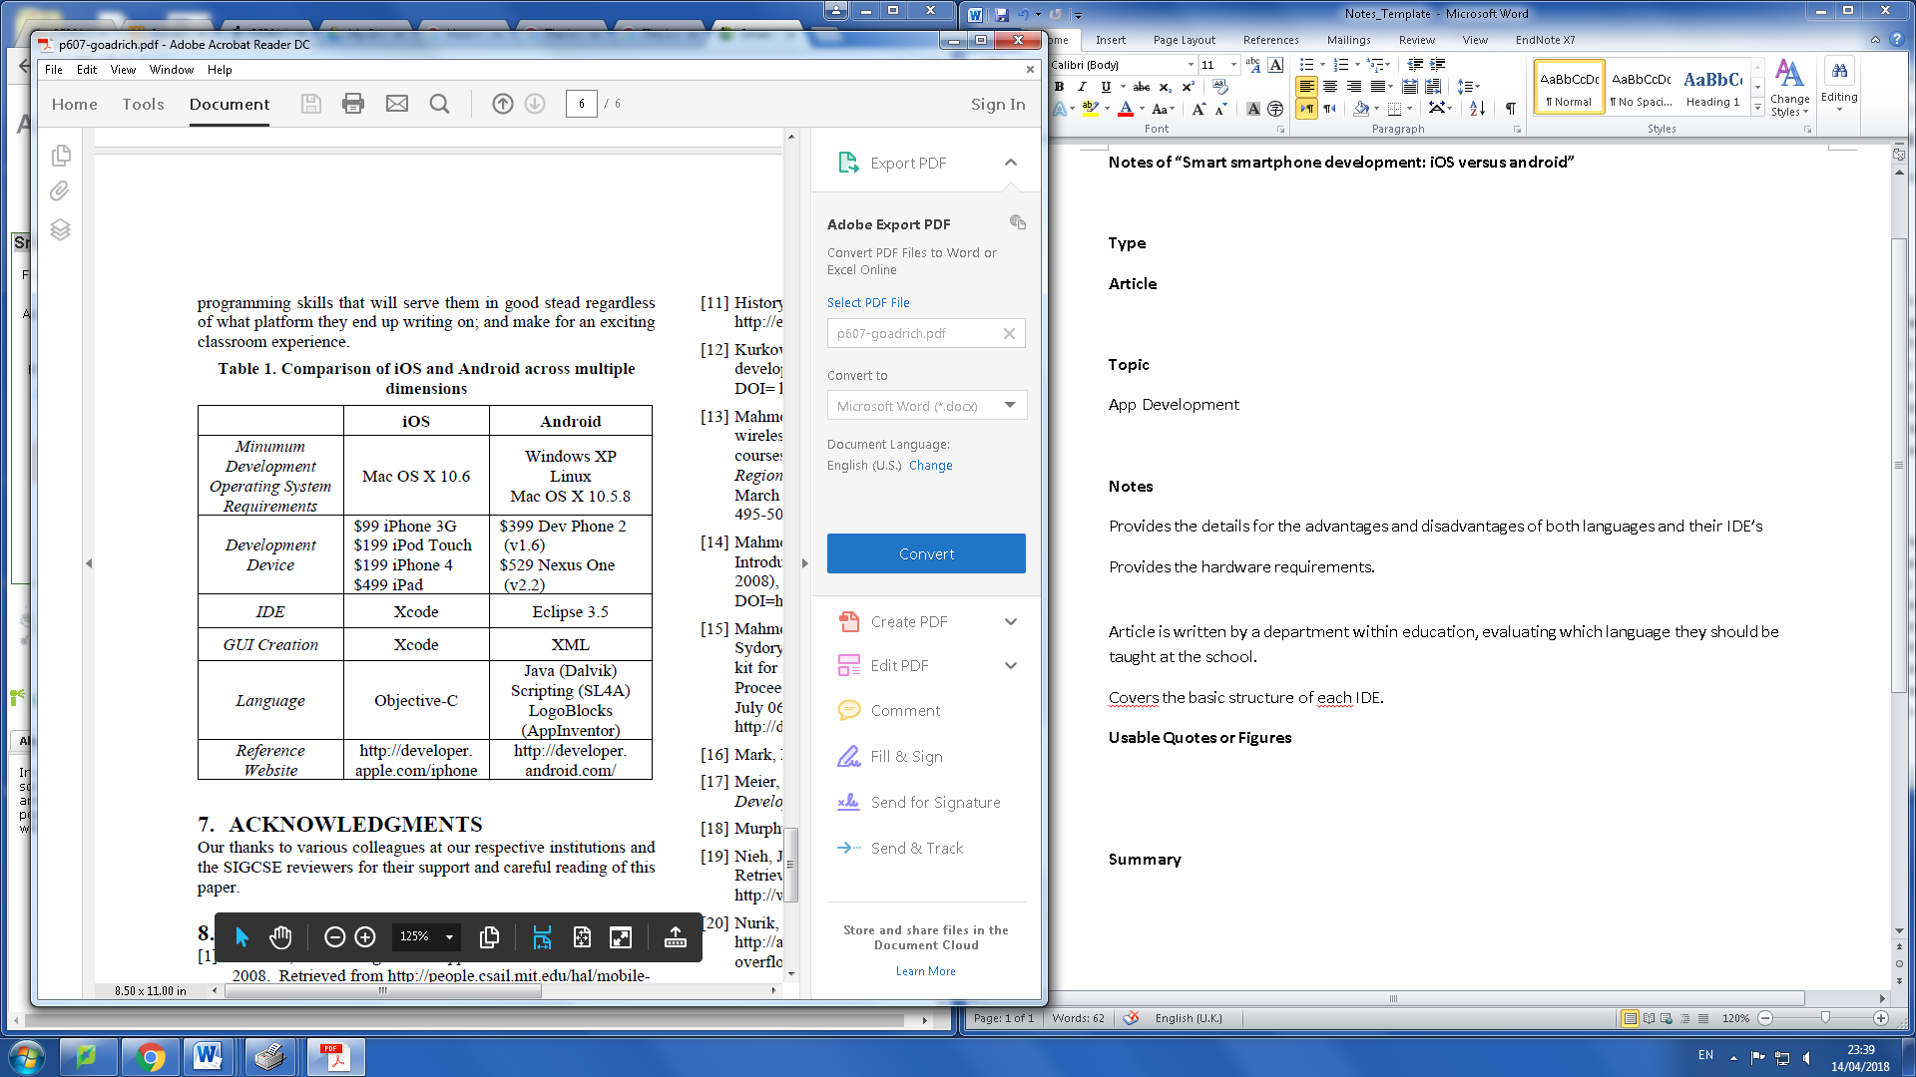

*Amendment. IOS/ Language also has Swift*

**Summary**

A very useful article which weighs up the pros and cons for the two languages that are being considered for the app. Since the document’s purpose is to explain which langauge should be taught at the editor’s school, it covers a broad range of important areas that will define which language is best suited for the project. Both languages provide a simulator for testing however for accurate testing a physical device is required. The resources for the project are limited to apple products thus the language used is heavily influced by the avaliable hardware.