**Notes of “How to Learn a Foreign Language”**

**Type**

Book

**Topic**

Concept

**Notes**

FSI is a common rating system used to measure the technical level of an individual’s ability to use a language. Researchers studied a group of students learning a language over three years and found the following;

Conditions: 6 Hours per Day, 5 Days a Week and Led by a trained instructor.

**Usable Quotes or Figures**

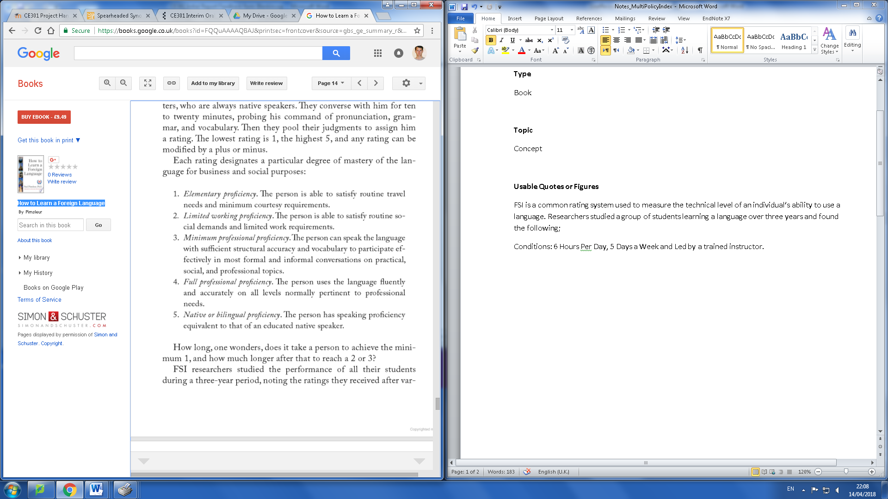

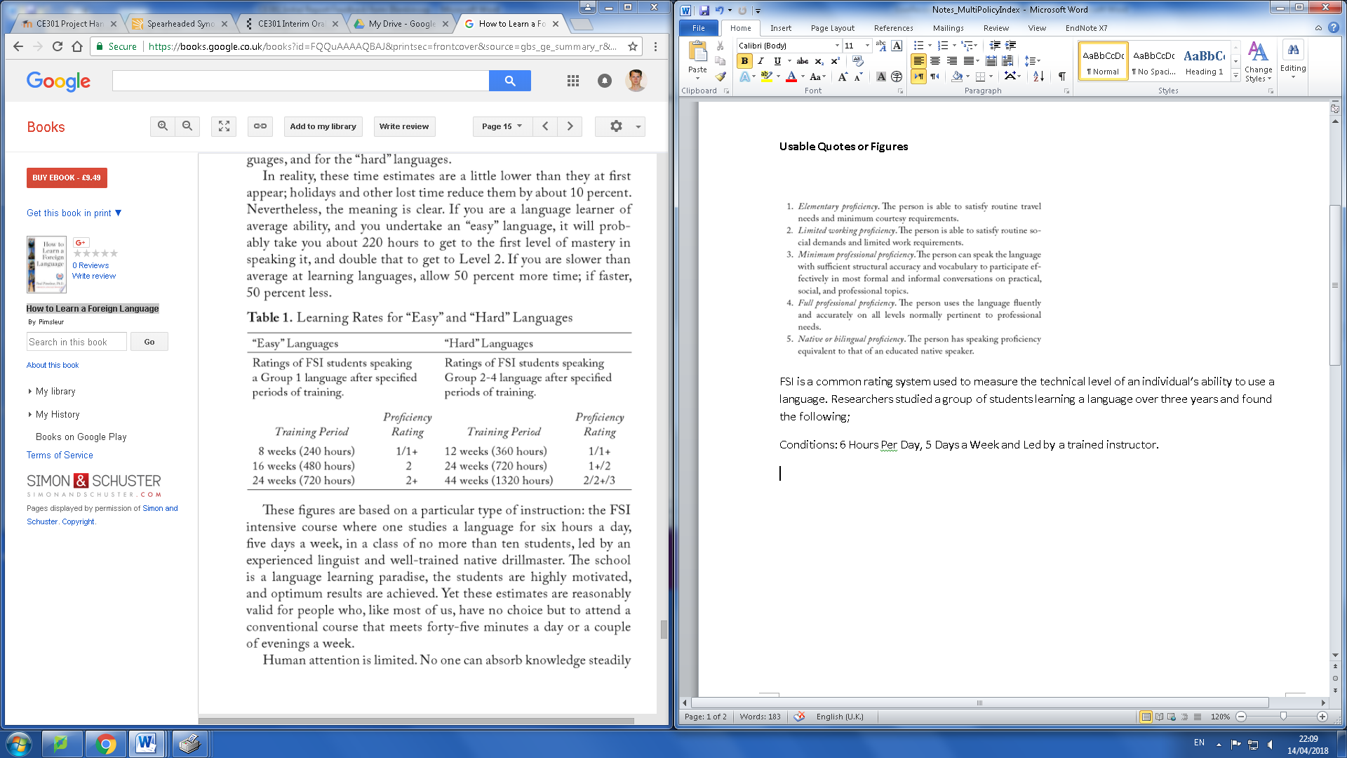

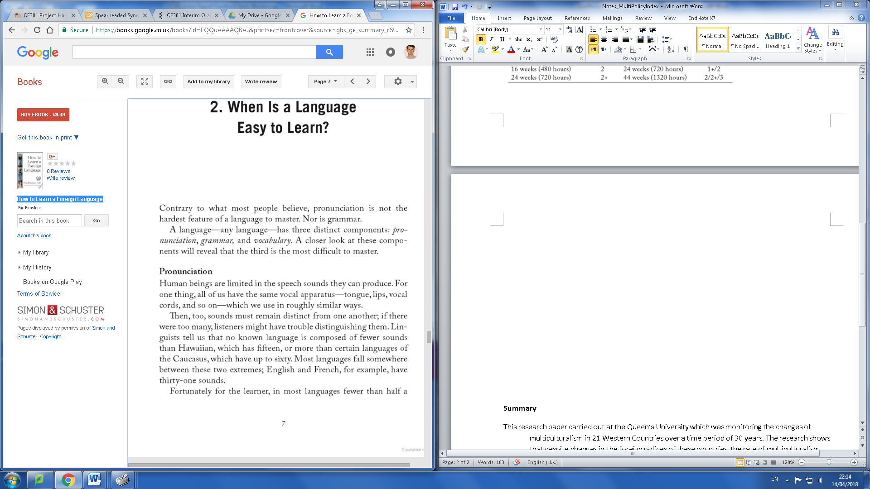

**Summary**

The book provides a well-researched synopsis on the stages of learning a new language. The interesting aspect of this book is the research that was found on length of time it takes to learn a foreign language. Firstly, there are many different technical levels when learning a language. The common ratings system used is FSI which breaks down the ability into 5 categories.

1. Elementary Proficiency: The person is able to satisfy routine travel needs and minimum courtesy requirements
2. Limited Working Proficiency: The person is able to satisfy routine social demands and limited work requirements.
3. Minimum Professional Proficiency: The person can speak the language with sufficient structural accuracy and vocabulary to participate effectively in most formal and informal conversations on practical, social and professional topics.
4. Full Professional Proficiency: The person uses the language fluently and accurately on all levels normally pertinent to professional needs
5. Native or Bilingual Proficiency: The person has speaking proficiency equivalent to that of an educated native speaker.

According to research done by FSI researchers where data was collected from their intensive langage courses which took place 6 hours a day, 5 days a week with a trained instructor. The average person should expect to put in 720 hours to achieve a proficiency rating of 2+ in an easy langauge such as French or English. For a hard langauge such as russian, it will take on average 1320 hours to reach the same rating. Being able to create a product which can be effective enough to replace the need to learn a language would be very high in demand. It enables the large group of indivduals who do not have the time or the patience the ability to use a foreign language. Additonally, Paul Pimsler states that the hardest component of learning a language is not pronucation or grammar but the vocabulay. Vocabulary is where solutions such as computerized translations excel as it’s easy for a system to store the dictionary of a language unlike it would be for a human.