**Task1**

Hourly count dataset:

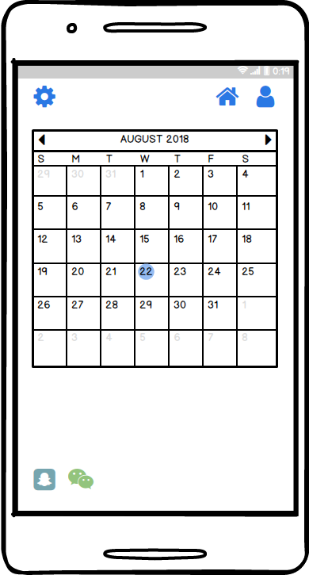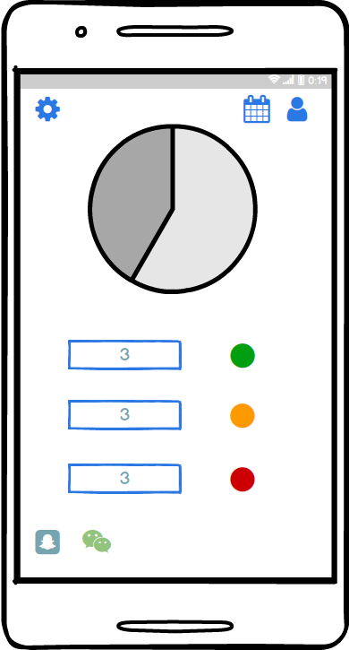

Rationale:

* According to the dataset, most of the time the steps are 0. It means clients can not manage their time on doing physical activity or they are too busy on their other works instead of doing exercise. Hence, the interface design is for clients who can not manage their time on both exercise and business well, to support them organize their exercise schedule. It also helps them to improve their amount of exercise through displaying whether the clients have done enough exercise per day/hour.

Daily count dataset:

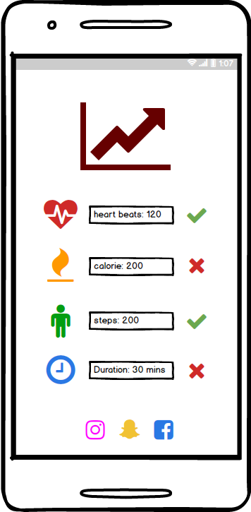

Rationale:

* Based on the dataset, the interface is focusing more on clients amount of exercises they have done per day/hour through displaying the number of each kind of health measurement. It also shows whether the amount of exercises they have done reaches to standard amount or not per day/hour, and additionally shows their weekly status in line graph.

**Task2**

The user goal:

* User can check whether their amount of exercise has reached to normal level
* User can measure when they should improve their amount of exercise

The rationale for the abstract task:

* Enable the users to measure how much of the exercise they need to improve
* Enable to make users well organize on time and exercise for each day

Concrete task:

* Concrete A: based on the results display, how many steps you have done for today/hour? Does it reach to the standard requirement?
* Concrete B: How much calorie you have spent for today/hour? Is it enough for today?
* Concrete C: What time/day are you going to do exercise?