When dealing with high frequencies, the choice of the substrate becomes critical. In particular, the permitivity and the loss tangent will be 2 major factors of choices.
Below is a 2nd order Chebyshev microstrip filter with a ripple of 0.5 dB in the bandwith. Its goal is to let through the 1.9 GHz and attenuates the other frequencies.

Here the one done with a FR4 substrate, 1.6 mm of substrate height, 35 µm of metal thickness, 0.014 of loss tangent and a permittivity of about 4.6 :

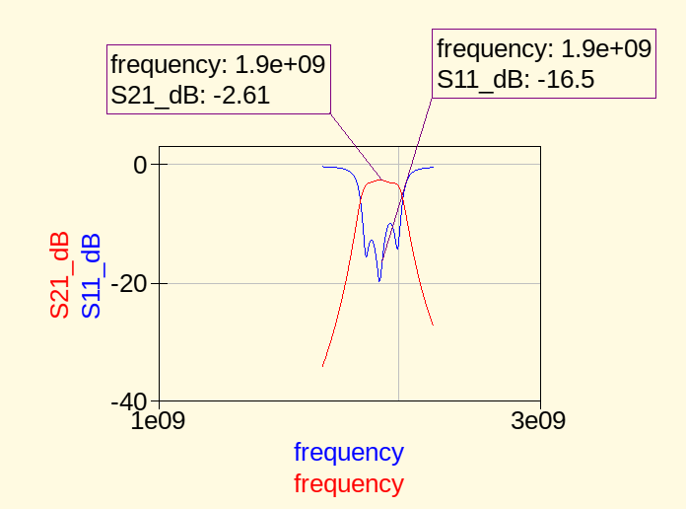
We loose almost half of the input power while going through the filter. Return loss is quite good.

Now, let’s see the response of the filter which uses the RO4003 substrate. It has a permitivity of about 3.38, a loss tangent of 0.0027, 1.51 mm of substrate height and 35 µm of metal thickness.

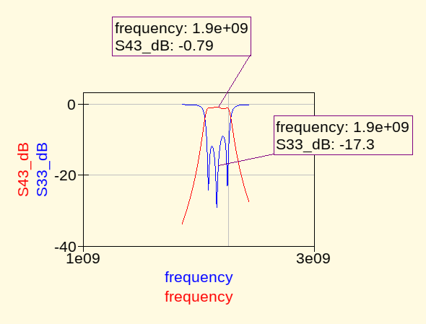
We can see that we loose a lot less power in the bandwidth. Return loss is slightly better.
Obviously, as the parameters of the substrate are different, length, width of the TL are different and also the spacing between the coupled microstrip lines.

It seems that the impedance network calculator from Qucs works well ! However, it does only support the lumped elements method. Compare it with the matching I did thanks to « slug ».

