Simple RF amplifier

Origins of the HF specificities
At first, I choose to design a very simple RF amplifier. For this, I made an common emitter amplifier, the same configuration as the very basic one I created a the beginning of the project. However, the operation frequency (1.9 GHz) is much bigger and is part of the HF spectrum. It means that the wavelength of the wave is not much longer anymore compared to the circuit’s dimension. One could draw something like this to illustrate :
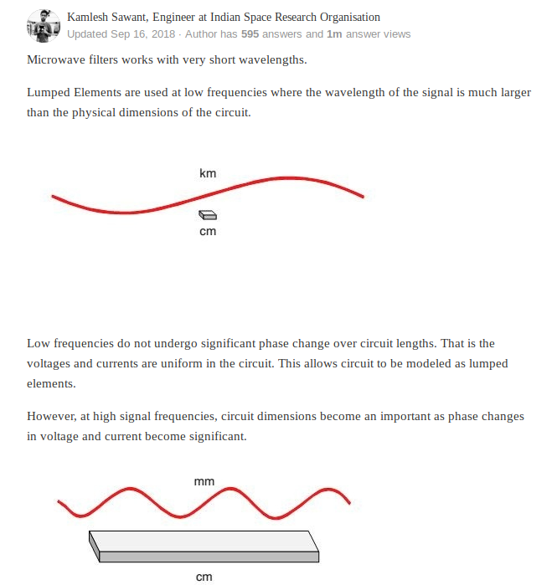
I could add to this guy’s answer that because of the variation of voltages/currents along the line, these latter can’t be properly measured. However what can be measured is how much these waves are being reflected/transmitted.
For this, the new representation of any device in HF (whether it is a passive filter, passive piece of track, active amplifier/transistor) can be modeled as a quadripole.

The Quadripole
A quadripole is a way of reprensenting an electronical circuit. It has two input : input current and voltage. And two output : output current and voltage.It links the input current/voltage to the output current/voltage. The goal is to study for example what can be the input and output impedances of such a quadripole. Here is a screenshot of a quadripole :
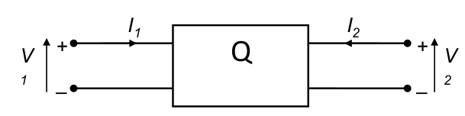
From this we can represents the impedance matrix :
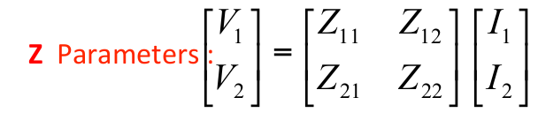
Below is the relationship linking the Z parameters to the voltages/currents :
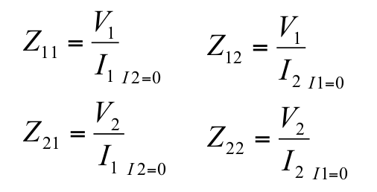
Z11 is measured when I2 is opened and is the ratio between V1 and I1. A huge Z11 means that almost no current flows into the quadripole.
Same thinking about Z22.
Z12 measures the impedance from output to the input and Z21 the impedance from input to output.
Each time, eaither I1 or I2 needs to be opened.

Other kind of matrices does exist, such as admittance matrix, hybrid matrix.

However, in HF, good open circuits or short circuits are difficult to achieve.
Therefore, new parameters has been defined and are called « Scattering Parameters ».

The S-Parameters
In the matrices, until now, we made the calculation in the spirit of voltages and current values.
Now, the spirit will be of voltage incident and reflected waves

All the input and output currents/voltages are decomposed into 2 waves : incident one and reflected one :
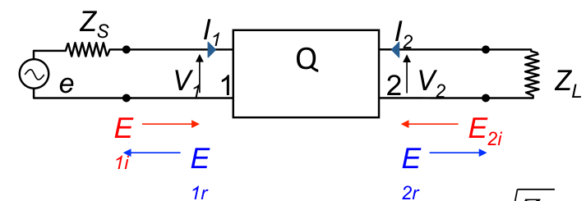
From what I can read, we define these new waves as voltages waves. Therefore :
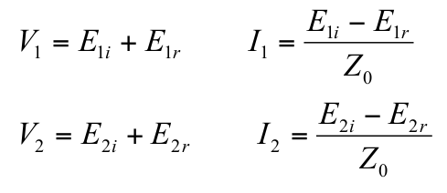

After some stuff, we obtain new variables :
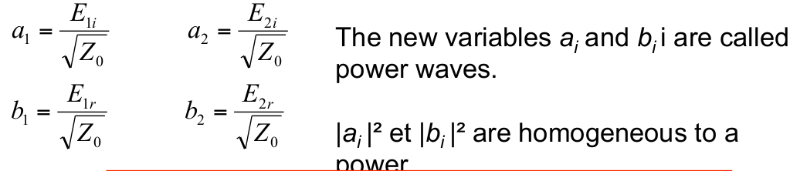
And finally, here is the S-parameters matrix :
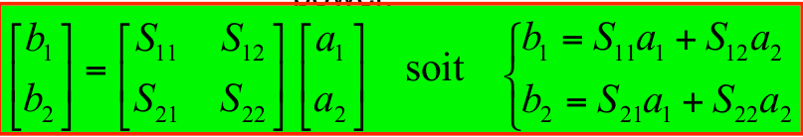

What we can say, is that these S-Parameters still represents a voltage gain, as we defined the incident and reflected waves as voltages waves. It means if we want the gain in dB, we need to mutiply its value by 20*log.

S11 is the measurement of the reflected wave at port 1 when incident wave is injected at port 1
It is called « Return loss » and is not suitable. The lower the better.

S12 is the measurement of the reflected wave at port 1 when incident wave is injected at port 2
We want to minimize this one

S21 is the measurement of the reflected wave at port 2 when incident wave is injected at port 1
We want to maximize this one

S22 is the measurement of the reflected wave at port 2 when incident wave is injected at port 2

We usually measure these parameters thanks to a Vector Network Analyzer, by ending the line by a 50 Ohms load. Notice that a VNA is like a child : when you are setting up it for the measurements, you have to tell it manually what stands for an open circuit, a short circuit and a 50 Ohms termination. OC or SC termination are usually part of some VNAs kits.

Particular case of the power amplifier
S-Parameters are used to describe a linear device in HF. For example, the 1st amplifier created was linear, as the input voltage was so small, that it did not affect the Q-bias point of the transistor.In other words, the input voltage magnitude was so small, that it did not get distorted at the output and the transistor. Keep in mind that when dealing small signal amplifier, the Q-Bias point has to be set at half the value of Vcc, and therefore the peak value of the output voltage cannot exceed Vcc/2.
For this, the input voltage must be low, otherwise distortion may occur. These small signal amplifier are usually used in low frequencies.

When working with power amplifier (e.g large signal) , we know that we will have to deal with distortion at the output. We also know that the drain/collector’s current will be higher than in small signal case. We also know that depending on the class implemented, the drain/collector’s efficiency will be more or less good. Power amplifier are widely used when dealing with high frequency as well, meaning that we think in terms of input power and output power. Distortion points need to be caracterized (P1dB, OP3, IP3). These properties belong only to the PA. P1dB stands for the compression point at 1 dB. This means « how my real output power differs from 1dB from the theorical one ? ». It shows at whcih point the large signal amplifier starts to be non linear.

Well ok, but where do you want to go with that ?
As we want to design a power amplifier, we can no longer use only the S-parameters,as they describe a fully linear device in HF. We need to use something else. And we are going to use the X-Parameters.These can be used also with linear amplifier (small signal), in this case X-params will be simplified to S-params. Well, in fact it is Keysigh (Agilent before) who seem to have created this term. Another way of talking about these « non linear S parameters » is the « Harmonic balance ». This how Qucs, NI AWR are calling the simulation of the S-Parameters in the large signal case.
Qucs does not manage well the harmonic balance simulation. I don’t have many options for a PA.
It will be now either ADS or AWR. Qucs would be perfect in the scope of a small signal RF amplifier. We can see the limits of the opensource. If you want to do something specific, and in a professionnal way, at one point you need to have the proper tool, including professionnal licensed software, as I’m not interested in searching for hours/days a tool that I have to include myself in Qucs. Documentation say it : « rudimentary version of HB implemented in Qucs ».
Last try in Xyce. If it gets nowhere, I’m using ADS or AWR. Yes ok, if I want to use Xyce, I have to download the source and recompile everything from scratch, as the executable avaiable are not intended to work on Ubuntu. No, thank you, I’m doing electronics, not computers tricks. Let’s move on licensed FULLY WORKING sofwares.

