Why impedance adaptations

In others papers (especially the RF amplifier one), we saw that without adaptation there were a gain loss du to reflecion inside the tracks.

A useful tool is the transducic gain. This one allows us to see what is lost between the source and the load. It describes the ratio between what is delivered to the load over what is avaiable at the source.
Sa formule générale est la suivante :
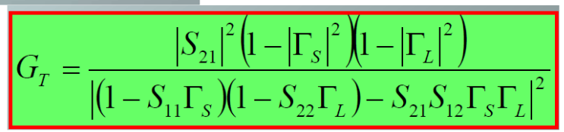
Also :
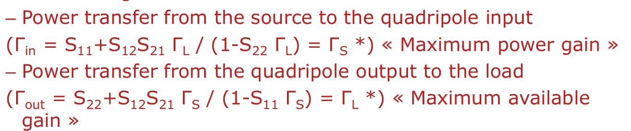
Let’s take an example where we know that at its output, a device has to « see » the load at this complex impedance value : 123.46 + 15.60*j.
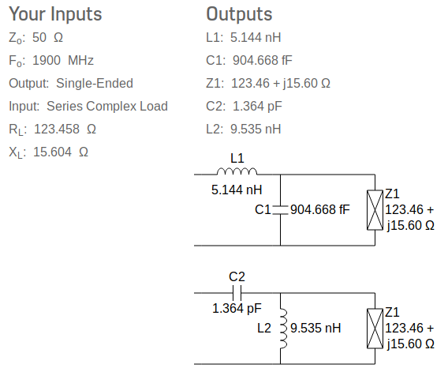

Above the circuit with lumped elements that we should insert between the output device and the load. On a PCB, it would be between the output device and the output coupling capacitors, for example. How does the calculator proceed ?
Well, for the lumped elements adaptation technique, here is the methodology (you’ll need a Smith chart) :
1 – Put the load impedance on the chart
2 – Capacitor is in parallel => go to admittance
3 – Draw the mirror 50 Ohms circle on the chart
4 – Start from susceptance (imaginary part of admittance). CAPACITIVE SUSCEPTANCE is POSITIVE. So we have to get up on the chart.
5 – Stop at the intersection point between the mirror circle and the susceptance circle.
6 – From this point, go to impedance (as the inductor is in series). If everything is good, you should end up on the 50 Ohms circle.
7 – Start from this reactance (imaginary part of impedance). INDUCTIVE REACTANCE is POSTIVE. So we have to get up on the chart.

An adaptation thanks to stub or slug can also be achieved.
A stub is a PARALLEL TL ended with either an open circuit or a short circuit, and separated from the load by a SERIE TL of a calculated length. Both stub and TL have their width at the caracteristic impedance.
Length are calculated thanks to Smith Chart.
For example :
-Put impedance on Smith chart
-Get in admittance
-Get up towards generator
-2 possible intersection point with 50 Ohms circle.
-Admittance brang by the stub can be determined. From this point, go to the 50+0j Ohms point. The imaginary part you added or substracted corresonds to the admittance of the stub.
-The TL between stub and load is calculated this way : going towards generator, calculate the difference between intersection point and admittance.
-The stub length can be calculated this way : start from either Zcc or Zco towards generator and measure the difference between intersection point and Zcc/Zco.
Sometimes, you’ll see open circuit on the left and short circuit on the right. It is simply because the peoples writing it are thinking in admittance way.
That’s all.

Let’s take the filter we have calculated :
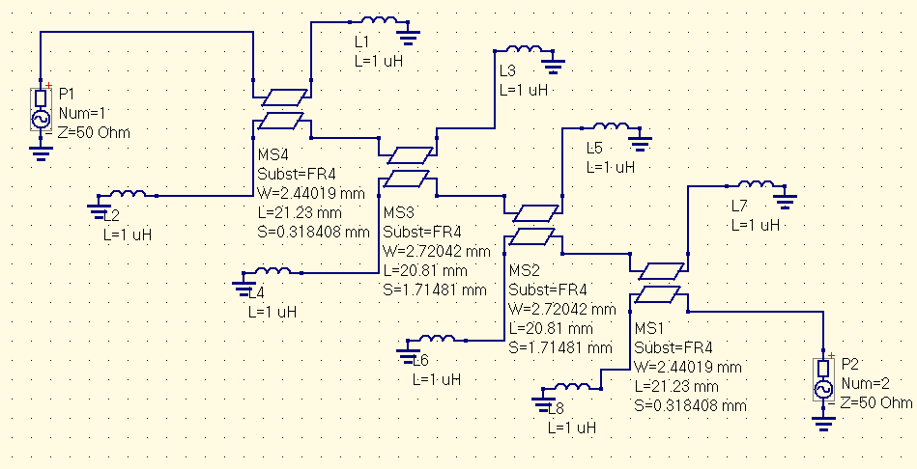
Here are its S-Parameters :
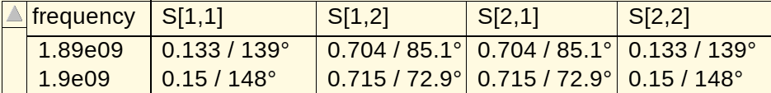
Let’s see if we can reduce the amplitude of S11 and S22 (reflection parameters).
With load and source impedances at 50 Ohms :
rhoS = S11* and rhoL = S22*

ZS = 38.2759 – 6.2250jOhms
ZL = 38.2759 – 6.2250jOhms

z = 0.76552 – 0.12jOhms.

Using a slug adaptation :
1 – Place impedance on Smith chart
2 – TL between slug and load can be calculated this way : towards generator, measure the difference between Zco and the impedance point
3 – Draw the impedance circle and measure the radius of this circle
4 – Calculate Zt = 50*sqrt(r)
5 – Converts this impedance to a width. If it is a microstrip line, lots of width calculators can be found online to determine the corresponding width.

slug_to_load length = 20.467 mm
slug width = 2.32 mm

Here is the new computed S-parameters :
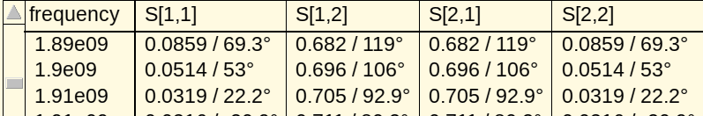
We can see that the amplitude of the 2 reflected waves has been reduced. Adaptation network works well. However, it costed that the transmission wave has been slightly reduced.

To sumarize, source and load impedances are usually set to a physical 50 Ohms. However, 50 Ohms is not often the impedance value that ensure a max gain optimization. In fact, we want the device to see another impedance value. And this value will be the optimized impedance.

