RF amplifier module

The choosen one is the TQP9111. Here is its pin description :
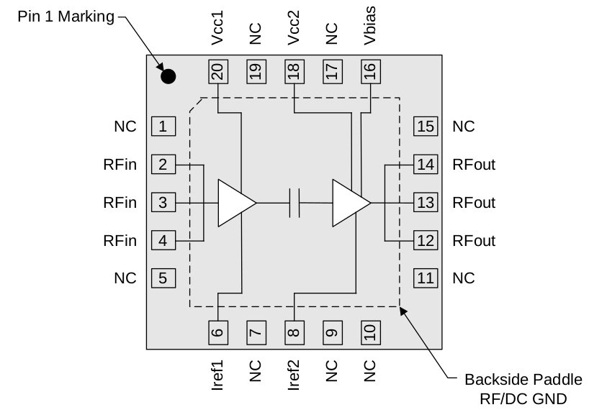
Rfin and Rfout are the input and output of the signal. Iref1 and Iref2 are the pins to bring the bias current to the 1st and 2nd amplifier. Vbias is the voltage bias to make the amplifier works in their active region. Vcc1 and Vcc2 are the supply voltages. Every other pin can be tied to the ground.
Inductors will be needed for the DC pins in order the the RF signal to not go in the DC signal.

Here is the schematic made on Kicad :
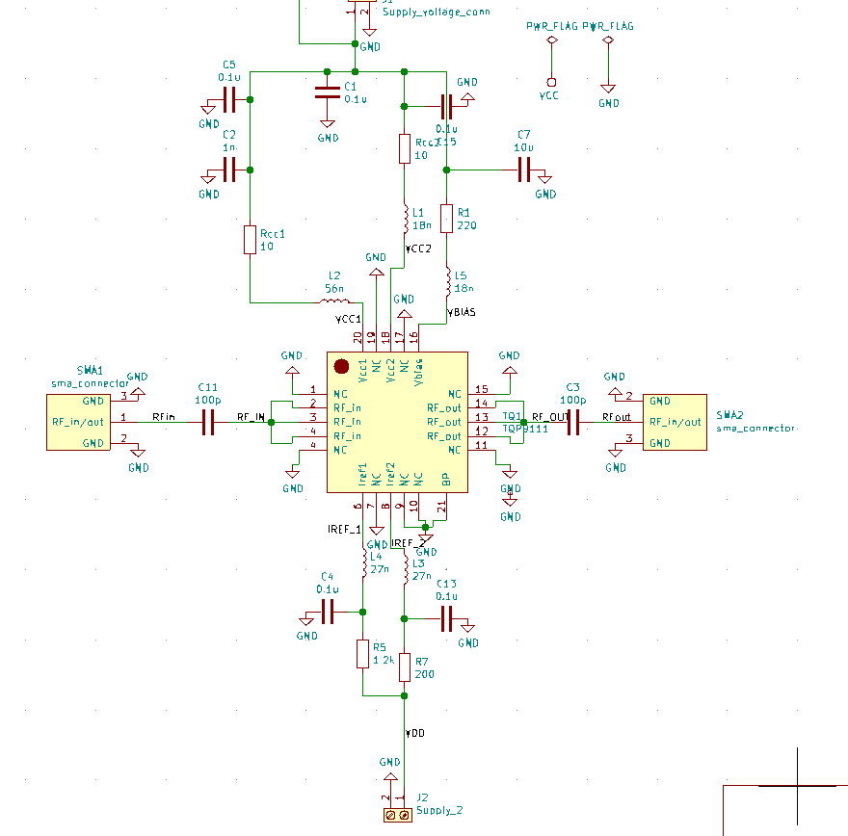
R5 establishes the bias current Iref 1 and R7 Iref2. R1 establishes the voltage bias of the amplifier.
The inductors are carefully choosen in order to have their SRF at 1.9GHz. The SRF of an inductor is when the inductance and capacitance of an inductor are resonating with each other. So the inductor acts as an open circuit at 1.9GHz. Iref2 is around 25 mA. Iref1 is 4.5 mA and Icc1/2 are 500 mA, thanks to the supply resistors (10 Ohms).C11 and C3 are coupling capacitors. They are linking the input to the amplifier and the output to the amplifier when at 1.9GHz.
The others are bypass capacitors used to avoid a violent current sweep.
I used the values of capacitors given in the datasheet.

Below the 1st version of the amplifier’s PCB (Missing Rcc1 and Rcc2) :

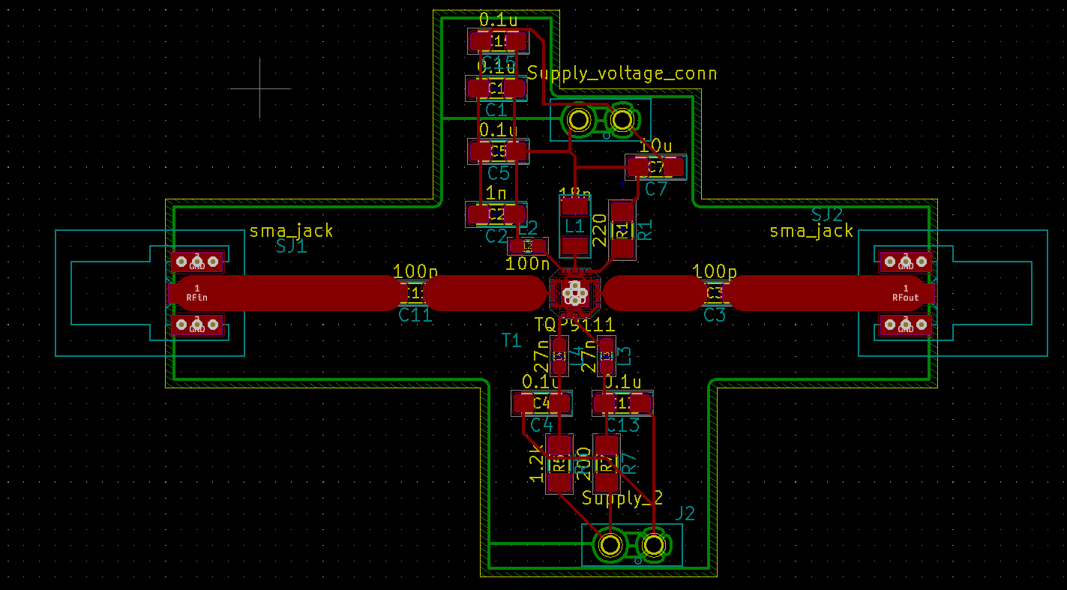
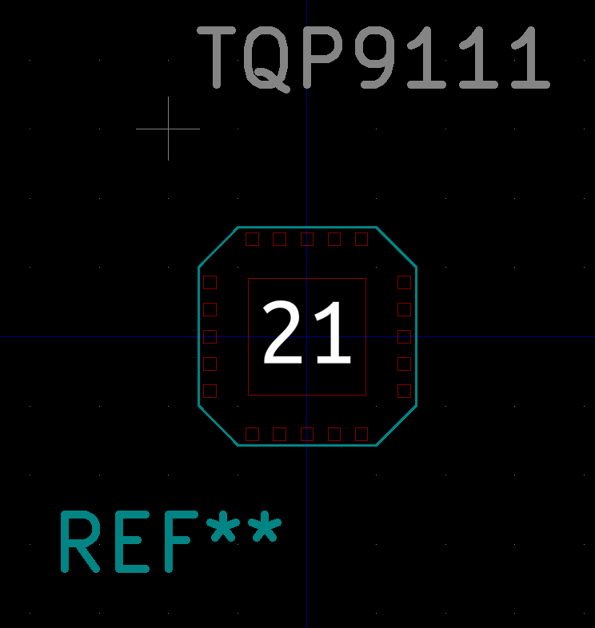
Custom footprint for the amplifier :

From now on, we can go to the simulation of this amplifier. Exactly in the same way as the attenuator, the amplifier’s manufacturer provides its S-parameters. And this what they measured with their own PCB (TriQuint, with Icq = 545 mA, Vcc = Vpd = 5V) :
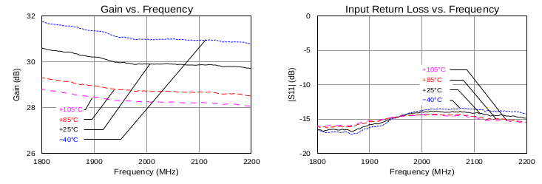
So, let’s draw the schematic in Qucs and make its simulation with length of TL matching the one drawn on the PCB :
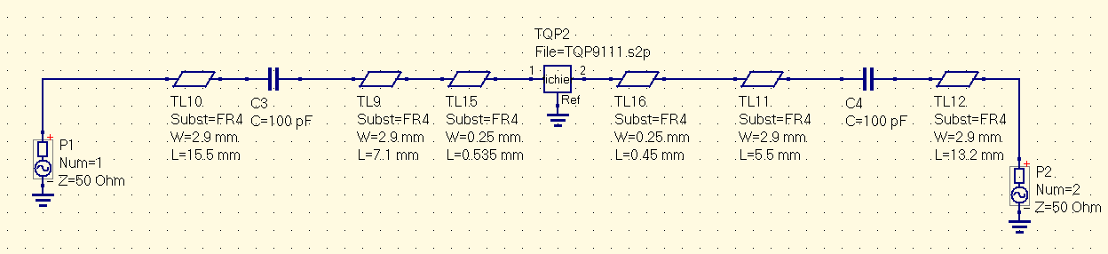
Here is the simulation :
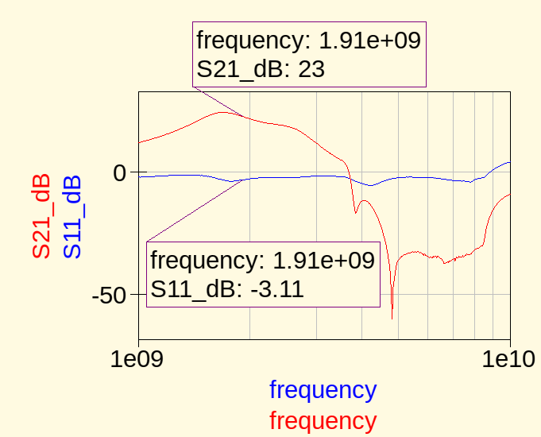
The amplifier’s datasheet says that at 1.9GHz, we should have a gain of slightly more than 30 dB. We are 7 dB less, and get a quite awful return loss. Which means input waves are being reflected, which means we need to do again some impedance adaptation.

Impedance adaptation
I already explained in the attenuator’s paper a little bit of theory concerning why and how to make adaptation. (not all details though) . Here is the S-parameters provided by Qorvo :
Using slug adaptation and Smith Chart, we get the following results :
ZS = 8.4378 – 3.6896j and ZL = 4.67518 + 0.51033
After normalizing it to 50 Ohms and playing with Smith Chart, we get the following results :

Slug_to_load_in has a length of 19.9 mm and a width of 2.9 mm
Slug_in has a length of 18.6 mm and a width of 0.369 mm

Slug_to_load_out has a length of 17.1 mm and a width of 2.9 mm
Slug_out has a length of 18.6 mm and a width of 0.137 mm (0.2 mm taken => minimum allowed width).

Here is the new schematic :
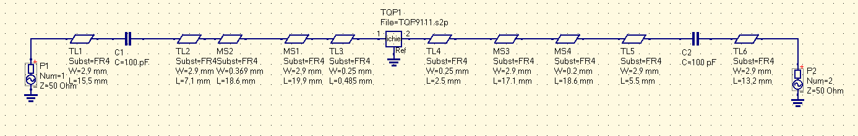
And its simulation :
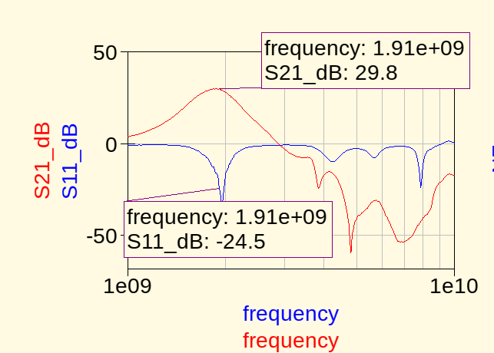

We can see that both gain and the return loss are well improved compared to the unmatched case.

So here is the new PCB, with this time Rcc1 and Rcc2 as well :
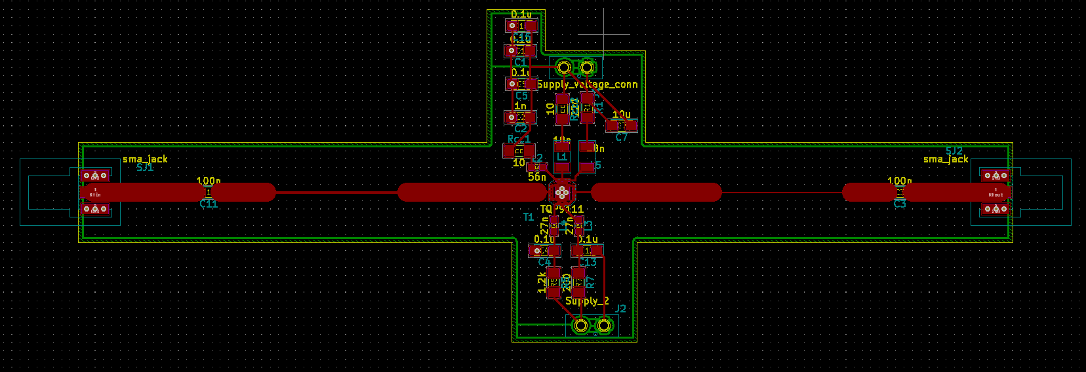
We can recognize the slugs and the transmission line connecting the slugs to the load (here their load is the amplifer). You can note as well that if you look at the amplifier datasheet, they used an adaptation thanks to the « lumped component » technique. In other words, a combination of capacitors and inductors in series/parallel.

The noise
We can also look at the noise generated. Here is what we get :
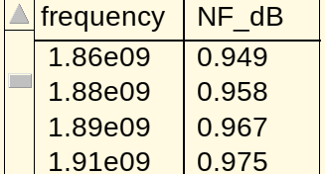

As we made an impedance matching in order to achieve the maximum gain,we do not have Nfmin, but NF. And as strange as it can be, our RF amplifier get a better noise figure than the LNA. Strange.Really.

