Signal behaviour in reception part

The noise

THE thing to look at and analyse when dealing with a receiver is the SNR at the end of the chain.
When a signal arrives on the reception part, it carries with it an unwanted signal : the noise.
After filtering, here is the signal’s situation :

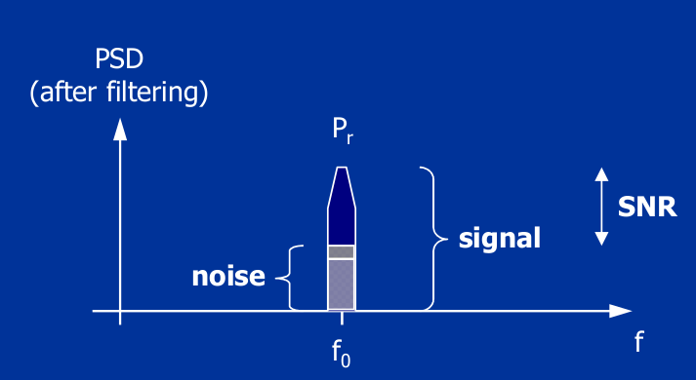
The signal hold a certain amount of noise, and so a SNR more or less great. However, it is mandatory to have the greatest SNR possible to get a Bit error rate or symbol error rate as low as possible. The value of the SNR depends on the kind of modulation.
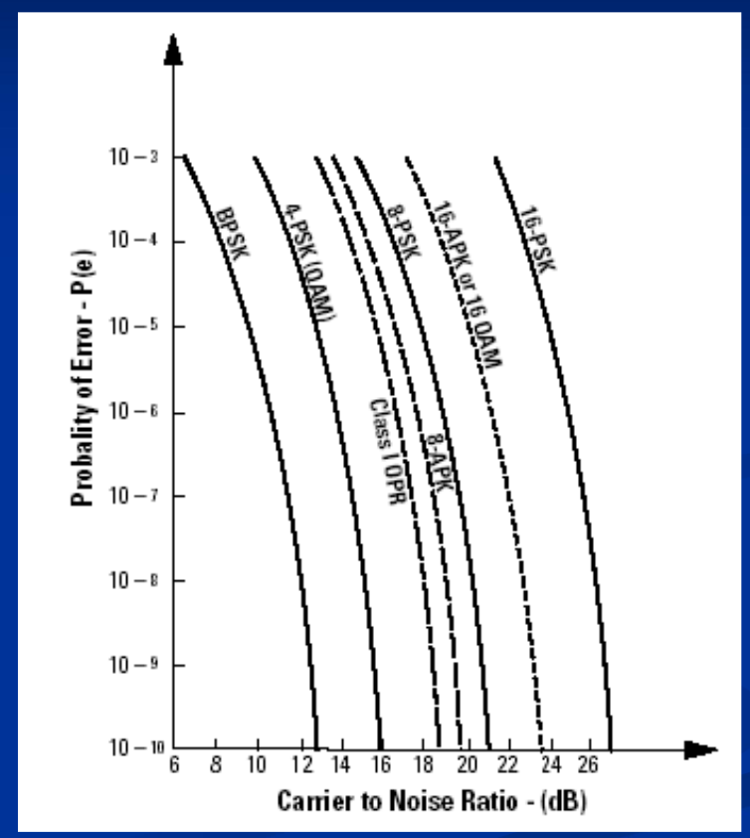

This graph shows the minimal SNR value to ensure a decent BER/SER.

Also, we can dtermine wich is the power lost when the wave is propagating through air.
It depends on the 2 antennas distance, and the wavelength of the wave.

Donc à 30 m, les pertes dans l’air s’élèveraient à 84 dB. A 5 mètres,à 67.6 dB.
For example, for a 1.9GHz wave (lambda = 0.157 m) , with a travelling distance of 30 m, losses would be of about 114 dB.
Now, let’s calculate what is the power arriving at the receiving antenna, just before the bandpass filter.We consider a distance of 10 meters between the 2 antennas.
Prx = Gtx + Grx – Ploss + Ptx

Prx is the received power, Gtx the emitting antenna gain (usually in dBi), Grx the reception antenna gain, Ploss the power lost in the air. The antenna, as shown in the paper talking about it, we saw that we have a peak gain of about 2.36 dBi.At 10 meters :

Prx = 2.36 dB + 2.36 dB – 114 dB + 30 dBm.
Prx = -79.28 dBm (11.8 pW)
It is the maximum received power, when both antennas are oriented according to their peak gains.
Let’s imagine that it gets through the LNA (gain around 19 dB).
-79.28 dBm + 19 dB = -30.28 dBm = 0.9 nW.
In the paper dealing about the reception part, we saw that to have a really low BER/SER with a 64QAM, the input power should be of around 850 uW. Here as the input pwer is 0.9 nW , it means that chances of errors while demodulating are greater.

Sensitivity is the study if which input power is requiered in order to minimze the BER/SER while demodulating.
The formula is :
The -174 term is expressed in dBm/Hz and come from k*Ts, with k blotzmann constant and Ts = 290k. It stands for the noise carried by the signal before entering the 1st reception channel component.One could say it is the thermal noise of the source.
So now we take the 0.9 nW calculated previously and let’s see for a 64QAM the corresponding SNR.
SNR = +174 – 10log(BW) - NF + Pin (sensitivity)
SNR = 174 – 70 – 7.15 – 30.28 = 66.57 dB.

The noise factor if the LNA is calculated like this :
(1 + (Tamp/Ts) ), with Tamp the thermal noise of the amplifier.Noise figure = 10*log(Noise factor)

For a reception part with several components, the total noise at the input if the modualtor can be calculated thanks to the Friis formula.
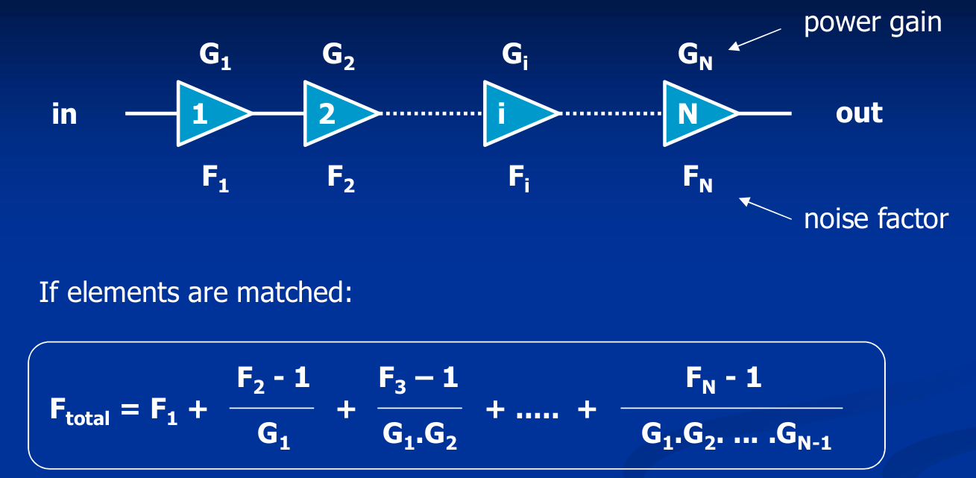
Fi and Gi are expressed in LINEAR. Fi is the noise factor of the i component and Gi its gain.

Linearity
When talking about linearity, 2 parameters are vital to analyse. There are the P1dB and the IP3.
P1dB (compression point at 1 dB) is the output power value at which the theorical output power and the measured output power will deviate of 1 dB. In other words, the amplifier starts to be non linear.
IP3 (interception point of 3rd order) is apparently the most important criteria. I do not fully unterstand it, as it is more a mathematical thing rather than a physical criteria.
As I understand it, if we reach this point, we know that the amplifier is not linear at all anymore.
The highest, the better.
A drawing is better than a long talk :
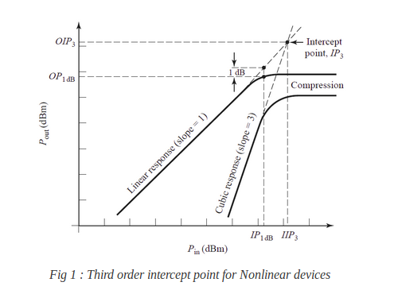
Again, if we have multiple devices in the chain, we can calculate the total IP3, and so know if the total chain is linear or not. Obviously, a filter does not have any IP3, so just ignore this one when calculating the IP3 of the whole chain.
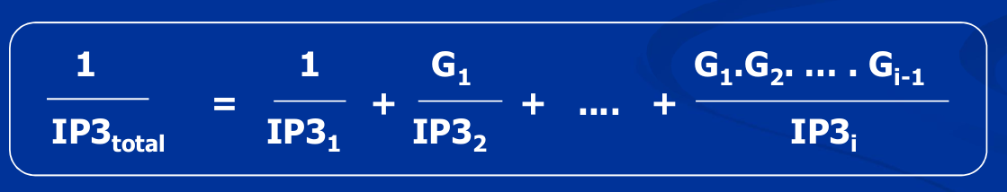
Cette fois, l’équation n a pas de nom. Les différentes valeurs de IP3 et de G sont exprimées en linéaire.

