Already made antenna

The choosen one has a frequency range between 617MHe and 3.8GHz
It can hold 5W as a maximum power.
Here is the pattern diagramm for 3 different frequencies, with the peak gain and the average gain.The gain is expressed compared to an isotropic antenna (this why dBi).
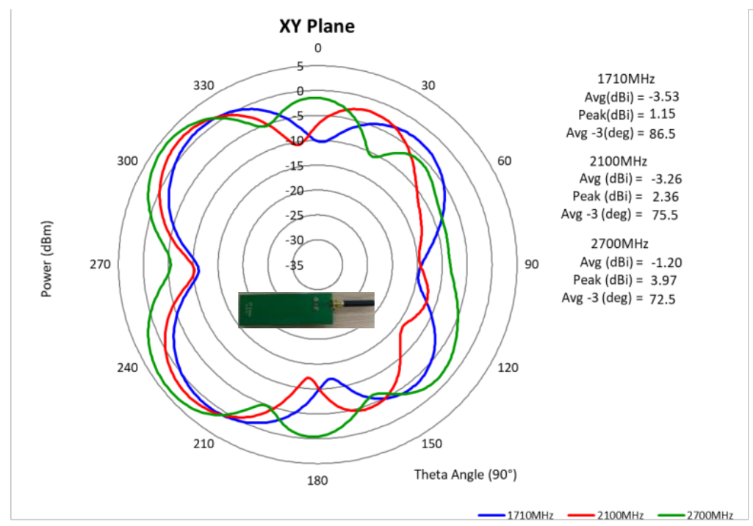
The pattern diagramm says us in which direction the antenna has the highest directivity. In the one where there is the peak diagramm.
In the datasheet, we can see as well the following diagramm :
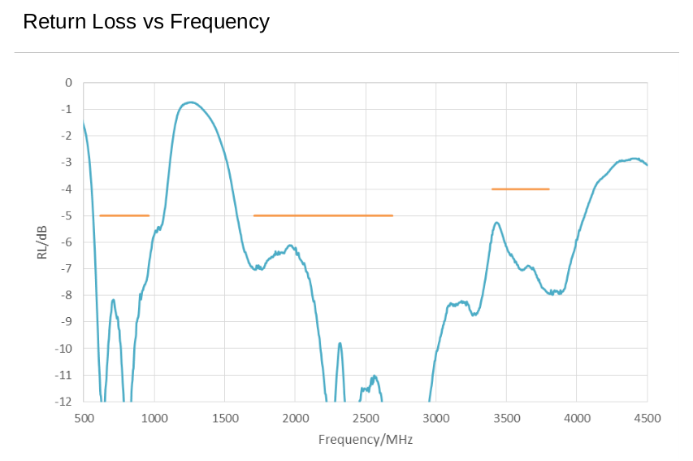
For f=1.9GHz, the return loss is around -6.5 dB
RL = -20log(rho) and VSWR = (1+rho)/(1-rho)
rho = 0.47 and VSWR =2.796. It is not that awful.

