In this paper, we’ll focus on the device used in order to attenuate the signal coming from the SDR.

The attenuator
Its goal is to lower the power of the incoming signal. As written in the RF amplifier’s datasheet, its gain is of 30 dB. Its P1dB is about 33 dBm (output power for which the amplifier starts to be non-linear). In addition, we want an output power of around 30 dBm. As well, we can read in the SDR’s datasheet that the output power is at least 10 dBm. This is why we need an attenuator. If we do nothing, the output signal will be most likely distorted. In that spirit, the numerical atttenuator F1958 is the choosen one. We just have to supply some pins in order to choose the gain’s attenuation.
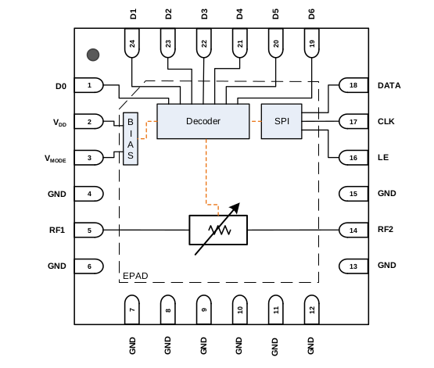
Here, the pins which control the attenuation are D0...D6. VDD corresponds to the supply pin,clearly at 3.3V. Vmode state will determine whether the attenuation mode is in direct parallel or latched parallel. These two achieve the same goal, but in a different way. RF1 and RF2 corresponds to the input and output signal. DATA and CLK are used only in latched parallel.
Direct parallel is when the attenuation reacts immediatly to the D0...D6 state changes.
To choose this mode, I grounded Vmode, CLK and DATA, put LE to « HIGH » state.
High corresponds to 3.3V and LOW to 0V (gnd).

Below is a screenshot of the created electric schematic.Capacitors and resistors are here to ensure the signal’s integrity.
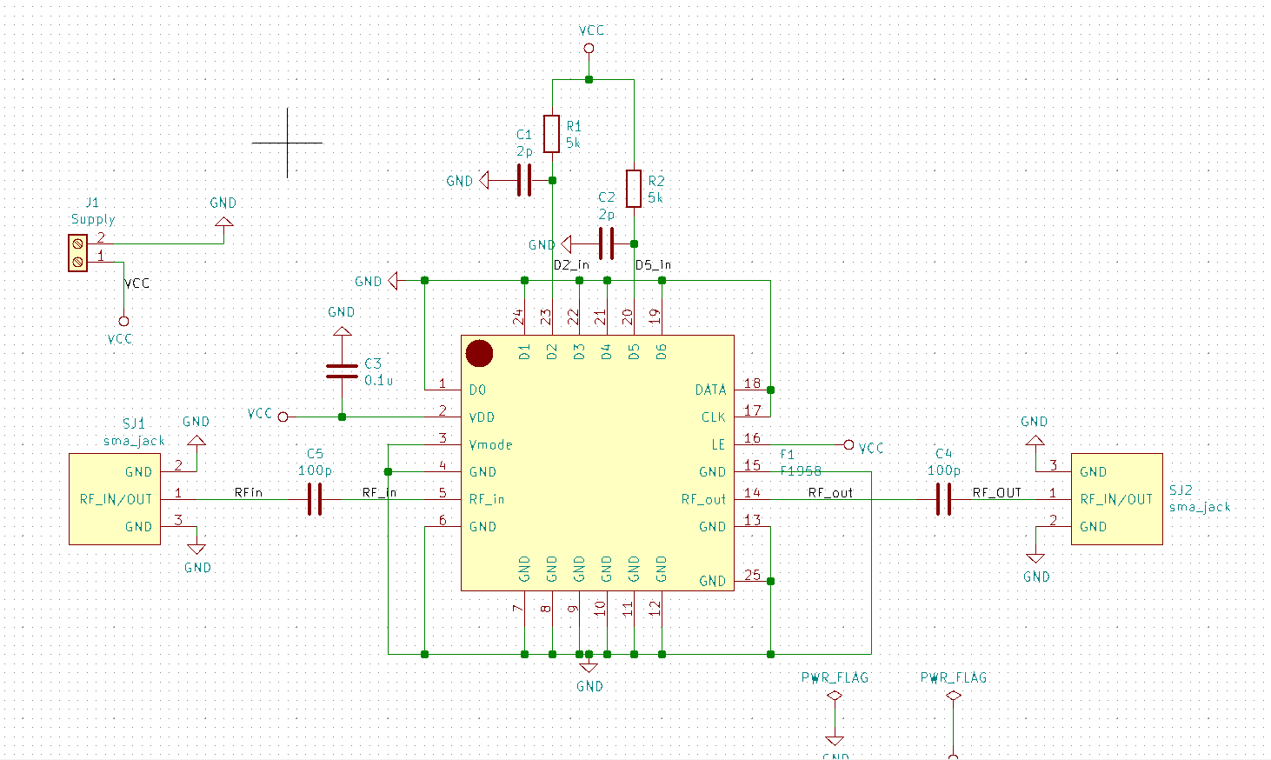
.SJ1, SJ2 as well as the F1958 symbols does not exist in Kicad. Therefore, they have been created.
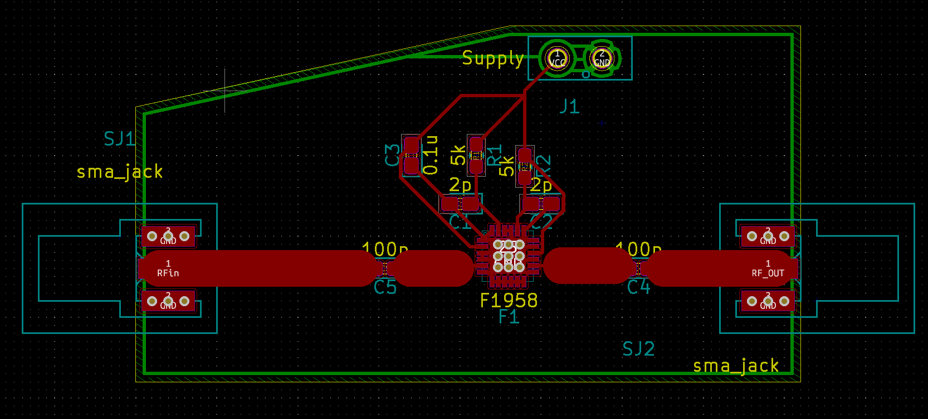
Here is the 1st version of the attenuator’s PCB. « Supply » is a screw driver. Also, customs footprints have been created for SJ1, SJ2, the F1958 and the screw driver, as they do not exist in Kicad.

The 3 following screenshots show the 3 mentionned footprints.PRT-08084 is the screw driver’s reference on Mouser website, the same for the SMA connector.
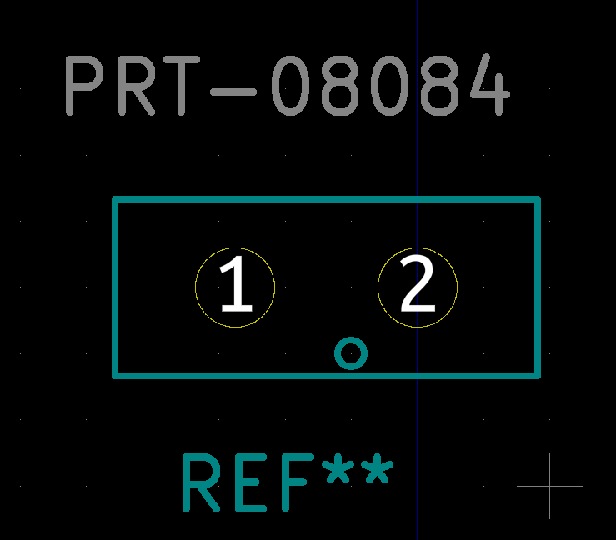
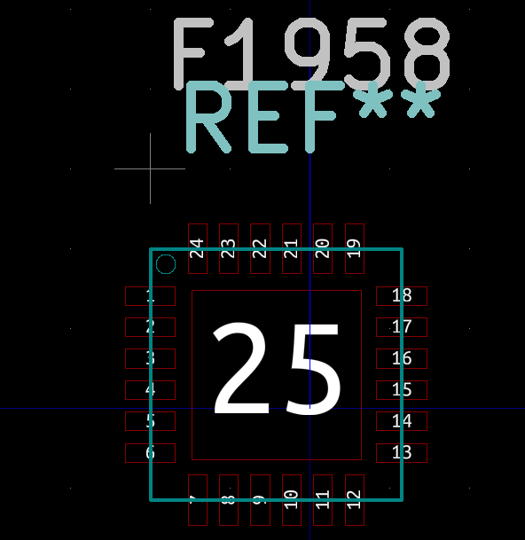

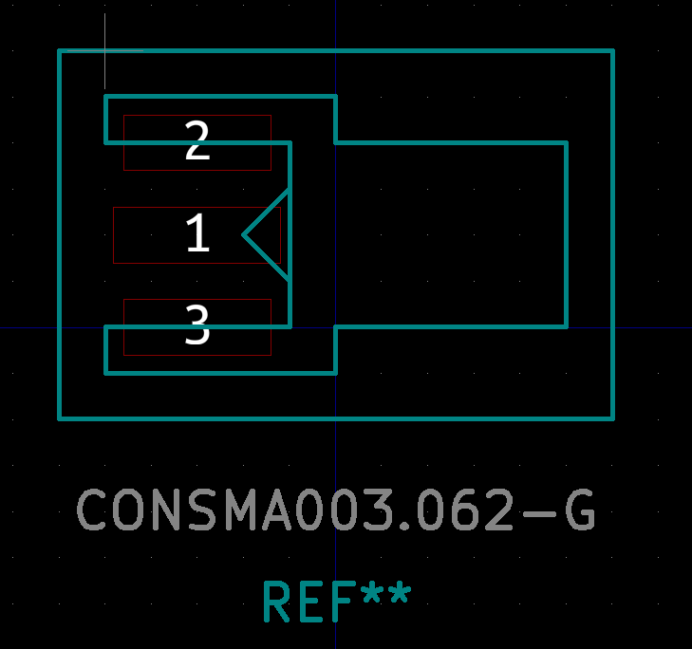

These footprints have been created thanks to the dimensional datas found in the component’s datasheet. On the PCB, we can see that the tracks going from the SMAs to the F1958 are wider than the others. These tracks are carrying our HF signal. Without entering into details, these width track has been calculated for the 1.9 GHz frequency in order that the HF signal is not reflected while travelling into these tracks.

Now, let’s look at the F1958 S-parameters simulation. In HF, instead of talking about voltages or currents, we are talking about waves. Incident and reflected ones. This is how we measure the performance of the device under test. The choosen attenuation is about 12 dB.

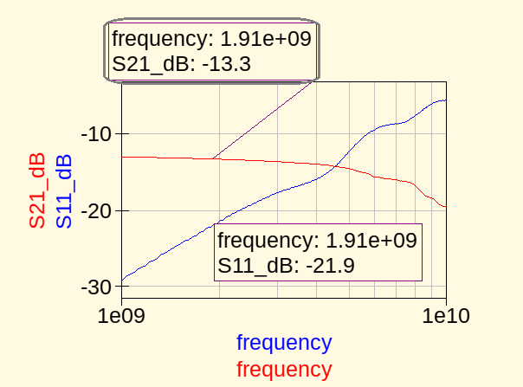

S21 is the gain of the device. Here, we want an attenuation. This what we have. A bit stronger, but still good. S11 is the measure if the signal’s power lost at the input. In other words, when injecting a signal at the device’s input, we want to measure what is reflected or transmitted. A low S11 (very negative) means that a lot of the signal has not been reflected from the input to the input. A high S11 (close to 0 in logarithmic scale) means that almost all the signal has been reflected from the input to the input.We can notice as well that S-parameters are not fixed and are varying with frequency.
A concept called « impedance matching » can improve the S11 and S21 parameters.

The adaptation
About the quadripoles in HF (a transistor, or amplifier or attenuator or every device in HF) :
-THE 1st thing we learn, is that to have a maximum gain transmission, the 1st criteria is that the source and load impedance have to be the conjugate of each other. (50 Ohms and 50 Ohms for example).
-The 2nd criteria is when the 1st criteria is filled and if the component is unconditionnaly stable then we can say that in order to optimize the gain : rhoIN = S11 = rhoS* and rhoOUT = S22 = rhoL*
Stability can be studied thanks to the Rollet factor. If it not unconditionnaly stable, care must be taken when choosing source/load impedance.

Let’s apply these concepts :
S-parameters are usually given by the device’s manufacturer.They are measured on a test PCB, in certain conditions (Supply voltage, bias current, bias voltage) which are specified in the S-parameters file.
The S-parameters from the attenuator are given in dB/angle and in this order : S11,S21,S12,S22.
As stated previously, only two parameters interests us (S11 and S22).
Thanks to Octave :
ZS = 44.48000 + 0.21702i ( zS = 0.8896001 + 0.0043405i)
ZL = 44.89218 + 0.44403i ( zL = 0.8978437 + 0.0088806i)
Note that as said previously, the load and source impedances are both 50 Ohms. In fact, it is their physical value. What we want to do, is to make a modification of the circuit so that the device « sees » another value of source and load impedances.

For adaptation, I used a Smith Chart and the « slug » adaptation. The latter consists of a serie piece of track, length = lambda/4 (connected to the source) and connected to a piece of track (connected to the load) of width corresponding to 50 Ohms impedance (2.9 mm at 1.9 GHz) and length calculated using Smith Chart.
Given the imaginary part of the calculated impedances are virtually equal to 0, the length of the 2.9 mm length tracks (at input and output) will be really close to lambda/4.As Im(ZL) is greater than Im(ZS), therefore output slug_to_load_out will be shorter than the slug_to_load_in length.
Here are the values that I have choose : LS = 18 mm and LL = 17.8 mm.
For the lambda/4 length track, we find that input width is 2.62 mm and output width is 2.65 mm.

Some pictures of my drawing on the Smith chart will be added, or presented later.

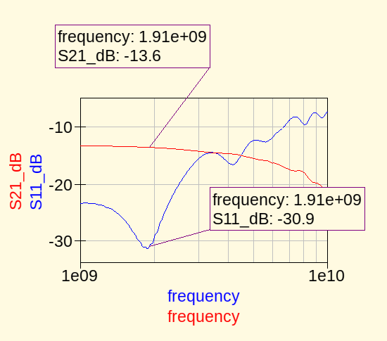

Above is a simulation of the circuit (designed on Qucs, and with account of the little pieces of tracks used to connect the attenuator to the 50 Ohms track).
We can see that the gain is not improved. However, the return loss (S11) is improved by far.

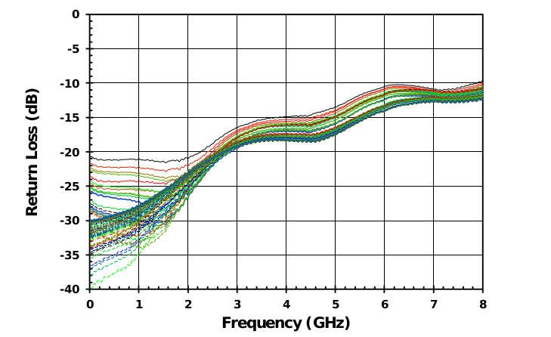
Here is what the manufacturer measured in terms od return loss on their test PCB.
We can see that we have somthing similar.

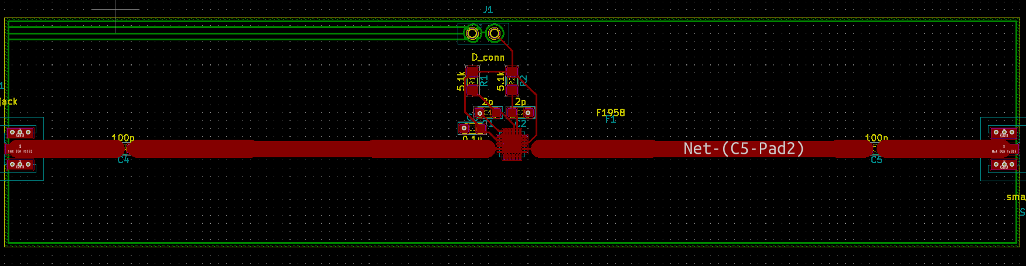
Finally, here is the final version of our PCB,which implants the adaptation made previously.

Also, here is the schematic made on Qucs (reprensenting the attenuator’s PCB) :
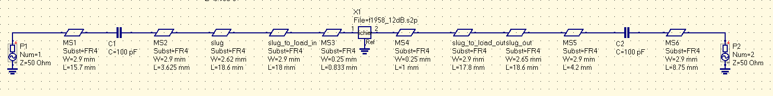
The F1958 is reprensented by the 2 ports device called « X1 » on the schematic. No bias network (i.e resistors/capacitors/inductors) are requiered as the S-parameters represents the device when it is ON.

Here is the bias conditions and the 1.9GHz parameters measured by the manufacturer (given in the S-parameters file) :
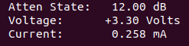

Recall: Couple dB/angle °

