Design from scratch of a Chebyshev bandpass filter

Microstrip lines are used instead of the usual capacitors/inductors as we deal with HF signals, which means their wavelength is similar to the length of the circuit.Therefore, voltages and currents are not constant along the line, and according to the transmission line length, a capacitor, resonnator, inductor can be designed.

For a bandpass filter, 3 main configuration are mainly used :
-Chebyshev
-Butterworth
-Bessel

Chebyshev

Chebyshev grants a more violent slope when cuting frequencies are reached. On the other hand, we have to deal with ripples in the bandwith.It is widely use in HF as we need fast transitions between cutoff band and pass band.
The idea of a Chebyshev filter is to start from a low pass filter and then go to a bandpass filter.
Here is the transfer function of a Chebyshev bandpass filter :
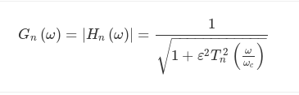

-Epsilon is the ripple
-Tn is the Chebyshev polynomial of n order
-Wc is the angular cutoff frequency

Butterworth

It has a longer transition between pass band abd stop band, however, there is no ripples

La fonction de transfert d’un passe bas-Butterworth est donnée par :
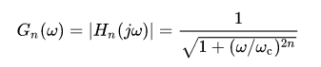

Bessel
It is the slowest one concerning the transition between pass band and stop band.
In our case, we want a really fast transition, so Chebyshev seems to be what we need here.

Hence, let’s go for the design of a bandpass Chebyshev filter
What we know :

-Fo = 1.9GHz
-BW = 10MHz
-pass band ripple 0.5 dB
-Impédance source : 50 Ohms

Design of the normalized low pass filter
It is the 1st step. The goal is to find the g coefficient of the Chebyshev low pass. Normalized means that RL = RS = 1 Ohm and Wc = 1 rad/s
From there, some formulas allow to find these g coeffcients

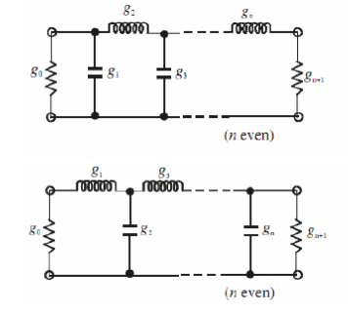

These coefficient, as shown on both schematic are in fact the values of the capacitors/inductors of the normalized filter.
Usually, you don’t need to recalculate these g coefficients. Instead, some tables are provided online, where according the your filter order and the bandwith ripple, you can read the g coefficients.

For those who are interested anyway in seeing the calculations to find these g coefficients, you’ll find the formulas on the next page.

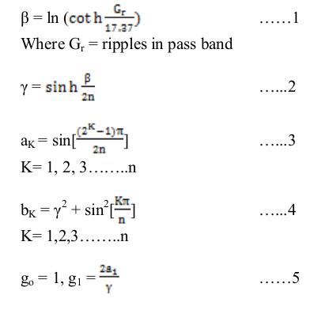
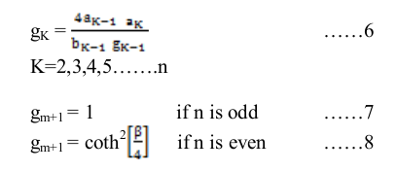

One of the table I mentionned before, with 0.5 dB of ripple :
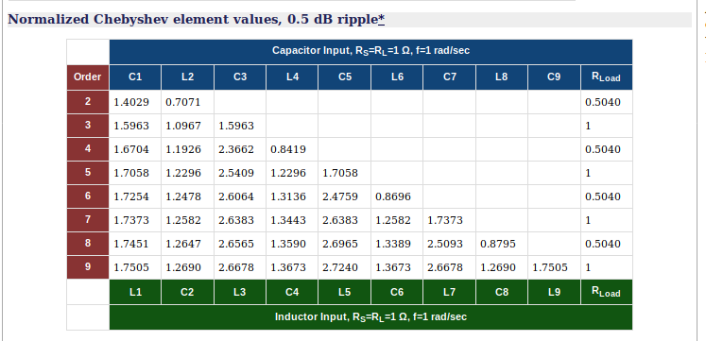
This table comes from the rfcafe.com website. We can notice the Li and Ci values, as well as the Rload value which are all normalized. So for us, here are the capacitors and inductors values, with a Tee structure : L1 = 1.705 H, C2 = 1.2690 F and L3 = 2.6678 H .
You’ll also notice that for even values of n, Rload is not 1. rfcafe says that a Chebyshev filter of an even order is not designable when Rload = 1 Ohm.
Let’s draw the schematic on LTSpice, and look at the cutoff frequency, for example.
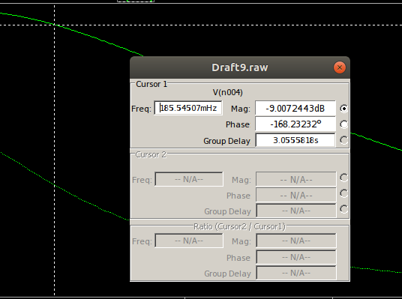
Racall : Wc = 2*pi*fc. Ici, Wc = 1, donc fc = 159mHz (theorical value)
We looked at Gbw – 3dB (1st order filter) to see the cutoff frequency of the low pass.
We can see that the simulated value is quite close of the calculated one.

From low pass to bandpass
After that, each big component of this low pass is cut in two smaller components : one inductor and one capacitor. These 2 new components (n=3, so 6 in total) will be in series-parallel-series (a Tee structure).
Formulas to find the values of the smaller components :
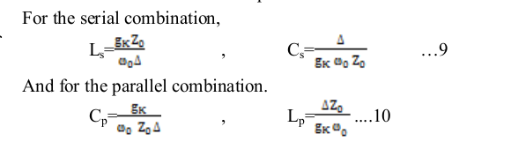
each couple of Ls/Cs and Cp/Lp corresponds to a big inductor/capacitor of the low pass.
With « s » standing for « serial » and « p » standing for parallel.
Wo is given by sqrt(w1*w2) (corresponding to the 2 cutoff angular frequencies), and Delta = (w2-w1)/w0.
We did the job of a lot of calculators that you can find online, which compute Chebyshev bandpass filers.

Still with LTSpice, let’s we are going to simulate such a filter. A calculator is used.
Let’s use a Tee structure.

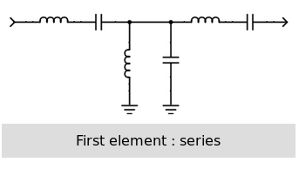

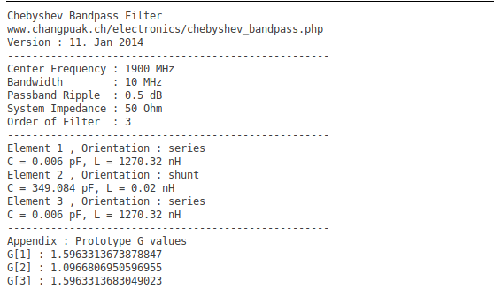

We just have to give the input and output impedance, the passband ripple, the order, center frequency and that’s all.
This time, we are not in low frequency anymore, so let’s use the Qucs software to see how well waves are being transmit

Here is the simulation :
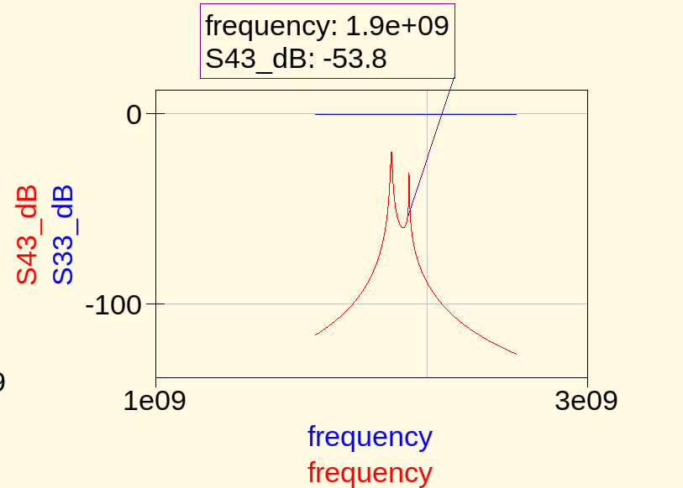
Clearly, we can see that it is not good at all. The very thin bandwith is responsible for this.
Let’s improve the bandwith to let’s say 100 MHz.
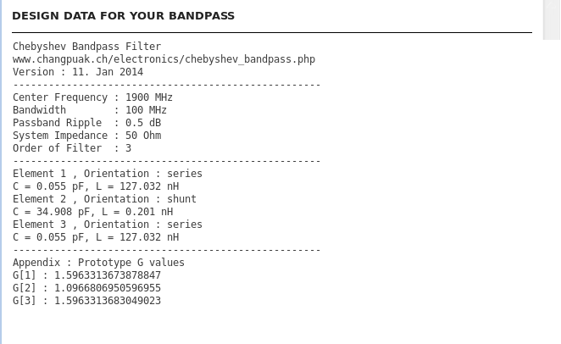

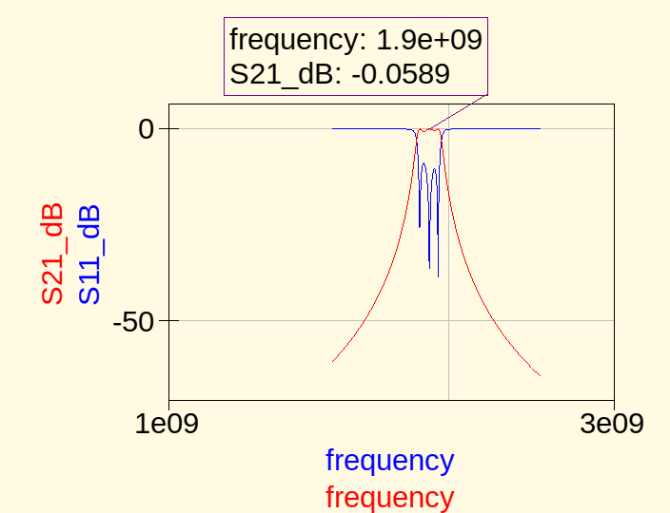
It is well better. A larger bandwith does not influence the gain.

Circuit résonnant LC

If you had to remember only one thing from the resonnator, it is this one : for 1 precise frequency, the inductor and capacitor will enter in resonnance du to their inductance and capacitance.
If you like maths, let’s put it that way : for one precise frequency, the capacitive reactance and the inductive reactance cancels with each other, leading to a resulting impedance which is only real.

Knowing this phenomenon, we can then observe the difference between a parallel and serail resonnator.

For a serial resonnator, when the reactances are cancelling, the equivalent circuit of a serial capacitor/inductor is a simple wire (very low impedance) . The voltage drop accros 2 points of a wire is nil, and the current flowing into the remaining resistor is equal to the voltage drop accros the resistor divided by the current flowing into it.Therefor, as we plot the voltage and current at the resonnance frequency, voltage is minimum and current maximum. In other words, current is the most needed when the inductor and capacitor forms a wire.

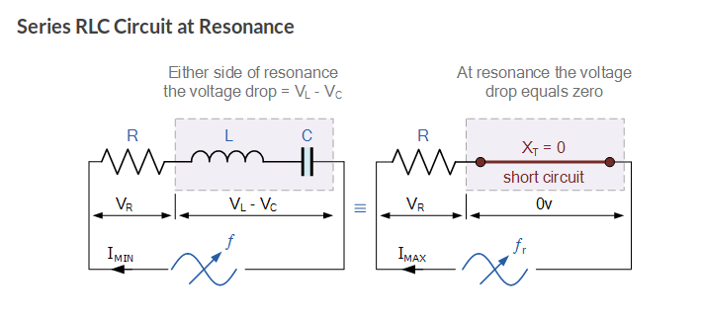

U = Z*I, avec Z = R et U = Vr + 0V = Vr
I = Vr/Z => Peak current

For a resonnant parallel, when the reactive parts are cancelling, the equivalent circuit is an open circuit (infinite impedance).
No current flows into the open circuit (as it does not need current),therefore the current is minimum at the resonant frequency,and as U = Z/I, the voltage is then at its maximum possible value.
As a recall, if an infinite impedance is put in parallel with a finite impedance, the equivalent impedance will be equal to the value of the finite impedance.
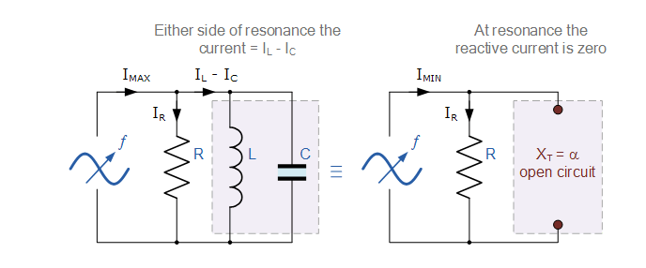

From voltages/current to S-parameters

S-Parameters are widely used in RF to caracterize the good or bad behaviour of any device.
Whether it is a filter,an amplifier or a piece of track.These parameters shows how well the input waves are transmitted (or not) accros the device. That’s their only goal. According to the results, impedance adaptation may be needed, or not.

From lumped elements to distributed elements
As said previously, in HF, we favored the distributed elements, as their is not parasitic elements, on the contrary of lumped elements.
Below is the simulation of a filter implanting 2 parallel resonnator networks in series with each other :
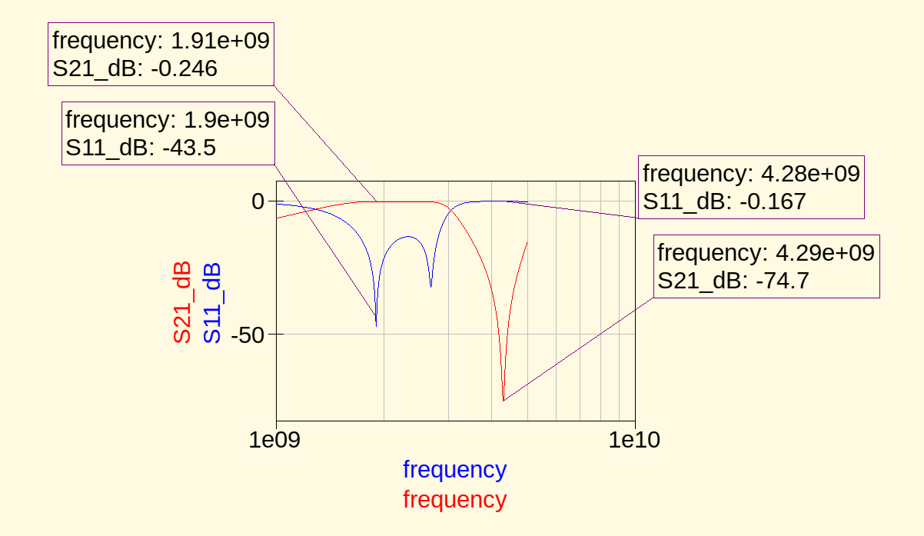
You may have already seen this filter if you have read the paper « used filter ».

From Chebyshev bandpass to coupled microstrip line
As explained in an other paper, Qucs allows to build in a really easy way a bandpass filter.
For example a Chebyshev bandpass filter, f1 = 1.7GHz and f2 = 2.1GHz.

Voici le résultat en simulation :

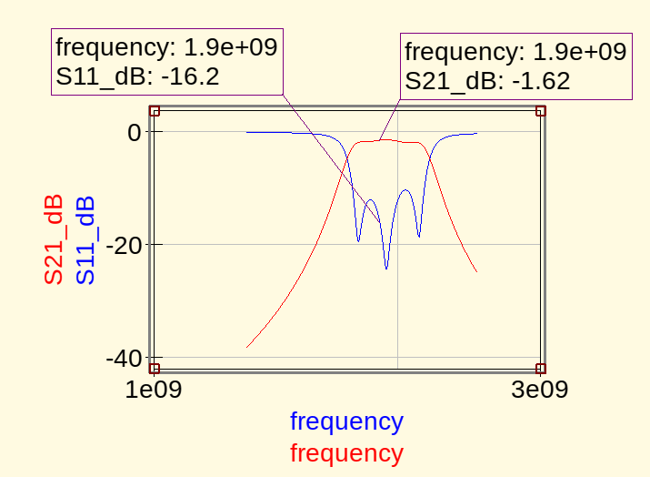
Return loss is correct and not much gain is lost when travelling through the filter (around 1/4W).

For the sake of curiosity, here is the behaviour of the filter in higher frequency :
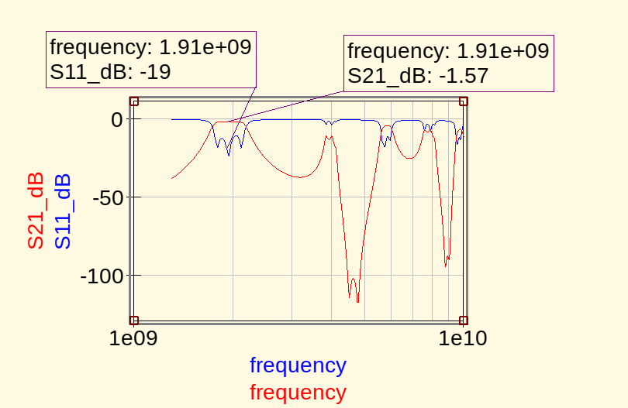
We can clearly see that the filter is a nice stopband filter around 4.7 GHz.

How it works

Coupled microstrip line are basically 2 pieces of tracks facing each other. They are separated by a tiny space, share same width and length. What we are calculating are what we call the odd/even mode impedances of the tracks. Even mode when both tracks are polarised in the same way and odd mode when polarised in a contrary sense. These phenomenon is linked to the fact that given an electromagntic field is radiated from the tracks, and that they are close, then there is some kind of interaction.

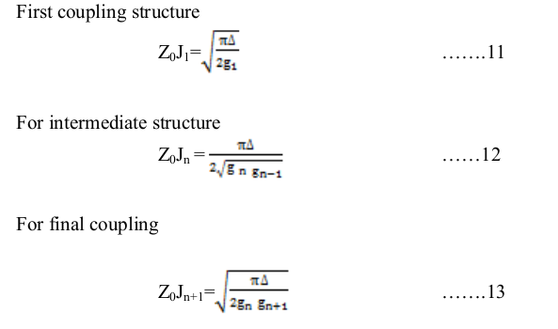
These formulas are the foundations in order to calculate afterward the odd/even impedances.
Z0 is choosen arbitrarily by me. A thumb rule is that the edges stages share the same dimensions and the middle stages share the same dimensions.

Then , we can calculate our impedances.

Here are the 2 formulas :
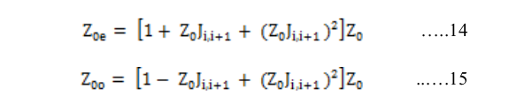
Z0 is the caracteristic impedance.

We know g1,g2,g3, delta, w0.

Here, n=3, so 4 stages.

For stage 1 (and so last stage) : Z0j1 = 0.32206, donc Z0j4 = 0.32206.Arbitrarily , I took Z0 = 53.08Ohms.
With the previous formulas : Zoe = 70.726 Ohms et Zoo = 36.536 Ohms.
Qucs provides a coupled microstrip calculator . Here is the values he gives me : w = 2.44019 mm et S = 0.318408 mm.

Passons au dimensionnement de l’étage 2 and 3: Z0j2 = 0.12518, so Z0j3 = 0.12518.Arbitrarily : Z0 = 51.89 Ohms.
Zoe = 59.199 Ohms et Zoo = 46.208 Ohms.
:W = 2.72042 mm et S = 1.71481 mm

Let’s create this custom filter, and see the simulation :
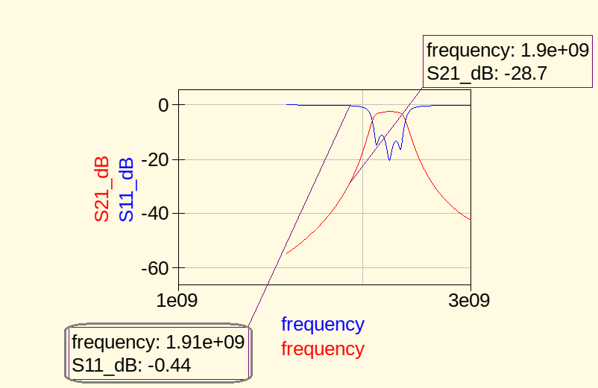
Well, it is shit. So let’s replace the length (fixed at lambda/4) by the ones in the Qucs filter.

Checking the simulation :
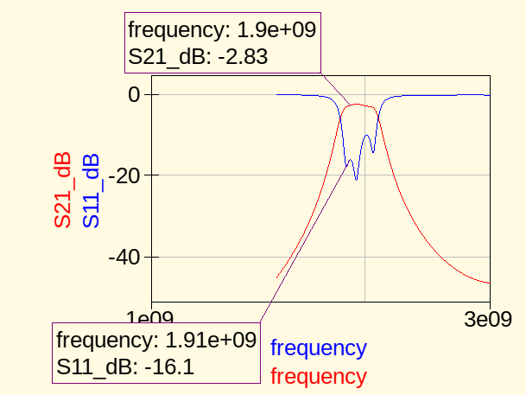

Let’s note that the custom filter has a f1=1.8GHz and a f2=2GHz, where the Qucs filter has f1=1.7GHz and f2=2.1GHZ.

Even impedance
When 2 coupled microstrip, we measure line 1 impedance when line 2 is polarised the same way

Odd impedance
When 2 coupled microstrip, we measure line 1 impedance when line 2 is reverse polarised

Differential impedance
Impedance between the 2 tracks when they have different polarisation. 2 times odd impedance

Common impedance
Impedance between the tracks when same polarisation. 2 times even impedance

Paramètres S
Pour être physiquement réalisable sur PCB, j’ai rajouté à des inductances à chaque endroit nécessaire afin de simuler un CO :
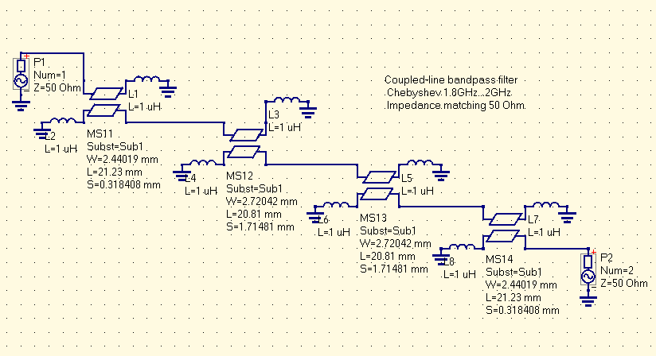
Voici une partie de ses paramètres S. Ceux qui nous intéressent sont ceux à 1.9GHz :
(S11,S12,S21,S22 ) #GHz MA R 50
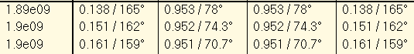
Reflexions are low. However, we may adapt the input and output impedances to further decrease input return loss and output return loss.

