LNA module

A low noise amplifier is a kind of filter specialized in the reception of (very) low input power.
It is located just after the bandpass filter, in the reception part, and just before the demodulator (or SDR). The latter is equiped with an ADC which will convert the incoming wave into a binary word (thanks to a combination of amplitude + phase) thanks to a 64QAM modulation.At a transistor level, a cascode (on which I started to work ) can be used to conceive a LNA.

The 4 main caracteritics of a LNA are :
-its gain (!)
-its Noise figure
-its linearity
-the impedance network (especially at the input)

For the project, we picked the TQL9093 LNA.
Here is its schematic :
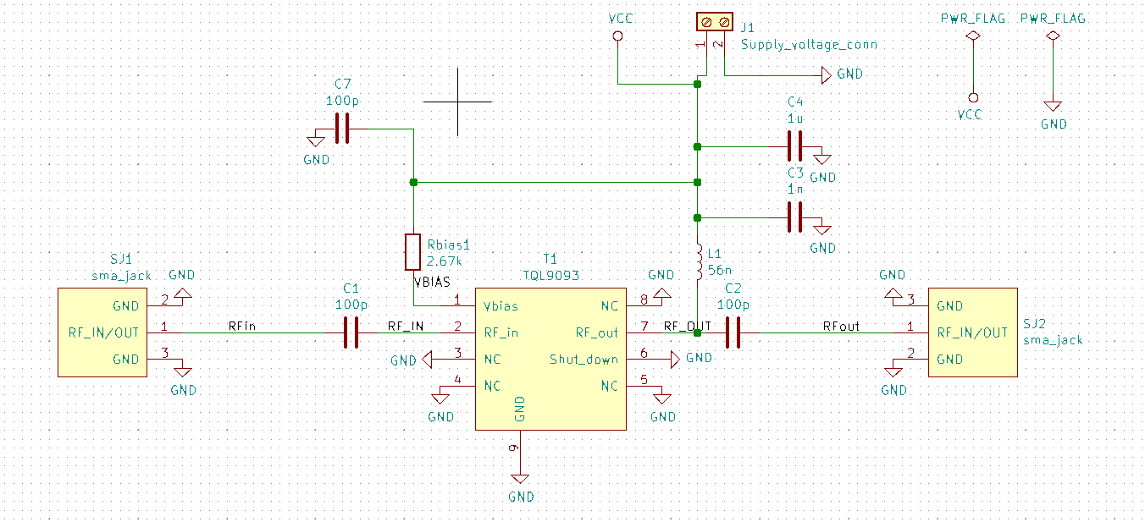
And the 1st PCB created :
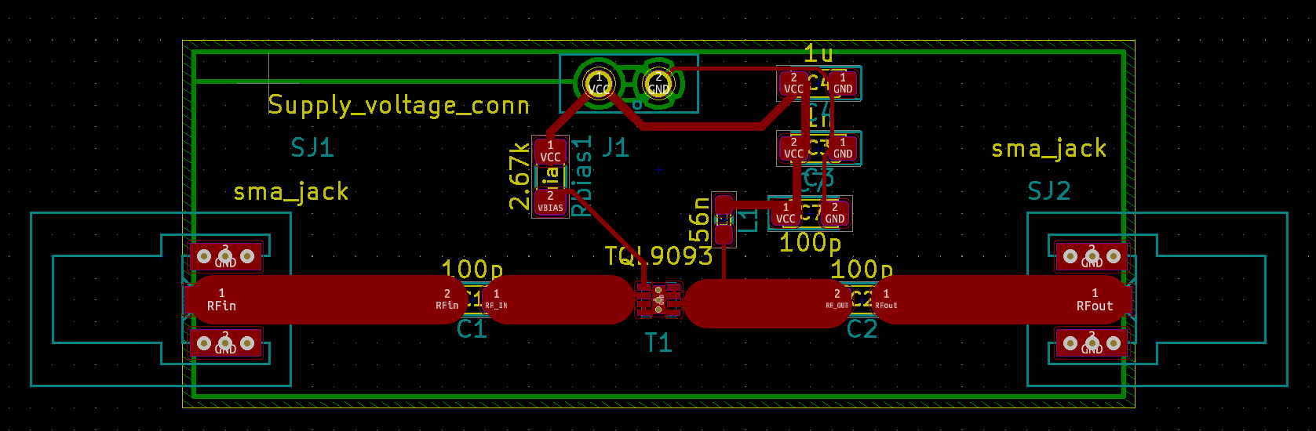

Here is the PCB schematic implanted on Qucs (S-Parameters provided by the manufacturer) :
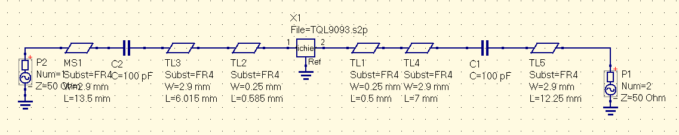

Same as attenuator and RF amplifier for the S-parameters. They depend on a certain configuration.
Here, it was this configuration : Vcc = 5V et Icc = 120 mA => Rbias = 3.1k. In our case, we took Rbias = 2.67k which lead to a supplu current Icc = 130 mA .Below the S-parameters simulation of our circuit.
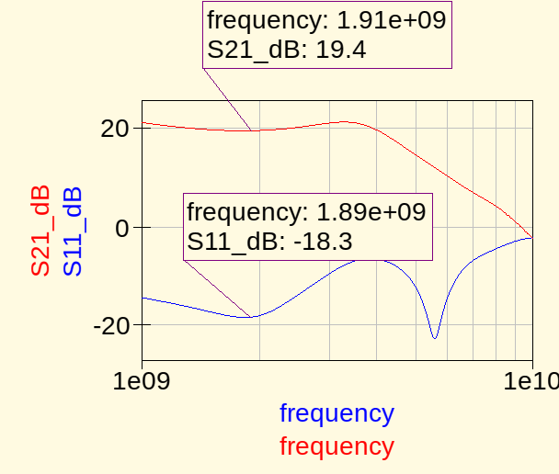

We can see that the gain is at its greatest value, and that the return loss is not that bad.

The noise figure
It is a really important parameter when dealing with LNA. Datasheet says that its Nfmin is about 0.6 dB. Let’s check this (still unmatched) :
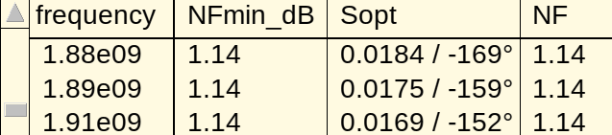
We can see that the Nfmin is not even close from 0.6 dB, but for some reason, the unmatched LNA’s noise figure is equal to the minimum achievable noise.

The gain adaptation
In order to further reduce the input return loss, we decided to make a gain adaptation at the input, instead of a noise adaptation.Let’s see the result we have, and how to make this adaptation.
In the same way as the attenuator and the RF amplifier, we have the following S-parameters (from datasheet) :
We found these values of width and length :
slug_to_load_in length = 17.7 mm
slug_in width = 2.4 mm
slug_to_load_out length = 11.2 mm
slug_out width = 2.77 mm.

The circuit looks like this :
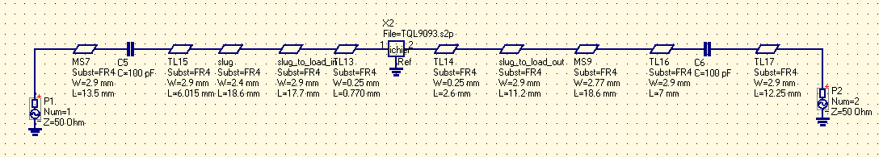
And here is the simulation :
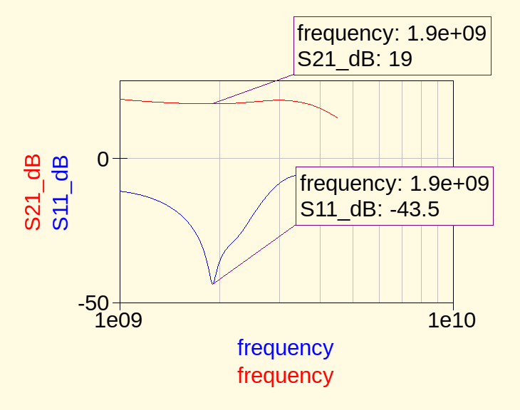

The gain is slightly attenuated, however we get a really improved return loss.

Here is the final version of the PCB :
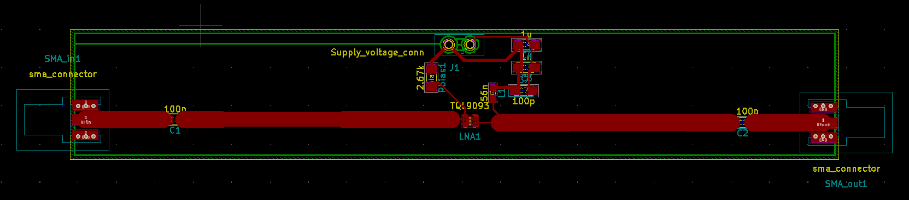
The slug at the output is there, bu its width is 2.77 mm and the 50 Ohms tack 2.9 mm, so see the difference is hard.

