Another way of designing an antenna

For the conception of the prototype, I prefered to buy some antennas already made, however, I have spent some time studying how to conceive what is called a « patch antenna »
The latter is an antenna made thanks to a microstrip line.
The length of such an antenna is usually lambda/2, to take advantage of the resonnator behaviour of a TL at this particular length.It has to be terminated by an open circuit.

Here is a link if you want to know more about why this piece of track does radiate. To sumarize, it is because of some electromagnetic field.

https://www.microwaves101.com/encyclopedias/microstrip-patch-antennas

Circuit et simulation d’une patch antenna
Due to an electromagntic radiation, the electrical length of such an antenna will be longer than the actual antenna physical length.
We can find a lot of calculators online which calculates the right patch antenna according to the frequency you wish to emit.Depends also on the characteristics of the substrate.
The website everything RF provide the calculations to design a patch antenna.

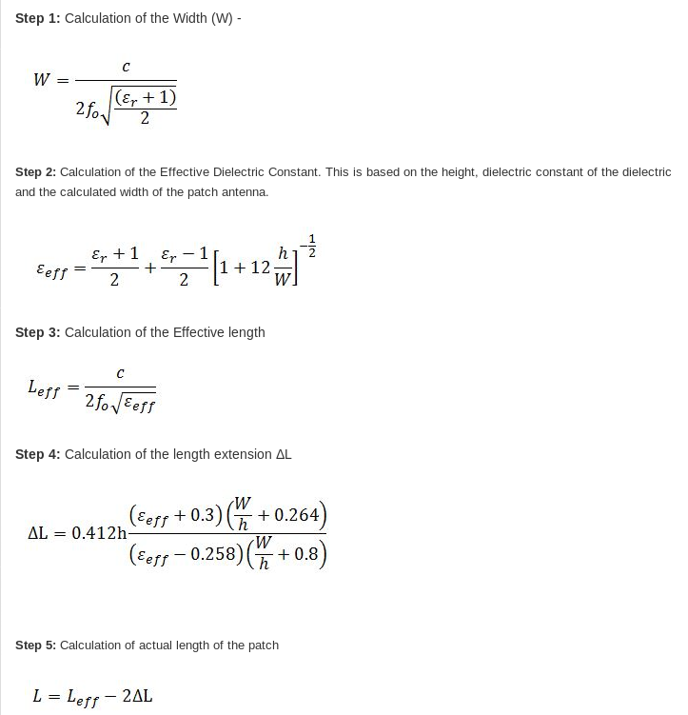

with C = 300 000 km/s , f0 = 1.9 GHz, h = 1.6 mm, Er = 4.5

DeltaL stands for the antenna electrical additionnal length I have mentionned earlier.
Effective length is calculated thanks to effective dielectric constant.
This constant is calculated with the substrate dieletric constane.
The reason of the existance of an effective dielectric constante is because a microstrip line is emitting a part of its electromagnitical in the air. Therefore, the effective dieletric constante needs to be determined.
From microwaves101.com, here is the calulation ;
H stands for the height of the substrate and w the length of tracks (calculated in the 1st page) :

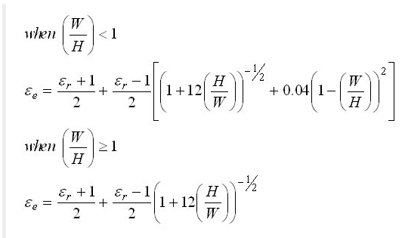
The caracteristic impedance of a microstrip line is calculated thanks to the following formulas :
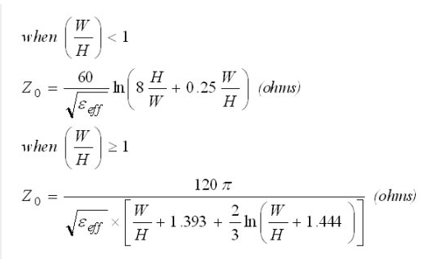

A most known example of caracteristic impedance is the one for the coaxial cable, with the inner radius and outside radius. Here, it is EXACTLY the same goal that we achieve, but only using very different calculation and logic.

Now, let’s design a patch antenna. The frequency we work at is 1.9GHz, substrate’s dielectric constant is 4.5 (FR4) and the height of PCB is 1.6 mm.
Mettons un peu de pratique derrière tout cela…

Thanks to some calculators online, we can find the length and width of patch antenna really easily :
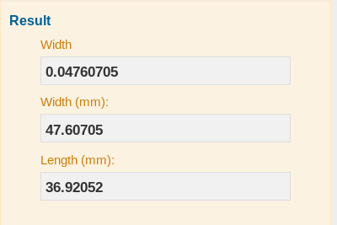

As said previously, the length of the antenna is slightly less than lambda/2

Now that we now the width, we can determine the caracteristic impedance of the antenna.
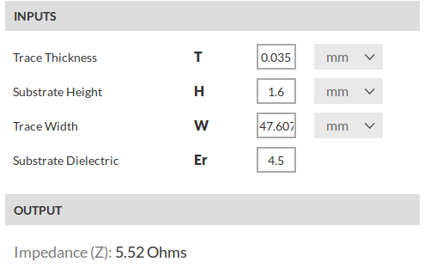

Here is the simulation of the S-Parameters for this antenna. It behaves like a bandpass filter, in fact.
Being a stop band for some frequencies and bandpass for others.
