Emission part simulation

unmatched attenuator, bandpass filter and RF amplifier

Simulation of the unmatched F1958 ( 9 dB attenuation) :
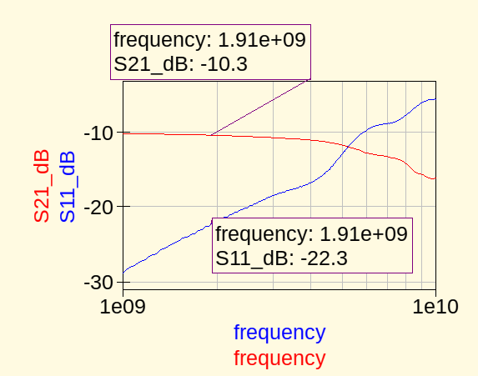

unmatched bandpass filter (the one we have calculated ) :
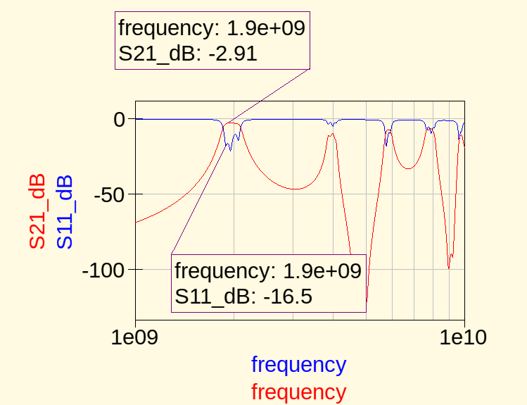

unmatched RF amplifier :
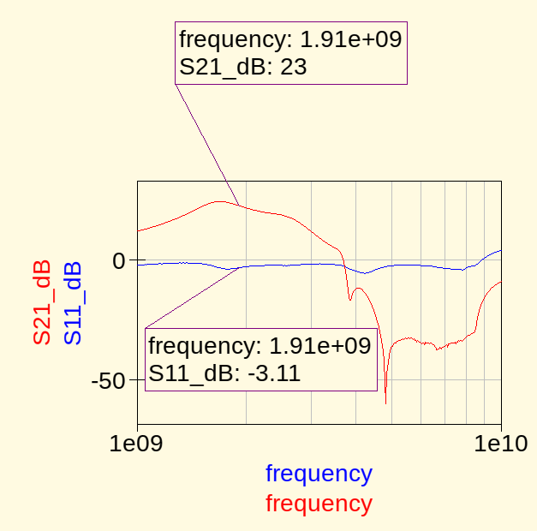

Total gain shoud be -10.3 dB -2.91 dB +23 dB = 9.79 dB

Let’s check :
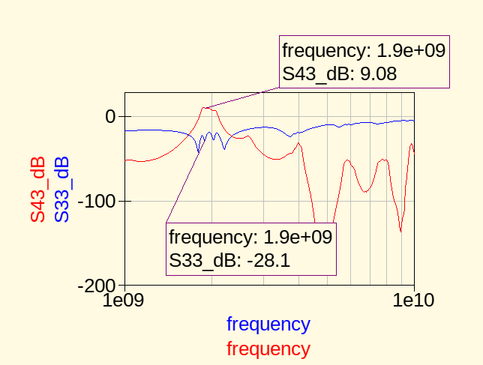

Simulated gain is 9.08 dB, which means we need 20.92 dBm at the input to reach 30 dBm at the output.

Matched part

Matched F1958 (12 dB attenuation) :
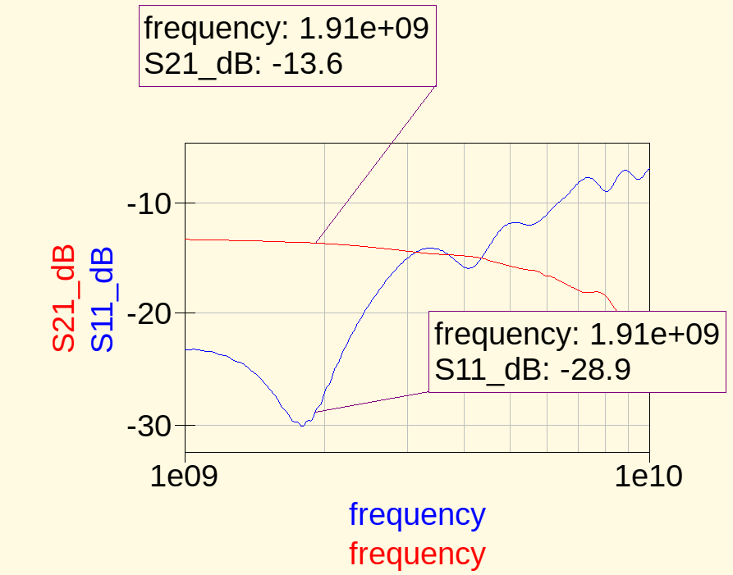

Matched RF amplifier :
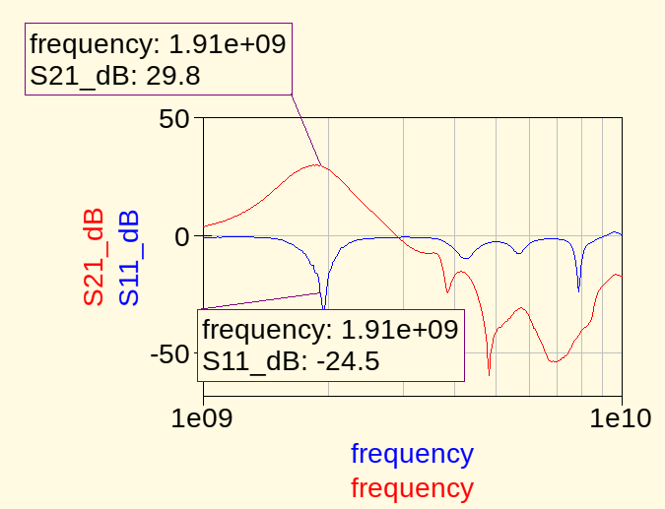

The total gain is -13.6 dB – 2.91 dB + 29.8 dB = 13.29 dB

Let’s check :
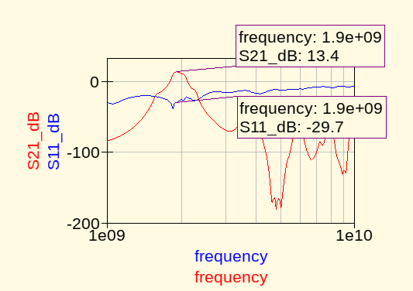
Input power shoud be 16.6 dBm at the input to reach 30 dBm at the output.
Il faut donc fournir une puissance de 16.3 dBm en entrée pour obtenir 30 dBm en sortie. La

Here is the total noise accross the emission part :
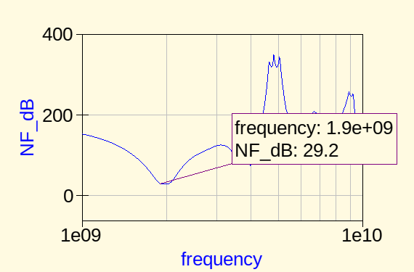

Friis formula will help us to understand this high noise figure.

F = F1 + ( (F2 – 1) / G1 ) + ( F3 – 1) / G1G2
Les valeurs de F1, F2, F3, G1 et G2 are in LINEAR !!
F1 = 2.295, G1 = 0.043, F2 = 1.94, G2 = 0.511, F3 = 1.12

=> F = 29.617. NF =10log(F) = 44 dB.The huge attenuation value from the F1958 is responsible for such a noise.

