Reception part simulation

Analysis with unmatched LNA :

Unmatched bandpass :

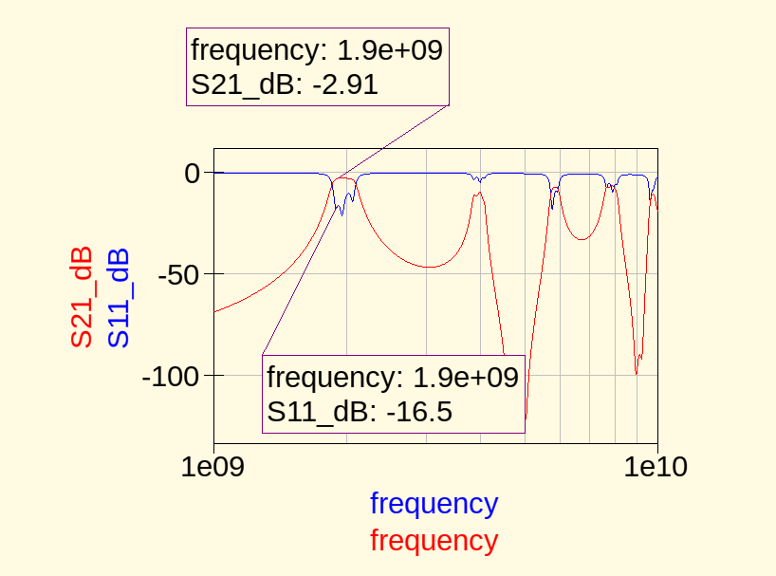

unmatched LNA :
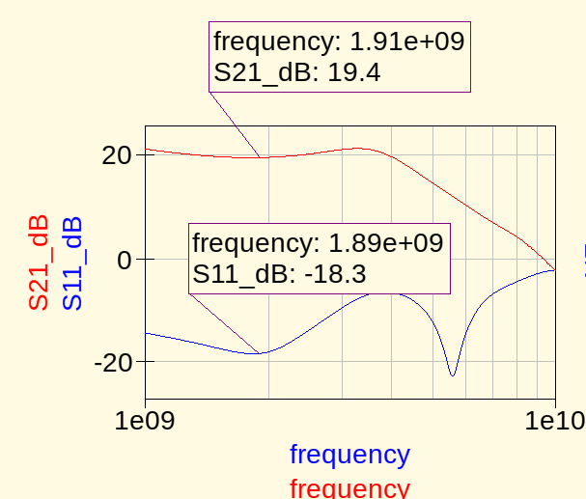

Total gain should be -2.91 dB + 19.4 dB = 16.49 dB

Let’s check the simulation :
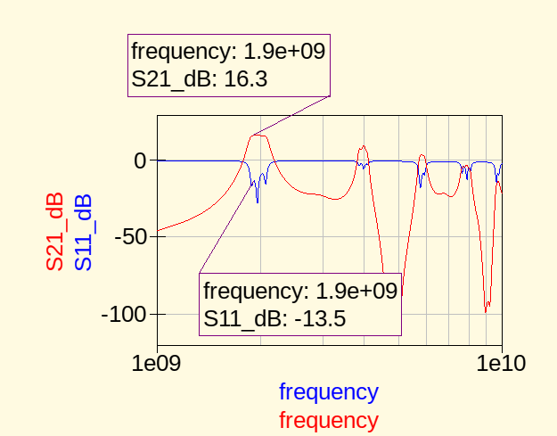

It is not far.

Analysis with matched LNA :

Unmatched bnadpass
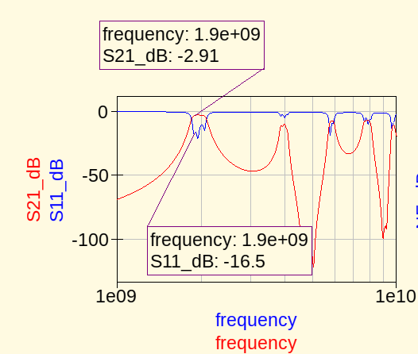

matched (gain) LNA :
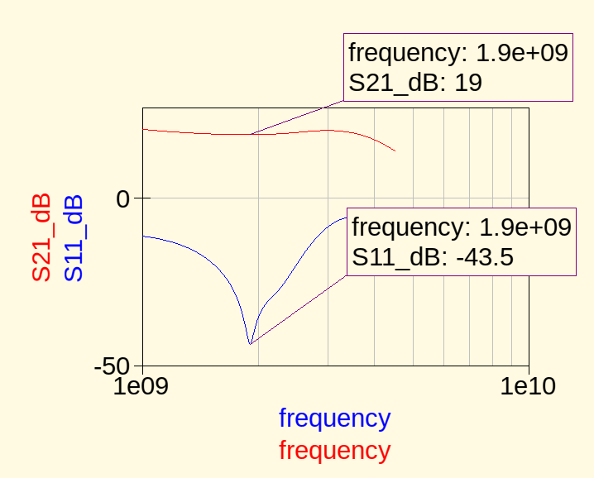

Total gain should be -2.91 dB + 19 = 16.09 dB
Let’s check the simulation :
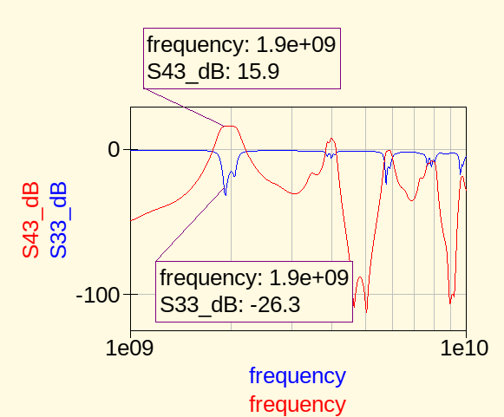

Gain is ok, return loss is ok.

Le bruit
It can be useful to analyse the noise, as the signal received by the LNA is very low.

The goal is to have a minimum noise factor. As the latter describes the SNR ration between input SNR and output SNR. If F is small, it means that the noise at the output is low compared to the noise at the input.

The formula below expresses the noise factor of a quadripole.
-Fmin is the minimum noise factor =>this is what we want to achieve.
-RhoOPT is the reflexion coefficient to get Fmin. RhoS must be conjugate matched with it to get Fmin.
-Rn is the equivalent noise resistance.

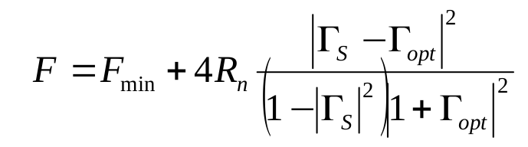
We can see that F depends only on the source value saw by the device. We must then play on the source impedance value to achieve the noise adaptation (i.e achieve Fmin).
So, instead of having rhoS = S11*, we have : rhoS = rhoOPT*
So gain adaptation and noise adaptation are not possible at the same time.

Let’s see how the reception part stands in term of noise :
Bandpass :

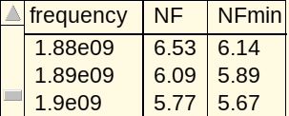

NF corresponds to the noise figure when no noise adaptation is made (e.g current state of the circuit)

Here are the values for the noise figure for the LNA :
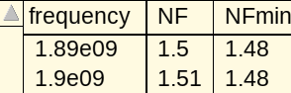

Thanks to Friis formula, we can now determine what should be the noise factor at the output of the LNA (last element of the reception chain).

F = F1 + ( (F2-1)/ G1 )

Bandpass is 1st, LNA is 2nd, then F1 is bandpass noise factor, G1 its gain and F2 the LNA’s noise factor.

F = 1.94 + ( (0.19) / 0.511) = 2.3118
NF = 3.64 dB.

Here is what the simulation says :
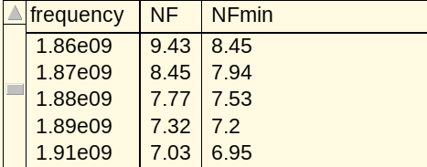

We have a greater value than expected.
We can then calculate the sensitivity. You can find a more in depth explanation in the « analyse bruit » paper. We need to know the kind of modulation used inside the USRP200. Apparently, it is a 64QAM (6 bits quadrature resolution ) thanks to the AD9364 datasheet.

Here is a picture showing how the modulation works :
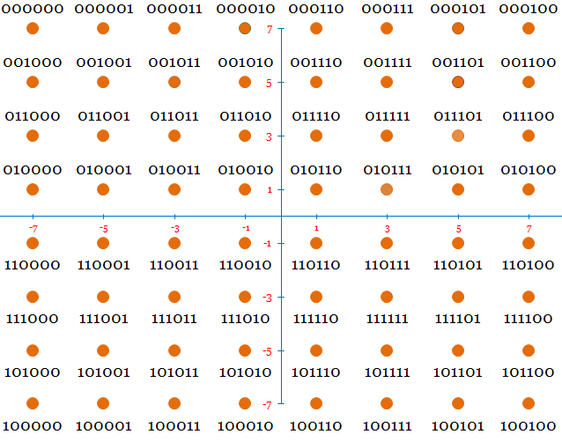
An ADC converts the input wave into a 6 binary word. The value of this word depends on a combination of phase/amplitude of the wave. I is the x axis and Q the y axis.
The binary word is then reported on the graph.
Also we have to be careful about the BER or SER (Bit error rate or Symbol error rate).
These 2 desribes the same thing : probability for the modulation part to make a wrong interpretation of an input wave. If we increase the input noise, the SNR decreases and then the BER/SER increases. If the input noise is low, SNR decreases and then the BER/SER decreases.
So the lower the noise the better. From dsprelated.com, we can find this graph :
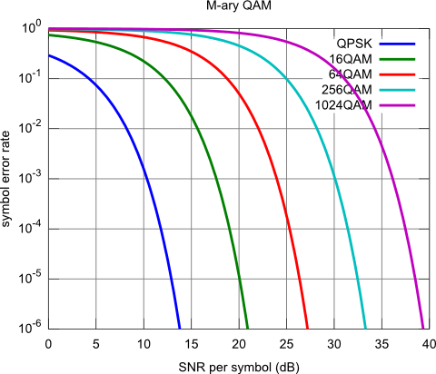

It plots the SER against the SNR. If we want a very low SER, let’s say 10^-6, the requiered SNR for a 64QAM modulation should be around 28 dB.
We now have all the necessary datas to calculate the minimum requiered power to get a minimum SER for a 64QAM. The bandwith is set to 10MHz.

Pin_min = -174 + 10log(BW) + NF + SNRmin
Pin_min = -174 + 70 + 71.5 + 28
Pin_min = -4.5 dBm

Pin_min_w = 10^-3 * 10^(-4.5/10)
Pin_min_w = 354.8 uW.
This is the minimum input power requiered at the input of the demodulator.

Little memo, for those who does not understand how to add, substract, multiply dB,dBm linear :
Add dB wih dBis like multiplying linear, so it is good.
Add dBm to dB is like multiplying watts with a linear constant, so it is good.
Add dBm to dBm is like multiplying watts with watts. What kind of unit is watt square or watt cube ? You tell me.

