Bandpass filter implantation

In an other paper, I talked a lot (in french) about how to create a coupled microstrip Chebyshev bandpass filter from scratch (starting from 1st order low pass and then compute g parameters, dividing the low pass in 2 parts in order to get the bandpass and then calculate the necessary impedances to deduce the length and width of the different TL of the filter).

To summarize what I did, for those who do not speak a single word of french, I calculated from scratch my own filter. With a filter of the 3rd order, I calculated the values for the space between the tracks as well as their width, based on the values of their odd/even impedances.
At first, I took a length of 18.6 mm (lambda/4 at 1.9 GHz for a FR4 substrate) to make the S-Parameters simulation.
This is what I get :
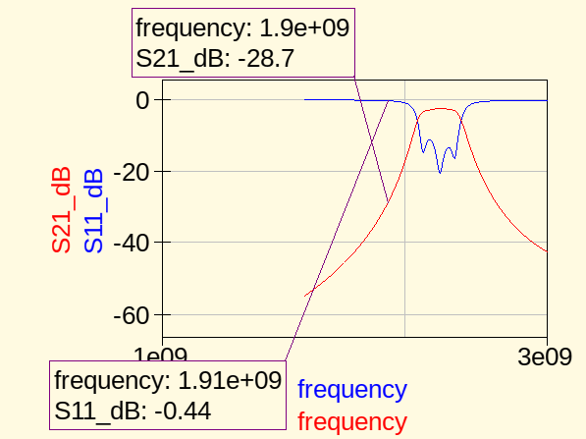

We can see that the signal does not get through, reflection at the input is huge.
Then I used the Qucs’s filter synthesis tool to compute a Chebyshev n=3 bandpass filter.
This is what I get :
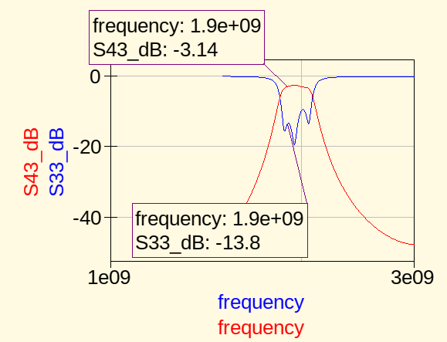

We can see that the result is much better. If we observe the length of the track, those computed by Qucs are greater than 18.6 mm. The length for the 2 edge stages are the same, and greater than 18.6 mm. Same for the 2 middle stages. So let’s put the tracks length of my filter equal to the Qucs’s one :
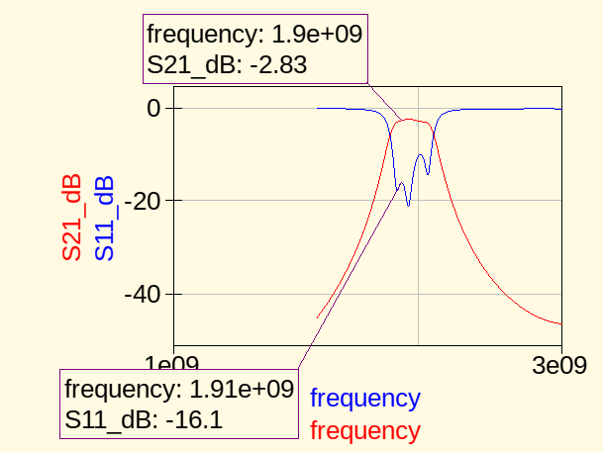
We can see that after have corrected the lengths values, we have a slightly better performance for our filter than the Qucs one.

These 2 filters have been created on PCB, so it is possible to measure in real life the true differences between the 2 filters.Also, a last filter have been designed and created on PCB.
It is not a Chebyshev coupled microstrip filter bandpass, but a simple microstrip line filter, which represents 2 parallel resonators connected in serie thanks to a 50 Ohms piece of track.
Here is its simulation :
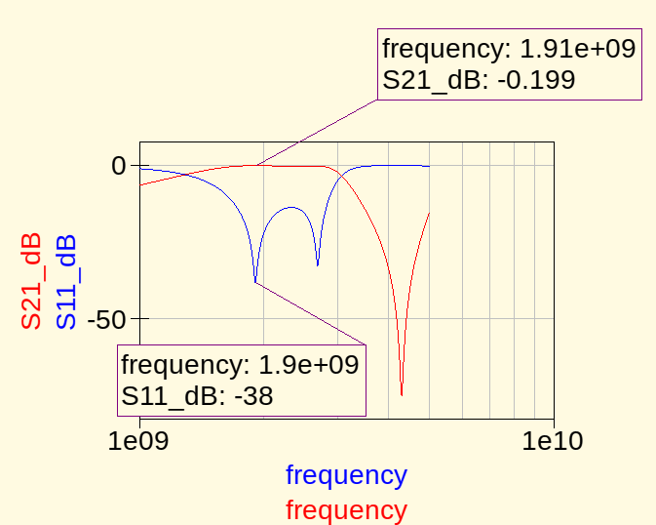

We can see that S21 is greater and a better return loss. However, the bandwith is larger.

Here is the schematics for the Chebyshev coupled microstrip filter :
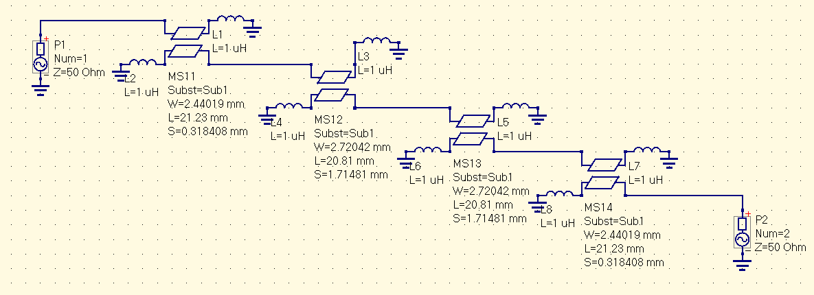
The high inductance inductors make an open circuit in HF.

And here is the schematic for the resonator filter :
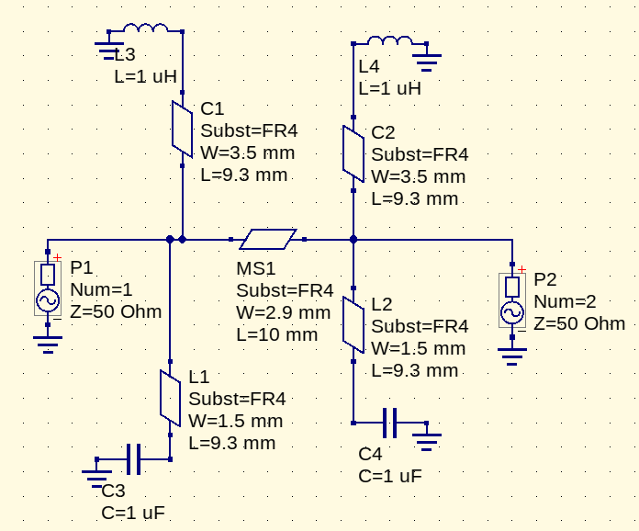
To understand, transmission line theory must be known.This theory says that a transmission line terminated by an open circuit will behave like a capacitor if its length is equal to lambda/8. (Also for other lengths, but let’s keep it simple).
Short circuit of lambda/8 will be an inductor.So it means that this filter will be a bandpass for 1.9GHz, a band rejecter for another and a bandpass filter for again antother frequency.

Noise analysis
As our filter will be used in the reception part as well, it could be good if the filter has a very low Noise figure (or Noise factor).
Let’s 1st study the noise figure of the Chebyshev coupled microstrip bandpass. We are going to compute the value of Nfmin. This value is the minimum noise figure we can expect. To achieve this, it is mandatory to match the source impedance to the optimum reflection coefficient. If source impedance is matched to the conjugate of optimum impedance, we’ll reach the minimum noise figure, but the gain can be lower.

Noise performance of the Chebyshev filter :
We can see what is the minimum noise figure expectable and to which optimum impedance should be conjugate matched the source impedance, and the noise in the currrent state of the circuit :
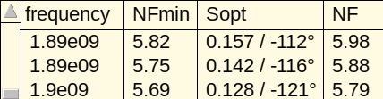

Noise performance of the resonnator filter, with the same parameters :
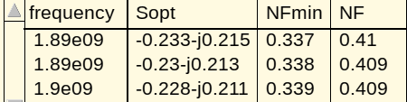

We can see that the resonnator filter seems to have a better noise performance than the coupled microstrip filter one. However, it possesses a larger bandwith, but with a very little S21 attenuation and a satisfying return loss.

The 3 filters (coupled Qucs microstrip, custom coupled and resonator) have been made on PCB. Tests will show which one best fits our situation.

That’s all for this quick overview of 2 very differents kind of filters, but which achieve the same goal.

