**Voice over IP with Cisco Call Manager Express**

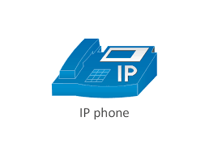

**By, Liam Gilmartin**

**Purpose -** The purpose of this lab was to learn how to set up a working IP phone configuration that could call out.

**Background Information on Lab Concepts –** A VoIP phone uses a certain voice over IP tech for transmitting phone calls using the internet, unlike a standard phone which uses the public telephone network to make calls.

**Lab Summary -** We connected a router to a switch which is then connected to a Cisco IP phone. First the router and switch configs were completed then came the new and harder part which was the Cisco IP phone. The IP phone had to first be factory reset then the new configurations had to be completed on the switch and router to allow the Cisco IP phone to be able to call out.

**Lab Commands -**

ip dhcp excluded-address #.#.#.# #.#.#.#

vtp mode transparent

ntp server #.#.#.#

**Network Diagram with IP’s -**

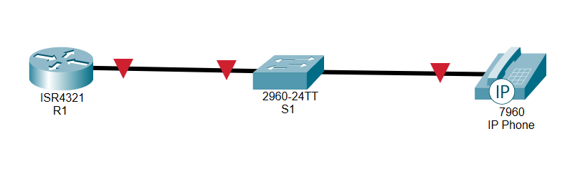**Configurations -**

version 12.2  
 no service pad  
 service timestamps debug uptime  
 service timestamps log uptime  
 no service password-encryption  
 hostname S1  
 no aaa new-model  
 vtp domain CCNP  
 vtp mode transparent  
 ip subnet-zero  
 no file verify auto  
 spanning-tree mode pvst  
 spanning-tree extend system-id  
 vlan internal allocation policy ascending  
 vlan 10  
 name DATA  
 vlan 20  
 name VOICE  
 vlan 30  
 name MGT  
 vlan 40  
 name MISC  
 vlan 50  
 name NATIVE  
 vlan 99  
 name MANAGEMENT  
 interface FastEthernet0/1  
 description CONNECTION TO ROUTER  
 switchport trunk encapsulation dot1q  
 switchport mode trunk  
 interface FastEthernet0/2  
 switchport access vlan 20  
 switchport mode access  
 interface FastEthernet0/3  
 switchport access vlan 20  
 switchport mode access  
 interface FastEthernet0/4  
 switchport access vlan 20  
 switchport mode access  
 interface FastEthernet0/5  
 interface FastEthernet0/6  
 interface FastEthernet0/7  
 interface FastEthernet0/8  
 interface FastEthernet0/9  
 interface FastEthernet0/10  
 switchport access vlan 10  
 switchport mode access  
 interface FastEthernet0/11  
 interface FastEthernet0/12  
 interface FastEthernet0/13  
 interface FastEthernet0/14  
 interface FastEthernet0/15  
 interface FastEthernet0/16  
 interface FastEthernet0/17  
 interface FastEthernet0/18  
 interface FastEthernet0/19  
 interface FastEthernet0/20  
 interface FastEthernet0/21  
 interface FastEthernet0/22  
 interface FastEthernet0/23  
 interface FastEthernet0/24  
 interface GigabitEthernet0/1  
 interface GigabitEthernet0/2  
 interface Vlan1  
 no ip address  
 shutdown  
 ip classless  
 ip http server  
 control-plane  
 line con 0  
 line vty 5 15  
 end

hostname R1  
 boot-start-marker  
 boot-end-marker  
 no aaa new-model  
 resource policy  
 memory-size iomem 5  
 no network-clock-participate slot 1  
 ip subnet-zero  
 ip cef  
 no ip dhcp use vrf connected  
 ip dhcp excluded-address 192.168.1.1 192.168.1.9  
 ip dhcp excluded-address 192.168.2.1 192.168.2.9  
 ip dhcp pool VOIP  
 network 192.168.10.0 255.255.255.0  
 option 150 ip 192.168.10.1  
 default-router 192.168.10.1  
 ip dhcp pool DATA  
 network 192.168.2.0 255.255.255.0   
 default-router 192.168.2.1  
 dns-server 4.2.2.2   
 voice-card 0  
 no dspfarm  
 voice-card 1  
 no dspfarm  
 ntp server 64.209.210.20  
 clock timezone PST -7  
 interface FastEthernet0/1  
 no shutdown  
 no ip address  
 duplex auto  
 speed auto  
 interface FastEthernet0/0.10  
 encapsulation dot1Q 10  
 ip address 192.168.10.1 255.255.255.0  
 ip helper-address 172.16.2.5  
 no shutdown  
 duplex auto  
 speed auto  
 interface FastEthernet0/1  
 ip address dhcp  
 duplex auto  
 speed auto  
 interface FastEthernet0/1/0  
 interface FastEthernet0/1/1  
 interface FastEthernet0/1/2  
 interface FastEthernet0/1/3  
 interface FastEthernet0/1/4  
 interface FastEthernet0/1/5  
 interface FastEthernet0/1/6  
 interface FastEthernet0/1/7  
 interface FastEthernet0/1/8  
 interface Serial0/2/0  
 no ip address  
 shutdown  
 no fair-queue  
 interface Vlan1  
 no ip address  
 ip classless  
 ip http server  
 no ip http secure-server  
 tftp-server P00308000500.sbn  
 tftp-server P00308000500.loads  
 tftp-server flash:P00308000500.bin alias P00308000500  
 tftp-server flash:P00308000500.sb2  
 control-plane  
 voice-port 0/3/0  
 voice-port 0/3/1  
 voice-port 0/3/2  
 voice-port 0/3/3  
 voice-port 1/0/0  
 voice-port 1/0/1  
 telephony-service   
 load 7960-7940 P00308000500  
 max-ephones 5  
 max-dn 5  
 ip source-address 192.168.10.1 port 2000  
 create cnf-files version-stamp Jan 01 2002 00:00:00  
 max-conferences 8 gain -6  
 transfer-system full-consult  
 ephone-dn 1  
 number 1  
 ephone 1  
 device-security-mode none  
 mac-address *insert*  
 button 1:1  
 line con 0  
 line aux 0  
 line vty 0 4  
 login  
 scheduler allocate 20000 1000  
 end

**Problems -** The problems we had during this lab consisted of not understanding how to properly set up the Cisco IP phone itself. It took us a very long time to figure out how to factory reset the IP phone because there are so many different versions of the Cisco IP phone that unless you know the exact one, you're working with this may pose as a challenge. Another problem we had it we forgot to add one zero to one single command of the lab which caused us to have to troubleshoot for a long period of time, but we eventually figured out that we were missing that one zero and fixed it which allowed the lab to instantly work.

**Conclusion -** In conclusion we learned how to set up a working Cisco IP phone configuration using one router and one switch to do so. I also learned that you need to be extremely careful when typing anything into any configuration even if it's something very simple, because you never know if that one small mistake may hold you back from completing the configuration.