HSC BUSINESS STUDIES
Exam focus
Short-answer practice on the points you flagged
93 short-answer questions across 20 syllabus points in four topics
Drawn from NESA HSC 2019–2023, school trial papers 2023–24, and topic question banks.
- Short answer only — no multiple choice, and no 20-mark extended responses.
- Ruled space follows each question, sized to its mark value.
- A question testing two of these points is printed once and cross-referenced from the other.

CONTENTS
Operations
Inventory management 5
Global factors 5
Corporate social responsibility 5
Finance
Planning and implementing 2
Ethical issues of financial statements 10
Profitability and working capital management 8
Equity financing 3
Global financial management strategies 7
Marketing
Consumer laws 6
Identifying target markets 5
Developing marketing strategies 1
Implementation, monitoring and controlling 1
Market segmentation ↗2
Promotion mix 4
Distribution channels 4
Human Resources
Strategic role of human resource management 2
Outsourcing 7
Processes of human resource management 7
Leadership style 2
Indicators 9
TOPIC

Operations

Inventory management
1. 22 (b) Reddam Trial 2024 2 marks
Describe ONE inventory management strategy Buffy’s Florist Pty Ltd could use in the business.
Stimulus Balance Sheet for Buffy’s Florist, 1/1/24 – 30/6/24. Current Assets: Cash $10 000; Accounts Receivable $70 000; Inventory $80 000 (total $160 000). Non-Current Assets: Retail Premises $800 000; Delivery vans $100 000. Current Liabilities: Accounts Payable $90 000; Bank overdraft $60 000 (total $150 000). Non-Current Liabilities: Mortgage $600 000. Owners’ Equity: Capital $260 000; Retained Profit $50 000. Additional financial information: Industry Average Liquidity/Working Capital Ratio = 2:1.

2. 22 (a) Independent Trial 2024 · Newington Trial 2024 2 marks
Recommend an inventory management system that can be used by this business to better manage stock.
Stimulus Style Furniture Pty Ltd is an Australian business that manufactures and sells furniture in Sydney. The business is holding excess stock which is difficult to sell. Management is attempting to improve its furniture production and reduce the cost of its operations processes. It is also investigating if outsourcing its operations processes to an overseas manufacturer or investing in technology will assist it in achieving its goals.

3. 21 (b) Reddam Trial 2023 2 marks
Describe ONE disadvantage of holding stock for the car retailer.
Stimulus A car retailer expects high demand and orders extra stock of the latest release lower priced, electric car. The car retailer also provides longer warranties than competitors as well as car repairs and services.

4. 23 (d) Newington Trial 2023 3 marks
Recommend and justify an inventory management system this business should use
Stimulus Rebecca owns and operates a health food business. Due to an increase in competition from large retail chains, she needs to revise her operational strategies. A problem that her customers have identified is products that are consistently 'out of stock', as well as damaged goods in need of replacing.

5. 21 (b) 2022 HSC Business Studies 3 marks
Recommend an appropriate inventory management strategy for this business.
Stimulus Scenario: Michael would like to open a new burger restaurant.

Global factors
6. 21 (a) 2023 HSC Business Studies 2 marks
Outline ONE potential issue this business could face in relation to both cost and quality of outputs.
Stimulus An Australian tyre manufacturer is expanding its business. In order to reduce operating costs and increase sales and profit, rubber will be sourced from the global market. The business wants to: maintain quality outputs; achieve economies of scale.

7. 21 (b) 2023 HSC Business Studies 3 marks
Explain the benefits of achieving economies of scale for both the business and consumers.
Stimulus An Australian tyre manufacturer is expanding its business. In order to reduce operating costs and increase sales and profit, rubber will be sourced from the global market. The business wants to: maintain quality outputs; achieve economies of scale.

8. 21 (d) Roseville Trial 2024 4 marks
Explain how the operations strategies of global sourcing and economies of scale might be beneficial to this business.
Stimulus Sushi Train — a successful global Japanese fast food company rapidly expanding in Australia. Customers are attracted to its unique process layout, in which little plates of sushi rotate around on a train-style system. Customers take meals directly from the train and watch their meals being produced in front of them.

9. 22 (c) Independent Trial 2024 · Newington Trial 2024 4 marks
What are the advantages of this business outsourcing its operations process overseas.
Stimulus Style Furniture Pty Ltd is an Australian business that manufactures and sells furniture in Sydney. The business is holding excess stock which is difficult to sell. Management is attempting to improve its furniture production and reduce the cost of its operations processes. It is also investigating if outsourcing its operations processes to an overseas manufacturer or investing in technology will assist it in achieving its goals.

10. 22 (c) Knox Trial 2023 5 marks
Recommend TWO global factors that HiTel should implement to meet cost and speed performance objectives.
Stimulus HiTel is a leading Australian electronics company expanding rapidly in the Asia Pacific region. It is moving its Sydney-based manufacturing to India. The cost of the change is forecast at $40 million, it will take six months to implement, and 250 staff will be impacted.

Corporate social responsibility
11. 22 (a) Barker Trial 2024 2 marks
Distinguish between legal compliance and corporate social responsibility.

12. 21 (c) Reddam Trial 2023 2 marks
Why may this business exceed its legal obligations when offering warranties to customers?
Stimulus A car retailer expects high demand and orders extra stock of the latest release lower priced, electric car. The car retailer also provides longer warranties than competitors as well as car repairs and services.

13. 21 (d) Barker Trial 2023 4 marks
With reference to a business you have studied, discuss the impact of corporate social responsibility on the operations process.

14. 24 (c) 2019 HSC Business Studies 4 marks
Why might this business be reluctant to become more socially responsible?
Stimulus Question 24 scenario: A juice bar is operating in a shopping centre. The juice is served to customers in plastic cups with plastic straws. The high sales volume and quick turnover demand an efficient operations process. (Single-use plastic cups and straws are the environmental/social responsibility issue.)

15. 23 (c) Abbotsleigh Trial 2024 5 marks
Assess the influence of corporate social responsibility on operations management for Precision Shave.
Stimulus Precision Shave produces and sells a collection of eco-friendly razors made from sustainable materials. The business is also introducing a subscription service that delivers customised shaving kits catering to the specific needs of individual consumers.

TOPIC

Finance

Planning and implementing
16. 22 (b) 2021 HSC Business Studies 3 marks
Explain a financial risk associated with borrowing funds from the USA.
Stimulus A luxury Australian handbag business is going to expand. They intend to borrow 30 million US dollars to buy several new retail properties across Australia.

17. 24 (c) SIC Trial 2024 4 marks
Describe the importance of the planning and implementing process for this business.
Stimulus Key financial information for a manufacturing business planning to invest $10m into a new manufacturing facility over the next 3 years. Figures in $'000: Revenue 9 000; Accounts receivable 2 500; Cost of goods sold 3 600; Retained profit 1 400; Expenses 3 780. Industry averages: Gross Profit Ratio 50%; Net Profit Ratio 25%; Expense Ratio 45%.

Ethical issues of financial statements
18. 22 (d) Reddam Trial 2024 2 marks
Outline ONE ethical issue related to this financial report.
Stimulus Balance Sheet for Buffy’s Florist, 1/1/24 – 30/6/24. Current Assets: Cash $10 000; Accounts Receivable $70 000; Inventory $80 000 (total $160 000). Non-Current Assets: Retail Premises $800 000; Delivery vans $100 000. Current Liabilities: Accounts Payable $90 000; Bank overdraft $60 000 (total $150 000). Non-Current Liabilities: Mortgage $600 000. Owners’ Equity: Capital $260 000; Retained Profit $50 000. Additional financial information: Industry Average Liquidity/Working Capital Ratio = 2:1.

19. 22 (a) Roseville Trial 2024 2 marks
Outline ONE limitation of financial reports.

20. 21 (a) Knox Trial 2023 2 marks
Outline ONE limitation of this financial report.
Stimulus Financial information for Playsmart Child Care Ltd (balance sheet extract). Current Assets: Cash $40 000; Accounts Receivable $100 000; Inventory $100 000. Non-Current Assets: Building $320 000; Delivery van $40 000; Goodwill $100 000. Current Liabilities: Accounts Payable $100 000; Bank overdraft $130 000. Non-Current Liabilities: Mortgage $300 000. Owners' Equity: Capital $150 000; Retained Profit $20 000. Additional information: Debt to equity ratio = Total Liabilities / Total Equity; gearing industry average 2:1.

21. 2019 HSC Question 22 (a) 2021 Finance Practice HSC Questions · 2019 HSC Business Studies 2 marks
Outline ONE ethical issue related to the preparation of financial reports.

22. 22 (b) Loreto Trial 2024 3 marks
Explain ONE limitation of financial statements in providing a complete picture of Coffee Mania's financial health.
Stimulus Coffee Mania, a local cafe. Latest financial statement key figures: Current Assets $200,000; Non-Current Assets $800,000; Current Liabilities $150,000; Non-Current Liabilities $500,000; Owner's Equity $350,000.

23. 21 (b) Knox Trial 2023 3 marks
Explain ONE ethical issue related to financial reports for the stakeholders of this business.
Stimulus Financial information for Playsmart Child Care Ltd (balance sheet extract). Current Assets: Cash $40 000; Accounts Receivable $100 000; Inventory $100 000. Non-Current Assets: Building $320 000; Delivery van $40 000; Goodwill $100 000. Current Liabilities: Accounts Payable $100 000; Bank overdraft $130 000. Non-Current Liabilities: Mortgage $300 000. Owners' Equity: Capital $150 000; Retained Profit $20 000. Additional information: Debt to equity ratio = Total Liabilities / Total Equity; gearing industry average 2:1.

24. 2015 HSC Question 24 (a) 2021 Finance Practice HSC Questions 3 marks
Explain ONE possible limitation of this financial report.
Stimulus Extract from financial reports for Andrew's Discount Tyres as at 30 May 2015. Current assets: Accounts receivable $1 000; Inventory $2 000; Cash $2 000. Non-current assets: Building $13 000; Fittings $1 000; Research and development $5 000. Current liabilities: Overdraft $2 000; Accounts payable $1 000. Non-current liabilities: Mortgage $5 000. Owner's Equity $16 000. Other information: Net profit for Andrew's Discount Tyres $1000; Industry average gearing ratio (total liabilities ÷ total equity): 80%.

25. 24 (b) Abbotsleigh Trial 2024 4 marks
Describe TWO limitations of SK Pty Ltd's 2024 Balance Sheet.
Stimulus Balance Sheet for SK Pty Ltd as at year ending 30 June 2024. Current Assets: Cash $15,000; Receivables $10,000; Inventories $80,000. Non-Current Assets: Property $280,000; R&D $60,000; Equipment $100,000. Current Liabilities: Creditors $50,000. Non-Current Liabilities: Bank Loan $100,000. Owners Equity: Capital $350,000; Net Profit $65,000; Drawings $20,000. Other financial information: 2023 return on equity ratio = 11%; 2024 return on equity ratio industry average 13%; 2024 debt to equity ratio industry average 2:1.

26. 24 (c) 2023 HSC Business Studies 5 marks
Explain TWO limitations of financial reports.

27. 22 (a)–(b) 2021 Finance Practice HSC Questions 5 marks
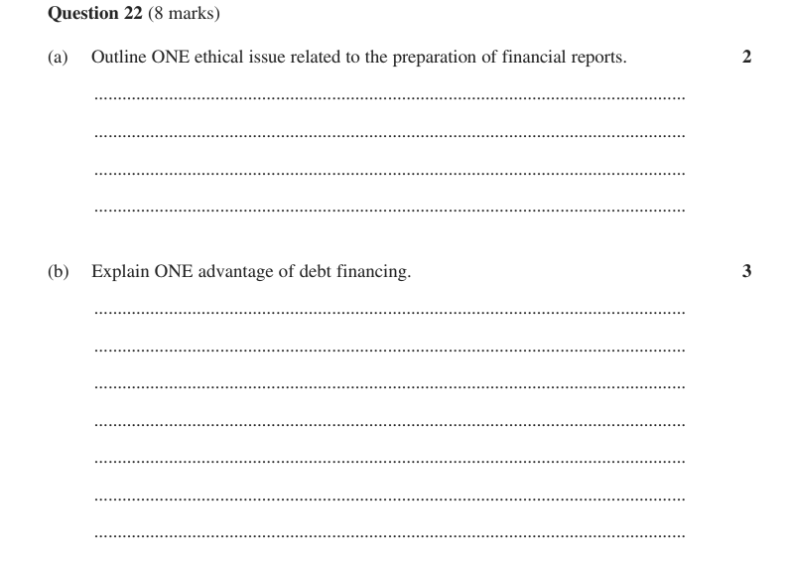

Profitability and working capital management
28. 22 (b) Reddam Trial 2023 2 marks
Recommend ONE working capital management strategy Local Grocer Pty Ltd. could use to improve its liquidity.
Stimulus Balance Sheet for Local Grocer Pty Ltd, June 2023.
Current Assets: Cash $25 000; Accounts Receivable $45 000; Inventory $55 000.
Non-Current Assets: Building $400 000; Delivery van $50 000.
Current Liabilities: Accounts Payable $35 000; Bank overdraft $65 000.
Non-Current Liabilities: Mortgage $225 000.
Owners' Equity: Capital $200 000; Retained Profit $50 000.
Additional financial information: Return on Owners' Equity ratio for 2022 = 0.1:1.

29. 23 (b) 2021 Finance Practice HSC Questions 3 marks
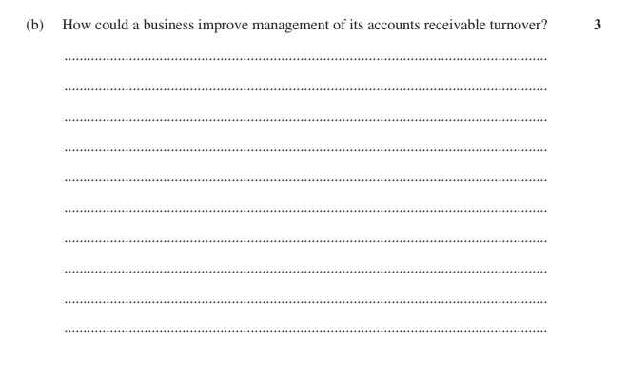

30. 22 (c) Reddam Trial 2024 4 marks
Discuss the impact of ONE working capital management strategy on Buffy’s Florist Pty Ltd.
Stimulus Balance Sheet for Buffy’s Florist, 1/1/24 – 30/6/24. Current Assets: Cash $10 000; Accounts Receivable $70 000; Inventory $80 000 (total $160 000). Non-Current Assets: Retail Premises $800 000; Delivery vans $100 000. Current Liabilities: Accounts Payable $90 000; Bank overdraft $60 000 (total $150 000). Non-Current Liabilities: Mortgage $600 000. Owners’ Equity: Capital $260 000; Retained Profit $50 000. Additional financial information: Industry Average Liquidity/Working Capital Ratio = 2:1.

31. 22 (d) Roseville Trial 2024 4 marks
Recommend TWO profitability management strategies for this business.
Stimulus Financial data for Smith Office Supplies Pty Ltd for the period ending 30 June 2023 (business figure, then industry average): Sales 180 000 / 240 000; Cost of Goods Sold 120 000 / 120 000; GROSS PROFIT 60 000 / 120 000; Operating expenses — Administrative 17 000 / 15 000, Sales and distribution 7 000 / 15 000, Financial 7 000 / 10 000; NET PROFIT 29 000 / 80 000.

32. 23 (b) Barker Trial 2023 · Barker Trial 2024 4 marks
How could Acme Kitchenware improve their level of working capital?
Stimulus Acme Kitchenware manufactures and sells pots and pans to department stores. Financial Information for Acme Kitchenware 2022 -- Current assets: Cash $125 000, Accounts receivable $60 500, Stock $110 000 (total current assets $295 500). Non-current assets: Vehicles $260 000, Equipment $216 580. Current liabilities: Accounts payable $120 000, Overdraft $120 780 (total current liabilities $240 780). Non-current liabilities: Mortgage $20 000. Owner's equity: Capital $430 800, Retained earnings $80 500 (total equity $511 300). Additional information: Net profit $75 000; industry average return on equity 18%. (Working capital is therefore only $54 720, a current ratio of about 1.23:1.)

33. 22 (d) Roseville Trial 2023 4 marks
Recommend TWO profitability management strategies that this business could use to improve its profitability result.
Stimulus Income statement for Manly Beach Pancakes Store Pty Ltd, year ended 30 June 2022, shown alongside Industry Average Results ($):
Sales 150 000 (industry 200 000); Cost of goods sold 105 000 (industry 100 000); Gross profit 45 000 (industry 100 000).
Operating expenses — Administrative 5 000 (industry 12 000); Selling & distribution 7 000 (industry 15 000); Financial 3 000 (industry 3 000); Net profit 30 000 (industry 70 000).
The business therefore has a gross profit ratio of 30% versus an industry average of 50%, and a net profit ratio of 20% versus an industry average of 35%.

34. 21 (c) Knox Trial 2023 5 marks
Analyse the use of sale and leaseback as a financial management strategy for this business.
Stimulus Financial information for Playsmart Child Care Ltd (balance sheet extract). Current Assets: Cash $40 000; Accounts Receivable $100 000; Inventory $100 000. Non-Current Assets: Building $320 000; Delivery van $40 000; Goodwill $100 000. Current Liabilities: Accounts Payable $100 000; Bank overdraft $130 000. Non-Current Liabilities: Mortgage $300 000. Owners' Equity: Capital $150 000; Retained Profit $20 000. Additional information: Debt to equity ratio = Total Liabilities / Total Equity; gearing industry average 2:1.

35. 24 (c)–(d) 2021 Finance Practice HSC Questions · 2020 HSC Business Studies 7 marks
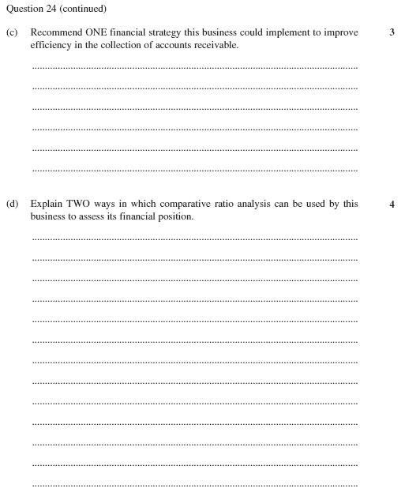

Also tested by question 1.

Equity financing
36. 22 (c) 2021 Finance Practice HSC Questions · 2019 HSC Business Studies 3 marks
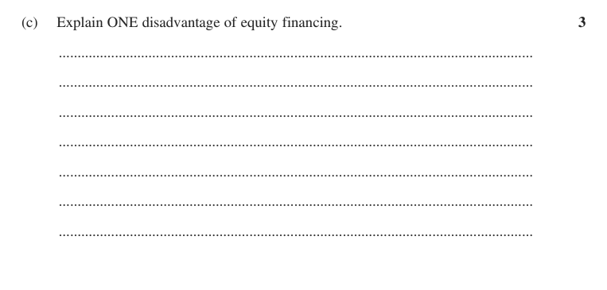

37. 23 (b) Independent Trial 2024 · Newington Trial 2024 4 marks
Discuss TWO sources of finance that Food Plus Pty Ltd can use to fund its expansion.
Stimulus Food Plus Pty Ltd is a health food grocery store, operating successfully in NSW for the last 10 years. Management is now aiming to expand overseas by opening three stores in the USA in the next two years. There are a number of global market influences which Food Plus Pty Ltd needs to consider in relation to this global expansion.

38. 22 (c) Loreto Trial 2024 5 marks
Coffee Mania wants to expand its business and is looking at different financing options.
Justify ONE source of finance to fund Coffee Mania's expansion.
Stimulus Coffee Mania, a local cafe. Latest financial statement key figures: Current Assets $200,000; Non-Current Assets $800,000; Current Liabilities $150,000; Non-Current Liabilities $500,000; Owner's Equity $350,000. (Debt to equity is therefore 1.87:1.) The business wants to fund an expansion.

Global financial management strategies
39. 2017 HSC Question 24 (a) 2021 Finance Practice HSC Questions 2 marks
How will an appreciation of the Australian dollar affect the competitive position of this business?
Stimulus Case scenario: A business imports computers from China and sells them to customers in Australia.

40. 24 (a) 2021 Finance Practice HSC Questions 2 marks
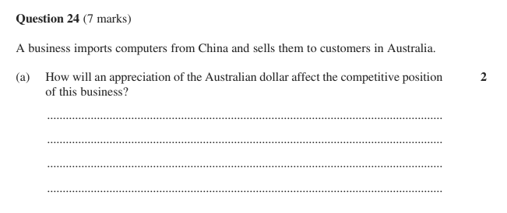

41. 2013 HSC Question 24 (a) 2021 Finance Practice HSC Questions 3 marks
Describe ONE method of payment the business could use to ensure that it receives payment for the sales.
Stimulus Case scenario: An Australian-owned business manufactures bicycles in China and sells them to wholesalers in France. These wholesalers do not pay in advance.

42. 24 (a) 2021 Finance Practice HSC Questions 3 marks
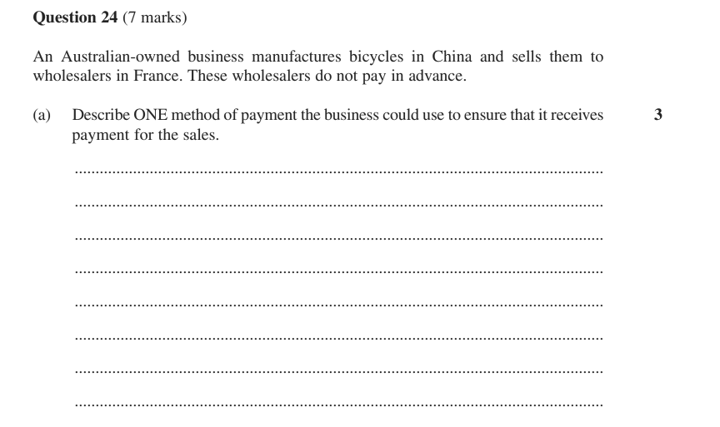

43. (b) 2021 Finance Practice HSC Questions · Independent Trial 2024 · Newington Trial 2024 4 marks
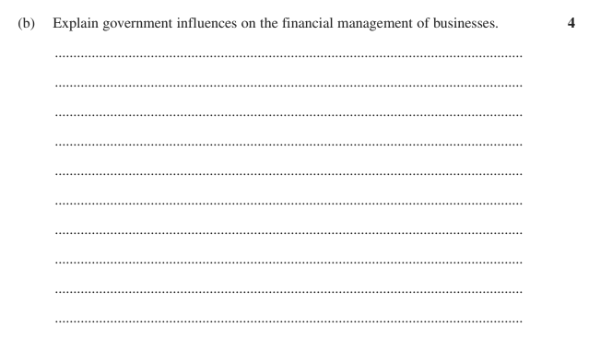

44. 24 (b) 2021 Finance Practice HSC Questions 4 marks
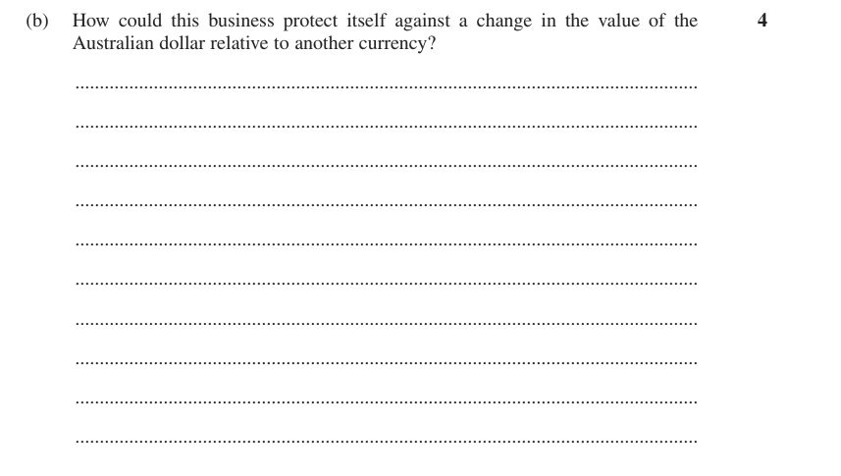

45. 24 (b) 2021 Finance Practice HSC Questions 5 marks
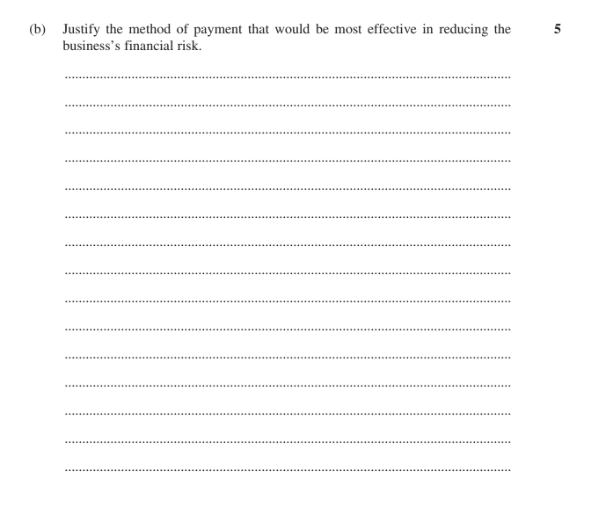

Also tested by question 16.
TOPIC

Marketing

Consumer laws
46. 23 (a) Abbotsleigh Trial 2023 1 mark
Identify ONE illegal marketing practice under Australian Consumer Law.

47. 24 (c) Reddam Trial 2023 3 marks
Explain the impact of ONE consumer law on ZZ's marketing strategies.
Stimulus ZZ's operates a function centre for large birthday parties for residents in the local area. ZZ's has renovated and expanded their function centre so that they can provide additional functions such as school formals and weddings.

48. 23 (b) Roseville Trial 2024 4 marks
A viewer sees this advertisement and orders the product. They receive the hair dryer and a single knife in the mail and are disappointed to find that the knife isn't sharp enough to cut ordinary fruit.
Explain how elements of this television advertisement may be in breach of Australian Consumer Law.
Stimulus A television commercial for a hair dryer on a shopping channel indicates that if customers order the hair dryer in the next ten minutes, they will also receive a free set of knives at no extra cost. The narrator tells viewers that these knives can cut through anything with a single slice.

49. 23 (c) Loreto Trial 2024 4 marks
How might aspects of Ecoclean's advertisement breach Australian consumer laws?
Stimulus EcoClean is a startup selling eco-friendly cleaning products. An advertisement for EcoClean (reproduced as an image in the paper) claims the products are "The best toxic free cleaning products on the market!" and states "We guarantee results*", with a fine-print footnote "*for houses that are already dirt free."

50. 24 (b) Knox Trial 2023 4 marks
Explain TWO legal influences that QuadTel will need to consider in their marketing.
Stimulus QuadTel is a US based business that sells innovative high quality drone technology to consumers. It is considering entering the Australian market and is currently reviewing the best way to market their products.

51. 24 (c) 2021 HSC Business Studies 4 marks
How might aspects of this advertisement breach Australian consumer laws?
Stimulus A printed advertisement for a fridge headed 'Be the envy of your neighbours' and claiming 'The best quality fridge in the market'. It promotes a limited-time 30% off store offer, 'Comes with a massive 6-month warranty***' and '**Zero carbon emissions'. Small-print disclaimers state: *30% off not applicable to this product; **Zero carbon emissions only in houses that are zero carbon powered; ***No repairs or returns will be considered after 6 months.

Identifying target markets
52. 24 (a) Reddam Trial 2023 2 marks
Outline ONE possible target market for ZZ's function centre.
Stimulus ZZ's operates a function centre for large birthday parties for residents in the local area. ZZ's has renovated and expanded their function centre so that they can provide additional functions such as school formals and weddings.

53. 23 (b) 2023 HSC Business Studies 3 marks
How could a niche market approach increase sales for this cereal manufacturer?
Stimulus A cereal manufacturer has decided to change the packaging of its product in an attempt to reverse a drop in sales and remain competitive with existing businesses. It is also considering growing its target market by catering for health-conscious consumers in Australia and eventually expanding into the global market.

54. 21 (c) Barker Trial 2024 4 marks
Why is identifying a target market important when developing a product?

55. 21 (c) Abbotsleigh Trial 2024 5 marks
Assess the importance of market segmentation in the development of effective marketing strategies for this business.
Stimulus Exquisite Gardens Pty Ltd, located in Bowral NSW, provides upmarket plants and garden furniture for consumers residing in country estates. Their customers are primarily professionals of high socioeconomic status who love gardening. The business is currently planning to expand its market throughout Australia, however management is concerned about the potential impact of a decline in Australia's current economic growth and an increase in government regulations on the business.

56. 23 (d) Abbotsleigh Trial 2023 5 marks
Explain how determining the target market of Sophie's Glamping Resort would assist the business to develop appropriate marketing strategies.
Stimulus Sophie's Glamping Resort, located in Northern Queensland, provides an upmarket camping experience of outstanding service and facilities for consumers of high socioeconomic status.

Developing marketing strategies
57. 22 (b) Barker Trial 2023 6 marks
Analyse THREE steps in the marketing process required to develop a new marketing plan for this business.
Stimulus Spook is an exclusive luxury fashion retailer with a target market of high-income customers. Recently they have experienced a decrease in sales and profits due to an economic downturn. The business has decided to review their marketing plan in response to this change.

Also tested by question 56.

Implementation, monitoring and controlling
58. 24 (b) 2022 HSC Business Studies 3 marks
How will the business know that their marketing plan has been successful for a new product range?
Stimulus Scenario: A business wishes to introduce new products into the market.

Market segmentation
No question of its own here. Tested inside questions 54, 55.

Promotion mix
59. 24 (a) 2022 HSC Business Studies 2 marks
Outline ONE promotion strategy this business could use to launch the new product range.
Stimulus Scenario: A business wishes to introduce new products into the market.

60. 23 (c) Roseville Trial 2024 3 marks
An influencer has been engaged to promote the sale of these hair dryers.
Explain how this influencer could successfully promote this product.
Stimulus A television commercial for a hair dryer on a shopping channel offers a free set of knives with any order placed within ten minutes, claiming the knives can cut through anything with a single slice.

61. 21 (b) Barker Trial 2024 3 marks
With reference to a business you have studied, describe how a business would benefit from using opinion leaders in their marketing.

62. 24 (c) Reddam Trial 2024 4 marks
Evaluate ONE promotional strategy Indulgence Ltd could use to increase sales of their new range of sugar free chocolates.
Stimulus Case scenario: Indulgence Ltd manufactures and sells high quality chocolates in their own retail outlets. Recently, the business has introduced a range of sugar free chocolates.

Distribution channels
63. Question 22 (a) HSC Final Exam Preparation — MARKETING 3 marks
Recommend ONE appropriate distribution channel for Trendy Masks to maximise market exposure.
Stimulus Trendy Masks is a newly established producer of personal protective equipment, including stylish face masks. They are looking to capitalise on the recent growth in this market. (Question 22 is worth 10 marks in total.)

64. 24 (c) Knox Trial 2023 4 marks
Why should this business consider the use of both direct and indirect distribution channels?
Stimulus QuadTel is a US based business that sells innovative high quality drone technology to consumers. It is considering entering the Australian market and is currently reviewing the best way to market their products.

65. Question 22 (c) HSC Final Exam Preparation — MARKETING 4 marks
Analyse TWO physical distribution issues that need to be considered by Trendy Masks.
Stimulus Trendy Masks is a newly established producer of personal protective equipment, including stylish face masks. They are looking to capitalise on the recent growth in this market. (Question 22 is worth 10 marks in total.)

66. 23 (c) SIC Trial 2024 5 marks
Discuss TWO suitable channel choices for this business for the new products.
Stimulus A business manufactures loungewear and is known for distinctive patterns and comfort. Management is introducing a new premium product range of athletic wear. Economic conditions have worsened and unemployment has risen.

TOPIC

Human Resources

Strategic role of human resource management
67. 24 (a) Roseville Trial 2023 2 marks
Outline the strategic role of human resource management.

68. 24 (a) Abbotsleigh Trial 2023 2 marks
Outline the strategic role of the human resource function.

Outsourcing
69. 24 (a) Roseville Trial 2024 1 mark
Identify one human resource function that Green Earth Ltd could outsource.
Stimulus Green Earth Ltd is a mid-sized manufacturing company that produces eco-friendly household products. Due to rapid growth and an increase in customer demand, the company's management team is considering outsourcing certain human resource functions to improve efficiency and focus on core activities.

70. 24 (a) Barker Trial 2024 2 marks
Outline ONE disadvantage of outsourcing human resources functions.

71. 24 (b) Roseville Trial 2023 2 marks
Describe ONE benefit that might result from deciding to outsource an aspect of human resource management.

72. 23 (b) 2021 HSC Business Studies 2 marks
Why might a business use a contractor to recruit staff?

73. 24 (b) Barker Trial 2023 3 marks
Why would a business outsource their human resource functions?

74. 24 (b) Roseville Trial 2024 4 marks
Describe two benefits this company might experience from outsourcing this human resource function.
Stimulus Green Earth Ltd is a mid-sized manufacturing company that produces eco-friendly household products. Due to rapid growth and an increase in customer demand, the company's management team is considering outsourcing certain human resource functions to improve efficiency and focus on core activities.

75. Question 22 (a) HSC Final Exam Preparation — HRM 4 marks
Outline TWO benefits of outsourcing key human resource functions for this business.
Stimulus A manufacturing business operating across Australia employs a large workforce. Management decides to outsource key human resource functions including recruitment, induction, change management, training and development of employees. Recently there has been an industrial dispute with employees demanding higher pay, and better working conditions.

Processes of human resource management
76. 22 (d) 2022 HSC Business Studies 3 marks
Explain the importance of carrying out an induction program for new employees.

77. 24 (c) Loreto Trial 2024 4 marks
Analyse the impact of technological influences on ONE of the human resource processes at TechWorld.
Stimulus TechWorld is reviewing its human resources strategies to ensure alignment with its goals for: growth; innovation; supportive work culture; current legal framework.

78. 23 (c) Reddam Trial 2024 4 marks
Explain how a business can use TWO human resources management processes to achieve a competitive advantage.

79. 21 (b) 2020 HSC Business Studies 4 marks
Distinguish between voluntary and involuntary separation.

80. 21 (c) 2020 HSC Business Studies 4 marks
Explain how technological influences and globalisation can lead to a company reducing staff numbers. Support your answer with relevant examples.

81. 22 (c) SIC Trial 2024 5 marks
Describe how changes in technology impact on Human Resources processes.

82. 21 (c) Newington Trial 2023 5 marks
Discuss the strategy of internal recruitment for Raj.
Stimulus Raj owns a business that designs security software. His business is rapidly expanding due to the increase in companies allowing their employees to work from home. Raj needs to increase his workforce to keep up with his demand. The work is complicated and requires excellent knowledge of coding and software design. Due to the expansion, Raj requires more employees in management roles.

Leadership style
83. 21 (a) Newington Trial 2023 2 marks
Identify TWO ways that leadership style can affect employee performance in a business.

84. 23 (b) Knox Trial 2023 6 marks
Justify the use of rewards and leadership style as strategies to improve the effectiveness of human resource management for this business.
Stimulus HiFashion is a fast fashion retail store with 40 stores around Australia employing 200 staff. Management is concerned about a reduction in productivity and staff feedback; staff cited rewards, leadership style and dispute resolution methods as key to their dissatisfaction. Data extract: staff turnover 10% (2021) to 20% (2022); employee satisfaction 80% (2021) to 65% (2022); number of disputes 10 per year (2021) to 25 per year (2022).

Indicators
85. 24 (a) Barker Trial 2023 2 marks
Define corporate culture.

86. 23 (a) Reddam Trial 2023 2 marks
Outline ONE indicator that can be used to measure the effectiveness of human resource management in a business.

87. 23 (a) 2021 HSC Business Studies 2 marks
Outline how corporate culture can affect staff turnover.

88. 24 (b) Barker Trial 2024 3 marks
Why is corporate culture an indicator of the effectiveness of human resource management?

89. 24 (c) Independent Trial 2024 4 marks
Explain how TWO indicators can be used to evaluate the effectiveness of the human resource function.

90. 22 (d) Abbotsleigh Trial 2024 4 marks
Recommend TWO indicators that could be used by Spend More to measure the effectiveness of its human resource management.
Stimulus The retail business, Spend More, has been rapidly expanding in the past 2 years and requires additional staff and premises. However, the increasing changes have led to conflict and uncertainty between management and employees in the workplace.

91. 24 (b) Loreto Trial 2024 4 marks
Recommend TWO indicators that could be used by TechWorld to measure the effectiveness of its human resource management.
Stimulus TechWorld is reviewing its human resources strategies to ensure alignment with its goals for: growth; innovation; supportive work culture; current legal framework.

92. 24 (b) Abbotsleigh Trial 2023 4 marks
To what extent is human resources management effective in this business? Support your answer with examples from the data.
Stimulus Table of data for a business, 2021 vs 2022. Human Resources costs: $2 600 000 (2021) vs $2 000 000 (2022). Training expenditure per employee: $1900 vs $1500. Absenteeism per employee: 10 days vs 14 days. Accidents per 1000 employees: 50 vs 30. Number of strike days: 2 vs 10. Staff turnover: 15% vs 10%.

93. 24 (c) Barker Trial 2023 · Barker Trial 2024 5 marks
Evaluate the effectiveness of human resources management at this business.
Stimulus Table of data for a business between 2022 and 2023: Absenteeism per employee 10 days (2022) rising to 15 days (2023); Staff turnover 15% rising to 18%; Training expenditure per employee $2 100 rising to $3 400; Accidents per 100 employees falling from 11 to 5.

Also tested by question 84.

