HSC BUSINESS STUDIES
Finance — exam focus
Short-answer practice on the points you flagged
31 short-answer questions across 5 syllabus points
Drawn from NESA HSC 2019–2023, school trial papers 2023–24, and topic question banks.
- Short answer only — no multiple choice, and no 20-mark extended responses.
- Ruled space follows each question, sized to its mark value.
- A question testing two of these points is printed once and cross-referenced from the other.

CONTENTS
Finance
Planning and implementing 2
Ethical issues of financial statements 10
Profitability and working capital management 9
Equity financing 3
Global financial management strategies 7
TOPIC

Finance

Planning and implementing
1. 22 (b) 2021 HSC Business Studies 3 marks
Explain a financial risk associated with borrowing funds from the USA.
Stimulus A luxury Australian handbag business is going to expand. They intend to borrow 30 million US dollars to buy several new retail properties across Australia.

2. 24 (c) SIC Trial 2024 4 marks
Describe the importance of the planning and implementing process for this business.
Stimulus Key financial information for a manufacturing business planning to invest $10m into a new manufacturing facility over the next 3 years. Figures in $'000: Revenue 9 000; Accounts receivable 2 500; Cost of goods sold 3 600; Retained profit 1 400; Expenses 3 780. Industry averages: Gross Profit Ratio 50%; Net Profit Ratio 25%; Expense Ratio 45%.

Ethical issues of financial statements
3. 22 (d) Reddam Trial 2024 2 marks
Outline ONE ethical issue related to this financial report.
Stimulus Balance Sheet for Buffy’s Florist, 1/1/24 – 30/6/24. Current Assets: Cash $10 000; Accounts Receivable $70 000; Inventory $80 000 (total $160 000). Non-Current Assets: Retail Premises $800 000; Delivery vans $100 000. Current Liabilities: Accounts Payable $90 000; Bank overdraft $60 000 (total $150 000). Non-Current Liabilities: Mortgage $600 000. Owners’ Equity: Capital $260 000; Retained Profit $50 000. Additional financial information: Industry Average Liquidity/Working Capital Ratio = 2:1.

4. 22 (a) Roseville Trial 2024 2 marks
Outline ONE limitation of financial reports.

5. 21 (a) Knox Trial 2023 2 marks
Outline ONE limitation of this financial report.
Stimulus Financial information for Playsmart Child Care Ltd (balance sheet extract). Current Assets: Cash $40 000; Accounts Receivable $100 000; Inventory $100 000. Non-Current Assets: Building $320 000; Delivery van $40 000; Goodwill $100 000. Current Liabilities: Accounts Payable $100 000; Bank overdraft $130 000. Non-Current Liabilities: Mortgage $300 000. Owners' Equity: Capital $150 000; Retained Profit $20 000. Additional information: Debt to equity ratio = Total Liabilities / Total Equity; gearing industry average 2:1.

6. 2019 HSC Question 22 (a) 2021 Finance Practice HSC Questions · 2019 HSC Business Studies 2 marks
Outline ONE ethical issue related to the preparation of financial reports.

7. 22 (b) Loreto Trial 2024 3 marks
Explain ONE limitation of financial statements in providing a complete picture of Coffee Mania's financial health.
Stimulus Coffee Mania, a local cafe. Latest financial statement key figures: Current Assets $200,000; Non-Current Assets $800,000; Current Liabilities $150,000; Non-Current Liabilities $500,000; Owner's Equity $350,000.

8. 21 (b) Knox Trial 2023 3 marks
Explain ONE ethical issue related to financial reports for the stakeholders of this business.
Stimulus Financial information for Playsmart Child Care Ltd (balance sheet extract). Current Assets: Cash $40 000; Accounts Receivable $100 000; Inventory $100 000. Non-Current Assets: Building $320 000; Delivery van $40 000; Goodwill $100 000. Current Liabilities: Accounts Payable $100 000; Bank overdraft $130 000. Non-Current Liabilities: Mortgage $300 000. Owners' Equity: Capital $150 000; Retained Profit $20 000. Additional information: Debt to equity ratio = Total Liabilities / Total Equity; gearing industry average 2:1.

9. 2015 HSC Question 24 (a) 2021 Finance Practice HSC Questions 3 marks
Explain ONE possible limitation of this financial report.
Stimulus Extract from financial reports for Andrew's Discount Tyres as at 30 May 2015. Current assets: Accounts receivable $1 000; Inventory $2 000; Cash $2 000. Non-current assets: Building $13 000; Fittings $1 000; Research and development $5 000. Current liabilities: Overdraft $2 000; Accounts payable $1 000. Non-current liabilities: Mortgage $5 000. Owner's Equity $16 000. Other information: Net profit for Andrew's Discount Tyres $1000; Industry average gearing ratio (total liabilities ÷ total equity): 80%.

10. 24 (b) Abbotsleigh Trial 2024 4 marks
Describe TWO limitations of SK Pty Ltd's 2024 Balance Sheet.
Stimulus Balance Sheet for SK Pty Ltd as at year ending 30 June 2024. Current Assets: Cash $15,000; Receivables $10,000; Inventories $80,000. Non-Current Assets: Property $280,000; R&D $60,000; Equipment $100,000. Current Liabilities: Creditors $50,000. Non-Current Liabilities: Bank Loan $100,000. Owners Equity: Capital $350,000; Net Profit $65,000; Drawings $20,000. Other financial information: 2023 return on equity ratio = 11%; 2024 return on equity ratio industry average 13%; 2024 debt to equity ratio industry average 2:1.

11. 24 (c) 2023 HSC Business Studies 5 marks
Explain TWO limitations of financial reports.

12. 22 (a)–(b) 2021 Finance Practice HSC Questions 5 marks
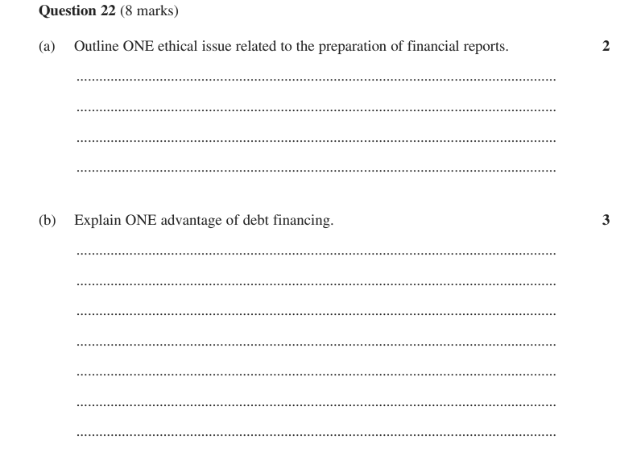

Profitability and working capital management
13. 22 (b) Reddam Trial 2024 2 marks
Describe ONE inventory management strategy Buffy’s Florist Pty Ltd could use in the business.
Stimulus Balance Sheet for Buffy’s Florist, 1/1/24 – 30/6/24. Current Assets: Cash $10 000; Accounts Receivable $70 000; Inventory $80 000 (total $160 000). Non-Current Assets: Retail Premises $800 000; Delivery vans $100 000. Current Liabilities: Accounts Payable $90 000; Bank overdraft $60 000 (total $150 000). Non-Current Liabilities: Mortgage $600 000. Owners’ Equity: Capital $260 000; Retained Profit $50 000. Additional financial information: Industry Average Liquidity/Working Capital Ratio = 2:1.

14. 22 (b) Reddam Trial 2023 2 marks
Recommend ONE working capital management strategy Local Grocer Pty Ltd. could use to improve its liquidity.
Stimulus Balance Sheet for Local Grocer Pty Ltd, June 2023.
Current Assets: Cash $25 000; Accounts Receivable $45 000; Inventory $55 000.
Non-Current Assets: Building $400 000; Delivery van $50 000.
Current Liabilities: Accounts Payable $35 000; Bank overdraft $65 000.
Non-Current Liabilities: Mortgage $225 000.
Owners' Equity: Capital $200 000; Retained Profit $50 000.
Additional financial information: Return on Owners' Equity ratio for 2022 = 0.1:1.

15. 23 (b) 2021 Finance Practice HSC Questions 3 marks
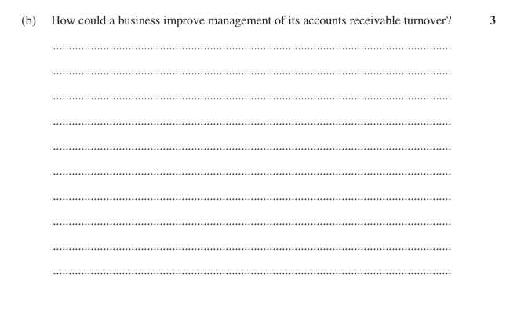

16. 22 (c) Reddam Trial 2024 4 marks
Discuss the impact of ONE working capital management strategy on Buffy’s Florist Pty Ltd.
Stimulus Balance Sheet for Buffy’s Florist, 1/1/24 – 30/6/24. Current Assets: Cash $10 000; Accounts Receivable $70 000; Inventory $80 000 (total $160 000). Non-Current Assets: Retail Premises $800 000; Delivery vans $100 000. Current Liabilities: Accounts Payable $90 000; Bank overdraft $60 000 (total $150 000). Non-Current Liabilities: Mortgage $600 000. Owners’ Equity: Capital $260 000; Retained Profit $50 000. Additional financial information: Industry Average Liquidity/Working Capital Ratio = 2:1.

17. 22 (d) Roseville Trial 2024 4 marks
Recommend TWO profitability management strategies for this business.
Stimulus Financial data for Smith Office Supplies Pty Ltd for the period ending 30 June 2023 (business figure, then industry average): Sales 180 000 / 240 000; Cost of Goods Sold 120 000 / 120 000; GROSS PROFIT 60 000 / 120 000; Operating expenses — Administrative 17 000 / 15 000, Sales and distribution 7 000 / 15 000, Financial 7 000 / 10 000; NET PROFIT 29 000 / 80 000.

18. 23 (b) Barker Trial 2023 · Barker Trial 2024 4 marks
How could Acme Kitchenware improve their level of working capital?
Stimulus Acme Kitchenware manufactures and sells pots and pans to department stores. Financial Information for Acme Kitchenware 2022 -- Current assets: Cash $125 000, Accounts receivable $60 500, Stock $110 000 (total current assets $295 500). Non-current assets: Vehicles $260 000, Equipment $216 580. Current liabilities: Accounts payable $120 000, Overdraft $120 780 (total current liabilities $240 780). Non-current liabilities: Mortgage $20 000. Owner's equity: Capital $430 800, Retained earnings $80 500 (total equity $511 300). Additional information: Net profit $75 000; industry average return on equity 18%. (Working capital is therefore only $54 720, a current ratio of about 1.23:1.)

19. 22 (d) Roseville Trial 2023 4 marks
Recommend TWO profitability management strategies that this business could use to improve its profitability result.
Stimulus Income statement for Manly Beach Pancakes Store Pty Ltd, year ended 30 June 2022, shown alongside Industry Average Results ($):
Sales 150 000 (industry 200 000); Cost of goods sold 105 000 (industry 100 000); Gross profit 45 000 (industry 100 000).
Operating expenses — Administrative 5 000 (industry 12 000); Selling & distribution 7 000 (industry 15 000); Financial 3 000 (industry 3 000); Net profit 30 000 (industry 70 000).
The business therefore has a gross profit ratio of 30% versus an industry average of 50%, and a net profit ratio of 20% versus an industry average of 35%.

20. 21 (c) Knox Trial 2023 5 marks
Analyse the use of sale and leaseback as a financial management strategy for this business.
Stimulus Financial information for Playsmart Child Care Ltd (balance sheet extract). Current Assets: Cash $40 000; Accounts Receivable $100 000; Inventory $100 000. Non-Current Assets: Building $320 000; Delivery van $40 000; Goodwill $100 000. Current Liabilities: Accounts Payable $100 000; Bank overdraft $130 000. Non-Current Liabilities: Mortgage $300 000. Owners' Equity: Capital $150 000; Retained Profit $20 000. Additional information: Debt to equity ratio = Total Liabilities / Total Equity; gearing industry average 2:1.

21. 24 (c)–(d) 2021 Finance Practice HSC Questions · 2020 HSC Business Studies 7 marks
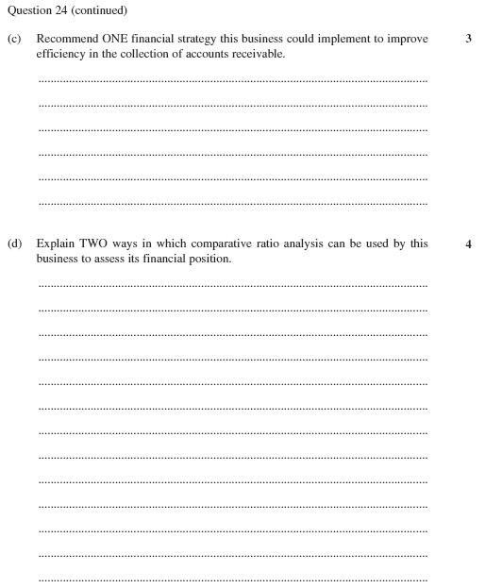

Equity financing
22. 22 (c) 2021 Finance Practice HSC Questions · 2019 HSC Business Studies 3 marks
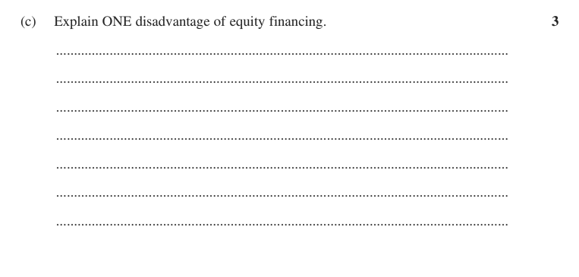

23. 23 (b) Independent Trial 2024 · Newington Trial 2024 4 marks
Discuss TWO sources of finance that Food Plus Pty Ltd can use to fund its expansion.
Stimulus Food Plus Pty Ltd is a health food grocery store, operating successfully in NSW for the last 10 years. Management is now aiming to expand overseas by opening three stores in the USA in the next two years. There are a number of global market influences which Food Plus Pty Ltd needs to consider in relation to this global expansion.

24. 22 (c) Loreto Trial 2024 5 marks
Coffee Mania wants to expand its business and is looking at different financing options.
Justify ONE source of finance to fund Coffee Mania's expansion.
Stimulus Coffee Mania, a local cafe. Latest financial statement key figures: Current Assets $200,000; Non-Current Assets $800,000; Current Liabilities $150,000; Non-Current Liabilities $500,000; Owner's Equity $350,000. (Debt to equity is therefore 1.87:1.) The business wants to fund an expansion.

Global financial management strategies
25. 2017 HSC Question 24 (a) 2021 Finance Practice HSC Questions 2 marks
How will an appreciation of the Australian dollar affect the competitive position of this business?
Stimulus Case scenario: A business imports computers from China and sells them to customers in Australia.

26. 24 (a) 2021 Finance Practice HSC Questions 2 marks
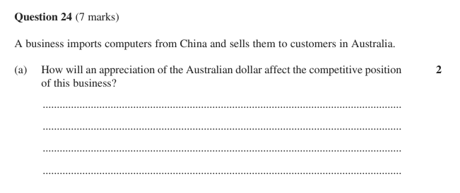

27. 2013 HSC Question 24 (a) 2021 Finance Practice HSC Questions 3 marks
Describe ONE method of payment the business could use to ensure that it receives payment for the sales.
Stimulus Case scenario: An Australian-owned business manufactures bicycles in China and sells them to wholesalers in France. These wholesalers do not pay in advance.

28. 24 (a) 2021 Finance Practice HSC Questions 3 marks
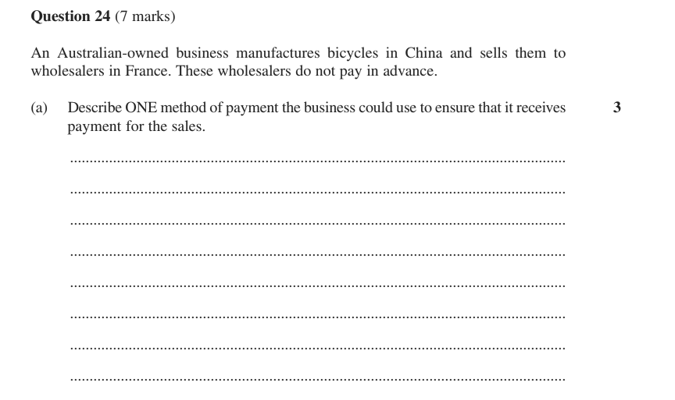

29. (b) 2021 Finance Practice HSC Questions · Independent Trial 2024 · Newington Trial 2024 4 marks
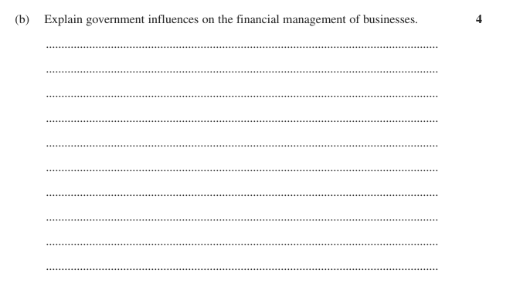

30. 24 (b) 2021 Finance Practice HSC Questions 4 marks
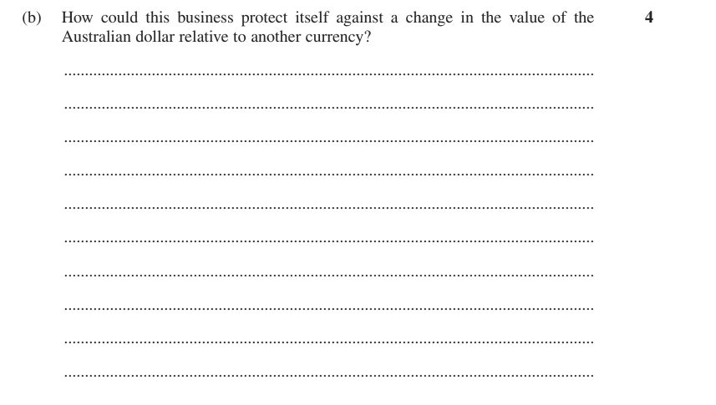

31. 24 (b) 2021 Finance Practice HSC Questions 5 marks
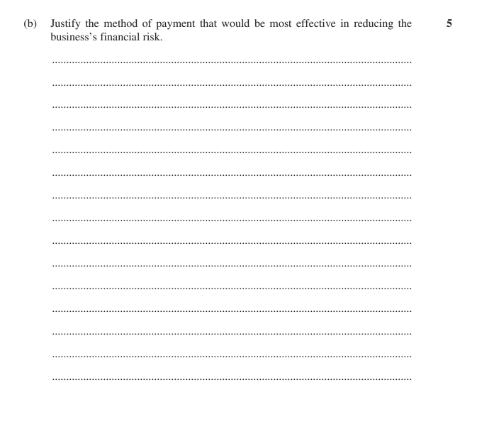

Also tested by question 1.

