HSC BUSINESS STUDIES
Finance
Practice questions by syllabus point
146 questions · 53 shown as screenshots of the printed paper · 19 of 21 syllabus points covered
Drawn from 23 papers: NESA HSC 2019–2023, school trial papers 2023–24, and topic question banks.
How to use this booklet
- Questions sit under the syllabus dot point they actually test, in syllabus order.
- Ruled space follows each question, sized to its mark value — write straight onto the page, on paper or with a stylus.
- A question testing more than one dot point is printed once and cross-referenced from the others.
- Where a scan of the original page exists it is shown as-is, so you see the real layout and mark boxes.

Contents
Role of financial management
Strategic role of financial management ↗2
Objectives 9
Interdependence with other key business functions 3
Influences on financial management
Internal sources of finance 3
External sources — debt 8
External sources — equity 2
Financial institutions 1
Influence of government 3
Global market influences 1
Processes of financial management
Planning and implementing 3
Debt and equity financing 5
Matching the terms and source of finance to business purpose ↗9
Monitoring and controlling 11
Financial ratios 32
Comparative ratio analysis 5
Limitations of financial reports 7
Ethical issues related to financial reports 3
Financial management strategies
Cash flow management 3
Working capital management 6
Profitability management 2
Global financial management 8

PART 1

Role of financial management

Strategic role of financial management
No short-answer question of its own. Covered inside questions 13, 14.

Objectives
1. 23 (a) Independent Trial 2024 · Newington Trial 2024 2 marks
Outline how the short-term and long-term financial goals of this business may conflict.
Stimulus Food Plus Pty Ltd is a health food grocery store, operating successfully in NSW for the last 10 years. Management is now aiming to expand overseas by opening three stores in the USA in the next two years. There are a number of global market influences which Food Plus Pty Ltd needs to consider in relation to this global expansion.

2. 23 (c) Barker Trial 2023 2 marks
Why is efficiency a financial objective?

3. 24 (a) 2021 Finance Practice HSC Questions 2 marks
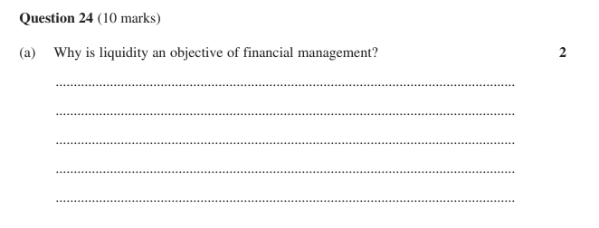

4. 21 (e) Abbotsleigh Trial 2023 3 marks
Explain how Bakers Dozen's current financial position impacts on the solvency of the business.
Stimulus Balance sheet for Bakers Dozen Pty. Ltd. as at 30 June 2023. Current Assets: Cash $19 000, Debtors $2 500, Stock $34 000. Non-current Assets: Equipment $62 000, Buildings $318 000, Land $160 000. Total Assets $595 500. Current Liabilities: Overdraft $30 000. Non-current Liabilities: Debentures $94 000, Mortgage $291 500 (total liabilities $415 500). Owner's Equity: Capital $95 000, Retained profit $85 000 (total equity $180 000). Net profit for 2022-2023 was $160 000; industry average for liquidity is 2.5:1; industry gearing (total liabilities ÷ owner's equity) is 1:1. The business plans to expand nationally.

5. 21 (a) 2021 Finance Practice HSC Questions · 2023 HSC Business Studies 3 marks
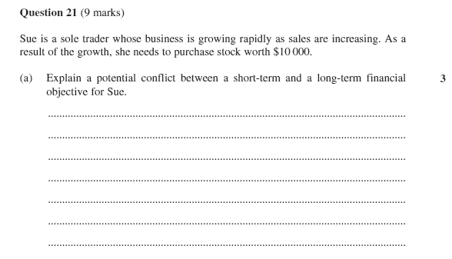

6. 22 (b) Newington Trial 2023 4 marks
Using the financial information provided, explain why solvency is an important objective for this business.
Stimulus Balance Sheet for Simon's Sporting Goods Pty Ltd (a large sporting goods retailer), as at 30 June 2023, figures in '000s. ASSETS: Cash at bank 800; Inventories 300; Accounts receivable 800 (current assets 1900); Plant & Equipment 500; Motor Vehicles 1200; Land & Buildings 4000 (non-current assets 5700); Total assets 7600. LIABILITIES: Accounts payable 1000; Overdraft 300 (current liabilities 1300); Two-year bank loan 1500; Mortgage 3000 (non-current liabilities 4500). OWNER'S EQUITY: Capital 1000; Retained Profit 800 (total equity 1800). Other information: Net profit for 2023 = $300 000; Return on Equity (net profit ÷ total equity) for 2022 = 20%. Industry Averages: Debt to Equity (total liabilities ÷ total equity) = 2:1; Current Ratio (current assets ÷ current liabilities) = 1:1.

7. 22 (c)–(d) 2021 Finance Practice HSC Questions 8 marks
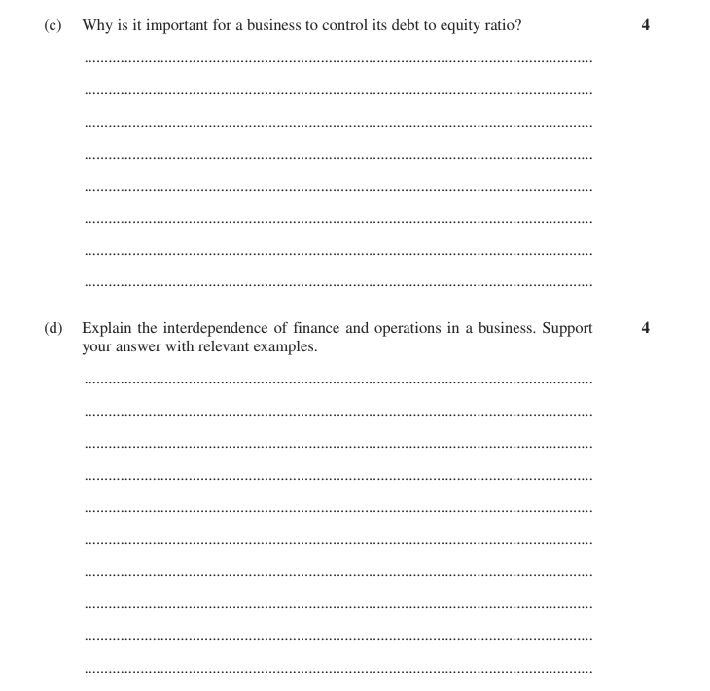

8. 4 2021 Finance Practice HSC Questions multiple choice
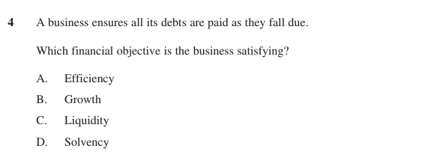
Answer:
9. 4 2021 Finance Practice HSC Questions multiple choice
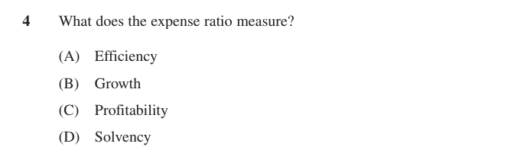
Answer:
Also tested by questions 15, 16, 17, 18, 19, 20, 21.

Interdependence with other key business functions
10. 24 (c) Abbotsleigh Trial 2023 4 marks
Using the data, analyse the interdependence between human resources management and financial management in this business.
Stimulus Table of data for a business, 2021 vs 2022. Human Resources costs: $2 600 000 (2021) vs $2 000 000 (2022). Training expenditure per employee: $1900 vs $1500. Absenteeism per employee: 10 days vs 14 days. Accidents per 1000 employees: 50 vs 30. Number of strike days: 2 vs 10. Staff turnover: 15% vs 10%.

11. 2012 HSC Question 22 (d) 2021 Finance Practice HSC Questions 4 marks
Explain the interdependence of finance and operations in a business. Support your answer with relevant examples.

12. 21 (b) 2019 HSC Business Studies 4 marks
Explain the interdependence between marketing and finance for this business.
Stimulus Question 21 scenario: A business sells luxury cars. The cars are stylish, high performance and include advanced safety features integrating leading edge technology.

Also tested by questions 7, 22.
PART 1 · EXTENDED RESPONSE

Role of financial management — 20-mark questions
10 questions. Plan and write these on separate paper.
13. 2017 HSC Question 25 2021 Finance Practice HSC Questions 20 marks
The directors have asked you to write a business report in which you:
• outline ONE strategic role of financial management
• recommend TWO strategies to improve financial performance
• explain the importance of monitoring and controlling the business's marketing strategy.
Stimulus Case scenario (business report): Sportyz Goodz Ltd is a retailer that has been operating for the past 20 years in Australia. The directors have provided the following information: in 2013 the business issued new shares on the Australian Securities Exchange and expanded its retail activities internationally; the business is facing increasing competition; the directors are concerned about the positioning of their product in the market; the directors want the business to operate for the benefit of shareholders in the long term. A line graph of financial data (amount in millions of $, 2012-2017) shows both Sales and Profit peaking in 2012, falling sharply to a low in 2013, recovering partially in 2014, then declining steadily through to 2017; Profit sits below Sales across the whole period.
14. 25 2021 Finance Practice HSC Questions 20 marks
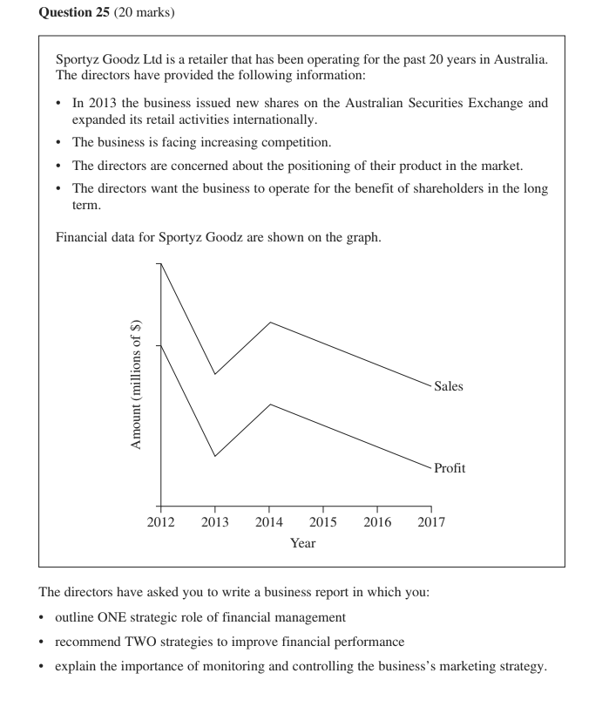
15. 27 Newington Trial 2024 20 marks
Analyse how financial management strategies can be used to improve financial objectives
16. 27 Reddam Trial 2024 20 marks
Analyse the impact of financial management strategies on liquidity and profitability financial objectives.
17. 26 Loreto Trial 2024 20 marks
Assess the significance of financial management strategies in ensuring the long-term objectives of a business are achieved.
18. 26 Knox Trial 2023 20 marks
Analyse how different sources of finance impact the financial objectives of a business.
19. 27 Abbotsleigh Trial 2023 20 marks
Assess the importance of financial management strategies in achieving the objectives of financial management.
20. 2020 HSC Question 26 2021 Finance Practice HSC Questions · 2020 HSC Business Studies 20 marks
Evaluate the effectiveness of financial management strategies used to achieve profit and growth objectives.
21. 2012 HSC Question 27 2021 Finance Practice HSC Questions 20 marks
How can different sources of funds help a business achieve its financial objectives?
22. 25 Barker Trial 2023 20 marks
Management of Marvels Metals has hired you as a consultant to write a report addressing:
• Outline the strategic role of human resources management for this business.
• Examine the interdependence between finance and human resources for this business.
• Recommend ONE appropriate financial management strategy to address the business' financial problems.
Stimulus Marvel Metals manufactures metal products for the Australian building industry. Over the past few years, the business has experienced decreasing profitability and cash flow management problems. Rising inflation has affected a range of their costs such as raw materials, utilities and wages. They have also noticed significant delays in receiving payment from their customers. Management is looking to adopt new technology, which will result in job cuts and retraining for some staff. Employees are unhappy with this potential change and it is contributing to increasing rates of absenteeism and staff turnover.
PART 2

Influences on financial management

Internal sources of finance
23. 22 (a) Roseville Trial 2023 2 marks
Define retained profits.

24. (b) 2021 Finance Practice HSC Questions 6 marks
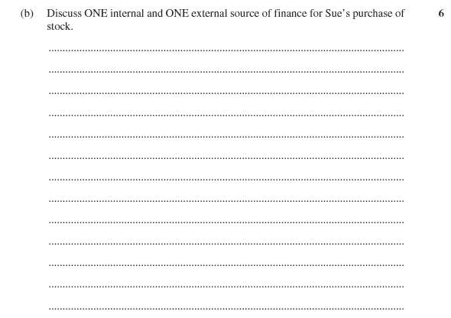

25. 6 2021 Finance Practice HSC Questions multiple choice
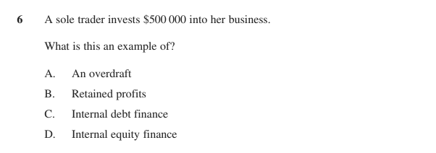
Answer:
Also tested by questions 18, 21.

External sources — debt
26. 23 (b) Independent Trial 2024 · Newington Trial 2024 4 marks
Discuss TWO sources of finance that Food Plus Pty Ltd can use to fund its expansion.
Stimulus Food Plus Pty Ltd is a health food grocery store, operating successfully in NSW for the last 10 years. Management is now aiming to expand overseas by opening three stores in the USA in the next two years. There are a number of global market influences which Food Plus Pty Ltd needs to consider in relation to this global expansion.

27. 24 (c) Abbotsleigh Trial 2024 4 marks
Justify why this business should use debt finance to fund its expansion.
Stimulus Balance Sheet for SK Pty Ltd as at year ending 30 June 2024. Current Assets: Cash $15,000; Receivables $10,000; Inventories $80,000. Non-Current Assets: Property $280,000; R&D $60,000; Equipment $100,000. Current Liabilities: Creditors $50,000. Non-Current Liabilities: Bank Loan $100,000. Owners Equity: Capital $350,000; Net Profit $65,000; Drawings $20,000. Other financial information: 2023 return on equity ratio = 11%; 2024 return on equity ratio industry average 13%; 2024 debt to equity ratio industry average 2:1. Additional information for this part: SK Pty Ltd is considering expansion by opening a new store and has been given approval from the bank to borrow $500,000 to finance their expansion.

28. 22 (d) Reddam Trial 2023 4 marks
Compare and contrast TWO sources of debt finance used by Local Grocer Pty Ltd.
Stimulus Balance Sheet for Local Grocer Pty Ltd, June 2023.
Current Assets: Cash $25 000; Accounts Receivable $45 000; Inventory $55 000.
Non-Current Assets: Building $400 000; Delivery van $50 000.
Current Liabilities: Accounts Payable $35 000; Bank overdraft $65 000.
Non-Current Liabilities: Mortgage $225 000.
Owners' Equity: Capital $200 000; Retained Profit $50 000.
Additional financial information: Return on Owners' Equity ratio for 2022 = 0.1:1.

29. 22 (c) Loreto Trial 2024 5 marks
Coffee Mania wants to expand its business and is looking at different financing options.
Justify ONE source of finance to fund Coffee Mania's expansion.
Stimulus Coffee Mania, a local cafe. Latest financial statement key figures: Current Assets $200,000; Non-Current Assets $800,000; Current Liabilities $150,000; Non-Current Liabilities $500,000; Owner's Equity $350,000. (Debt to equity is therefore 1.87:1.) The business wants to fund an expansion.

30. 2018 HSC Question 24 (c) 2021 Finance Practice HSC Questions 5 marks
Discuss the use of leasing and the use of mortgages as a source of long-term finance for this business.
Stimulus Case scenario: A business has decided to expand into a larger factory and is now considering its financial options.

31. 24 (c) 2021 Finance Practice HSC Questions 5 marks
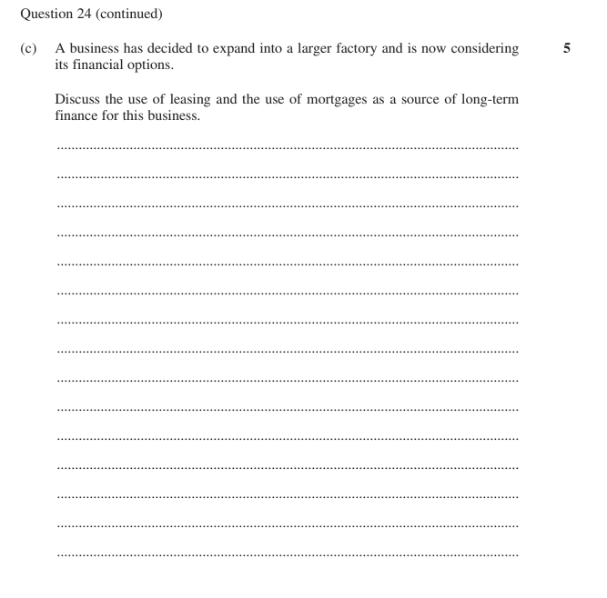

32. 2 2021 Finance Practice HSC Questions multiple choice
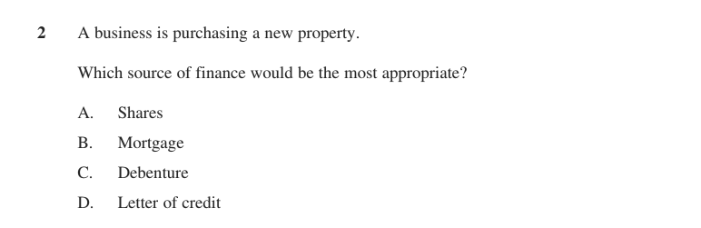
Answer:
33. 7 2021 Finance Practice HSC Questions multiple choice
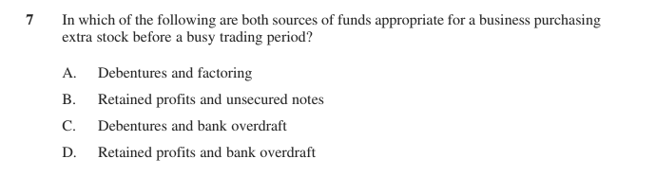
Answer:
Also tested by questions 18, 21, 24, 41, 42, 43, 44, 45.

External sources — equity
34. 22 (c) 2021 Finance Practice HSC Questions · 2019 HSC Business Studies 3 marks
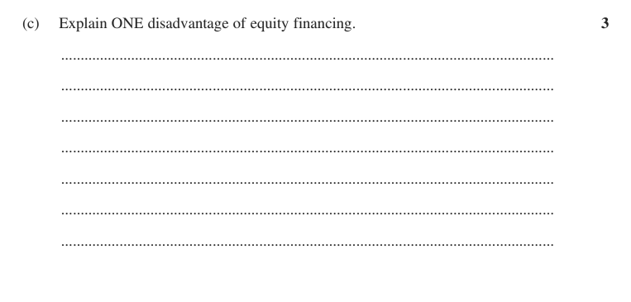

35. 12 2021 Finance Practice HSC Questions multiple choice
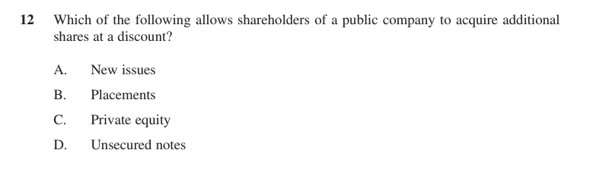
Answer:
Also tested by questions 18, 21, 25, 26, 29, 41, 42, 43, 44, 46.

Financial institutions
36. 4 2021 Finance Practice HSC Questions multiple choice
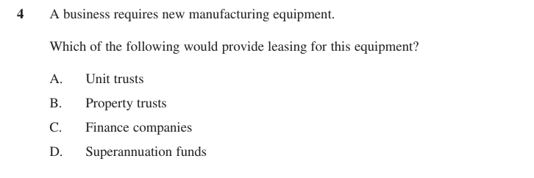
Answer:

Influence of government
37. 21 (d) Abbotsleigh Trial 2023 2 marks
Describe how Australian Securities and Investment Commission impacts this business.
Stimulus Bakers Dozen Pty. Ltd. Over the past two years the business has experienced remarkable success, with consistently strong profits and a devoted customer base. Fuelled by this growth, the owners' intentions are to expand nationally. Bakers Dozen's expansion aims to reach a wider audience while maintaining the same high-quality and personalised touch that secured such early success within their local community.

38. (b) 2021 Finance Practice HSC Questions · Independent Trial 2024 · Newington Trial 2024 4 marks
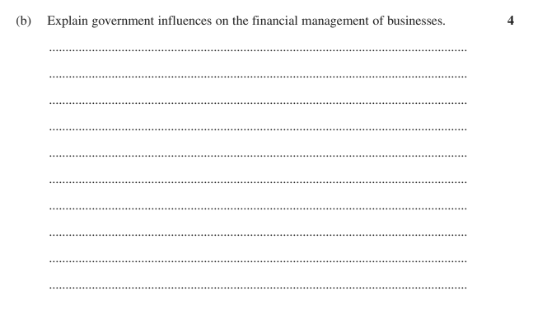

39. 16 2021 Finance Practice HSC Questions multiple choice
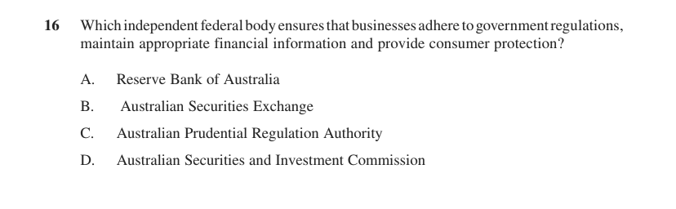
Answer:
Also tested by questions 41, 47.

Global market influences
40. 8 2021 Finance Practice HSC Questions multiple choice
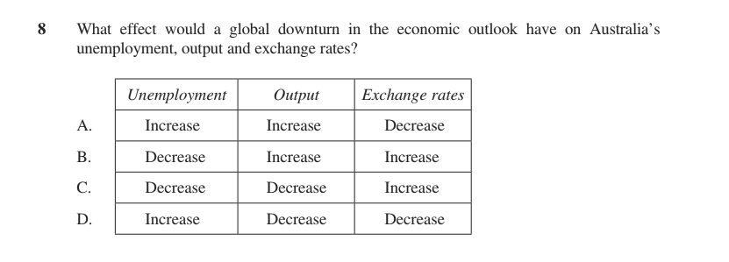
Answer:
Also tested by questions 38, 41, 47.
PART 2 · EXTENDED RESPONSE

Influences on financial management — 20-mark questions
7 questions. Plan and write these on separate paper.
41. 27 Abbotsleigh Trial 2024 20 marks
Assess financial management strategies a business may implement in response to the influences on financial management.
42. 25 SIC Trial 2024 20 marks
The directors have asked you to write a business report in which you:
- Outline the impact of variation in demand and variety on this business.
- Discuss a suitable source of finance for this business expansion.
- Recommend TWO working capital strategies for this business.
Stimulus Roberto y Carlos Pty Ltd (RYC): the founding partners are shareholders in a national fast food chain franchise. The business currently owns a large head office and 25 out of 200 stores. RYC is popular amongst students and businesspeople for its affordable products and friendly, quick service. They are planning to introduce a new menu with expanded options. RYC is seeking to go global next year and requires significant external funding to support the expansion; an investor has offered the total capital to fund the expansion in return for 51% equity. Other key financial information: current ratio of 0.8:1 (30% lower than the industry average); rent affordability is currently at a 5-year low; current interest rates are high at around 8%.
43. 25 2023 HSC Business Studies 20 marks
The directors have asked you to write a business report in which you:
• outline some of the challenges including the global factors of costs, skills and supply the business may need to consider in recruiting and retaining staff
• compare the use of debt and equity as sources of finance
• recommend ONE source of finance this business could use to fund its expansion.
Stimulus Future Century Gaming Pty Ltd operates an online gaming platform targeting players aged 18–40 in Australia. It has been in operation since 2012, providing subscription access to a variety of online games. The business is considering expanding into emerging global markets but is finding it challenging to recruit and retain skilled, qualified game designers and developers in Australia. It is considering international labour markets to overcome staff shortages. The business has decided to finance its expansion into global markets through external sources. Answer is to be presented as a business report.
44. 25 2021 HSC Business Studies 20 marks
You have been hired as a consultant by Ozzi Baby Food Pty Ltd to write a business report to the owners. In your report:
- outline TWO operations influences affecting this business
- discuss the use of retraining and redundancy payments to help overcome employee resistance to these changes
- compare the use of a mortgage to a new issue of shares to fund the factory purchase.
Stimulus Hypothetical business: Ozzi Baby Food Pty Ltd has a trusted reputation in domestic and global markets due to its safe and sustainably-sourced product range, which has led to a significant increase in demand. It is considering purchasing a larger automated factory, which will lead to some job losses. External finance is required to fund the purchase, using either a mortgage or becoming a public company on the Australian Securities Exchange (ASX). The response must be presented as a business report.
45. 2014 HSC Question 25 2021 Finance Practice HSC Questions 20 marks
You have been hired as a consultant to write a report to the management. In your report:
• recommend a source of finance for the factory expansion
• discuss outsourcing overseas compared with the factory expansion
• explain the global factors that need to be considered if they decide to use outsourcing as an operations strategy.
Stimulus Case scenario (business report): Emu Uniform Manufacturers Pty Ltd are a successful business based in NSW. They currently supply a range of school, sport and work uniforms to a large number of customers throughout Australia. They are known for their outstanding customer service and high quality products. Sales have been increasing for many years and they have recently received a large long-term contract to supply uniforms to a major company. This will require them to significantly expand their output. To do this, the business will have to outsource overseas or spend $5 million to expand its existing factory in NSW.
46. 25 2021 Finance Practice HSC Questions 20 marks
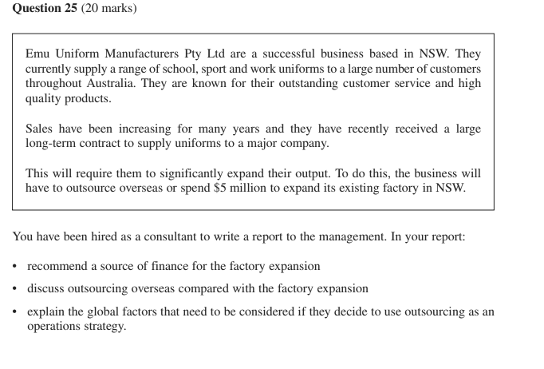
47. 27 Reddam Trial 2023 20 marks
Analyse the influence of government and the global market on financial management strategies.
PART 3

Processes of financial management

Planning and implementing
48. 22 (b) 2021 HSC Business Studies 3 marks
Explain a financial risk associated with borrowing funds from the USA.
Stimulus A luxury Australian handbag business is going to expand. They intend to borrow 30 million US dollars to buy several new retail properties across Australia.

49. 24 (c) SIC Trial 2024 4 marks
Describe the importance of the planning and implementing process for this business.
Stimulus Key financial information for a manufacturing business planning to invest $10m into a new manufacturing facility over the next 3 years. Figures in $'000: Revenue 9 000; Accounts receivable 2 500; Cost of goods sold 3 600; Retained profit 1 400; Expenses 3 780. Industry averages: Gross Profit Ratio 50%; Net Profit Ratio 25%; Expense Ratio 45%.

50. 14 2021 Finance Practice HSC Questions multiple choice
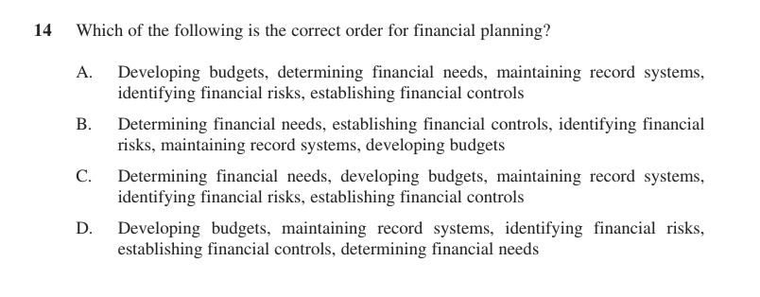
Answer:
Also tested by question 114.

Debt and equity financing
51. 22 (c) Reddam Trial 2023 2 marks
Explain ONE advantage of Local Grocer Pty Ltd using debt finance rather than equity finance.
Stimulus Balance Sheet for Local Grocer Pty Ltd, June 2023.
Current Assets: Cash $25 000; Accounts Receivable $45 000; Inventory $55 000.
Non-Current Assets: Building $400 000; Delivery van $50 000.
Current Liabilities: Accounts Payable $35 000; Bank overdraft $65 000.
Non-Current Liabilities: Mortgage $225 000.
Owners' Equity: Capital $200 000; Retained Profit $50 000.
Additional financial information: Return on Owners' Equity ratio for 2022 = 0.1:1.

52. 23 (d) 2022 HSC Business Studies 3 marks
Using the financial information provided, explain why the business should use debt finance to acquire the two new stores.
Stimulus A gifts and homewares business sells goods such as candles, bags, cushions, soaps and jewellery. Financial information: Operating income (revenue) $1 500 000; Gross profit $1 100 000; Expenses $600 000; Total liabilities $2 000 000; Net profit $500 000; Owner's equity $1 800 000 (return on owner's equity 27.8%). The family-owned business is considering expansion by opening two new stores. Their bank has given approval to borrow $3 000 000 at 4% interest to finance their expansion.

53. 23 (c) 2022 HSC Business Studies 3 marks
Why is the level of gearing an important consideration for the lender to this business?
Stimulus A gifts and homewares business sells goods such as candles, bags, cushions, soaps and jewellery. Financial information: Operating income (revenue) $1 500 000; Gross profit $1 100 000; Expenses $600 000; Total liabilities $2 000 000; Net profit $500 000; Owner's equity $1 800 000. The family-owned business is considering expansion by opening two new stores. Their bank has given approval to borrow $3 000 000 at 4% interest to finance their expansion.

54. 2012 HSC Question 22 (c) 2021 Finance Practice HSC Questions 4 marks
Why is it important for a business to control its debt to equity ratio?
Stimulus Balance Sheet for Chalker Pty Ltd as at year ending 30 June 2012. Current Assets: Cash $8 000; Receivables $12 000; Inventories $15 000 (total current assets $35 000). Non-Current Assets: Property, Plant and Equipment $33 000. Total Assets $68 000. Current Liabilities: Creditors $14 000. Non-Current Liabilities: Loan $20 000. Owners Equity: Capital $15 000; Retained Net Profit $19 000 (total $34 000). Total Liabilities and Owners Equity $68 000.

55. 22 (a)–(b) 2021 Finance Practice HSC Questions 5 marks
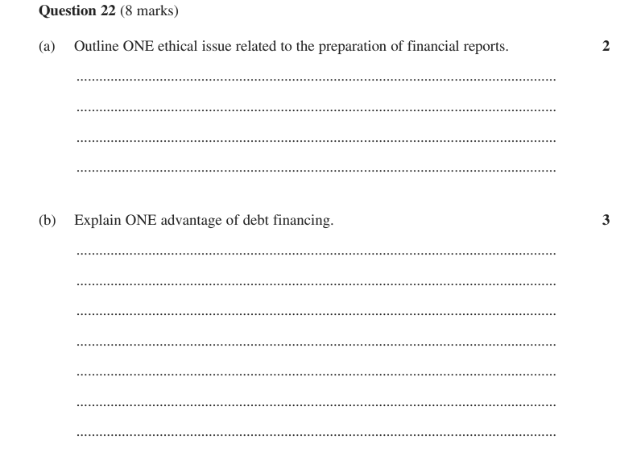

Also tested by questions 26, 27, 29, 34, 43, 44, 46, 115.

Matching the terms and source of finance to business purpose
No short-answer question of its own. Covered inside questions 24, 26, 28, 30, 31, 32, 33, 43, 46.

Monitoring and controlling
56. 2014 HSC Question 24 (a) (i) 2021 Finance Practice HSC Questions 1 mark
Calculate the opening cash balance for March.
Stimulus Extract from a cash flow statement for a business ($): Cash in - Jan 6000, Feb 5000, March 3000, April 2000, May 4000, June 3000. Cash out - Jan 3000, Feb 3000, March 8000, April 8000, May 3000, June 2000. The opening cash balance for January is $5000.

57. 2014 HSC Question 24 (a) (ii) 2021 Finance Practice HSC Questions 1 mark
In which month did the business start with a negative cash balance?
Stimulus Extract from a cash flow statement for a business ($): Cash in - Jan 6000, Feb 5000, March 3000, April 2000, May 4000, June 3000. Cash out - Jan 3000, Feb 3000, March 8000, April 8000, May 3000, June 2000. The opening cash balance for January is $5000.

58. 24 (a) SIC Trial 2024 2 marks
Distinguish between a balance sheet and an income statement.
Stimulus Question 24 data: key financial information for a manufacturing business that plans to invest $10m into a new manufacturing facility over the next 3 years. Figures in $'000: Revenue 9 000; Accounts receivable 2 500; Cost of goods sold 3 600; Retained profit 1 400; Expenses 3 780. Industry averages: Gross Profit Ratio (gross profit / sales) = 50%; Net Profit Ratio (net profit / sales) = 25%; Expense Ratio (expense / sales) = 45%.

59. 24 (a) 2023 HSC Business Studies 2 marks
What is the purpose of a cash flow statement?

60. 22 (a) 2021 HSC Business Studies 2 marks
Identify where the business could record the loan and the properties on its balance sheet.
Stimulus A luxury Australian handbag business is going to expand. They intend to borrow 30 million US dollars to buy several new retail properties across Australia.

61. 24 (a) 2021 Finance Practice HSC Questions 2 marks
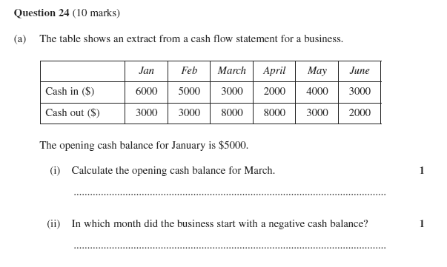

62. 11–12 2021 Finance Practice HSC Questions multiple choice
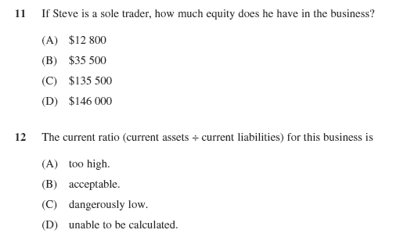
Answer:
63. 10 2021 Finance Practice HSC Questions multiple choice
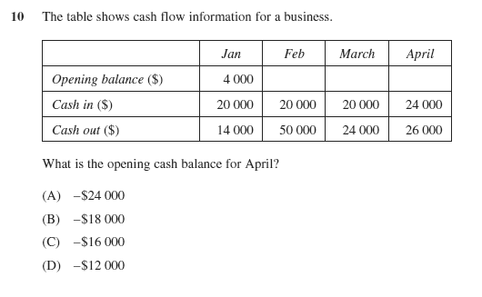
Answer:
64. 17–18 2021 Finance Practice HSC Questions multiple choice
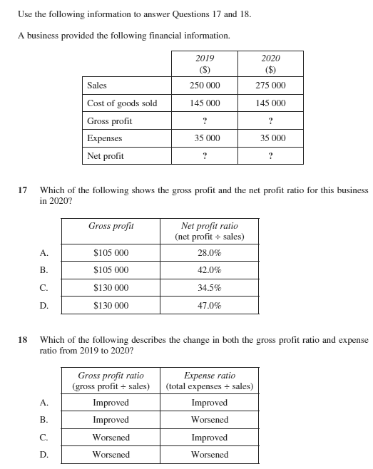
Answer:
65. 11–12 (stimulus) 2021 Finance Practice HSC Questions multiple choice
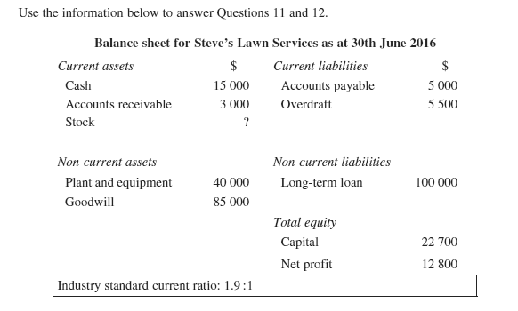
Answer:
66. 15 2021 Finance Practice HSC Questions multiple choice
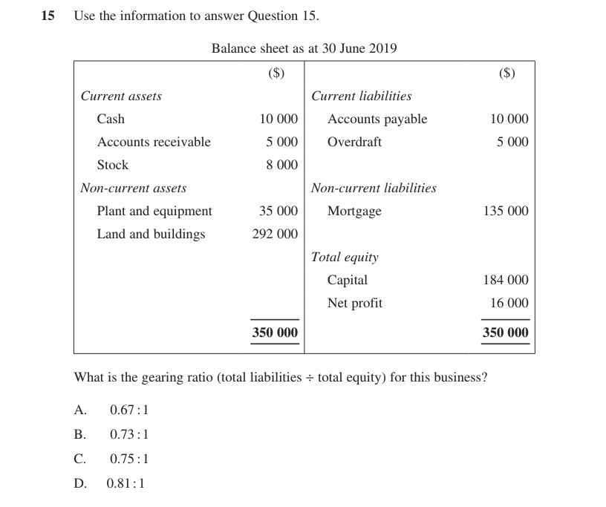
Answer:
Also tested by question 114.

Financial ratios
67. 22 (b) Roseville Trial 2024 1 mark
Calculate the expense ratio for Smith Office Supplies Pty Ltd.
Stimulus Financial data for Smith Office Supplies Pty Ltd for the period ending 30 June 2023 (business figure, then industry average): Sales 180 000 / 240 000; Cost of Goods Sold 120 000 / 120 000; GROSS PROFIT 60 000 / 120 000; Operating expenses — Administrative 17 000 / 15 000, Sales and distribution 7 000 / 15 000, Financial 7 000 / 10 000; NET PROFIT 29 000 / 80 000. Formulae given: Gross Profit Ratio = Gross Profit / Sales; Net Profit Ratio = Net Profit / Sales; Expense Ratio = Total expenses / Sales.

68. 21 (a) Abbotsleigh Trial 2023 1 mark
Calculate the return on owners' equity ratio (net profit ÷ total equity) for Bakers Dozen.
Stimulus Balance sheet for Bakers Dozen Pty. Ltd. as at 30 June 2023. Current Assets: Cash $19 000, Debtors $2 500, Stock $34 000 (total current assets $55 500). Non-current Assets: Equipment $62 000, Buildings $318 000, Land $160 000. Total Assets $595 500. Current Liabilities: Overdraft $30 000. Non-current Liabilities: Debentures $94 000, Mortgage $291 500. Owner's Equity: Capital $95 000, Retained profit $85 000 (total equity $180 000). Total Liabilities + Equity $595 500. Other information: Net profit for 2022-2023 was $160 000; industry average for liquidity is 2.5:1; industry gearing (total liabilities ÷ owner's equity) is 1:1.

69. 2020 HSC Question 24 (a) 2021 Finance Practice HSC Questions · 2020 HSC Business Studies 1 mark
Calculate the accounts receivable turnover ratio (sales ÷ accounts receivable) for this business.
Stimulus Financial Information for robotics company ($): Sales 225 000; Cost of goods sold 105 000; Selling expenses 8 500; Administration expenses 6 000; Financial expenses 4 000; Accounts receivable 30 000; Robotics company credit policy 30 days; Industry expense ratio 10%.

70. 22 (a) Loreto Trial 2024 2 marks
Calculate and comment on Coffee Mania's current ratio (current assets ÷ current liabilities).
Stimulus Coffee Mania, a local cafe. Latest financial statement key figures: Current Assets $200,000; Non-Current Assets $800,000; Current Liabilities $150,000; Non-Current Liabilities $500,000; Owner's Equity $350,000.

71. 22 (a) Reddam Trial 2024 2 marks
Calculate and comment on the Liquidity/Working Capital Ratio for Buffy’s Florist Pty Ltd. Round off your calculation to 1 decimal point.
Stimulus Balance Sheet for Buffy’s Florist, 1/1/24 – 30/6/24. Current Assets: Cash $10 000; Accounts Receivable $70 000; Inventory $80 000 (total $160 000). Non-Current Assets: Retail Premises $800 000; Delivery vans $100 000. Current Liabilities: Accounts Payable $90 000; Bank overdraft $60 000 (total $150 000). Non-Current Liabilities: Mortgage $600 000. Owners’ Equity: Capital $260 000; Retained Profit $50 000. Additional financial information: Industry Average Liquidity/Working Capital Ratio = 2:1.

72. 24 (a) Abbotsleigh Trial 2024 2 marks
Calculate and comment on the return on equity ratio (net profit ÷ total equity) for this business.
Stimulus Balance Sheet for SK Pty Ltd as at year ending 30 June 2024. Current Assets: Cash $15,000; Receivables $10,000; Inventories $80,000. Non-Current Assets: Property $280,000; R&D $60,000; Equipment $100,000. Current Liabilities: Creditors $50,000. Non-Current Liabilities: Bank Loan $100,000. Owners Equity: Capital $350,000; Net Profit $65,000; Drawings $20,000. Other financial information: 2023 return on equity ratio = 11%; 2024 return on equity ratio industry average 13%; 2024 debt to equity ratio industry average 2:1.

73. 23 (c) Barker Trial 2024 2 marks
Outline how ONE ratio can be used to measure financial efficiency.

74. 22 (a) Reddam Trial 2023 2 marks
Calculate and comment on the Return on Owner's Equity for Local Grocer Pty Ltd. Round off your calculation to 1 decimal point.
Stimulus Balance Sheet for Local Grocer Pty Ltd, June 2023.
Current Assets: Cash $25 000; Accounts Receivable $45 000; Inventory $55 000.
Non-Current Assets: Building $400 000; Delivery van $50 000.
Current Liabilities: Accounts Payable $35 000; Bank overdraft $65 000.
Non-Current Liabilities: Mortgage $225 000.
Owners' Equity: Capital $200 000; Retained Profit $50 000.
Additional financial information: Return on Owners' Equity ratio for 2022 = 0.1:1.

75. 22 (a) Newington Trial 2023 2 marks
Calculate and interpret the change in the return on equity (net profit ÷ total equity) for this business between 2022 and 2023.
Stimulus Balance Sheet for Simon's Sporting Goods Pty Ltd (a large sporting goods retailer), as at 30 June 2023, figures in '000s. ASSETS: Cash at bank 800; Inventories 300; Accounts receivable 800 (current assets 1900); Plant & Equipment 500; Motor Vehicles 1200; Land & Buildings 4000 (non-current assets 5700); Total assets 7600. LIABILITIES: Accounts payable 1000; Overdraft 300 (current liabilities 1300); Two-year bank loan 1500; Mortgage 3000 (non-current liabilities 4500). OWNER'S EQUITY: Capital 1000; Retained Profit 800 (total equity 1800). Other information: Net profit for 2023 = $300 000; Return on Equity (net profit ÷ total equity) for 2022 = 20%. Industry Averages: Debt to Equity (total liabilities ÷ total equity) = 2:1; Current Ratio (current assets ÷ current liabilities) = 1:1.

76. 21 (b) Abbotsleigh Trial 2023 2 marks
Calculate the current ratio (current assets ÷ current liabilities) for Bakers Dozen and comment on their liquidity.
Stimulus Balance sheet for Bakers Dozen Pty. Ltd. as at 30 June 2023. Current Assets: Cash $19 000, Debtors $2 500, Stock $34 000 (total current assets $55 500). Non-current Assets: Equipment $62 000, Buildings $318 000, Land $160 000. Total Assets $595 500. Current Liabilities: Overdraft $30 000. Non-current Liabilities: Debentures $94 000, Mortgage $291 500. Owner's Equity: Capital $95 000, Retained profit $85 000 (total equity $180 000). Total Liabilities + Equity $595 500. Other information: Net profit for 2022-2023 was $160 000; industry average for liquidity is 2.5:1; industry gearing (total liabilities ÷ owner's equity) is 1:1.

77. 23 (a) 2022 HSC Business Studies 2 marks
Calculate the efficiency (total expenses ÷ total sales) of this business.
Stimulus A gifts and homewares business sells goods such as candles, bags, cushions, soaps and jewellery. Financial information provided: Operating income (revenue) $1 500 000; Gross profit $1 100 000; Expenses $600 000; Total liabilities $2 000 000; Net profit $500 000; Owner's equity $1 800 000.

78. 2020 HSC Question 24 (b) 2021 Finance Practice HSC Questions · 2020 HSC Business Studies 2 marks
Interpret this business's expense ratio (total expenses ÷ sales).
Stimulus Financial Information for robotics company ($): Sales 225 000; Cost of goods sold 105 000; Selling expenses 8 500; Administration expenses 6 000; Financial expenses 4 000; Accounts receivable 30 000; Robotics company credit policy 30 days; Industry expense ratio 10%.

79. 22 (b) 2021 Finance Practice HSC Questions 2 marks
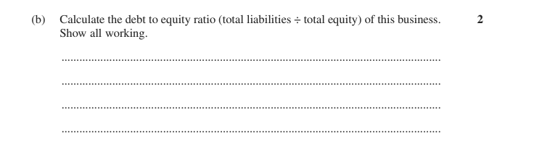

80. 22 (a) 2021 Finance Practice HSC Questions 2 marks
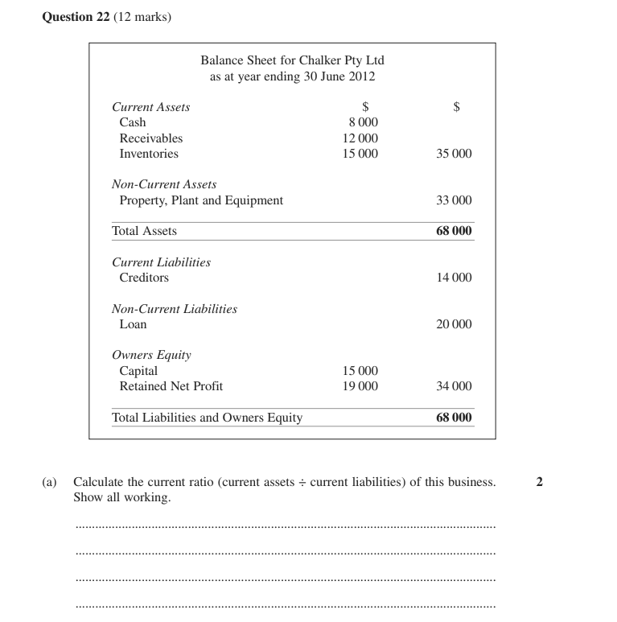

81. 23 (b) 2022 HSC Business Studies 3 marks
Explain how the expense ratio can help this business determine their efficiency.
Stimulus A gifts and homewares business sells goods such as candles, bags, cushions, soaps and jewellery. Financial information provided: Operating income (revenue) $1 500 000; Gross profit $1 100 000; Expenses $600 000; Total liabilities $2 000 000; Net profit $500 000; Owner's equity $1 800 000.

82. 24 (a)–(b) 2021 Finance Practice HSC Questions 3 marks
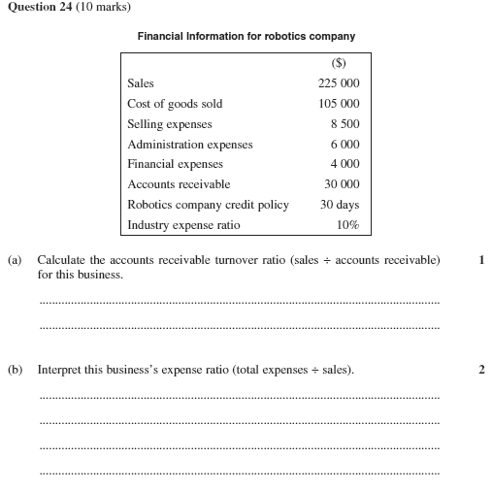

83. 22 (c) Roseville Trial 2024 4 marks
Assess the profitability of this business against industry averages.
Stimulus Financial data for Smith Office Supplies Pty Ltd for the period ending 30 June 2023 (business figure, then industry average): Sales 180 000 / 240 000; Cost of Goods Sold 120 000 / 120 000; GROSS PROFIT 60 000 / 120 000; Operating expenses — Administrative 17 000 / 15 000, Sales and distribution 7 000 / 15 000, Financial 7 000 / 10 000; NET PROFIT 29 000 / 80 000. Formulae given: Gross Profit Ratio = Gross Profit / Sales; Net Profit Ratio = Net Profit / Sales; Expense Ratio = Total expenses / Sales.

84. 24 (b) SIC Trial 2024 4 marks
Assess the profitability of this business.
Stimulus Key financial information for a manufacturing business planning to invest $10m into a new manufacturing facility over the next 3 years. Figures in $'000: Revenue 9 000; Accounts receivable 2 500; Cost of goods sold 3 600; Retained profit 1 400; Expenses 3 780. Industry averages: Gross Profit Ratio (gross profit / sales) = 50%; Net Profit Ratio (net profit / sales) = 25%; Expense Ratio (expense / sales) = 45%.

85. 23 (a) Barker Trial 2024 4 marks
Evaluate the solvency (total liabilities ÷ total equity) for this business.
Stimulus Acme Kitchenware manufactures and sells pots and pans to department stores. Table 'Financial Information for Acme Kitchenware 2022':
Current assets — Cash $30 000; Accounts Receivable $45 000; Inventory $50 000.
Non-current assets — Vehicles $45 000; Plant and Equipment $20 000; Goodwill $30 000.
Current liabilities — Accounts Payable $60 000; Overdraft (figure not legible in the source file).
Non-current liabilities — Term loan $130 000.
Owner's equity — Capital and Retained earnings of $70 000 and $150 000 (total equity $220 000).
Additional information: 2021 solvency ratio 105%; industry solvency ratio 70%. (The paper's marking guidelines state the 2022 solvency ratio is 93.2%.)

86. 23 (a) Barker Trial 2023 4 marks
Evaluate the owner's return on equity (net profit ÷ total equity).
Stimulus Acme Kitchenware manufactures and sells pots and pans to department stores. Financial Information for Acme Kitchenware 2022 -- Current assets: Cash $125 000, Accounts receivable $60 500, Stock $110 000 (total current assets $295 500). Non-current assets: Vehicles $260 000, Equipment $216 580. Current liabilities: Accounts payable $120 000, Overdraft $120 780 (total current liabilities $240 780). Non-current liabilities: Mortgage $20 000. Owner's equity: Capital $430 800, Retained earnings $80 500 (total equity $511 300). Additional information: Net profit $75 000; industry average return on equity 18%. (Return on equity therefore works out at approximately 14.7%.)

87. 22 (c) Newington Trial 2023 4 marks
Using the financial information provided, assess the recent financial performance of Simon's Sporting Goods Pty Ltd.
Stimulus Balance Sheet for Simon's Sporting Goods Pty Ltd (a large sporting goods retailer), as at 30 June 2023, figures in '000s. ASSETS: Cash at bank 800; Inventories 300; Accounts receivable 800 (current assets 1900); Plant & Equipment 500; Motor Vehicles 1200; Land & Buildings 4000 (non-current assets 5700); Total assets 7600. LIABILITIES: Accounts payable 1000; Overdraft 300 (current liabilities 1300); Two-year bank loan 1500; Mortgage 3000 (non-current liabilities 4500). OWNER'S EQUITY: Capital 1000; Retained Profit 800 (total equity 1800). Other information: Net profit for 2023 = $300 000; Return on Equity (net profit ÷ total equity) for 2022 = 20%. Industry Averages: Debt to Equity (total liabilities ÷ total equity) = 2:1; Current Ratio (current assets ÷ current liabilities) = 1:1.

88. 22 (c) Roseville Trial 2023 4 marks
Using the information above, assess the profitability of this business.
Stimulus Income statement for Manly Beach Pancakes Store Pty Ltd, year ended 30 June 2022, shown alongside Industry Average Results ($):
Sales 150 000 (industry 200 000); Cost of goods sold 105 000 (industry 100 000); Gross profit 45 000 (industry 100 000).
Operating expenses — Administrative 5 000 (industry 12 000); Selling & distribution 7 000 (industry 15 000); Financial 3 000 (industry 3 000); Net profit 30 000 (industry 70 000).
Formulae supplied: Gross Profit Ratio = gross profit / sales; Net Profit Ratio = net profits / sales.

89. 22 (c) 2021 HSC Business Studies 5 marks
Account for the changes in this business's current and forecast profitability and gearing.
Stimulus Ratio table for the luxury Australian handbag business (which is borrowing US$30 million to buy retail properties in Australia), comparing Current (before loan) with Forecast (12 months after loan): Gross profit 65% to 70%; Net profit 21% to 18%; Debt to equity 0.85:1 (85%) to 1.5:1 (150%).

90. 2015 HSC Question 24 (b) 2021 Finance Practice HSC Questions 5 marks
Discuss the gearing of Andrew's Discount Tyres.
Stimulus Extract from financial reports for Andrew's Discount Tyres as at 30 May 2015. Current assets: Accounts receivable $1 000; Inventory $2 000; Cash $2 000. Non-current assets: Building $13 000; Fittings $1 000; Research and development $5 000. Current liabilities: Overdraft $2 000; Accounts payable $1 000. Non-current liabilities: Mortgage $5 000. Owner's Equity $16 000. Other information: Net profit for Andrew's Discount Tyres $1000; Industry average gearing ratio (total liabilities ÷ total equity): 80%.

91. 19–20 2021 Finance Practice HSC Questions multiple choice
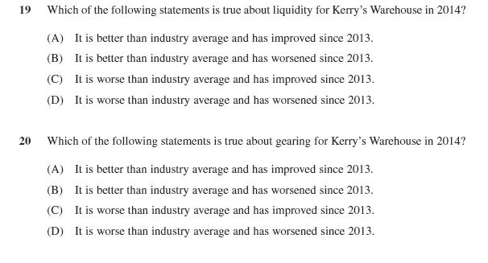
Answer:
92. 17 2021 Finance Practice HSC Questions multiple choice
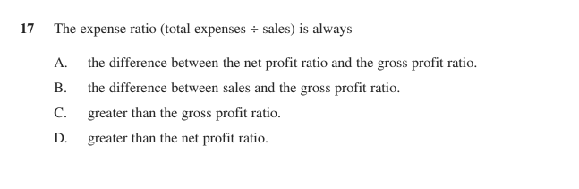
Answer:
93. 19 2021 Finance Practice HSC Questions multiple choice
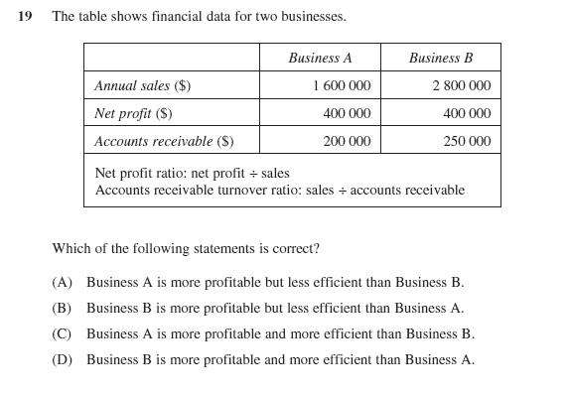
Answer:
94. 20 2021 Finance Practice HSC Questions multiple choice
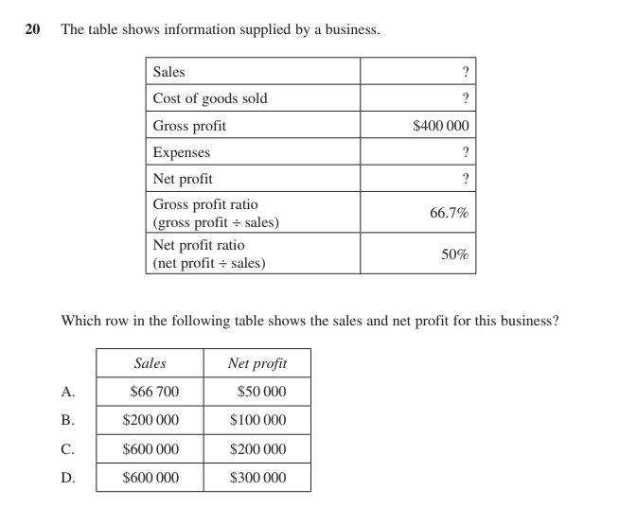
Answer:
95. 19–20 (stimulus) 2021 Finance Practice HSC Questions multiple choice
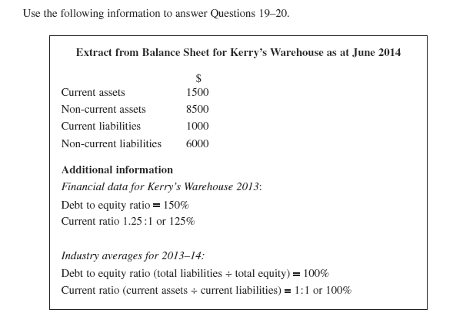
Answer:
96. 19–20 2021 Finance Practice HSC Questions multiple choice
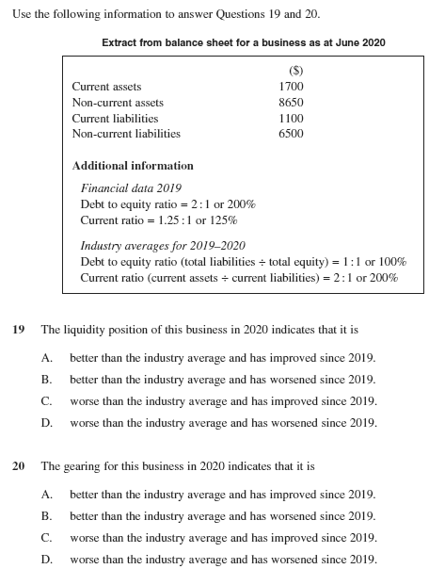
Answer:
97. 19–20 2021 Finance Practice HSC Questions multiple choice
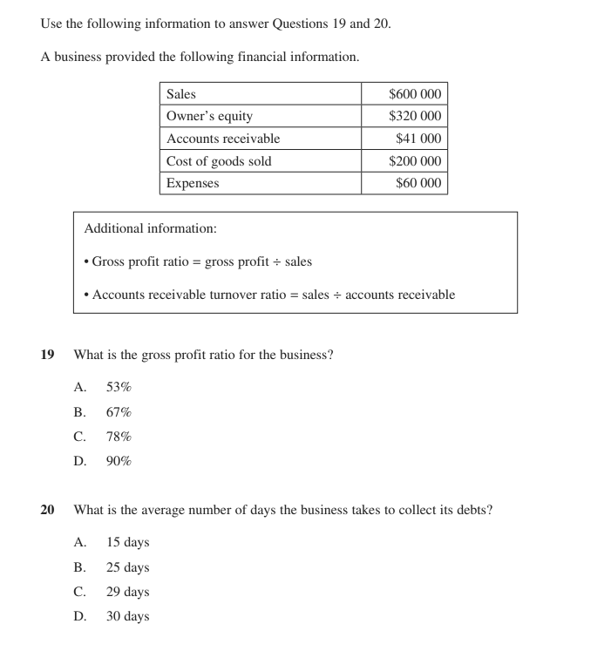
Answer:
98. 10 2021 Finance Practice HSC Questions multiple choice
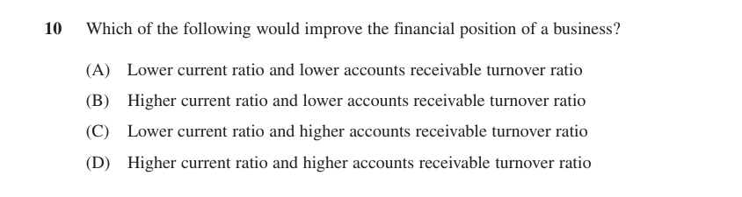
Answer:
Also tested by questions 4, 6, 7, 9, 52, 53, 54, 62, 64, 65, 66.

Comparative ratio analysis
99. 22 (b) Roseville Trial 2023 2 marks
Describe the purpose of comparative ratio analysis for a business.

100. 2020 HSC Question 24 (d) 2021 Finance Practice HSC Questions · 2020 HSC Business Studies 4 marks
Explain TWO ways in which comparative ratio analysis can be used by this business to assess its financial position.
Stimulus Financial Information for robotics company ($): Sales 225 000; Cost of goods sold 105 000; Selling expenses 8 500; Administration expenses 6 000; Financial expenses 4 000; Accounts receivable 30 000; Robotics company credit policy 30 days; Industry expense ratio 10%.

101. 24 (c)–(d) 2021 Finance Practice HSC Questions · 2020 HSC Business Studies 7 marks
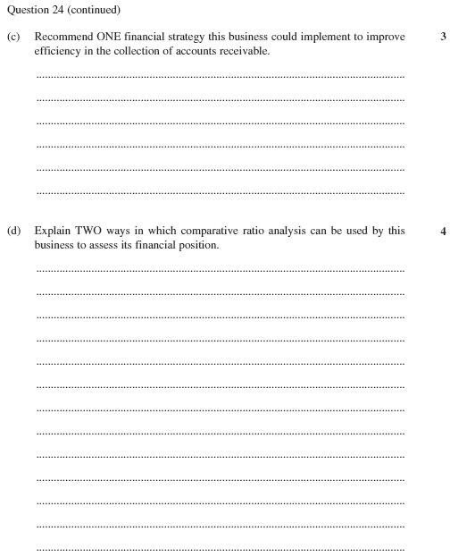

102. 12 2021 Finance Practice HSC Questions multiple choice
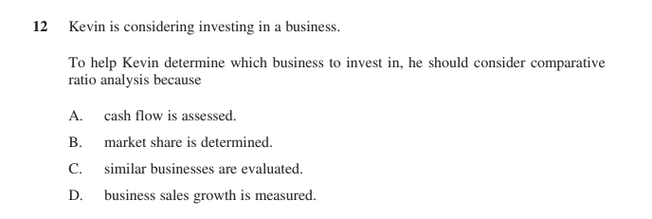
Answer:
103. 15 2021 Finance Practice HSC Questions multiple choice
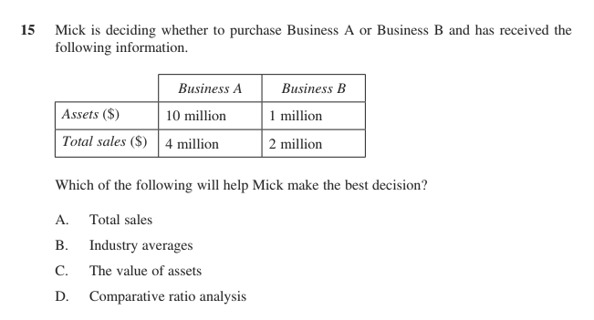
Answer:
Also tested by questions 64, 71, 72, 74, 75, 76, 78, 82, 83, 84, 85, 86, 87, 88, 89, 90, 91, 93, 95, 96.

Limitations of financial reports
104. 22 (a) Roseville Trial 2024 2 marks
Outline ONE limitation of financial reports.

105. 21 (a) Knox Trial 2023 2 marks
Outline ONE limitation of this financial report.
Stimulus Financial information for Playsmart Child Care Ltd (balance sheet extract). Current Assets: Cash $40 000; Accounts Receivable $100 000; Inventory $100 000. Non-Current Assets: Building $320 000; Delivery van $40 000; Goodwill $100 000. Current Liabilities: Accounts Payable $100 000; Bank overdraft $130 000. Non-Current Liabilities: Mortgage $300 000. Owners' Equity: Capital $150 000; Retained Profit $20 000. Additional information: Debt to equity ratio = Total Liabilities / Total Equity; gearing industry average 2:1.

106. 22 (b) Loreto Trial 2024 3 marks
Explain ONE limitation of financial statements in providing a complete picture of Coffee Mania's financial health.
Stimulus Coffee Mania, a local cafe. Latest financial statement key figures: Current Assets $200,000; Non-Current Assets $800,000; Current Liabilities $150,000; Non-Current Liabilities $500,000; Owner's Equity $350,000.

107. 2015 HSC Question 24 (a) 2021 Finance Practice HSC Questions 3 marks
Explain ONE possible limitation of this financial report.
Stimulus Extract from financial reports for Andrew's Discount Tyres as at 30 May 2015. Current assets: Accounts receivable $1 000; Inventory $2 000; Cash $2 000. Non-current assets: Building $13 000; Fittings $1 000; Research and development $5 000. Current liabilities: Overdraft $2 000; Accounts payable $1 000. Non-current liabilities: Mortgage $5 000. Owner's Equity $16 000. Other information: Net profit for Andrew's Discount Tyres $1000; Industry average gearing ratio (total liabilities ÷ total equity): 80%.

108. 24 (b) Abbotsleigh Trial 2024 4 marks
Describe TWO limitations of SK Pty Ltd's 2024 Balance Sheet.
Stimulus Balance Sheet for SK Pty Ltd as at year ending 30 June 2024. Current Assets: Cash $15,000; Receivables $10,000; Inventories $80,000. Non-Current Assets: Property $280,000; R&D $60,000; Equipment $100,000. Current Liabilities: Creditors $50,000. Non-Current Liabilities: Bank Loan $100,000. Owners Equity: Capital $350,000; Net Profit $65,000; Drawings $20,000. Other financial information: 2023 return on equity ratio = 11%; 2024 return on equity ratio industry average 13%; 2024 debt to equity ratio industry average 2:1.

109. 24 (c) 2023 HSC Business Studies 5 marks
Explain TWO limitations of financial reports.

110. 16 2021 Finance Practice HSC Questions multiple choice
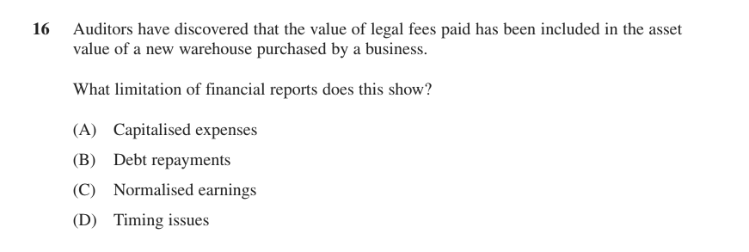
Answer:
Also tested by questions 116, 117, 118.

Ethical issues related to financial reports
111. 22 (d) Reddam Trial 2024 2 marks
Outline ONE ethical issue related to this financial report.
Stimulus Balance Sheet for Buffy’s Florist, 1/1/24 – 30/6/24. Current Assets: Cash $10 000; Accounts Receivable $70 000; Inventory $80 000 (total $160 000). Non-Current Assets: Retail Premises $800 000; Delivery vans $100 000. Current Liabilities: Accounts Payable $90 000; Bank overdraft $60 000 (total $150 000). Non-Current Liabilities: Mortgage $600 000. Owners’ Equity: Capital $260 000; Retained Profit $50 000. Additional financial information: Industry Average Liquidity/Working Capital Ratio = 2:1.

112. 2019 HSC Question 22 (a) 2021 Finance Practice HSC Questions · 2019 HSC Business Studies 2 marks
Outline ONE ethical issue related to the preparation of financial reports.

113. 21 (b) Knox Trial 2023 3 marks
Explain ONE ethical issue related to financial reports for the stakeholders of this business.
Stimulus Financial information for Playsmart Child Care Ltd (balance sheet extract). Current Assets: Cash $40 000; Accounts Receivable $100 000; Inventory $100 000. Non-Current Assets: Building $320 000; Delivery van $40 000; Goodwill $100 000. Current Liabilities: Accounts Payable $100 000; Bank overdraft $130 000. Non-Current Liabilities: Mortgage $300 000. Owners' Equity: Capital $150 000; Retained Profit $20 000. Additional information: Debt to equity ratio = Total Liabilities / Total Equity; gearing industry average 2:1.

Also tested by question 55.
PART 3 · EXTENDED RESPONSE

Processes of financial management — 20-mark questions
5 questions. Plan and write these on separate paper.
114. 26 Barker Trial 2024 20 marks
Assess the use of financial strategies to improve financial processes.
115. 25 Newington Trial 2023 20 marks
You have been hired as a consultant to write a report for Fly Well Airlines Ltd.
In your report:
▪ Outline ONE advantage and ONE disadvantage of outsourcing aircraft servicing and maintenance.
▪ Discuss issues involved in raising funds through both debt and equity finance and make a recommendation to management about which source of funding to use.
▪ Explain TWO human resource strategies that could assist Fly Well Airlines Ltd to address management concerns and help achieve business success.
Stimulus Fly Well Airlines Ltd is a low-cost Australian based domestic airline that has been exploring options to expand globally. Its domestic customers in Australia typically tend to be business executives and budget conscious leisure travellers. The business intends to begin operating flights into the highly competitive Asian market in the latter part of 2023. To achieve this, the business will have to fund the purchase of new computerised ticketing and baggage facilities at its Sydney terminal. Management believes there is also opportunity for the airline to move all scheduled aircraft servicing and maintenance to a contractor in Singapore. Employees who belong to unions have indicated they will respond to this with industrial action. Management is also concerned about the best way to achieve a sustainable competitive advantage in their new overseas markets.
116. Question 25 Roseville Trial 2023 20 marks
You have been hired as a consultant by ACB Pty Ltd to write a business report to the owners.
In your report:
• outline how human resources is interdependent with finance in this business.
• explain the limitations of financial reports that this business must be aware of when purchasing the 5 existing American retail sporting stores.
• recommend global financial management strategies that could help to reduce financial risks for this business.
Stimulus Aussie Cricket Bats (ACB) Pty Ltd is an Australian cricket bat manufacturing company hoping to cash in on the newfound popularity of the sport in America by selling cricket bats into that market. ACB plans to sell to Americans via (1) its already well-established Australian website, (2) taking ownership over 5 existing retail sporting stores on the east coast of America, and (3) becoming a supplier of bats to other established American sporting retail chains. To fund these plans ACB needs to borrow the equivalent of $15 million Australian Dollars. The owners are unsure whether to borrow in Australian Dollars from an Australian bank or in US Dollars from an American bank, and are worried about how to staff the 5 American retail stores as well as potentially paying too much for those businesses because they lack accounting expertise.
117. 2016 HSC Question 26 2021 Finance Practice HSC Questions 20 marks
The potential new partner has asked you to write a business report in which you:
• explain possible limitations of the financial reports
• recommend appropriate working capital management strategies for the business
• evaluate a pricing strategy the business could use.
Stimulus Case scenario (business report): Lee's Catering is a small business with a high profile chef and food of excellent quality. It has many bookings for future events. Extract from financial reports for Lee's Catering: Cash $1000; Accounts receivable $10 000; Inventory $50; Accounts payable $11 050; Goodwill $200 000; Current ratio (current assets ÷ current liabilities) 100% (industry average 150%); Gross profit ratio (gross profit ÷ sales) 30% (industry average 50%); Expense ratio (total expenses ÷ sales) 60% (industry average 30%). A potential new partner is concerned about the accuracy of the financial reports and the effectiveness of current management.
118. 26 2021 Finance Practice HSC Questions 20 marks
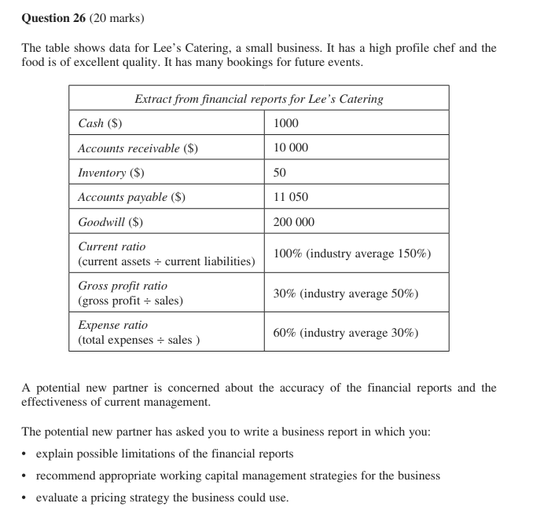
PART 4

Financial management strategies

Cash flow management
119. 21 (c) Abbotsleigh Trial 2023 2 marks
Recommend a cash flow management strategy to improve Bakers Dozen's liquidity.
Stimulus Balance sheet for Bakers Dozen Pty. Ltd. as at 30 June 2023. Current Assets: Cash $19 000, Debtors $2 500, Stock $34 000 (total current assets $55 500). Current Liabilities: Overdraft $30 000. Non-current Liabilities: Debentures $94 000, Mortgage $291 500. Owner's Equity: Capital $95 000, Retained profit $85 000. Total Assets $595 500. Net profit for 2022-2023 was $160 000; industry average for liquidity is 2.5:1; industry gearing is 1:1. The business's current ratio is well below the industry average.

120. 23 (b) 2021 Finance Practice HSC Questions 3 marks
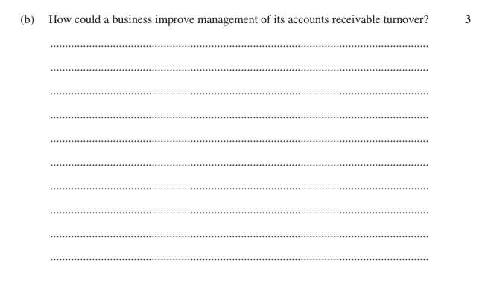

121. 24 (c) 2021 Finance Practice HSC Questions 4 marks
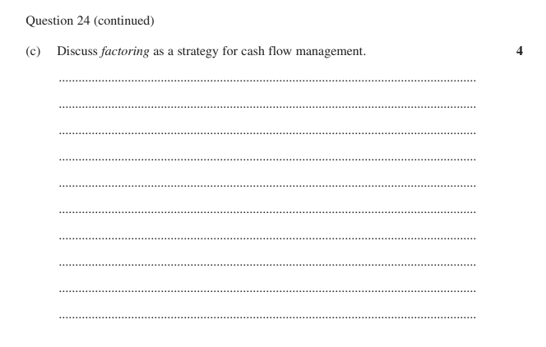

Also tested by questions 15, 16, 17, 19, 20, 22, 41, 56, 57, 61, 101, 114, 138, 139, 140, 141, 142.

Working capital management
122. 22 (b) Reddam Trial 2024 2 marks
Describe ONE inventory management strategy Buffy’s Florist Pty Ltd could use in the business.
Stimulus Balance Sheet for Buffy’s Florist, 1/1/24 – 30/6/24. Current Assets: Cash $10 000; Accounts Receivable $70 000; Inventory $80 000 (total $160 000). Non-Current Assets: Retail Premises $800 000; Delivery vans $100 000. Current Liabilities: Accounts Payable $90 000; Bank overdraft $60 000 (total $150 000). Non-Current Liabilities: Mortgage $600 000. Owners’ Equity: Capital $260 000; Retained Profit $50 000. Additional financial information: Industry Average Liquidity/Working Capital Ratio = 2:1.

123. 22 (b) Reddam Trial 2023 2 marks
Recommend ONE working capital management strategy Local Grocer Pty Ltd. could use to improve its liquidity.
Stimulus Balance Sheet for Local Grocer Pty Ltd, June 2023.
Current Assets: Cash $25 000; Accounts Receivable $45 000; Inventory $55 000.
Non-Current Assets: Building $400 000; Delivery van $50 000.
Current Liabilities: Accounts Payable $35 000; Bank overdraft $65 000.
Non-Current Liabilities: Mortgage $225 000.
Owners' Equity: Capital $200 000; Retained Profit $50 000.
Additional financial information: Return on Owners' Equity ratio for 2022 = 0.1:1.

124. 22 (c) Reddam Trial 2024 4 marks
Discuss the impact of ONE working capital management strategy on Buffy’s Florist Pty Ltd.
Stimulus Balance Sheet for Buffy’s Florist, 1/1/24 – 30/6/24. Current Assets: Cash $10 000; Accounts Receivable $70 000; Inventory $80 000 (total $160 000). Non-Current Assets: Retail Premises $800 000; Delivery vans $100 000. Current Liabilities: Accounts Payable $90 000; Bank overdraft $60 000 (total $150 000). Non-Current Liabilities: Mortgage $600 000. Owners’ Equity: Capital $260 000; Retained Profit $50 000. Additional financial information: Industry Average Liquidity/Working Capital Ratio = 2:1.

125. 23 (b) Barker Trial 2023 · Barker Trial 2024 4 marks
How could Acme Kitchenware improve their level of working capital?
Stimulus Acme Kitchenware manufactures and sells pots and pans to department stores. Financial Information for Acme Kitchenware 2022 -- Current assets: Cash $125 000, Accounts receivable $60 500, Stock $110 000 (total current assets $295 500). Non-current assets: Vehicles $260 000, Equipment $216 580. Current liabilities: Accounts payable $120 000, Overdraft $120 780 (total current liabilities $240 780). Non-current liabilities: Mortgage $20 000. Owner's equity: Capital $430 800, Retained earnings $80 500 (total equity $511 300). Additional information: Net profit $75 000; industry average return on equity 18%. (Working capital is therefore only $54 720, a current ratio of about 1.23:1.)

126. 21 (c) Knox Trial 2023 5 marks
Analyse the use of sale and leaseback as a financial management strategy for this business.
Stimulus Financial information for Playsmart Child Care Ltd (balance sheet extract). Current Assets: Cash $40 000; Accounts Receivable $100 000; Inventory $100 000. Non-Current Assets: Building $320 000; Delivery van $40 000; Goodwill $100 000. Current Liabilities: Accounts Payable $100 000; Bank overdraft $130 000. Non-Current Liabilities: Mortgage $300 000. Owners' Equity: Capital $150 000; Retained Profit $20 000. Additional information: Debt to equity ratio = Total Liabilities / Total Equity; gearing industry average 2:1.

127. 6 2021 Finance Practice HSC Questions multiple choice
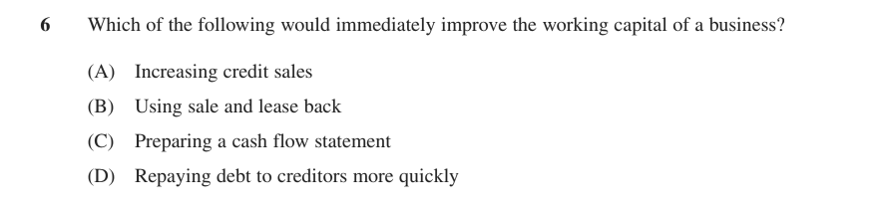
Answer:
Also tested by questions 15, 16, 17, 19, 20, 41, 42, 101, 114, 117, 118, 120, 138, 139, 140, 142, 143, 144.

Profitability management
128. 22 (d) Roseville Trial 2024 4 marks
Recommend TWO profitability management strategies for this business.
Stimulus Financial data for Smith Office Supplies Pty Ltd for the period ending 30 June 2023 (business figure, then industry average): Sales 180 000 / 240 000; Cost of Goods Sold 120 000 / 120 000; GROSS PROFIT 60 000 / 120 000; Operating expenses — Administrative 17 000 / 15 000, Sales and distribution 7 000 / 15 000, Financial 7 000 / 10 000; NET PROFIT 29 000 / 80 000.

129. 22 (d) Roseville Trial 2023 4 marks
Recommend TWO profitability management strategies that this business could use to improve its profitability result.
Stimulus Income statement for Manly Beach Pancakes Store Pty Ltd, year ended 30 June 2022, shown alongside Industry Average Results ($):
Sales 150 000 (industry 200 000); Cost of goods sold 105 000 (industry 100 000); Gross profit 45 000 (industry 100 000).
Operating expenses — Administrative 5 000 (industry 12 000); Selling & distribution 7 000 (industry 15 000); Financial 3 000 (industry 3 000); Net profit 30 000 (industry 70 000).
The business therefore has a gross profit ratio of 30% versus an industry average of 50%, and a net profit ratio of 20% versus an industry average of 35%.

Also tested by questions 13, 14, 15, 16, 17, 19, 20, 22, 41, 114, 118, 138, 139, 140, 141, 142, 145.

Global financial management
130. 2017 HSC Question 24 (a) 2021 Finance Practice HSC Questions 2 marks
How will an appreciation of the Australian dollar affect the competitive position of this business?
Stimulus Case scenario: A business imports computers from China and sells them to customers in Australia.

131. 24 (a) 2021 Finance Practice HSC Questions 2 marks
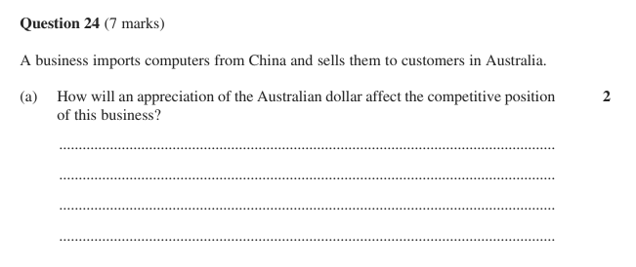

132. 2013 HSC Question 24 (a) 2021 Finance Practice HSC Questions 3 marks
Describe ONE method of payment the business could use to ensure that it receives payment for the sales.
Stimulus Case scenario: An Australian-owned business manufactures bicycles in China and sells them to wholesalers in France. These wholesalers do not pay in advance.

133. 24 (a) 2021 Finance Practice HSC Questions 3 marks
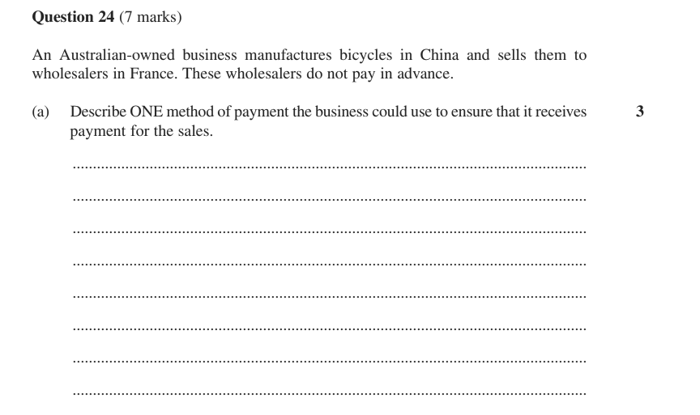

134. 24 (b) 2021 Finance Practice HSC Questions 4 marks
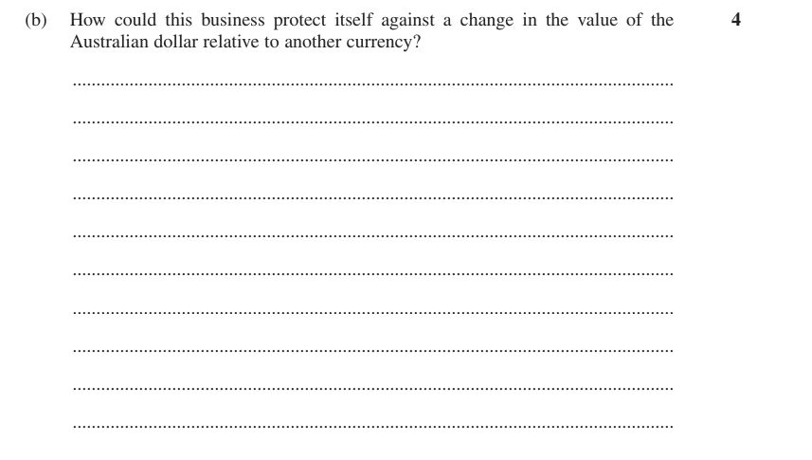

135. 24 (b) 2021 Finance Practice HSC Questions 5 marks
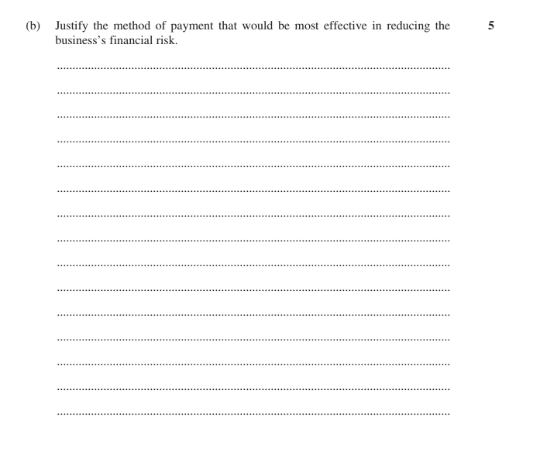

136. 18 2021 Finance Practice HSC Questions multiple choice
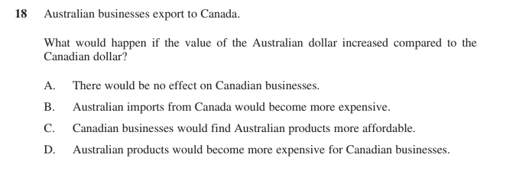
Answer:
137. 20 2021 Finance Practice HSC Questions multiple choice
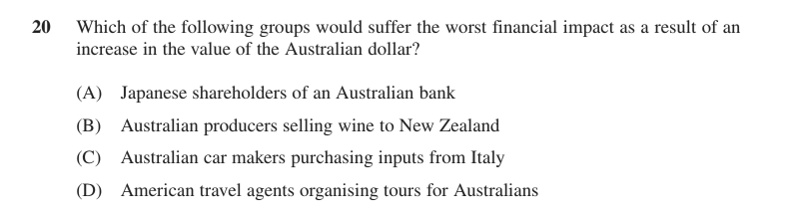
Answer:
Also tested by questions 15, 17, 38, 41, 47, 48, 114, 116, 139, 140, 146.
PART 4 · EXTENDED RESPONSE

Financial management strategies — 20-mark questions
9 questions. Plan and write these on separate paper.
138. 27 Independent Trial 2024 20 marks
Analyse how financial management strategies can be used to improve the cash flow and profitability of a business.
139. 26 Roseville Trial 2024 20 marks
Assess strategies that management can use to respond to influences on finance.
140. 2015 HSC Question 28 2021 Finance Practice HSC Questions 20 marks
Evaluate the importance of financial management strategies in improving business performance.
141. 2013 HSC Question 26 2021 Finance Practice HSC Questions 20 marks
You have been employed as a consultant by the owners. Write a report to the owners recommending marketing and financial management strategies to improve the performance of the business.
Stimulus Case scenario (business report): Kingland Office Supplies operates in a large NSW city in a highly competitive market. A paid manager is responsible for the day-to-day running of the business. The owners are concerned about the low profitability of the business. Investigations by the owners indicate the following problems: customers find the product mix unappealing; poor management of cash flow; poor accounts receivable turnover compared to similar businesses. The manager has also identified low prices offered by larger competitors as a cause of the low profitability.
142. 26 2021 Finance Practice HSC Questions 20 marks
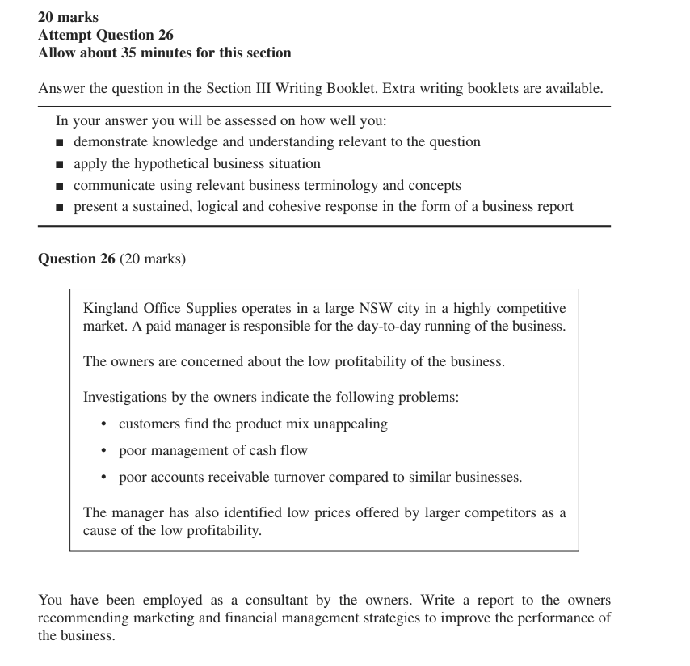
143. 2019 HSC Question 25 2021 Finance Practice HSC Questions · HSC Final Exam Preparation — HRM · 2019 HSC Business Studies 20 marks
You have been hired as a consultant to write a report for the owners. In your report:
• discuss methods this business could use in the acquisition and development of staff
• recommend TWO appropriate working capital management strategies for this business.
Stimulus Case scenario (business report): A business, Roo's Outback Eatery Pty Ltd, is opening an additional restaurant in NSW. They plan to position the restaurant as an exclusive restaurant specialising in modern Australian food with quality customer service. The owners require assistance with the following: the acquisition and development of suitable staff; additional funds for the day-to-day running of the business; the close monitoring of working capital.
144. 25 2021 Finance Practice HSC Questions 20 marks
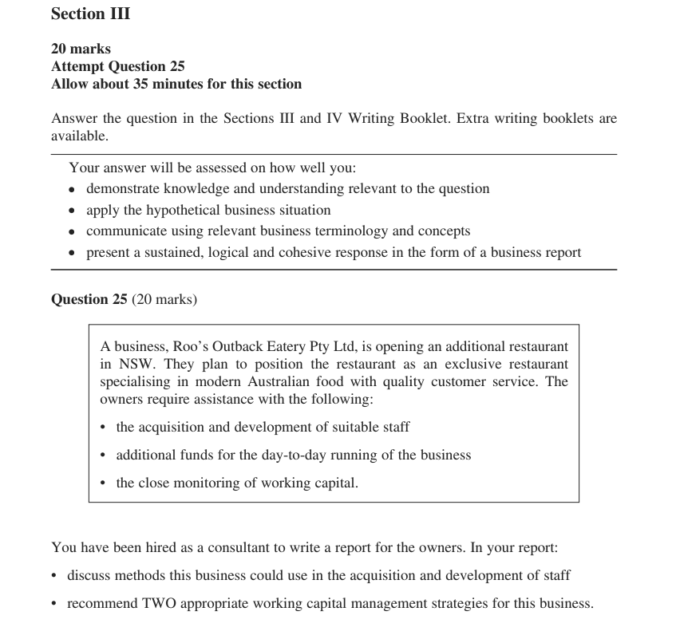
145. Question 25 HSC Final Exam Preparation — OPERATIONS 20 marks
You have been employed as a consultant to prepare a report for the management of Fast Car Parts Ltd. In your report:
• Outline TWO National Employment Standards the Human Resource manager should be aware of while negotiating the new enterprise agreement.
• Describe ONE influence on operations at Fast Car Parts Ltd.
• Discuss TWO appropriate operations strategies management could implement at Fast Car Parts Ltd.
• Recommend ONE profitability strategy the business could use to help increase sales or reduce expenses.
Stimulus Fast Car Parts Ltd is a successful producer of car parts with a number of factories throughout NSW. It is experiencing difficulties with its operations due to the rapidly changing nature of global markets and increased competition. This has led to declining sales and increasing expenses. The Human Resource manager is currently negotiating a new enterprise agreement with staff. Management are unsure about the various strategies they need to implement to solve the issues the company faces.
146. 25 2022 HSC Business Studies 20 marks
You have been hired as a consultant by Bee Sticky Pty Ltd to write a business report for the owners. In your report:
• describe branding and product strategies the business could use to expand into global markets
• recommend a channel choice that would suit this business's expansion
• analyse the global financial management strategies required for a successful expansion.
Stimulus Bee Sticky Pty Ltd is an established Australian manufacturing business that produces a wide range of high quality and premium organic honey. It is expanding into global markets and will lease warehouses in Malaysia and the USA. A recently completed SWOT analysis is provided. Strengths: high quality, premium and organic honey products; approved for consumption and medical uses; made by honeybees from Australian flora. Weaknesses: frequent breakage of product during transportation; lack of experience in foreign payment systems. Opportunities: expanding market for high quality honey in countries overseas; falling bee populations overseas; potential collaborations with up-market restaurants/chefs. Threats: established competition in foreign markets; fluctuations in the Australian dollar.

