Markdown

Liam

2018년 9월 3일

## R Markdown

This is an R Markdown document. Markdown is a simple formatting syntax for authoring HTML, PDF, and MS Word documents. For more details on using R Markdown see <http://rmarkdown.rstudio.com>.

When you click the **Knit** button a document will be generated that includes both content as well as the output of any embedded R code chunks within the document. You can embed an R code chunk like this:

summary(cars)

## speed dist   
## Min. : 4.0 Min. : 2.00   
## 1st Qu.:12.0 1st Qu.: 26.00   
## Median :15.0 Median : 36.00   
## Mean :15.4 Mean : 42.98   
## 3rd Qu.:19.0 3rd Qu.: 56.00   
## Max. :25.0 Max. :120.00

## Including Plots

You can also embed plots, for example:



Note that the echo = FALSE parameter was added to the code chunk to prevent printing of the R code that generated the plot.

## mpg cyl disp hp drat wt qsec vs am gear carb  
## Mazda RX4 21.0 6 160 110 3.90 2.620 16.46 0 1 4 4  
## Mazda RX4 Wag 21.0 6 160 110 3.90 2.875 17.02 0 1 4 4  
## Datsun 710 22.8 4 108 93 3.85 2.320 18.61 1 1 4 1  
## Hornet 4 Drive 21.4 6 258 110 3.08 3.215 19.44 1 0 3 1  
## Hornet Sportabout 18.7 8 360 175 3.15 3.440 17.02 0 0 3 2  
## Valiant 18.1 6 225 105 2.76 3.460 20.22 1 0 3 1

car_cor = cor(mtcars)

round(car_cor, 2)

## mpg cyl disp hp drat wt qsec vs am gear carb  
## mpg 1.00 -0.85 -0.85 -0.78 0.68 -0.87 0.42 0.66 0.60 0.48 -0.55  
## cyl -0.85 1.00 0.90 0.83 -0.70 0.78 -0.59 -0.81 -0.52 -0.49 0.53  
## disp -0.85 0.90 1.00 0.79 -0.71 0.89 -0.43 -0.71 -0.59 -0.56 0.39  
## hp -0.78 0.83 0.79 1.00 -0.45 0.66 -0.71 -0.72 -0.24 -0.13 0.75  
## drat 0.68 -0.70 -0.71 -0.45 1.00 -0.71 0.09 0.44 0.71 0.70 -0.09  
## wt -0.87 0.78 0.89 0.66 -0.71 1.00 -0.17 -0.55 -0.69 -0.58 0.43  
## qsec 0.42 -0.59 -0.43 -0.71 0.09 -0.17 1.00 0.74 -0.23 -0.21 -0.66  
## vs 0.66 -0.81 -0.71 -0.72 0.44 -0.55 0.74 1.00 0.17 0.21 -0.57  
## am 0.60 -0.52 -0.59 -0.24 0.71 -0.69 -0.23 0.17 1.00 0.79 0.06  
## gear 0.48 -0.49 -0.56 -0.13 0.70 -0.58 -0.21 0.21 0.79 1.00 0.27  
## carb -0.55 0.53 0.39 0.75 -0.09 0.43 -0.66 -0.57 0.06 0.27 1.00

library(corrplot)

## corrplot 0.84 loaded

corrplot(car_cor)

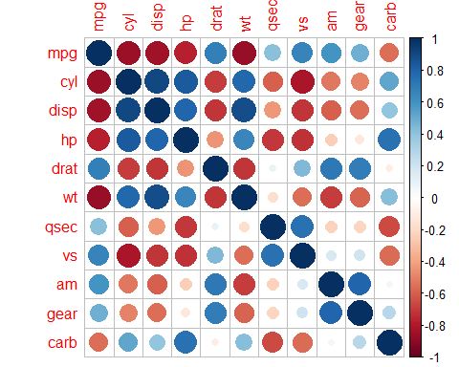

corrplot(car_cor, method = "number")

