April 1, 2021

Liam Neate (N0919032), Clive Kimari (N0937738), Zain Siu (N0935198), Vineet Sethi (N0914011), Hassan Rizwan (N0926473)

SYSTEMS ANALYSIS & DESIGN ASSESSMENT 1

system proposal report for ABC university and their track and trace app

Contents

Summary and Introduction 2

Executive Summary 2

Introduction 2

Methodology 3

Project Planning 5

Feasibility and Risk Assessment 5

Project Scheduling 7

Requirements Analysis 12

Requirement Capturing 12

Functional Requirements 14

Non-Functional Requirements 15

Functional Analysis 15

Actors 15

Major Use Cases 16

Use Case Diagram 16

Structural Analysis 18

Object Classes & Characteristics 18

Class Diagram 19

20

Behavioural Analysis 21

Sequence Diagram 21

Database Design 22

Entity Relationship Diagram (ERD) 22

Sample SQL 23

User Interface (UI) Design 25

UI Prototype 25

UI explanation 25

Individual Reflection 26

Group Leader (Liam Neate) 26

Clive Kimari 26

Zain Siu 27

Vineet Sethi 27

Hassan Rizwan 27

# Summary and Introduction

## Executive Summary

This is a system report for a track and trace app for the ABC University. It will start off by covering our initial plans for the app and, loosely, how we are going to develop/make it. Then we will be doing an assessment to look at any sorts of problems that the project may go into, so that we can evaluate them and find ways to avoid said problem. Using the development methodology (the method for development) we decided earlier, we will then lay out a schedule for the work that will be needed, and who will be doing it. We then interviewed key members of the ABC University to get a list of all of the functions we would need to implement into the app. We have then made a use case diagram which shows how each entity/actor (e.g., user, staff) will interact with the system and each other. We created a class diagram as well which shows how the system will work and each different function of the system. With these diagrams done, we created a sequence diagram which shows how the system would work if the user wanted to enter a test result. With the bare bones of the system mapped out, we then looked at the database where all the data will be stored. We created an example of what the tables will look like and created some test SQL to show how a few of the features would work. To finish up, we created a mock-up of what the end app will look like on the users phone.

## Introduction

This report is for the development of a contact tracing app for the ABC University. There are multiple reasons for why a contact tracing app would be useful for the ABC University. One reason is that it makes it easier for the university to be able to track all the COVID-19 cases as well as any other crisis. This shows that the university cares about its student, benefitting their reputation as a university. The application would be more personalised for the universities use. As well as the notes for the students would be more accessible. This would uniquely separate the university in comparison to the other universities with their support and services for their students.

In terms of the aims of the project, the project aims to slow down the outbreak of Covid-19 by giving statistics on different locations of the university for example the different campuses. This app will allow students and staff to record symptoms they may have if they feel a slight reason that they do have Covid-19. From understanding the locations of where the symptoms are appearing it will allow the university to identify were students and staff are most at risk of contracting the disease throughout the university therefore helping to warn people about these potential high-risk areas. This app also aims to benefit the university long-term in the case that there is another outbreak it will allow the university to easily adapt to situations through getting information out to students and staff an again through statistics.

A recent example of a contact tracing system would be the NHS Track and Trace app, which is being used to help reduce the spread of COVID-19 in the UK.  It has been quite effective in achieving this, thanks to the many features a contact tracing system has. One of the main features is the ability to track who you have been in contact with, which enables the app to tell you if you have been in contact with anyone who has, or had symptoms of, COVID-19. In addition, it allows the government to send out updates of the current lockdown level in the user’s area. A contact tracing system like this could be a crucial asset to a University.

The group are going to build this track and trace application to be built with many useful features for staff and students. It will be very personalised for each person and teacher, including the information on students and information on classes and support lessons provided. By making it more personalised we will make it very practical and useful daily so that the user can have consistent and relevant updates on the situation and updates to university life. For this we also wanted to include a way for students and staff to contact each other and be able to update each other on the situation. This is also done by giving a profile for each student that the teacher can view to see any test results and whether they may require extra support while isolating. For our system to work we will need students to enter extra details such as their number and email. This will be done to help contact when needed for things such as test results or if someone they have been in contact recently has tested positive. For each student there will be a way to enter the test results and each of their teacher will be notified if the test has come out positive, there will also be an option to also message classmates, additionally they can include it to message other students you have been in contact with. The application will also include an informative tab containing important information like nearby test sites, details and developments on a new vaccine/cure, the spread in the local area and new updates from the university.

## Methodology

Now, we are looking at the different methodologies we could use for developing this app. There are 3 main classes of methodologies that will be looked at: structured, RAD, and agile. Structured methodology possesses two sub methodologies with one being a waterfall methodology and the other being a parallel methodology. The waterfall methodology is a very linear methodology approach with a group going from phase to phase when developing a system. A benefit to this approach is that system requirements are identified long before building the system begins however this can act as a downfall as it may take longer to finalise the system. On the other hand, a parallel methodology is sub divided into sub projects which can then be worked on at the same time. This therefore reduces overall project time compared to waterfall; however, subproject require careful design decisions to prevent information from clashing with each other.

The agile methodology is the process of developing solutions through collaborative efforts as well as having a team that is cross-functional. An example of agile methodology is Extreme programming, this is useful for when a project is small and when the design is kept simple. The advantages of using an agile based methodology are that it has fast delivery of results. Works well in projects that have changing requirements. However, some of the disadvantages are that it requires a lot of discipline, works best in small projects, significant user involvement is essential. Another example of the agile methodology is scrum, this breaks down big and complex projects into smaller pieces, and this makes the project more manageable as therefore would allow the team to ship high quality and work faster, gives them more flexibility to adapt and change. The teams can also have short meeting more often to allow them to check their progress and plan for the next week.

The group chose to pick one of the RAD methodologies. This was chosen over agile and structured methodology as it was able to be produced quickly and get into the user’s hands as soon as a first iteration was made. By doing it this way we allow for a lot of user feedback as the system is put together and developed while the user is using an early version. RAD methodologies are very flexible, and we felt it was best suited for a system of this type. Additionally, it allows for a faster production of a product as it relies less on planning and more on the user’s feedback to produce a functional and intuitive design quickly and efficiently. Overall, the RAD best suited our needs for this specific system as it allows for a fast and productive development.

RAD consists of 3 main methodologies: phased/iterative, prototyping and throw-away. For this specific system however, phased would be the best methodology. To sum it up briefly, phased enables a development team to give more value earlier and more frequently than other development methodologies (Moving from Waterfall to Iterative Development: An Empirical Evaluation of Advantages, Disadvantages and Risks of RUP, 2011). Whilst all these RAD methods are the best for getting a system out quickly to the user, phased will be able to get a system out the quickest, and most complete. This is an important feature since the University would want something quick to respond to the outbreak with. After the initial version of the system is released, there will be more versions that will come that will have the rest of the features that the previous version did not. This enables the app to be developed as time goes on meaning that the users’ needs for the app can change too. This would be a problem, however, for prototyping due to its development cycle making it hard for bigger features to be added in newer versions.

# Project Planning

## Feasibility and Risk Assessment

### *Technical feasibility*

Description of familiarity with functional area:

* Risk description: users who have never used a contact tracing app may initially struggle to navigate the app
* Severity (high/ low/ medium): low
* Potential impact: the time period in which new users fully understand how to navigate the app may take longer than others
* Ways to mitigate: a tutorial on how to navigate the application, the app is also given a simple design

Description of familiarity with technology:

* Risk description: a new software is being used and due to the team not having any experience in using the software in creating applications
* Severity (high/ low/ medium): high
* Potential impact: the lack of experience with the software will have a significant impact on the time period of the app being released as the team understand how to use the software beforehand.
* Ways to mitigate since the group are using a phase methodology it allows for the group to make prototypes which allows the team to constantly improve the app before releasing the final version therefore preventing errors in the app.

Description of Project Size:

* Risk description: due to the phased methodology being used, the time period that the app is made may take longer than other methodologies due to prototypes being made.
* Severity (high/ low/ medium): medium
* Potential impact: the time period of the application may need to be extended if need be.
* Ways to mitigate: Due to a 5-man team working together to make the app the overall efficiency of the of creating the application will be higher consequently leading too time period of creating the app being shortened.

Description of compatibility:

* Risk description: The app is not compatible with their existing systems/does not work on their systems.
* Severity (high/ low/ medium): High
* Potential impact: A lack of compatibility with their existing systems may reduce the effectiveness of the app and may cause it to have issues if trying to use on said systems.
* Ways to mitigate: Do some research into their existing systems and understand how they work. This will enable us to create an app which is compatible with all the systems we look at, thanks to the knowledge we gained from studying them.

### *Economic feasibility*

Description of tangible Costs and Benefits:

* Risk description: Budget could not be enough to cover the cost of the whole project due to unforeseen circumstances
* Severity (high/ low/ medium): Medium
* Potential impact: Budget could become a problem as the team would set up a thing called the ‘scope creep’ this is where set requirements would be made but as the project goes ahead these would end up changing therefore having an effect on the budget.
* Ways to mitigate: Make sure the team have more than enough money so that they can cover anything they don’t expect.

### *Organisational feasibility*

Description of strategic alignment:

* Risk description: The strategic alignment might not be in line with the corporate strategy
* Severity (high/ low/ medium): High
* Potential impact: Might not be able to fully meet the demands of the customers, or effectively meet them.
* Ways to mitigate: Have our strategic alignment be more in line with the corporate strategy.

Description of user’s acceptance:

* Risk description: The app does not meet the users demands.
* Severity (high/ low/ medium): Medium.
* Potential impact: The app is missing key features that the user needs, and therefore does not accept the app.
* Ways to mitigate: Keep asking the user through development for anything they want to be added, which will be achieved by using our RAD development methodology.

## Project Scheduling

|  |
| --- |
| System Request |
| *Project Sponsor:* Our team, ABC University Management Team |
| *Business Need:* The purpose of this project is to create a contact tracing app to help reduce the spread of COVID-19 and other outbreaks in the future. Whilst there are currently contact tracing apps, they fail to meet a few business needs. Currently, most contact tracing apps,   * Offer little support for usage in a smaller, specific area, such as a University campus. * Do not offer quick an effective way for others to respond to outbreaks and/or provide support for those that needs it. * Currently, do not have a use after the COVID-19 outbreak. * Mainly closed systems so do not allow people such as staffs to see much information about specifics, such as, who has it and needs help. |
| *Business Requirements:* This app will enable students and staff to know who they have been in contact with and if there has been an outbreak near them. The requirements the system will meet to achieve this includes:   * Being like other contact tracing apps, like the NHS track and trace app. * Be able to share vital information to everyone through the app. * Enable the staff/management team to respond to positive cases of COVID-19 and potential outbreaks. * Get notified if you have been in contact will someone who has COVID-19. * Get notified about any outbreaks on campus. * Allow students/staff to record their health daily. |
| *Business Value:* We expect that University admissions to the ABC University will increase with this application. That is because we believe it will show students that the University cares for their students and are being extra safe, which will be very attractive to upcoming students. The app will also set this University apart from others, once again, making it stand out more to prospective students. This increased attention, in turn, will increase admissions and, therefore, increase the profits of the University. The risk of a campus lockdown will be reduced too, thanks to the app allowing quick response to any problems. |
| *Special Issues or Constraints:*   * With the current COVID-19 situation, the system should be released as soon as possible, to allow a quick and effective response. |

For our staffing plan we will need four main roles for development. This will consist of a project manager, UI developer, Software developer and plan strategist. The project manager will organize each resource and split workloads to form a productive team. Our UI and Software developer will focus on the main development of the system producing quick results that are intuitive. Finally, the plan strategists will use the returned feedback or personal input to gather ideas on how to improve and reiterate a better system. With the help of the project manager this system will be efficiently produced with ease.

Since our system will be developed with the Phased methodology it will follow the system development lifecycle which follows the Planning, Analysis, Design then implementation. When each cycle is completed, a new version is developed and will be passed back through and improved based on the feedback on the previous version.

The time allocated between each section will be different and resources will have to be split across each role dependant on the cycle of development. This is the Project managers task, and they will adjust the resources effectively. For our system we want the first iteration of our system to be produced within at least two weeks of working days. Giving ten days total it will be split in the following way: three days of planning, one day of analysis, four days for design and two days to implement this.

For the planning all the roles will come together to plan this system, having all roles there will help planning as they will be experts in their own field allowing for a smarter plan which allow each role to work to their full potential also opening for more complex ideas and a deeper understanding of what is required for the system and see what it possible within the time frame for the first iteration. The analysis will be done by the project manager assuring that it meets the requirements and will adjust parts of it accordingly, additionally it will allow the project manager to assess other aspects of the system like accessibility for impaired users.

The design will follow on from the plan and require the Project manager and UI developer. They will pick a suitable layout for the application making it responsive and practical. The design is crucial as it will make it easier to use and more accessible. The Project manager will oversee this and based on his analysis will make sure it meets their requirements. Alongside the UI developers the Software developers will begin producing a solution for the system and test it to make sure it has been error checked and tested. The implementation of the system will be consisting of the Project manager and Software developers. The implementation is where all the areas come together and will focus on the integration of the system into the design by the UI developers. Once it has been successfully integrated the system will be ready for the consumers brining the first iteration to a close. This first version will be reiterated until it has met all requirements of user feedback and the goals for this system.

Next, we must develop a work-plan for the project. Our main challenge is that there is already a similar app that is in the market now, the NHS track and trace app. Our goal to solving this problem is to create a unique app that will allow the university to use it during the pandemic as well as when the situation has gone back to normal. This will make our app more unique and beneficial as it is more than just a track and trace app, it’s a way of making sure that the university is able to give as much support to their students as possible, especially during the pandemic when students feel they are struggling and feeling alone and isolated.

Goal:

Our goal is to create a fully functional track and trace app that is uniquely adapted to the universities needs and requirements. It will record all the student’s details and statistics. This should be completed as soon as possible in order to make improvements whenever necessary.

Objectives:

1) There will be many different sections in the app that will give the app the unique functionality that is adapted to the university’s needs. We are going to need to implement a section in the app where it will allow students and staff to record symptoms as they may have a slight chance of having Covid-19.

2) The app will also require details of the student, e.g., their phone number and email.

3) There will also be a section added where the students will be able to communicate with their classmates and support each other if needed. This also helps during situations like lockdowns when they cannot meet their classmates and wish to get to know them or just wish to socialise.

4) Setup a method of the staff being able to contact the students via the app.

Strategy:

1) Research more on the virus's symptoms to input them as options for the students to be able to select.

2) Set up a process for the use of the students unique NTU ID as well as their phone number if they wish to input this detail.

3) Setup a chat room for the students to be able to communicate with each other

4) Setup the details of each student on the app, allowing the staff to be able to locate the student and get in contact with them more easily.

We are going to consistently be presenting the product to the user to get feedback which will allow us to make changes to the product, this makes the process a whole lot faster allowing us to be able to get this product up and running as soon as possible.

### *Project time plan*

### *Network Diagram*



# Requirements Analysis

## Requirement Capturing

### *Company Director*

Interviewer – What is the main purpose of this app?

Company Director – The contact tracing app has a similar purpose to the NHS contact tracing app however our app is designed specifically for the University is assisting the staff and students.

Interviewer – and where will this app be able to be accessed?

Company Director – The app once completed will be able to be downloaded on mobile devices through the specified application stores, the team will make sure to allow this app to be download on all types of smart phone device stores.

Interviewer – So when do you hope to release this app?

Company Director – As soon as possible, as COVID-19 is still a major problem to combat especially in education.

Interviewer – So this is a contract tracing app for COVID-19, do you have any long-term goals for this application?

Company Director – Yes, long term aims have been made with this app.

Interviewer – Would you be able to elaborate on this?

Well, the main long-term goal for this application is for the application to be use in aid the university in the case that there is another outbreak as it will allow for the university to quickly adapt.

Interviewer – OK so how will you try to combat bugs if they appear in the application?

Company Director – The methodology that has been put in place has enabled us to minimalize the chances off this happening as before the complete version of the app is released, many prototype tests will be carried out to ensure that the application does not have these problems.

Interviewer – Will this application be storing the user’s data

Company Director – Yes, however this application plans to keep information at a minimal, furthermore the data collected will help the team analyse how the virus is spreading.

Interviewer – Would you care to expand on this?

Company Director – Yes so for example location data will allow for the team to analyse where the virus is most prevalent around the campuses and from this, the university will be able to put in protocols to reduce the change of students and staff from contracting the virus.

After having the interview with the company director, it is very clear to see how the process of this application has been structured both in the short and long-term. The company director also gave us insight into the long-term aims of this application stating that they want the app to also assist the university in the case that another outbreak does occur. Lastly, we talked about the type of data that will be stored in which the company director stated the stored data will allow for the university to further reduce the spread of the virus.

### *Sales Agent*

Interviewer – Who will be the main users of this app?

Sales Agent – The University is hoping for the main users to be the students, but also most of the staff. There also need a slightly different system for the management team. This will be so that they can keep track of what is happening on the app and keep in the loop in case of any problems.

Interviewer – What sort of devices will the app be used on?

Sales Agent – The app will be used on mainly mobile devices, but a wide range of them, brand wise. However, the system will also be used on some computer systems that are quite old since the University would like to incorporate this into their existing systems as much as possible, so that they can get started pretty much immediately.

Interviewer – That brings me onto my next question, when does the University want this app completed by.

Sales Agent – They would like it done as soon as feasibly possible, so that they can combat the spread of COVID-19 sooner rather than later.

Interviewer – What sort of information is the University hoping to keep stored in the app?

Sales Agent – They are looking to keep quite a bit of the student’s data stored in the app. Most notably, location data, contact details and any symptoms the students are feeling. However, the University is hoping that this data will not be stored after the student leaves University, but while it is being stored, they want it to be secure and/or encrypted.

Interviewer – And who would have access to the information being stored in the app?

Sales Agent – The University only wants the management team and a few technicians to have access to the student’s data to reduce the likelihood of a data leak.

Interviewer – While this is a contract tracing app mainly for helping reduce the spread of COVID-19, what are the long-term plan for the app after this pandemic?

Sales Agent – After the pandemic, the University will turn the app into more of an emergency response app, where they can quickly get out messages and notifications to the students in response to any evolving conditions in times of crisis.

After an interview with the sales agent for the app, we have a better understanding of what the University is hoping to get out of this app. We realise that there will also be a need for another system for the management team so that they can keep track of what is happening. We learnt that the University also wants as little data as possible stored in the app for safety reasons. The sales agent told us as well that they hope to keep using the app after the COVID-19 pandemic, so the app should be around for a while, and should be developed to be a long-term solution.

## Functional Requirements

### *Process Orientated:*

* The system must allow the users to input their symptoms into the app.
* The user should be able to put their details into the app.
* The system must check and warn the user if they have been in contact with a person who is known to have Covid.
* The system must have a chat section for the students to interact with each other in.
* The system should constantly update the user on the situation as well as university life.
* It should allow the student and staff to be able to contact each other.
* Should allow the users to create a personalised profile.

### *Information Orientated:*

* The system must retain the information of the user’s personalised profile.

-The user’s name

-Their contact details

-Test results

* It should retain information of the user’s classes and support lessons provided by the university.
* It should contain information on the nearby test centres available.
* Contain information about the situation with the vaccine for the virus as well as the Covid rates in the local area.
* The system must also contain information of emergency contact details.

## Non-Functional Requirements

### *Operational:*

* The app will run on both Android and Apple mobile devices.

### *Performance:*

* The system should be available to use 24 hours a day and 365 days a year.
* The system should not have any constant crashing problems.
* The system should support a lot of simultaneous user interaction.
* The system should load up and respond within 2-5 seconds of the user interacting to load.

### *Security:*

* The University will be able to see the student/staff records during emergency situations.
* The Technicians will be able to have authority to make any mending to the system if any are required. They will only see the parts of the system that needs the mending, keeping privacy and confidentiality.
* The system includes all safeguards for viruses and worms.

### *Cultural and Political:*

* The personal information is to be protected in compliance with the Data Protection Act.
* The system is only to be used for Nottingham Trent University.

# Functional Analysis

## Actors

* Users
* Admins
* System

## Major Use Cases

* Enter daily health
* Track location
* Contact admin
* View lasts advice
* Input COVID test results
* Check user data
* Update outbreak information
* Send out information
* Create users

## Use Case Diagram

### *Explanation*

A use case diagram shows how actors (in this case, university people and the system) will interact with one another in the app, and what they can do in the app. Most use cases stem off an actor, and are the n connected by extend and include lines. We are going to be using the major use cases and actors that we have recently defined in this diagram.

### *Diagram*

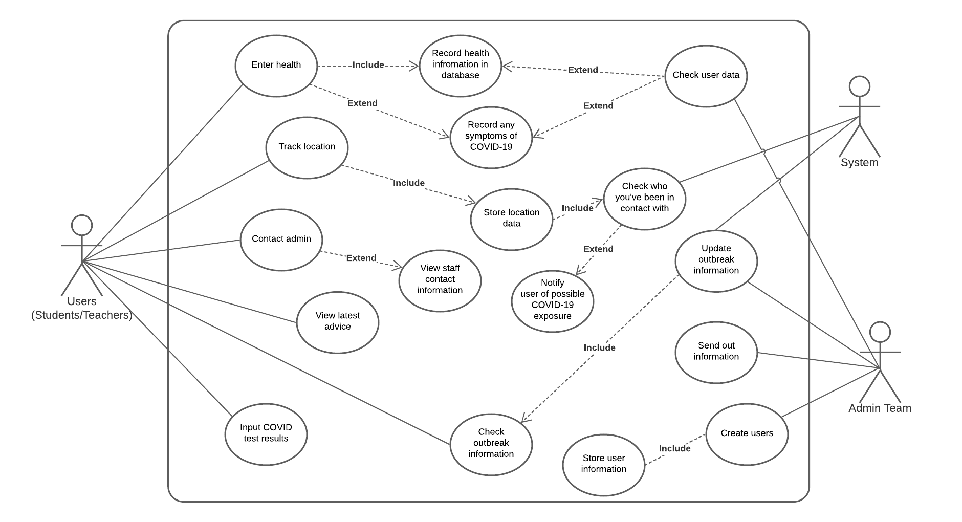

# Structural Analysis

## Object Classes & Characteristics

* Track and Trace app
  + Attributes
    - Messages
    - Notices
    - Account
    - Date
  + Methods
    - Sign in
    - Sign out
    - Chat with admin
* Admin
  + Attributes
    - Name
    - Email
  + Methods
    - Add user
    - Remove user
* University
  + Attributes
    - Name
* User Account
  + Attributes
    - Name
    - Password
  + Methods
    - Password change
* Input Symptoms
  + Attributes
    - Symptoms
  + Methods
    - Store Symptoms
* Input Daily Health
  + Attributes
    - Health
  + Methods
    - Store Health

We found each of these by looking back through our requirements analysis and seeing which features will need their own classes. Then, once we had the classes, we expanded each class and looked at what exactly each had to do and what they each have.]

Soo

## Class Diagram

### *Explanation*

The class diagram shows how each major class interacts with one another. It also gives information on the class such as the attributes it has and different methods it can call. We will use the classes and characteristics previously defined in the class diagram

### *Diagram*

# Behavioural Analysis

## Diagram, schematic Description automatically generatedSequence Diagram

# Database Design

## Entity Relationship Diagram (ERD)

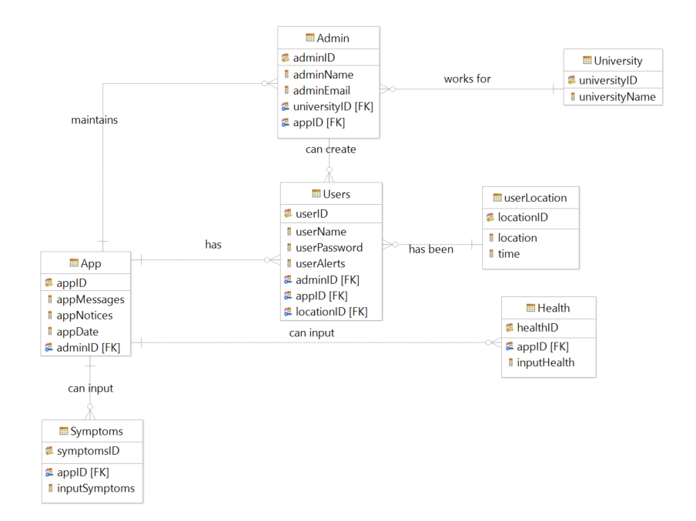

## Sample SQL

### *Create Tables*

*CREATE TABLE Admin (*

*adminID CHAR(10) NOT NULL,*

*adminName CHAR(20),*

*adminEmail CHAR(20),*

*universityID CHAR(10) NOT NULL,*

*appID CHAR(10) NOT NULL,*

*PRIMARY KEY (adminID)*

*);*

*CREATE TABLE App (*

*appID CHAR(10) NOT NULL,*

*appMessages CHAR(20),*

*appNotices CHAR(20),*

*appDate DATE,*

*adminID CHAR(10) NOT NULL,*

*PRIMARY KEY (appID)*

*);*

*CREATE TABLE Users (*

*userID CHAR(10) NOT NULL,*

*userName CHAR(20),*

*userPassword CHAR(10),*

*userAlerts CHAR(5),*

*adminID CHAR(10) NOT NULL,*

*appID CHAR(10) NOT NULL,*

*locationID CHAR(5) NOT NULL,*

*PRIMARY KEY (userID)*

*);*

*CREATE TABLE University (*

*universityID CHAR(10) NOT NULL,*

*universityName CHAR(20),*

*PRIMARY KEY (universityID)*

*);*

*CREATE TABLE Health (*

*appID CHAR(10) NOT NULL,*

*healthID CHAR(5) NOT NULL,*

*inputHealth CHAR(20),*

*PRIMARY KEY (healthID)*

*);*

*CREATE TABLE Symptoms (*

*appID CHAR(10) NOT NULL,*

*symptomsID CHAR(5) NOT NULL,*

*inputSymptoms CHAR(20),*

*PRIMARY KEY (symptomsID)*

*);*

*CREATE TABLE userLocation (*

*locationID CHAR(5) NOT NULL,*

*location CHAR(5),*

*time CHAR(5),*

*PRIMARY KEY (locationID)*

*);*

### *Select the alerts user x has received*

*SELECT Users.userAlerts*

*FROM Users*

*WHERE Users.userName="x";*

### *Get location at specific date*

*SELECT userLocation.location*

*FROM userLocation, Users*

*WHERE USERS.userName="x"*

*AND userLocation.time="y";*

# User Interface (UI) Design

## UI Prototype

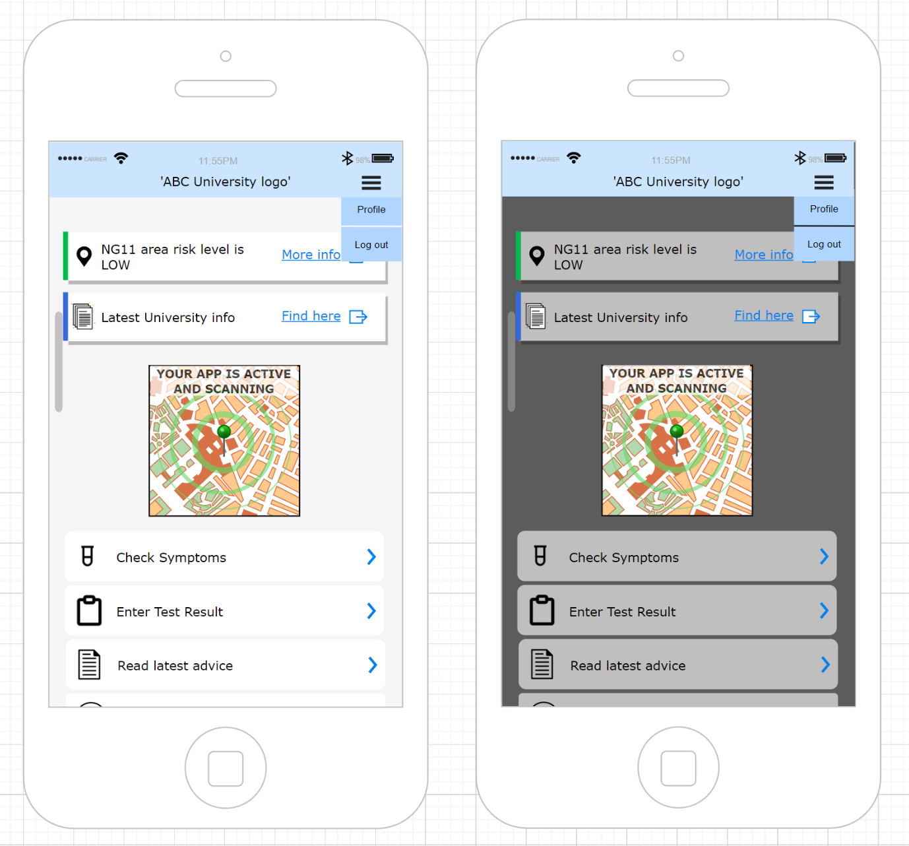

## UI explanation

For our UI, we decided to keep it simple. We used the NHS Track and Trace app as our starting point as the University did not want it to be too different. Also, because the University wanted it to be simple and easy for people to understand, which keeping it like an existing app they already use, enables. We added a map to the centre of the page, which will show the user which campus they are on which, in a future version, could be used to show areas of crisis to avoid. We put 2 tabs at the top: 1 to show what the current risk level is in the area by the government, and another which has a quick link to see the latest University advice. Below the map we have big buttons to allow the user to do the main functions. We kept them big so that they are easy to press and see. We also implemented a drop-down menu for a few of the things that we decided did not need to be part of the big buttons. We produced 2 mock-ups to show how the app would look in a light mode and a dark mode. This makes the app more universal and nicer to look at as some people will prefer one to the other, especially depending on the time of day.

# References

1). J. A. Osorio, M. R. V. Chaudron and W. Heijstek, "Moving from Waterfall to Iterative Development: An Empirical Evaluation of Advantages, Disadvantages and Risks of RUP," *2011 37th EUROMICRO Conference on Software Engineering and Advanced Applications*, Oulu, 2011, pp. 453-460, doi: 10.1109/SEAA.2011.69.

2). The Scalers, 4 Common Risks in Software Development Projects. [online] Available at: <https://thescalers.com/risks-in-software-development-projects/>