Created tables IN DynamoDB:

Lambda code for PlaceOrderFunction:
import json
import boto3
import uuid
from datetime import datetime

dynamodb = boto3.resource("dynamodb")
sqs = boto3.client("sqs")

table = dynamodb.Table("Orders")

QUEUE_URL = "https://sqs.eu-west-1.amazonaws.com/905418006565/OrderQueue"

def lambda_handler(event, context):
try:
body = json.loads(event.get("body", "{}"))

customer_name = body.get("customerName")
item = body.get("item")

if not customer_name or not item:
return {
"statusCode": 400,
"headers": {
"Access-Control-Allow-Origin": "*",
"Access-Control-Allow-Headers": "*",
"Access-Control-Allow-Methods": "*"
},
"body": json.dumps({"error": "customerName and item are required"})
}

order_id = str(uuid.uuid4())

order = {
"orderId": order_id,
"customerName": customer_name,
"item": item,
"status": "Pending",
"timestamp": datetime.utcnow().isoformat()
}

table.put_item(Item=order)

sqs.send_message(
QueueUrl=QUEUE_URL,
MessageBody=json.dumps({
"orderId": order_id,
"customerName": customer_name,
"item": item
})
)

return {
"statusCode": 200,
"headers": {
"Access-Control-Allow-Origin": "*",
"Access-Control-Allow-Headers": "*",
"Access-Control-Allow-Methods": "*"
},
"body": json.dumps({
"message": "Order placed successfully",
"orderId": order_id,
"status": "Pending"
})
}

except Exception as e:
return {
"statusCode": 500,
"headers": {
"Access-Control-Allow-Origin": "*",
"Access-Control-Allow-Headers": "*",
"Access-Control-Allow-Methods": "*"
},
"body": json.dumps({"error": str(e)})

}

Test for this code:
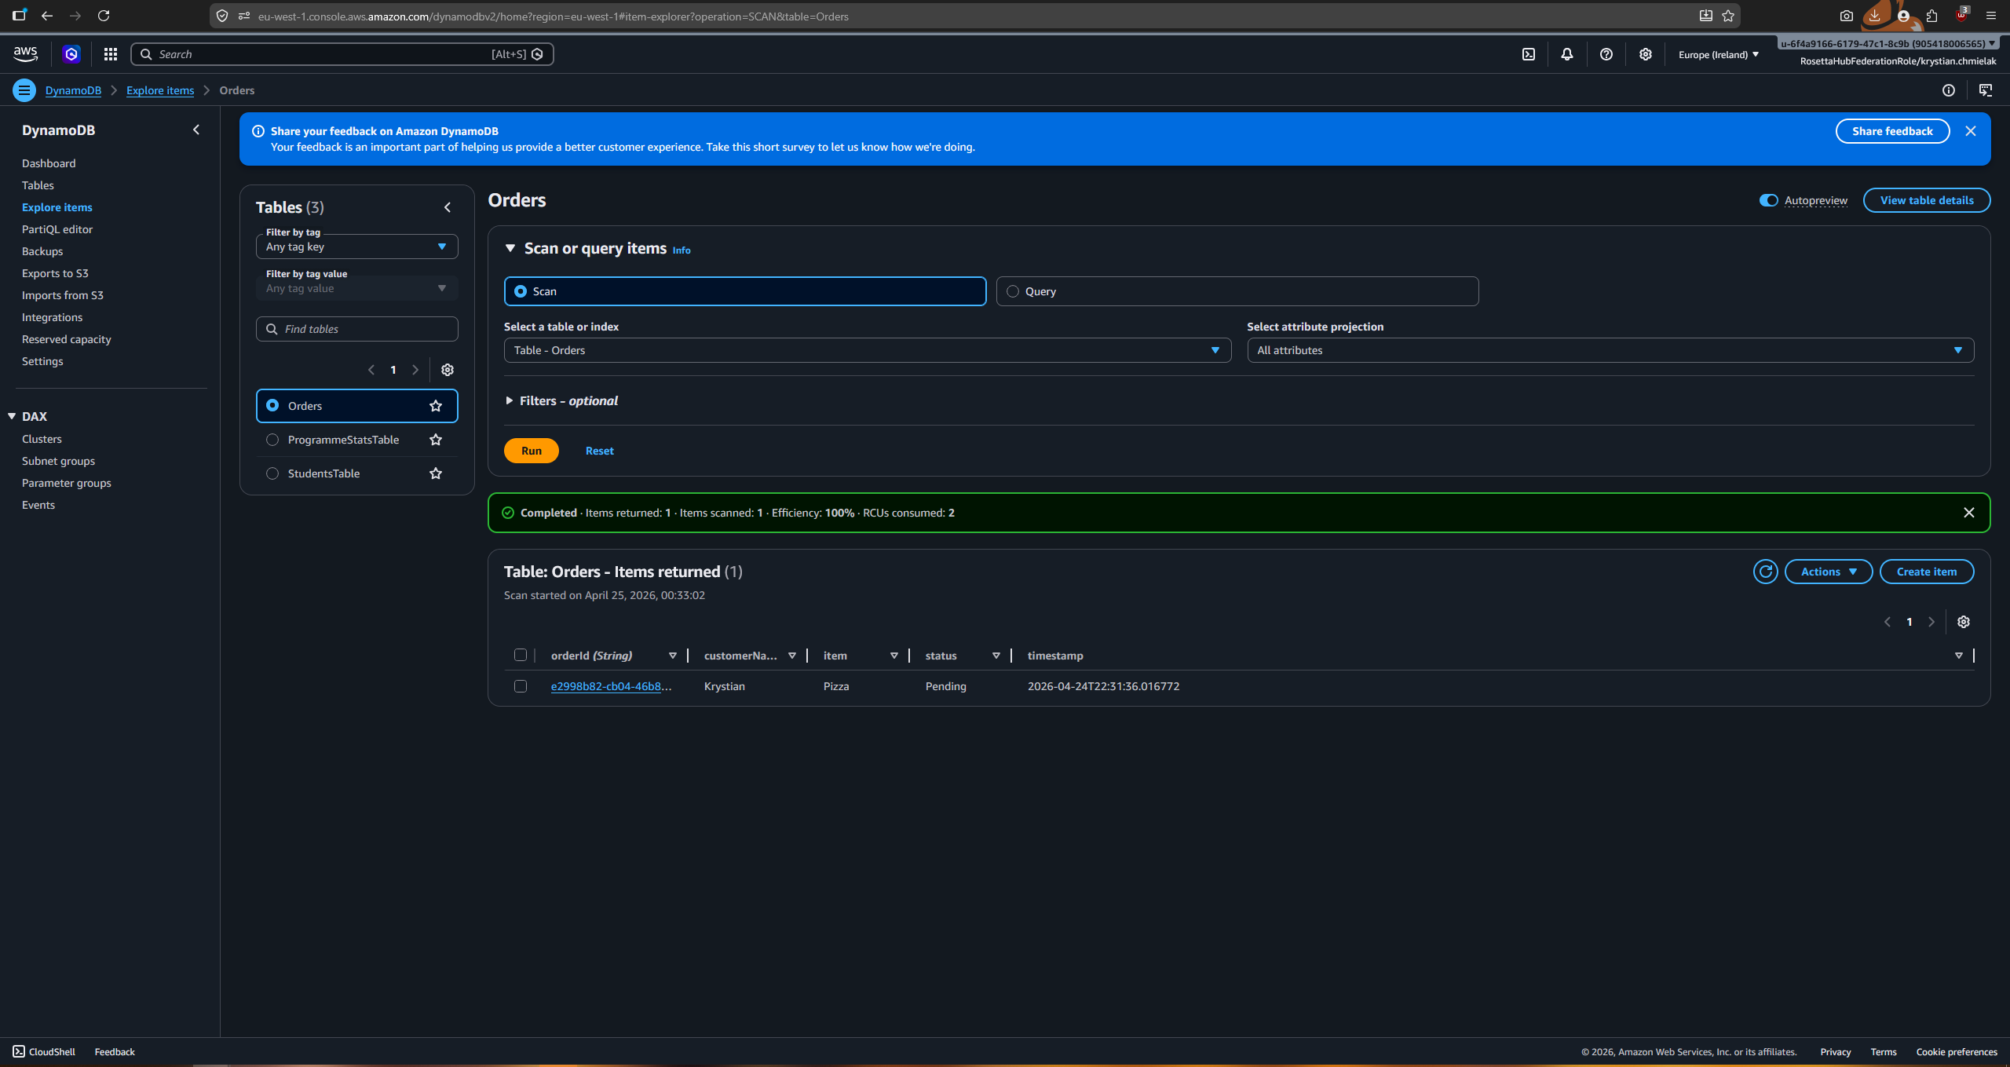

OrderProcessorFunction Code:
import json
import boto3
import time

dynamodb = boto3.resource("dynamodb")
sns = boto3.client("sns")

table = dynamodb.Table("Orders")

SNS_TOPIC_ARN = "arn:aws:sns:eu-west-1:975049908360:OrderNotifications"

def lambda_handler(event, context):
for record in event["Records"]:
message = json.loads(record["body"])
order_id = message["orderId"]
customer_name = message["customerName"]
item = message["item"]

table.update_item(
Key={"orderId": order_id},
UpdateExpression="SET #s = :status",
ExpressionAttributeNames={"#s": "status"},
ExpressionAttributeValues={":status": "Preparing"}
)

time.sleep(2)

table.update_item(
Key={"orderId": order_id},
UpdateExpression="SET #s = :status",
ExpressionAttributeNames={"#s": "status"},
ExpressionAttributeValues={":status": "Delivered"}
)

sns.publish(
TopicArn=SNS_TOPIC_ARN,
Subject="Order Delivered", delivered."
)

return {
"statusCode": 200,
"body": json.dumps("Order processed")

}

Test in postman for API
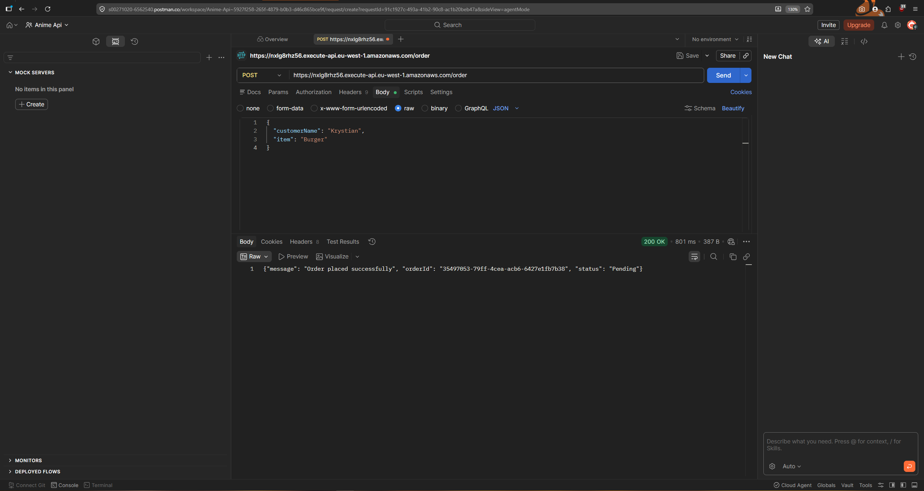

DynamoDB Table after postman testing:
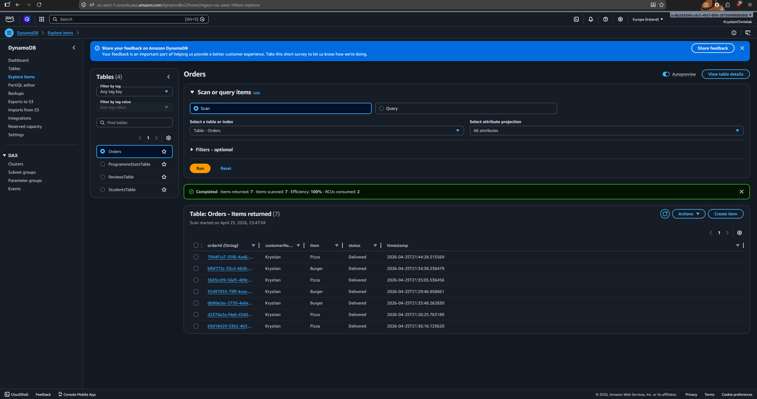

Email Notification for deliveries:
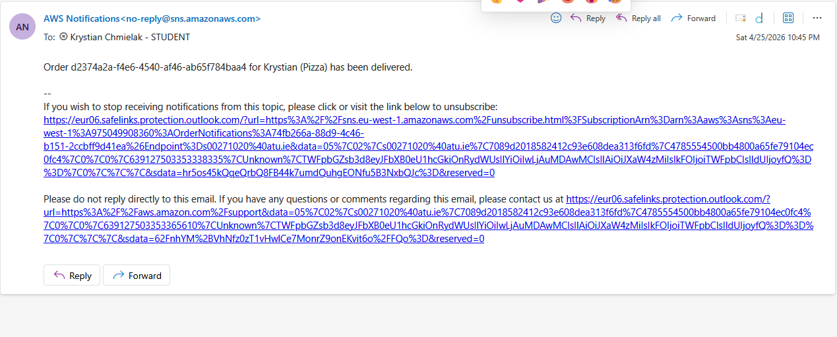

Cloudwatch logs:
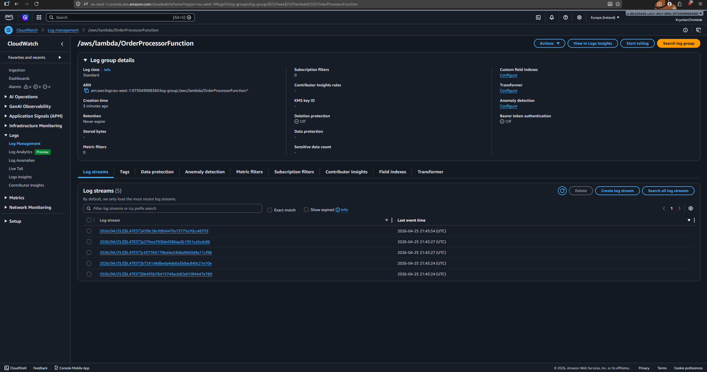

Postman test for get order with orderId:
