AWS Food Delivery Application Report
Introduction:
For this group project, we developed a cloud-based food delivery application using a serverless architecture on AWS services. We built the application using Amplify, Lambda, API Gateway, SQS Queue, DynamoDB and SNS. The goal for this application was to allow a user to be able to order food products from a menu selection and place an order. They would then be able to track their order using their order number.
We stored all required application files in the following GitHub repository: https://github.com/LiamNewt/AWSFoodDeliveryApp

The application is deployed on: https://main.d10441q1pl52l6.amplifyapp.com/

Infrastructure Implemented: (Frontend)
The frontend communicates with the backend through RESTful API endpoints that we get from the API Gateway. These then trigger the Lambda functions, enabling the interaction between the frontend and the backend.

HTML:
The HTML contains a very basic body with an input for the customer’s name and select dropdowns containing the products for each category. It also contains the buttons for placing an order and tracking an order.
<!doctype html>
<div class="outerContainer">
<head>
<link rel="stylesheet" href="styles.css" />
<script src="script.js"></script>

<title>Food Order Application</title>
</head>

<body>
<h1>Food Order Application</h1>
<section class="enterName">
<h3>Place an order:</h3>
<input
type="text"
id="name"
placeholder="Enter your name here:"
required
/><br /><br />
</section>

<section>
<div class="wrapper">
<div class="category">
<h3>Pizza</h3>
<label>Choose an Item:</label>
<select id="itemPizza">
<option value="Select">Select Here:</option>
<option value="Margherita">Margherita</option>
<option value="Pepporoni">Pepporoni</option>
<option value="Hawaiian">Hawaiian</option>
<option value="MeatFeast">Meat Feast</option>
<option value="BBQ Chicken">BBQ Chciken</option></select
><br /><br />
</div>
<div class="category">
<h3>Burgers</h3>
<label>Choose an Item:</label>
<select id="itemBurger">
<option value="Select">Select Here:</option>
<option value="Cheese">Cheese Burger</option>
<option value="ChcikenFillet">Chicken Fillet Burger</option>
<option value="QuaterPounder">Quater Pounder</option>
<option value="HalfPounder">Half Pounder</option>
<option value="Veggie">Veggie Burger</option></select
><br /><br />
</div>

<div class="category">
<h3>Chicken</h3>
<label>Choose an Item:</label>
<select id="itemChicken">
<option value="Select">Select Here:</option>
<option value="ChickenTenders">Chicken Tenders</option>
<option value="ChcikenNuggets">Chicken Nuggets</option>
<option value="ChcikenWings">Chicken Wings</option>
<option value="ShreddedChicken">Shredded Chicken</option>
<option value="5Piece">5 Piece Chicken</option></select
><br /><br />
</div>

<div class="category">
<h3>Kebab</h3>
<label>Choose an Item:</label>
<select id="itemKebab">
<option value="Select">Select Here:</option>
<option value="DonerKebab">Doner Kebab</option>
<option value="ChcikenTKebab">Chicken Tikka Kebab</option>
<option value="ShishKebab">Shish Kebab</option>
<option value="ChickenKebab">Chicken Kebab</option>
<option value="VeggieKebab">veggie Kebab</option></select
><br /><br />
</div>
</div>
<div class="buttonOrder">
<button class="placeOrder" onclick="placeOrder()">
Place Your Order
</button>
</div>
<p id="orderResult"></p>
</section>
<h1>
--------------------------------------------------------------------------------------------------------------------------------
</h1>

<section class="trackOrderSec">
<h2>Track Your Order</h2>
<input
type="text"
id="orderNum"
placeholder="Enter your order number:"
/><br /><br />
<button class="orderTrack" onclick="trackOrder()">Track Order</button>
<p id="orderStatus"></p>
</section>
</body>
</div>

JavaScript:
The JavaScript handles the user interaction for the functions placeOrder and trackOrder. It also handles the communication between the frontend and the backend using cloud services. The placeOrder function collects the information that the user has inputted in the input field and the select options menu. This data is then sent as JSON using a POST request method which processes the entire order, stores it in a database using DynamoDB and forwards the order to a queue using Amazon SQS. The order then returns a unique order number to identify each order.
The trackOrder function enables the user to track the process of their order. It sends a GET request to the API Gateway using the order number that was generated after placing the order. The order status is then retrieved by the backend Lambda function from the database in DynamoDB to which the order status is then displayed in the application for the user.
const API_BASE = "https://nxlg8rhz56.execute-api.eu-west-1.amazonaws.com";

async function placeOrder() {
const name = document.getElementById("name").value;

const pizza = document.getElementById("itemPizza").value;
const burger = document.getElementById("itemBurger").value;
const chicken = document.getElementById("itemChicken").value;
const kebab = document.getElementById("itemKebab").value;

let selectedItem = "";

if (pizza !== "Select") selectedItem = pizza;
else if (burger !== "Select") selectedItem = burger;
else if (chicken !== "Select") selectedItem = chicken;
else if (kebab !== "Select") selectedItem = kebab;

if (name === "" || selectedItem === "") {
document.getElementById("orderResult").innerText =
"Please enter your name and select one item.";
return;
}

try {
const response = await fetch(`${API_BASE}/order`, {
method: "POST",
headers: {
"Content-Type": "application/json",
},
body: JSON.stringify({
customerName: name,
item: selectedItem,
}),
});

const data = await response.json();

document.getElementById("orderResult").innerText =
`Order placed successfully! Your order number is: ${data.orderId}`;

document.getElementById("orderNum").value = data.orderId;
} catch (error) {
document.getElementById("orderResult").innerText = "Error placing order.";
console.log(error);
}
}

async function trackOrder() {
const orderId = document.getElementById("orderNum").value;

if (orderId === "") {
document.getElementById("orderStatus").innerText =
"Please enter an order number.";
return;
}

try {
const response = await fetch(`${API_BASE}/order/${orderId}`);
const data = await response.json();

if (data.error) {
document.getElementById("orderStatus").innerText = data.error;
} else {
document.getElementById("orderStatus").innerText =
`Order Status: ${data.status}`;
}
} catch (error) {
document.getElementById("orderStatus").innerText = "Error tracking order.";
console.log(error);
}
}

Note:
While I handled the frontend and the other group member covered the backend, as an additional feature I decided to implement an order details text change depending on time since order was placed. To do this I modified the Lambda function OrderProcessFunction and set a time.sleep(30) after each status update with the (30) referring to 30 seconds. I wanted to replicate the user experience of existing food applications.
AWS Amplify:
Amplify was used in the development to host and deploy the application to the web. The service enables the deployment of static web applications directly from GitHub repositories. The AWSFoodDeliveryApp repository was connected, with Amplify automatically handling the building and deployment process. If changes are made to the code and committed, the application will automatically redeploy with the implemented changes.
GitHub Repo: https://github.com/LiamNewt/AWSFoodDeliveryApp
Application deployed at: https://main.d10441q1pl52l6.amplifyapp.com/
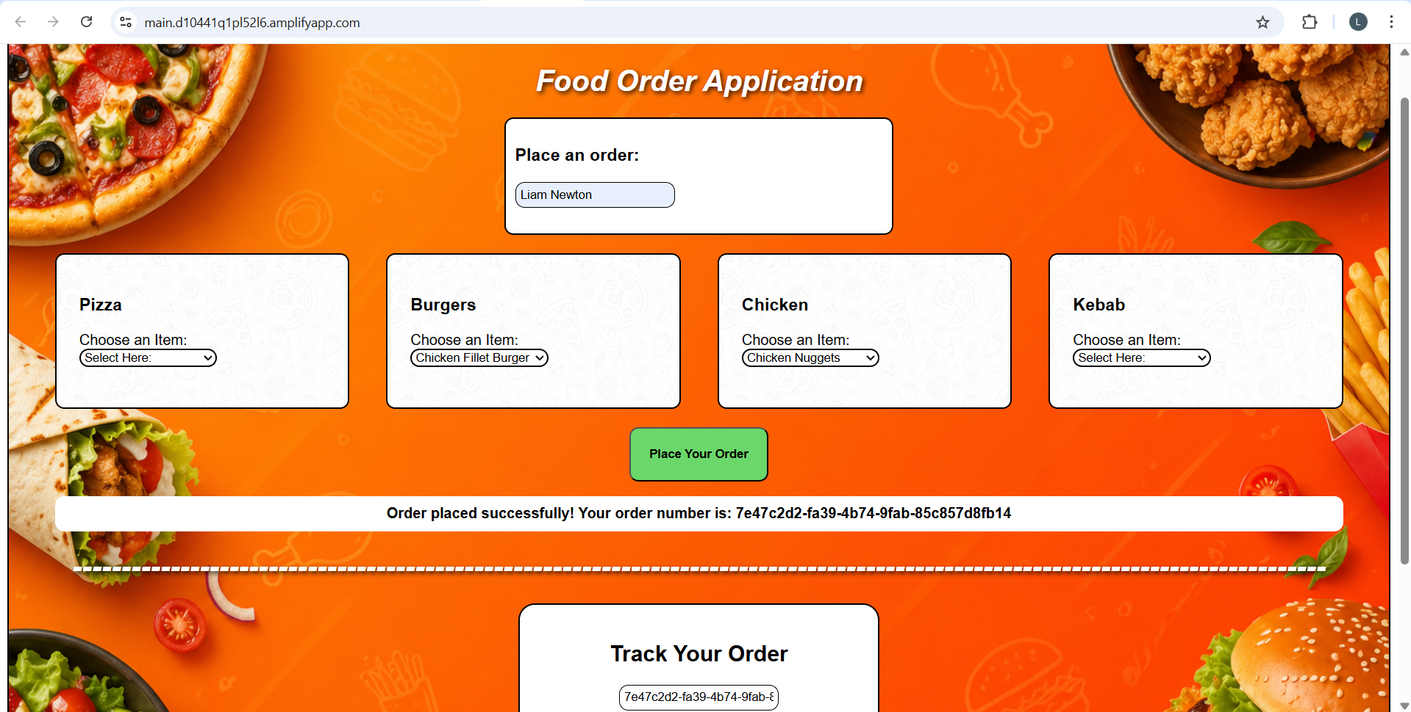

Different Order Status Details:
