Worksheet 2
Bootstrap styles implemented:

Navbar:
Current project.
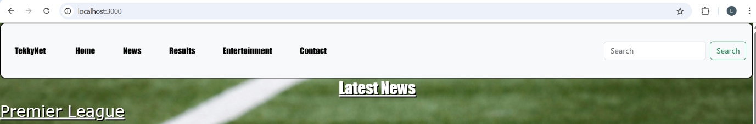

Year 1 Project: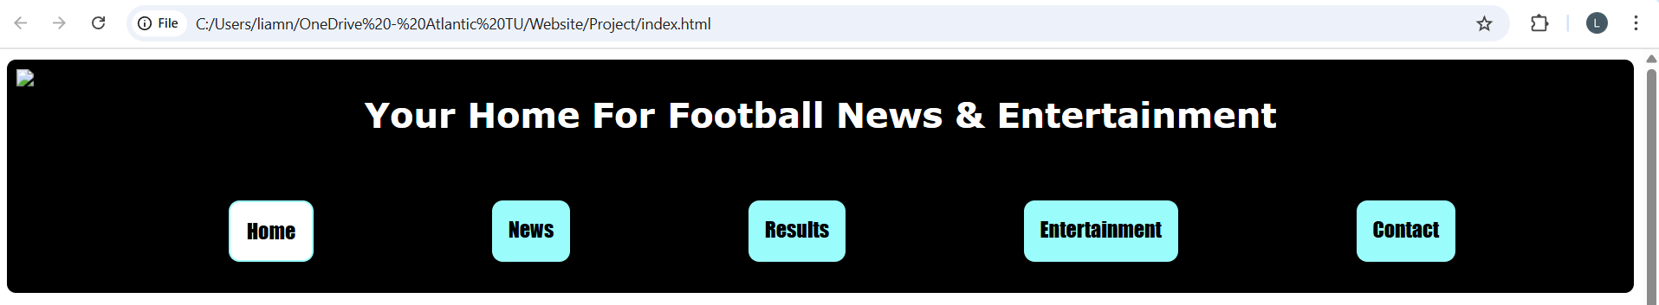

Aside:
Current project.
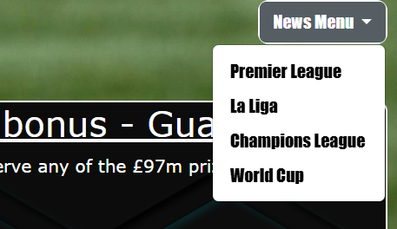

Year 1 Project.
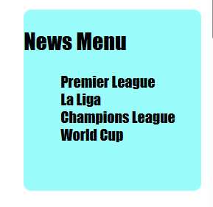

Toast:
Current project. (Could not get visually working on “Entertainment” page)
