**A Critical Evaluation of Cardiff’s Pipeline:**

Why Cardiff Oncology’s onvansertib will fail Phase 2 clinical trials and the stock will trade to $1

Liam Render

July 2025

Table of Contents

Executive Summary Page 3

Introduction Page 4

History of the Drug Page 5

Mechanism of Action Page 6

Preclinical Page 8

Clinical Trials Page 10

Conclusion Page 14

Sources Page 15

**NOTE: This is a VERY rough draft written just days before a key catalyst (data readout on the 29th) and was not finished beforehand. Due to this I think it would be disingenuous to finish the paper, and I leave it in its current state.**

**Executive Summary**

In this work, I will prove that the onvansertib Phase 2 trial will fail to meet its primary endpoint. The overwhelming odds that onvansertib can redo a trial and achieve significance this time due to post-hoc data mining in certain subgroups is low to none and the preliminary data that management says is indicative of a benefit is lacking due to small sample sizes and given a larger data set should repeat the same outcomes as before.

**Introduction**

Small tech biotech stocks trying to find the next investment or get more funding to stay alive usually try to find correlations in the data and come up with subgroups in post-hoc analysis. However, this is very flawed because hypothesis is meant to be tested prospectively and retrospective analysis against any set of data will more likely find false positives than actual correlation. In the case of Cardiff after failure in RAS-mut mCRC they found that Bev naïve patients (a drug used in combination of chemo regimens) respond better than Bev-exposed patients. Obviously with only one drug and many failures they need to show any promise in their pipeline for investments and capital raising if they just gave up on the trial, they’d be left with no way to raise equity. They have done this before in a leukemia trial for the same drug where they said -- . It’s a Sisyphean struggle for small biotech’s lacking capital, buy a drug, fail, find a subgroup, raise capital, fail in the subgroup, find a new drug. Drugs don’t work by accident, most drugs fail.

**History of Onvansertib**

Originally developed by Nerviano Medical Sciences in 2011 (Beria I, 2011)? And licensed by Trovagene (now Cardiff Oncology) in 2017 according to prospectus. Originally developed for Leukemia. Cardiff Oncology did multiple trials in mCRC, Leukemia, and Prostate Cancer.

NMS-P937 -> NMS-1286937 -> PCM-075 -> onvansertib

**Mechanism of Action**

(Smith, 2017).

PLK1 inhibitor ATP competitive (Weiss GJ, 2017) to bind to PLK1 instead of ATP and inducing mitotic arrest and apoptosis at certain thresholds of concentration, however very toxic at high doses and induces thrombocytopenia through apoptosis bone marrow.

KRAS-mut cells are more sensitive to PLK1 inhibition (Ahn, 2024). Phase 1b

The data suggests PLK1 inhibition to be effective in KRAS-mut cells. However, the high toxicity seen in human trial’s failures achieve significance seems to show that the doses at which the drug is effective are too toxic. 37.5% ORR n=7? or 16; PFS and DOR not S.S.

Fabricated explanation for why a Bev-exposed tumor would be resistant to onvansertib

Failure of another PLK1 inhibitor BI-2536 in pancreatic cancer (Mross, 2012).

**Preclinical**

Preclinical data showed F=0.23 or 23% bioavailability and significant anti-tumor growth in the 7g compound (60mg/kg). The toxic dose was 17mg/kg^2 and the ones used in the Phase II trials are 15mg/kg^2. In an average human if we use allometric scaling 60kg 1.62m^2 we find a 0.41mg/kg dosing. (Beria I, 2011) Inhibits the hypoxia pathway and shows antitumor activity through angiogenesis. (Ahn DH, 2025)

Image taken from (Ye, 2005)

Image taken from (Ye, 2005)

As we see in the image above the multiple compounds tested the 7g one being our key candidate named onvansertib we are discussing today. This compound seems acceptable at best (probably why the drug was sold to now Cardiff after the Leukemia failure in phase I). The low bioavailability, low half-life, and low AUC in the oral 7g compound shows some PK challenges.

**Clinical Trials**

**Phase I n=21 NCT01014429**

Before Cardiff licensed the drug from Nerviano Medical Sciences hence the compound name (NMS-P937/ NMS-1286937) they ran a Phase I in 2011 to determine the PK/PD and the MTD and DLTS (Weiss GJ, 2017). This Phase I led to the subsequent discontinuation of development by Nerviano and acquisition by now known as Cardiff.

Open Label metastatic solid tumors first-in-human trial. PLK1 inhibitors are highly sensitive to thrombocytopenia TEAEs and bone marrow. (Weiss GJ, 2017) MTD and RP2D at 24mg/m^2/day. “PLK inhibitors to induce mitotic cell cycle in rapidly proliferating blood cells and have also been observed with BI-2536 and volasertib”

Biomarkers in both pThr199 and pHH3 did not statistically increase, n=2 24mg/m^2 and 36 mg/m^2, and concentrations were below the threshold expected to modulate biomarkers in tumor and skin tissue based on preclinical studies. (Weiss GJ, 2017) Nerviano Medical Sciences.

“In the present study with NMS-1286937, disease stabilization was observed as the best response in 5 out of the 16 evaluable patients (26.3%), while no objective responses were observed.” “3 out of 5 instances of stable disease in our study were observed in patients with KRAS mutant tumors” (Weiss GJ, 2017)

**Phase Ib n=**

Leukemia P.E failed (Zeidan AM, 2020)

**Phase Ib/II n=**

Acute myeloid leukemia P.E failed (Croucher PJP, 2023) Was expected due to the failure of Volasertib (same MOA) also in acute myeloid leukemia with a 25% ORR p=0.071 OS p=0.757 (Dohner, 2021).

Claimed that because all patients with CR or Cri hadn’t previously been treated with an HMA that could be the group that its effective in. 27% ORR (Croucher PJP, 2023).

**Phase Ib n=23 NCT05593328**

In RAS-mut mCRC (Ahn DH, 2024)

**Phase II n=72 NCT03414034**

In mCRPC Failed P.E

**Phase II n=68 NCT03829410**

1L ORR in NCT03829410 = 10%; 2L = 77%; Even if the drug were to show a response in 2L (Bev naïve) patients the population ~9,500 as per press release, it wouldn’t be worth the funding required for further research and Pfizer? would stop working with them ~80m in cash probably down to <60m by now is not enough for further trials and requires heavy dilution or ---. In the overall population however, Failed P.E of ORR>30% ORR was 26.4% n=53 DOR not S.S. Used post-hoc analysis (n=4; wide SD; according to my t-test calculations p=0.8 in entire subgroup, p=0.1 in 30mg, 20mg even worse) to say Bev naïve patients responded better (they should respond better anyways?) Grade ¾ AE in 62%. (Ahn, 2025) In clinical studies you have equal populations in this case of Bev-exposed and Bev-naïve due to the better responses to Bev seen in Bev naïve patients so it doesn’t affect the outcome of the trial but I hypothesize that comparing Bev naïve to Bev naïve populations they will have a higher ORR in both control and active arms but won’t be a significant difference.

Patients not previously exposed to Bev are shown to have a better response than Bev-exposed and this post-hoc analysis seems uncorrelated to the MOA of PLK1 and how it would be more effective in a Bev naïve only population the ORR of SoC vs SoC+onvansertib should not be a significant difference.

**Phase II n=113 NCT06106308**

In the FORWARD study for paclitaxel, they found Bev-naïve patients with a 59% ORR compared to 35% in BEV pretreated (Husam, 2025); comparatively in the onvansertib study ORR was 77% for Bev naïve and 10% for BEV-exposed showing a clear distinction between patients’ response to Bev being a lot higher in naïve than pretreated. So, is onvansertib driving some or none of the ORR? It seems likely from previous trials and PK that Bev is driving most if not all the ORR at least enough that it would not achieve significance comparing control to onvansertib.

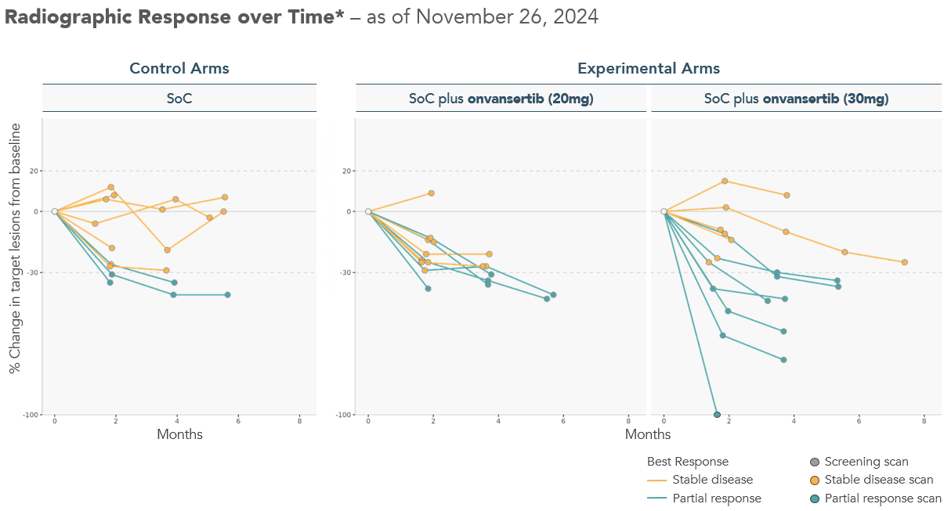

Management likes to claim the preliminary data was good 64% ORR vs 33% in 30mg vs control! That must be great data, right? However, doing a fisher’s exact test (instead of a t-test due to small sample size) we find the p values for each group as p=0.65, p=0.37, p=0.427; respectively for 20mg, 30mg, and combined doses. This preliminary data is lacking due to small sample size and no statistical significance. The overwhelming odds are that if you run a trial with the same drug in the same population that failed if the previous trial was structured well, it should not work this time.

But can the new data or the full data show significance? We cannot draw any conclusions on a dataset this low sample size but looking at previous observations it seems highly unlikely to show a significant benefit.

**Conclusion**

**Condition 1**: Bev-naïve patients were responding better due to onvansertib and not because they will naturally respond better to the SoC (Bev) anyways even though the n=4 post-hoc wasn’t S.S. The previous failure in whole population of RAS-mut mCRC can be thrown out and previous failures of PLK1 can be thrown out. Probability at most 20%

**Condition 2**: The drug can overcome the PK challenges at the current dosing and the results of previous trials and biomarker data can be thrown out. Probability at most 20%

**Condition 3**:The preliminary data is indicative of a benefit in the 30mg, and large sample sizes will show the same benefit without high PK. Probability at most 50%

The total probability of this drug succeeding in the RAS-mut mCRC Phase 2 is at most 2%. Their sole asset is onvansertib and once the drug fails again, I’m sure they will not find any partners to do further studies on this drug and will trade at book value.

**References**

Ahn, D. H., Ridinger, M., Cannon, T. L., Mendelsohn, L., Starr, J. S., Hubbard, J. M., Kasi, A., Barzi, A., Samuëlsz, E., Karki, A., Subramanian, R. A., Yemane, D., Kim, R., Wu, C. C., Croucher, P. J. P., Smeal, T., Kabbinavar, F. F., & Lenz, H. J. (2025). Onvansertib in combination with chemotherapy and bevacizumab in second-line treatment of KRAS-mutant metastatic colorectal cancer: A single-arm, phase II trial. *Journal of Clinical Oncology*, 43(7), 840-851. <https://doi.org/10.1200/JCO-24-01266>

Ahn, D. H., Barzi, A., Ridinger, M., Samuëlsz, E., Subramanian, R. A., Croucher, P. J. P., Smeal, T., Kabbinavar, F. F., & Lenz, H. J. (2024). Onvansertib in combination with FOLFIRI and bevacizumab in second-line treatment of KRAS-mutant metastatic colorectal cancer: A phase Ib clinical study. *Clinical Cancer Research*, 30(10), 2039-2047. <https://doi.org/10.1158/1078-0432.CCR-23-3053>

Croucher, P. J. P., Ridinger, M., Becker, P. S., Lin, T. L., Silberman, S. L., Wang, E. S., & Zeidan, A. M. (2023). Spliceosome mutations are associated with clinical response in a phase 1b/2 study of the PLK1 inhibitor onvansertib in combination with decitabine in relapsed or refractory acute myeloid leukemia. *Annals of Hematology*, 102(11), 3049-3059. <https://doi.org/10.1007/s00277-023-05442-9>

Zeidan, A. M., Ridinger, M., Lin, T. L., Becker, P. S., Schiller, G. J., Patel, P. A., Spira, A. I., Tsai, M. L., Samuëlsz, E., Silberman, S. L., Erlander, M., & Wang, E. S. (2020). A phase Ib study of onvansertib, a novel oral PLK1 inhibitor, in combination therapy for patients with relapsed or refractory acute myeloid leukemia. *Clinical Cancer Research*, 26(23), 6132-6140. <https://doi.org/10.1158/1078-0432.CCR-20-2586>

Beria, I., Bossi, R. T., Brasca, M. G., Caruso, M., Ceccarelli, W., Fachin, G., Fasolini, M., Forte, B., Fiorentini, F., Pesenti, E., Pezzetta, D., Posteri, H., Scolaro, A., Re Depaolini, S., & Valsasina, B. (2011). NMS-P937, a 4,5-dihydro-1H-pyrazolo[4,3-h]quinazoline derivative as potent and selective Polo-like kinase 1 inhibitor. *Bioorganic & Medicinal Chemistry Letters*, 21(10), 2969-2974. <https://doi.org/10.1016/j.bmcl.2011.03.054>

Weiss, G. J., Jameson, G., Von Hoff, D. D., Valsasina, B., Davite, C., Di Giulio, C., Fiorentini, F., Alzani, R., Carpinelli, P., Di Sanzo, A., Galvani, A., Isacchi, A., & Ramanathan, R. K. (2018). Phase I dose escalation study of NMS-1286937, an orally available Polo-like kinase 1 inhibitor, in patients with advanced or metastatic solid tumors. *Investigational New Drugs*, 36(1), 85-95. <https://doi.org/10.1007/s10637-017-0491-7>

Döhner, H., Symeonidis, A., Deeren, D., Demeter, J., Sanz, M. A., Anagnostopoulos, A., Esteve, J., Fiedler, W., Porkka, K., Kim, H. J., Lee, J. H., Usuki, K., D'Ardia, S., Won Jung, C., Salamero, O., Horst, H. A., Recher, C., Rousselot, P., Sandhu, I., ... Ottmann, O. G. (2021). Adjunctive Volasertib in patients with acute myeloid leukemia not eligible for standard induction therapy: A randomized, phase 3 trial. *Hemasphere*, 5(8), e617. <https://doi.org/10.1097/HS9.0000000000000617>

Mross, K., Dittrich, C., Aulitzky, W., et al. (2012). A randomised phase II trial of the Polo-like kinase inhibitor BI 2536 in chemo-naïve patients with unresectable exocrine adenocarcinoma of the pancreas – a study within the Central European Society Anticancer Drug Research (CESAR) collaborative network. *British Journal of Cancer*, 107, 280–286. <https://doi.org/10.1038/bjc.2012.257>

Smith, L., Farzan, R., Ali, S., et al. (2017). The responses of cancer cells to PLK1 inhibitors reveal a novel protective role for p53 in maintaining centrosome separation. *Scientific Reports*, 7, 16115. <https://doi.org/10.1038/s41598-017-16394-2>

Alqaisi, H. A., Cohn, D. E., Chern, J. Y., Duska, L. R., Jewell, A., Corr, B. R., Winer, I. S., Girda, E., Crispens, M. A., Dhani, N. C., Madariaga, A., Grant, R. C., Malaguti, M., Lee, C., Bowering, V., Wong, H., Poothullil, A., Speers, V., Wang, L., ... Lheureux, S. (2025). Randomized phase II study of bevacizumab with weekly anetumab ravtansine or weekly paclitaxel in platinum-resistant/refractory high-grade ovarian cancer (NCI trial). *Clinical Cancer Research*, 31(6), 993–1001. <https://doi.org/10.1158/1078-0432.CCR-24-3128>

Cardiff Oncology. (2024). Cardiff Oncology announces positive initial data from first-line RAS-mutated mCRC trial with onvansertib and standard of care in combination. [Press release.] Retrieved from <https://investors.cardiffoncology.com/news-releases/news-release-details/cardiff-oncology-announces-positive-initial-data-first-line-ras>

(Ye, 2005) <https://doi.org/10.1016/j.tiv.2005.06.047>