## 2.3 Data Definition

|  |  |  |  |
| --- | --- | --- | --- |
|  |  | **4 Person** | **3 Person** |
|  | **Table of Contents** |  |  |
|  |  |  |  |
| **2.3.1** | **Logical Data Model Diagram** | **All** | **All** |
|  |  |  |  |
| **2.3.2** | **Data Catalogue** |  |  |
|  |  |  |  |
|  | **2.3.4.0** **Data Element Descriptions** | **Split** | **Split** |
|  |  |  |  |
|  |  |  |  |
|  | **Appendices** |  |  |
|  |  |  |  |
|  | **None.** |  |  |

# Logical Data Model Diagram

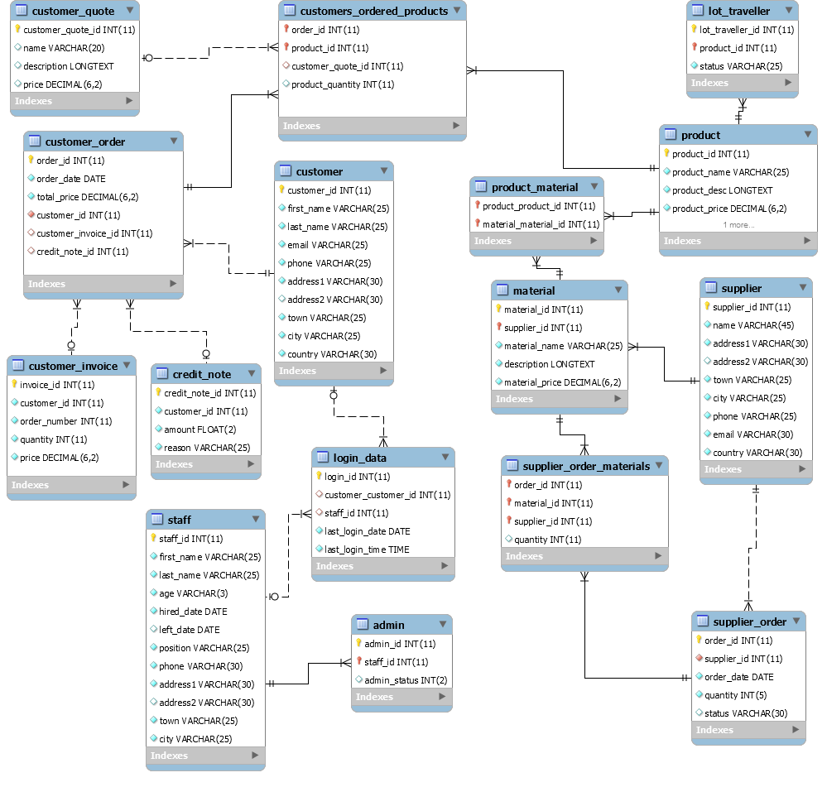

# Data Catalogue

## Introduction

In our Data Catalogue we primarily focused on how efficient and dynamic it is in order to retrieve data from our database. This is shown in our Logical Data Model Diagram from our Relationships where it will be efficient to retrieve data from our Database as well as inserting data to it.

## Customers

Customers were an intricate architecture to deal with as they include many to many relationships which are especially needed for orders.

As we can see in our “Customers_ordered_products” customers can have many different orders, but each product has a different quantity included in the order per product.

We related “customer_quote” with “customers_ordered_products” as each product will be quoted separately instead of the complete order. This is important in a customer’s quote, so they can pinpoint what product(“product_id”) what price. **N.B.** “customers_ordered_products” does not need a “customer_quote_id”, it is only necessary if they have been quoted; therefore, it can be NULL.

A Customer Order itself is information the customer might want to know about the order itself. Credit Note and Customer Invoice is related to a customer order because of this. It is not related to individual products therefore it is not directly related to “customers_ordered_products”

## Logins

All information is needed in order to improve the efficiency of how to manage MWE. This also includes why we need to track our user’s login data as it will be useful in terms of if we need to upgrade our servers to hold more traffic. Login Data requires either Staff ID or customer ID to not be null. Therefore, none are mandatory (As a customer cannot also be staff, they would have to sign up as customer otherwise).

## Staff

Staff data such as name, and hired date is necessary for MWE’s records to keep a history of who is working for us/who worked for us. Staff can change certain information on the website such as lot traveler information

## Admin

Admins are staff with special permissions that allow them also to edit and delete records in the website that staff do not have access to. Admins have the potential to have be able to change different aspects of the website depending on their “admin_status”.

## Products

A product is information regarding what we are able to sell. A Product’s price is different to a Customer’s quote price as the customer may request to buy in bulk or have specific requests to do with the product. If a customer requests a custom Circuit Board, it is entered to the product table.

Products have the potential to be tracked where they are in the production process using the “lot_traveller” table.

We have another many to many relationships as products can be made of many different materials.

## Materials

Materials are produced by suppliers and a same material can have different suppliers. This is why “Material_id” and “supplier_id” are the primary keys in this table.

## Suppliers

Suppliers are businesses who we order our materials from in order to make our Circuit Boards. It is important that we store as much information about them as possible which is why they are as important as customers

## Supplier Orders

Supplier Orders are similar to customer orders as they also include a many to many relationships. This is because an order from the supplier can have many different materials related to it. It also has the potential to include a status (depending on the supplier).

# Data Element Descriptions

## People

“People” include: “Staff”, “customer” and “supplier”. All “People” must include a name (Must be Atomic if actual person), an atomic address, that requires 3 lines (address2 is not mandatory but possibly needed for postal code). And non-actual persons require a country (as MWE is currently operational only in Ireland). Texts included in people are VARCHARs ranging from 3 (age) to 30.

## Staff

Unique to “staff” is also position and hired/left_date. Which are VARCHAR (25) and DATEs respectively.

## Orders

“Orders” include: “customer_ordered_products”, “customer_order”, “customer_invoice” and “credit_note”. All “Orders” relate to one another through the “customer_ordered_products”, as this is where the relationship begins, each “Orders” has a unique ID int(11). “customer_invoice” and “customer_ordered_products” have a quantity element int(11) for the amount the customer has ordered.

## Login

“Login” refers to the “customer” and “staff” “login_data”. Each of these has a unique ID int (11) also with a record on last_login DATE and last_login TIME. This record of login is to track when the user was last active on their account and can prompt the user to login if a certain period of time has passed since they last were active.

## Product

A “product” is made up of a name VARCHAR (25), description LONGTEXT and a price DECIMAL(6,2). The product is linked to the lot_traveller and product_material through foreign keys. They are linked in such a way as for product to be, the system needs to know the materials needed and the price of the materials to generate the product.

## Material

The “Material” includes: name VARCHAR (25), description LONGTEXT and a price DECIMAL(6,2). The record of the materials stored require these specific elements to aid in the production of a product, the relationship that this focuses on comes from the supplier who supplies the materials which gets turned into the product. The product pulls elements from this relationship such as the price so the product can set its own price accordingly.

## Quote

A “quote” contains a unique ID int (11), name VARCHAR (25), decription LONGTEXT and a price DECIMAL. A quote relates to the customer_ordered_products in a way that when a quote is added it generates an order which is then processed through the chain of relationships. The quote is the dependency or the starting point for a lot of the tables within this system as this is the starting point for generating an order which then gets processed into a product which is followed up with invoices.