**Benhurst United Website Manager User guide**

Please note that all information in this user guide is not real player/manager information.

Contents

Navigation around the website 2

Login 3

Homepage 4

Users 6

Create User 6

Search User 6

Edit/Delete User 7

Announcements 8

Create Announcement 8

Delete Announcement 8

Sessions 9

Create Location 9

Create Session 9

Edit/Delete Session 10

Availability 11

Attendance 13

Payments 14

Results 15

# Navigation around the website

In order to Navigate around the website you are able to click links within the menu bar located near the top of the page. These links will take you to different web pages. ie clicking Login will take you to the login page.

1.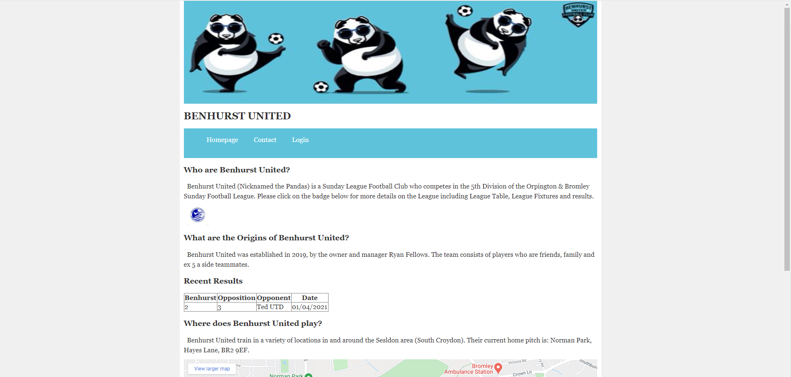

2.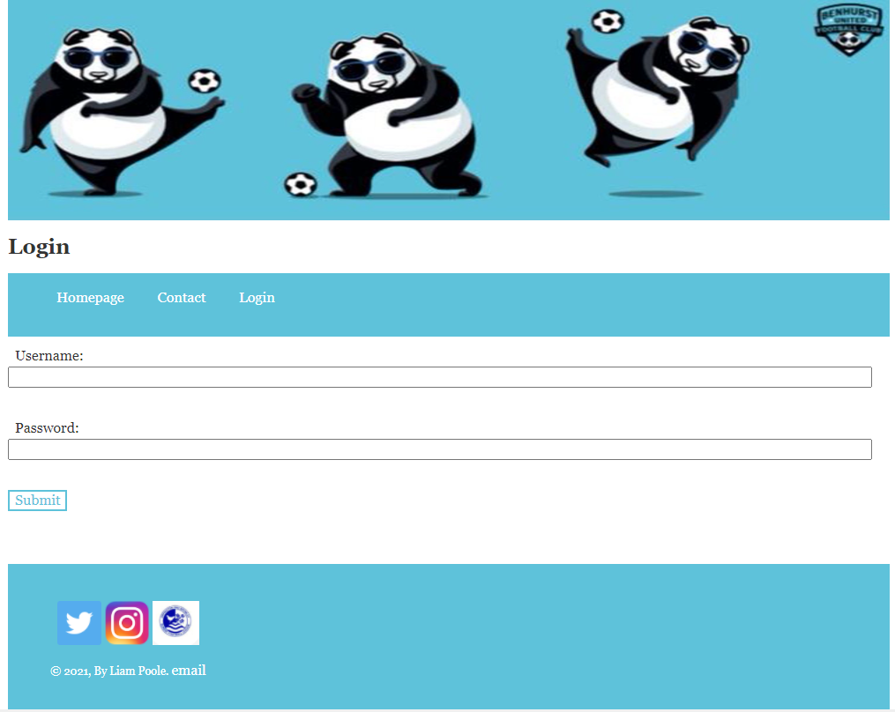

# Login

The login page consists of where you will be able to enter in your username and password to access your individual pages. A manager will need to create you as a user to login. The manager will give you your password and your username will be your email address.

1. Type in your email address in the username textbox.
2. Type in your password in the password textbox.
3. Click Submit.
4. You should then have access to your homepage.
5. Should you wish to logout, then please click the logout button underneath the menu.

Reasons error messages may display:

* A username must be an email address format and no more than 100 characters.
* The password needs to be at least 5 characters and no more than 50 characters.
* Your username and password must match the username and password within the system. (if you believe you are using the correct details, then please speak to a manager about resetting your details.

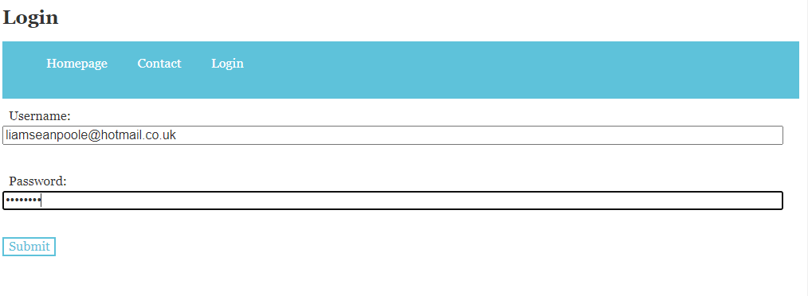

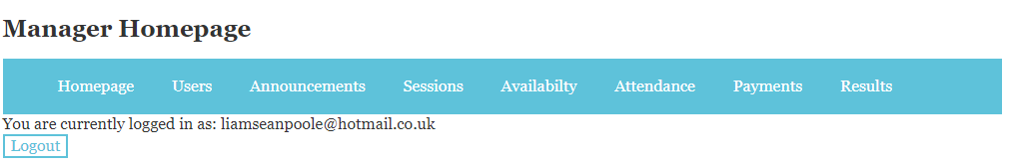

# Homepage

The homepage is the entry page after you have logged in, on this page there is a link to the user guide should you need.

Also, on the homepage has a table of the all the people requesting to join Benhurst United through the contact page, including their contact information. This can be used to contact the players if the club wants to offer the players a trial or reject the player from joining the club.

On this page you can delete any requests that people have had in joining the club.

1. Find the request number that you wish to delete
2. Enter the Request Number in the textbox
3. Click the delete button.

Reasons error messages may display:

* The Request Number must be a number.
* A row will only be deleted if the request number inputted is on the system.

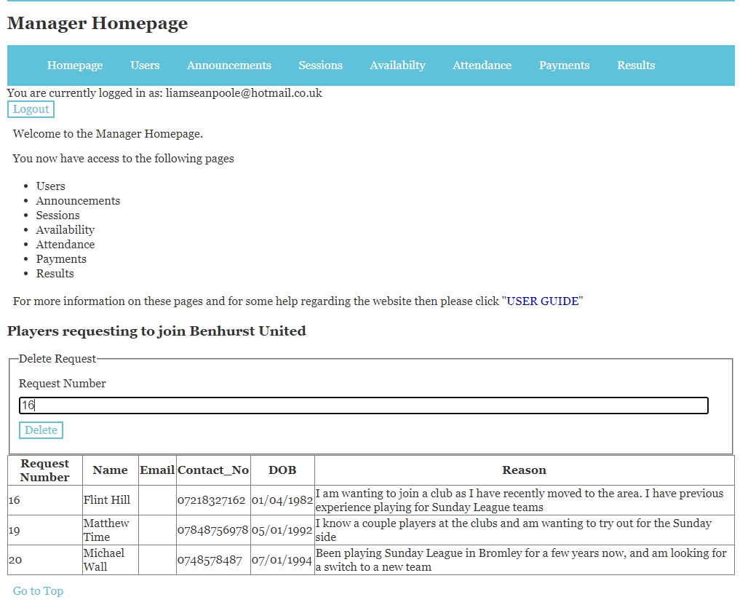

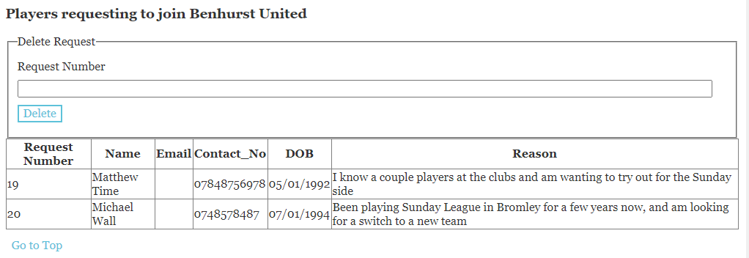

# Users

The User page can be split into 3 section, create user, search user and edit/delete user.

## Create User

In create a user, you can create a new user who will be able to log into the Benhurst website.

* Email address – This will be the username for the person who logs in. This must be an email address and is limited to a maximum of 100 characters. This is required to be entered.
* Type of user – You will select on a dropdown list between player and manager. This selection will grant the user different levels of access. This is required to be entered.
* Forename – Enter the Forename of the user. This must be letters and have a maximum of 50 characters. This is required to be entered.
* Surname - Enter the Surname of the user. This must be letters and have a maximum of 50 characters. This is required to be entered.
* Date of Birth – Open up the calendar or type in the date of birth of the user.
* Contact Number – Enter contact number of the user. This will be a maximum of 12 characters.
* Player Registration Number – Enter Player Registration Number. This must be numbers and will be a maximum of 9 characters.
* Click create user button.

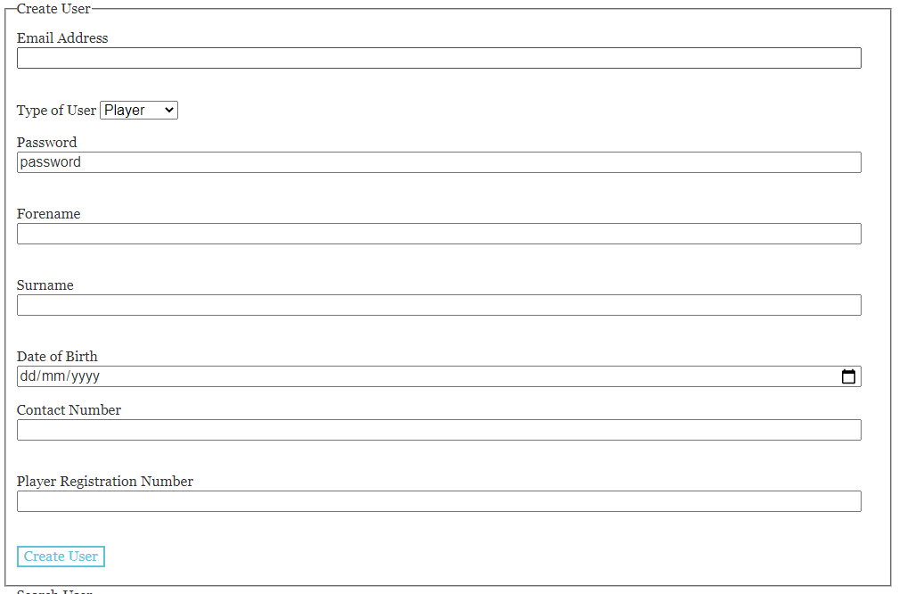

## Search User

Search User will filter the table of users below once you enter a search.

To search you must enter what you require in the correct textbox and then click search. These textboxes have the same restrictions as mentioned in restrict a user.

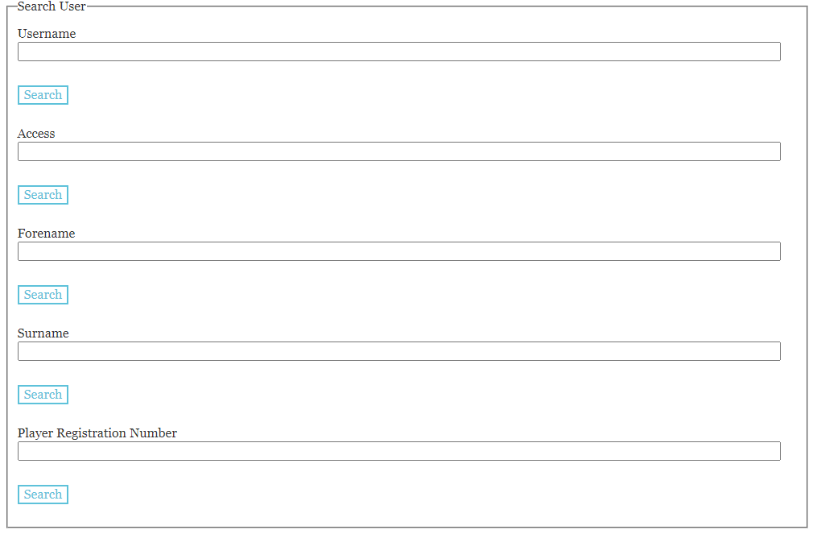

## Edit/Delete User

The below table shows the entire list of users who have access to the Benhurst United website.

To edit a user:

1. Click the edit button on the table of the row in which you want to edit
2. You can change any information apart from the email/username.
3. Click the button to update and make changes to the table/information or click cancel if you don’t wish for the changes to be made.

To Delete a User:

Click the delete button on the row in which user you want to delete.

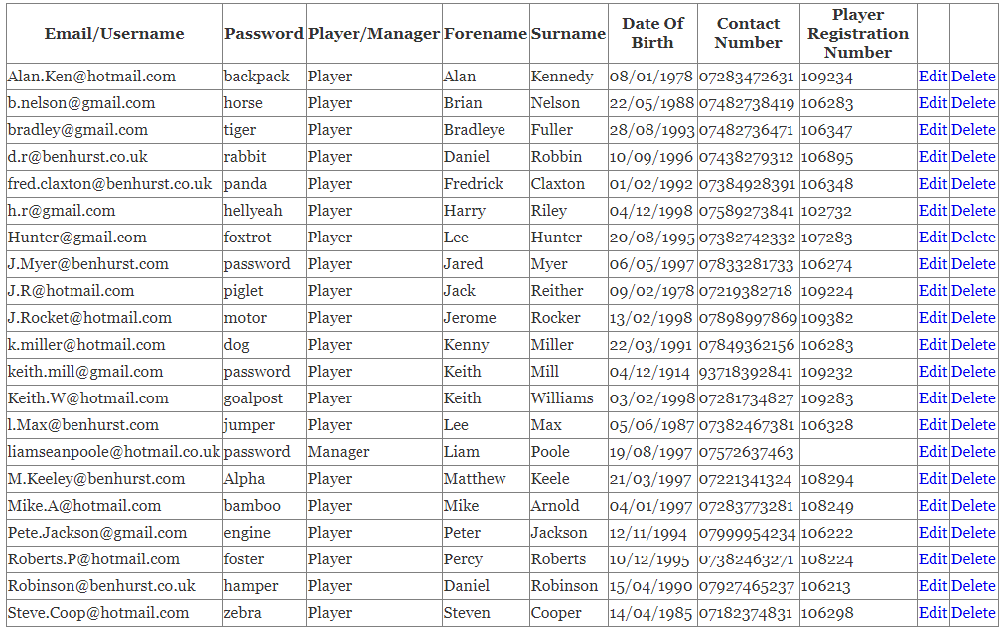

# Announcements

There are 2 parts to the announcements page create announcement and delete announcement.

## Create Announcement

In Create announcement you need to enter the following information:

* Title: Enter the title of the announcement. This is restricted to 60 characters.
* Date: Select the date of this announcement.
* Announcement: Enter the announcement. This is restricted to 500 characters.

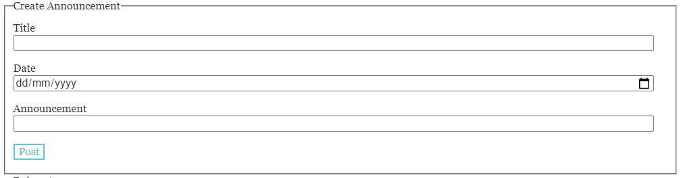

## Delete Announcement

For delete announcement, you can view a table of all the announcements that have been made. Above the table is a textbox where you can enter the Announcement Number, upon clicking the delete button, this will get rid of the row containing the entered Announcement Number.

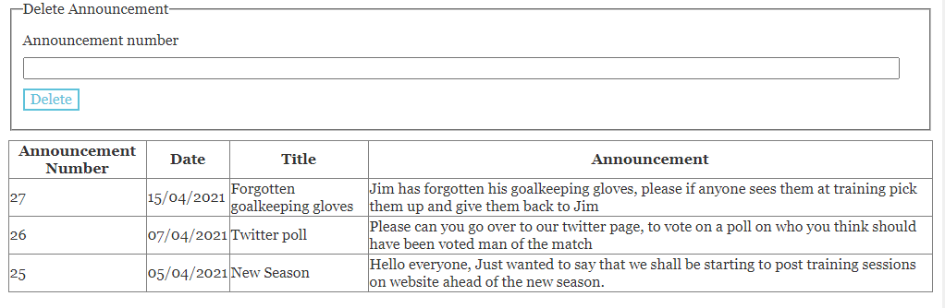

# Sessions

There are 3 part to sessions: Create Location, Create Session and Edit/Delete Session.

## Create Location

As locations can be repeated, you are able to create a location separate from creating a session.

To create a location, you will need to enter the following:

* Name: Enter Location Name. This is restricted to 50 characters. This is a required field.
* Address Line 1: Enter the first line of the address. This is restricted to 50 characters.
* Address Line 2: Enter the second line of the address. This is restricted to 50 characters.
* Address Line 3: Enter the third line of the address. This is restricted to 50 characters.
* Postcode: Enter the postcode of the address. This is restricted to 10 characters.
* Please click the submit button when this information has been entered.

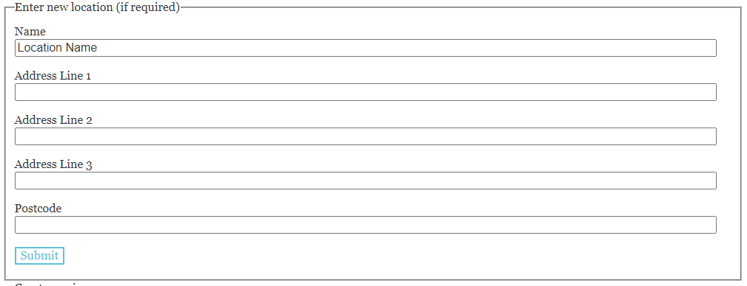

## Create Session

To create a session, you will need to enter the following:

* Type of Session: This is a dropdown list with the option between training and fixtures.
* Date: This is the date in which the session will take place. This is a required field.
* Time: This is the time in which the session will take place. This is a required field.
* Location: Please select from the dropdown list the name of the location in which the session will take place.
* Opposition: If you are facing any opposition teams for training or fixtures then please enter the name of the opposition. This is restricted to 50 characters.
* Kit colour: From the dropdown list please select the colour kit the players need to wear during the session.
* Contact Name: Please enter a contact name for the session. This is restricted to 50 characters.
* Contact Number: Please enter a contact number for the session. This is restricted to 12 characters.

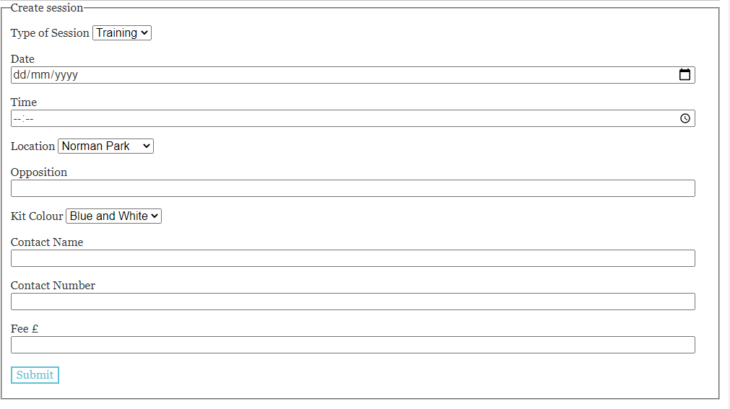

## Edit/Delete Session

The below table shows the list of upcoming sessions for Benhurst United.

To edit a user:

1. Click the edit button on the table of the row in which you want to edit.
2. You can change any information apart from the Session ID.
3. Click the button to update and make changes to the table/information or click cancel if you don’t wish for the changes to be made.

To Delete a Session:

Click the delete button on the row in which user you want to delete.

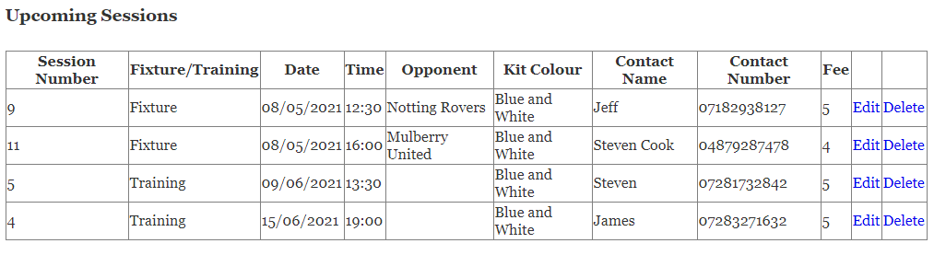

# Availability

The availability page is designed to either accept or reject a player for a session. If a player has registered their interest for a session, the manager can decide whether they want to accept the player onto the session.

To accept or reject a player from a session follow these steps:

* You can see the table of upcoming sessions. You must choose a session from the dropdown list.
* Click submit. This will bring up the players who have registered their interest in the session.
* Click the edit button on the row of the player you wish to edit.
* You can change Accept the Player on the session to “yes” or “no”
* Click the button to update and make changes to the table/information or click cancel if you don’t wish for the changes to be made.

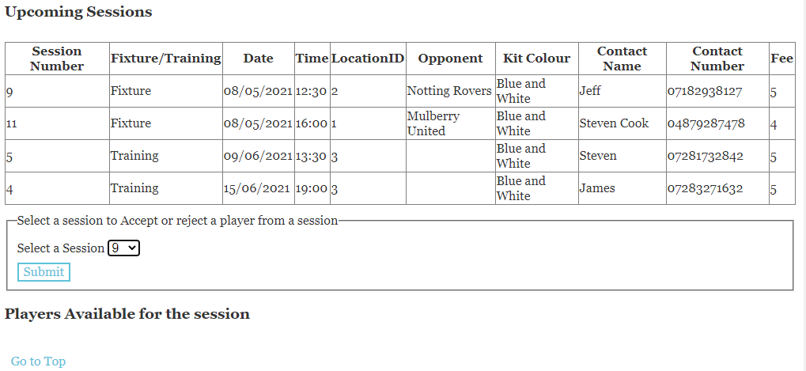

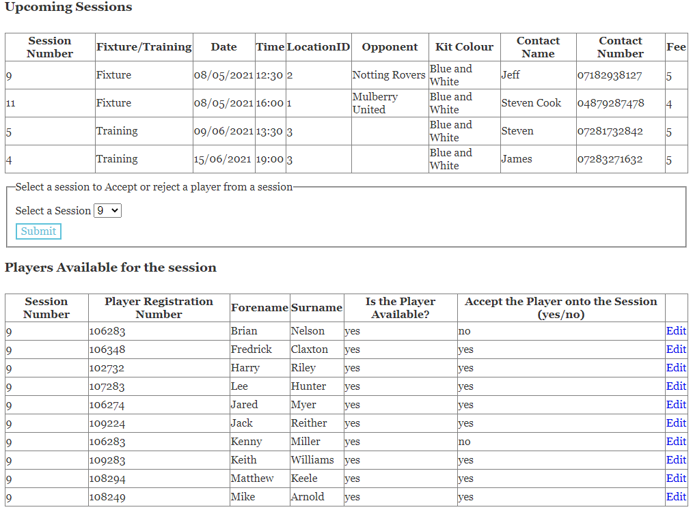

# Attendance

On the attendance page you will be recording on whether or a player attended or didn’t attend a session.

To confirm or deny a player attended follow these steps:

* You can see the table of past sessions. You must choose a session from the dropdown list.
* Click submit. This will bring up the players who were accepted onto a session.
* Click the edit button on the row of the player you wish to edit.
* You can change Did the Player Attend? on the session to “yes” or “no”
* Click the button to update and make changes to the table/information or click cancel if you don’t wish for the changes to be made.

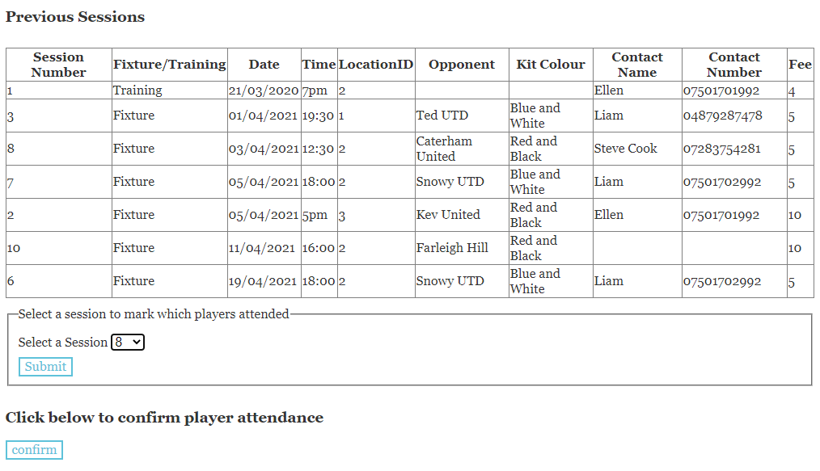

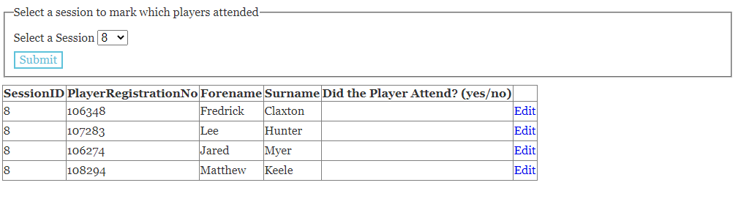

The last header on the page states Click below to confirm player attendance.

By clicking this button, you are confirming if a player has or has not attended. This will issue payments to the player if they did attend the session, this also allows you to enter player statistics to the players who attended.

# Payments

Upon typing in a player’s name or their registration number and clicking search, you can see the players outstanding payments. If there is a yes in Player stated paid, then there has been a message sent by the player indicating that they have sent their payment.

To edit the confirmation:

* Click the edit button on the row of the player you wish to edit.
* You can change Confirmation of payment received? on the session to “yes” or “no”
* Click the button to update and make changes to the table/information or click cancel if you don’t wish for the changes to be made.
* Upon issuing yes of completion this will then add the payment into historical payments.

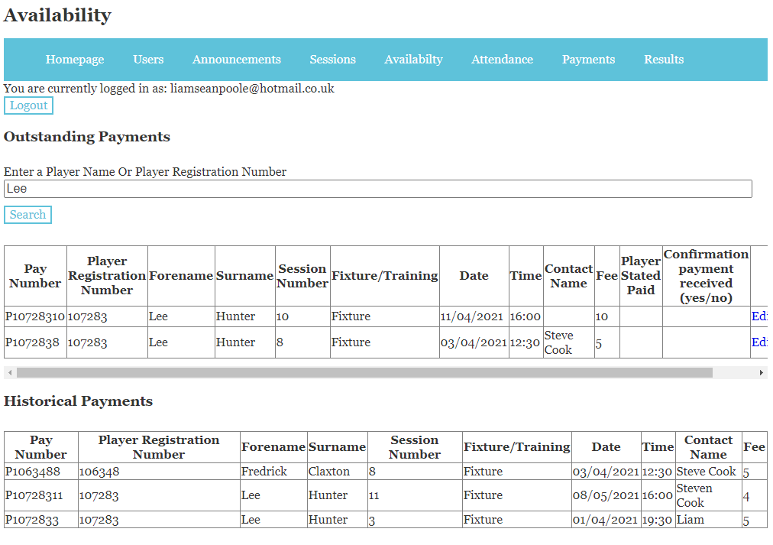

# Results

You can view previous matches that have taken place. To input the results and statistics you must first select a match number and click select.

The match result will appear where you will be able to edit the goals scored for and against Benhurst by clicking the edit button and clicking update.

To edit players stats:

* Click the edit button on the row of the player you wish to edit.
* You can change the amount of Goals, assists, yellows, reds and clean sheets
* Click the button to update and make changes to the table/information or click cancel if you don’t wish for the changes to be made.

