**Benhurst United Website Player User guide**

Please note that all information in this user guide is not real player/manager information.

Contents

Navigation around the website 2

Login 3

Homepage 5

Announcements 6

Sessions 6

Availability 8

Payments 9

Results and Statistics 10

# Navigation around the website

In order to Navigate around the website you are able to click links within the menu bar located near the top of the page. These links will take you to different web pages. ie clicking Login will take you to the login page.

1.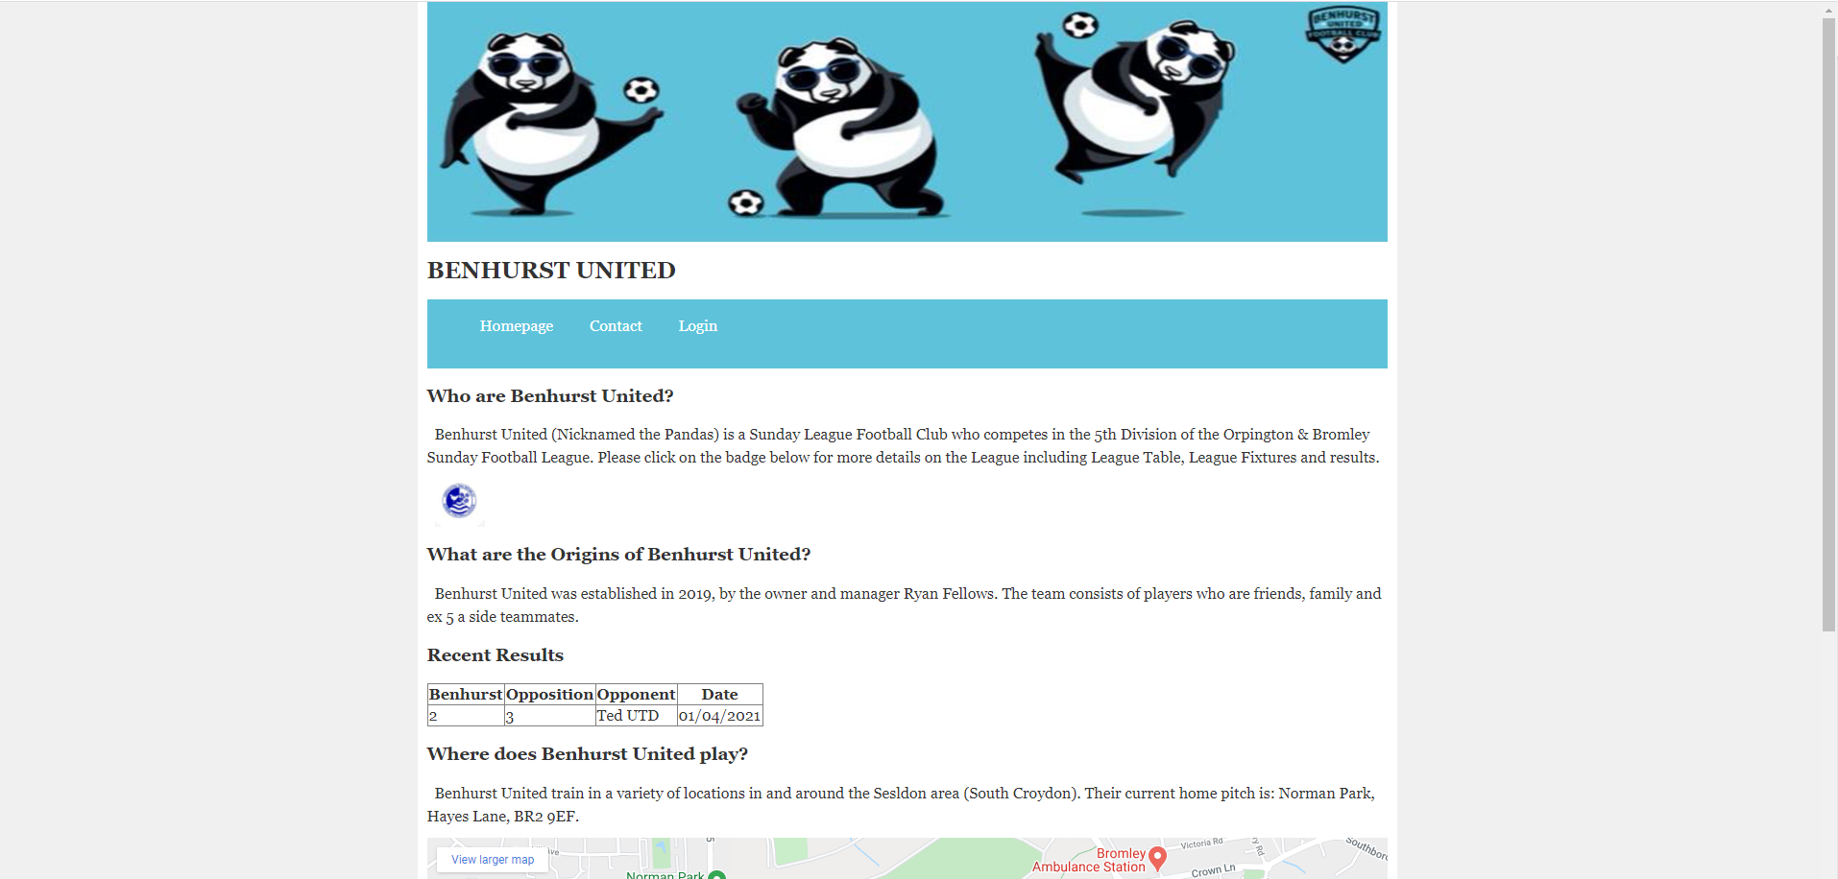

2.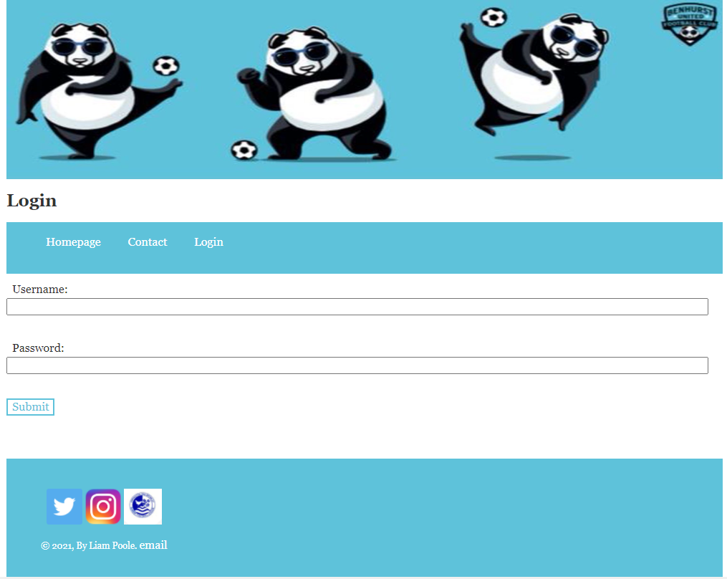

# Login

The login page consists of where you will be able to enter in your username and password to access your individual pages. A manager will need to create you as a user to login. The manager will give you your password and your username will be your email address.

1. Type in your email address in the username textbox.
2. Type in your password in the password textbox.
3. Click Submit.
4. You should then have access to your homepage.
5. Should you wish to logout, then please click the logout button underneath the menu.

Reasons error messages may display:

* A username must be an email address format and no more than 100 characters.
* The password needs to be at least 5 characters and no more than 50 characters.
* Your username and password must match the username and password within the system. (if you believe you are using the correct details, then please speak to a manager about resetting your details.

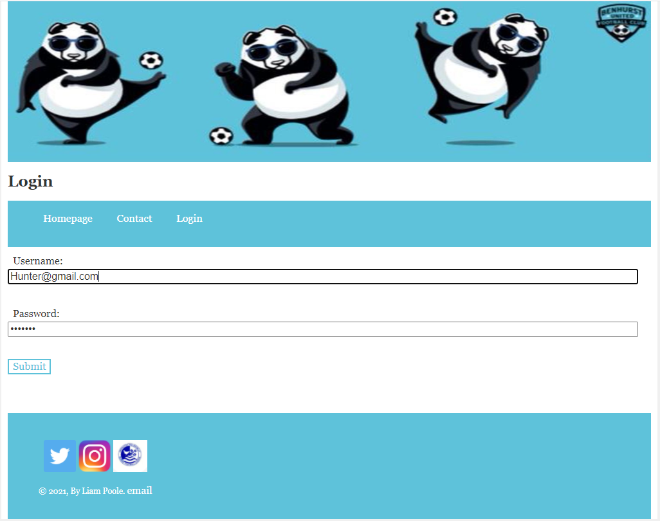

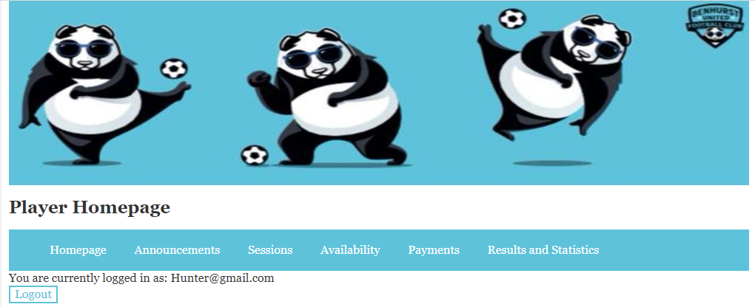

# Homepage

The homepage is the entry page after you have logged in, on this page there is a link to the user guide should you need.

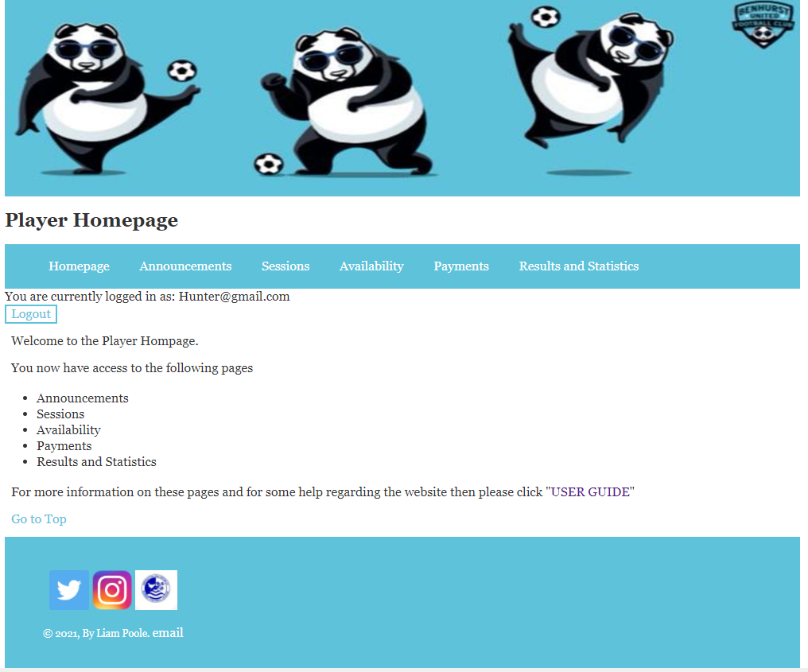

# Announcements

The Announcements page is for any managers to send any messages to all of their players. You will be able to see the announcements with the latest announcement at the top of the list.

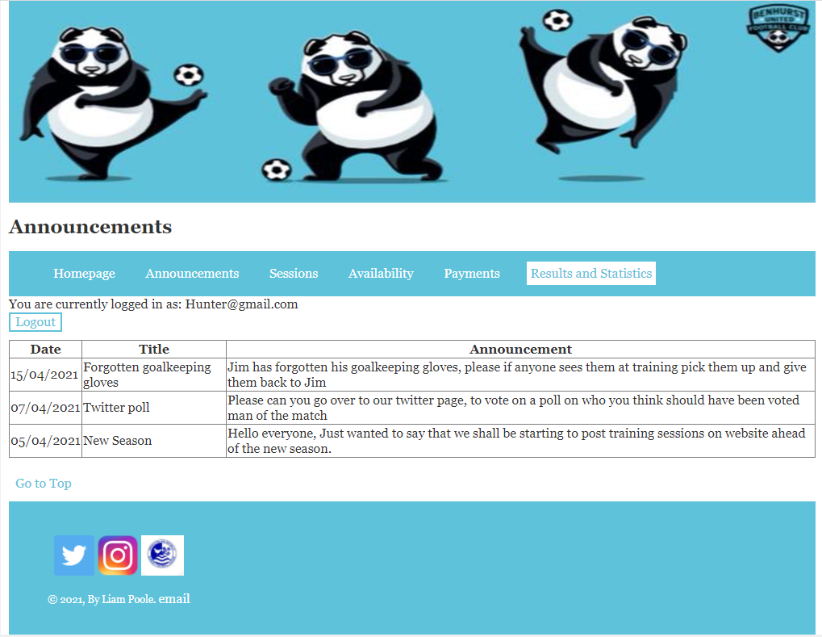

# Sessions

On the Sessions page, you will be able to view the upcoming Sessions, with the closest in time session at the top. You are also able to view as to which sessions you have registered your interest for.

How to register for a session?

1. Click on the dropdown box next to select a session
2. Choose the session number that you wish to attend.
3. Click submit.
4. As seen below, your page will update to show the session you have registered for.

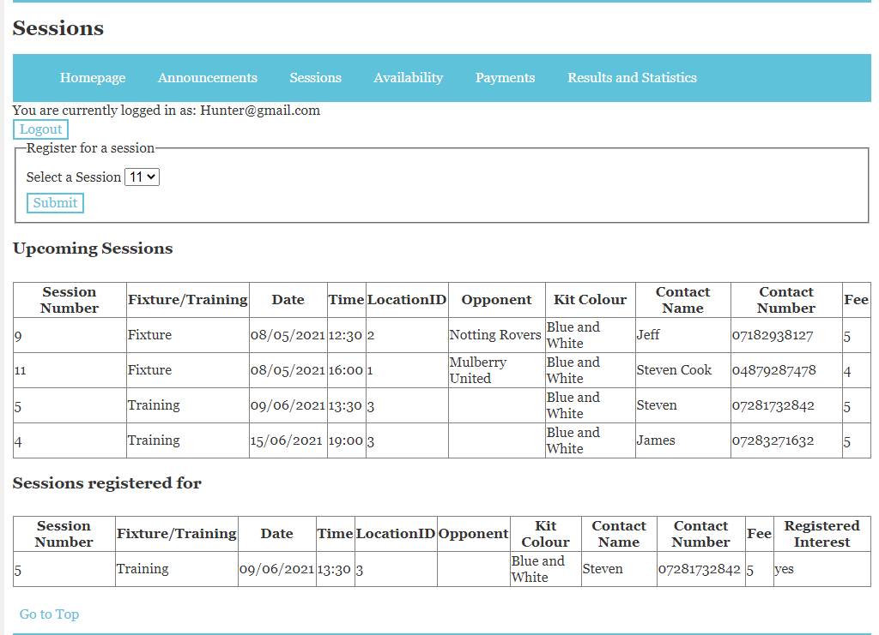

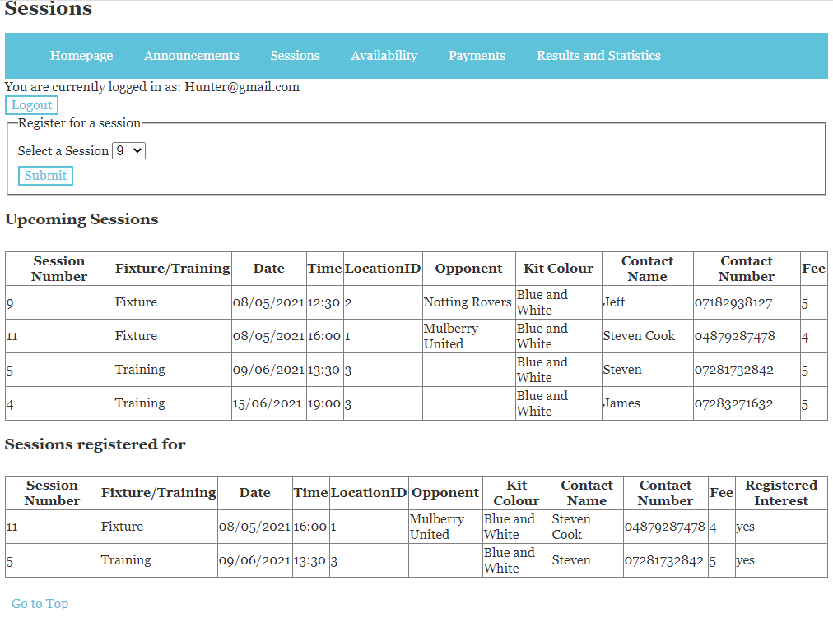

# Availability

On the Availability page you can view:

* Upcoming sessions that you registered for and the manager has accepted your request, therefore are able to attend the session.
* Upcoming sessions that you are still awaiting a response by a manager to accept whether you can join the session.
* Upcoming session that you are not able to attend as the manager has rejected your request.

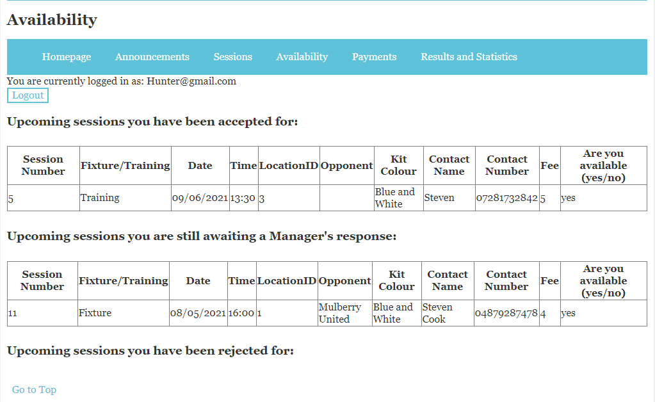

# Payments

On the payments page you can view any outstanding payments linked with your account.

The column paid, is to keep track on whether you believe you have sent the money across to the club.

The confirmation column is whether the club has received your payment.

To keep a record of when you have paid, once a payment of a session has been sent:

1. Type into the textbox the pay Number
2. Click submit
3. You should see in the column paid, this will switch to yes

Reasons error messages may display:

* The pay Number must start with a “p”
* The pay Number is a maximum of 100 characters
* The paid column will only update to paid, if the correct pay number is inputted

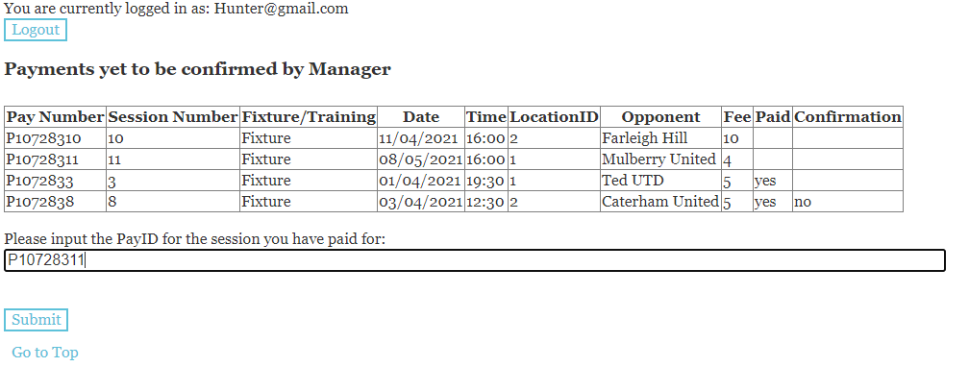

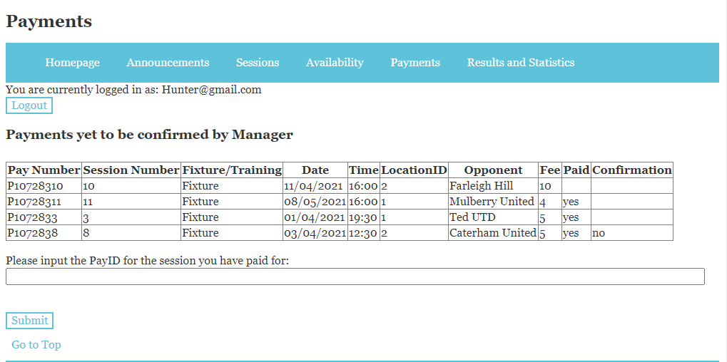

# Results and Statistics

On this page you can view Benhurst United’s results, with the most recent result at the beginning.

You are also able to view your personal overall statistics to see how many appearances you made as well as other stats.

