User documentation

# Introduction

## Purpose

This is the user documentation for mySURF project, it mainly aims to provide the website layout and operation manual for users. For more mySURF development details, please find in the Project Design Portfolio.

## Background

The mySURF.TV Web App will be serving as a media hosting website aimed to pique and attract recreational surfers’ interests all around Australia. The aim of this project is to expand sport development pathway and support Surfing Australia’s broader purpose, as well as to populate, promote, and commercialise programs provided by Surfing Australia. It is developed by mySURF project group in Griffith Trimester 1.

## Definitions, acronyms and abbreviations

|  |  |
| --- | --- |
| **Acronym** | **Definition** |
| CDN | Content Delivery Network - system for delivering web content to the user from the server. |
| API | Application Programming Interface - set of functions and procedures to allow applications to access features of another application or service. |
| SQL | Structured Query Language - standard language used to communicate with relational database management systems. |
| Laravel | PHP web application framework used for tasks such as authentication, routing, sessions and caching. |

# Installation

1. Install Laragaon via <https://sourceforge.net/projects/laragon/files/releases/4.0/laragon-full.exe/download>
2. Through laragon terminal ‘git clone <https://github.com/LiamSouthwell/mysurf.tv.git>'
3. Run composer update
4. Through laragon terminal ‘mv .env.example .env’
5. In terminal: ‘php artisan key:generate’
6. Within .env file change ‘DB_USERNAME=root’ and ‘DB_PASSWORD= ‘
7. Click “start all” button on laragon to start SQL and Apache
8. In terminal: ‘php artisan migrate:reset’
9. In terminal: ‘php artisan db:seed’
10. In terminal: ‘php artisan serve’
11. Check app is live at ‘localhost:8000’ on browser
12. Get node JS via <https://nodejs.org/en/>
13. Navigate to laragaon\www\mysurf.tv in WINDOWS command prompt and run ‘npm install’

# Overview

## Website guide

The figures below point out the layout of the mysurf.tv website, which includes two main pages, home page and video play page. They have the same top and bottom, on the top is a navigation bar. It has the links to latest/trending videos, login, dark mode change and there is a button to open the search bar. At the bottom of page are three external links, including Facebook, Instagram and link to Surfing Australia website.

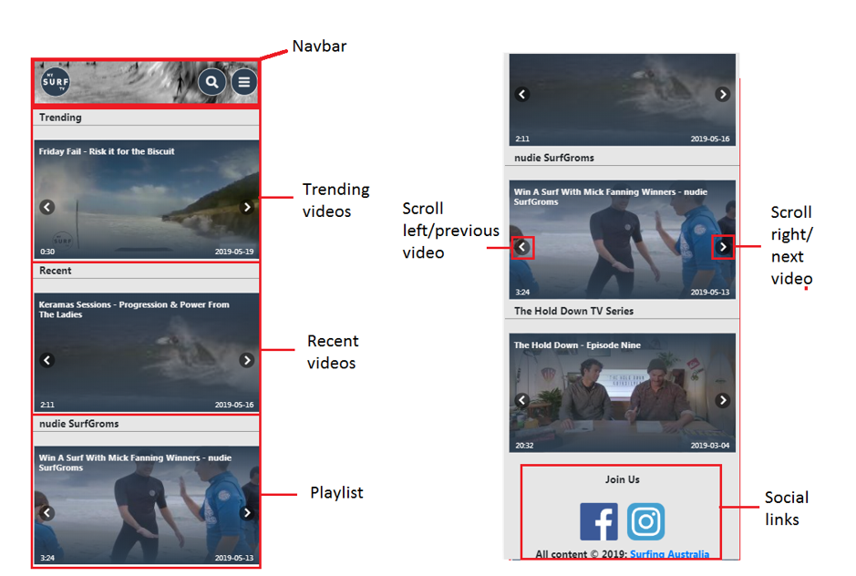

**Figure 1: Front page**

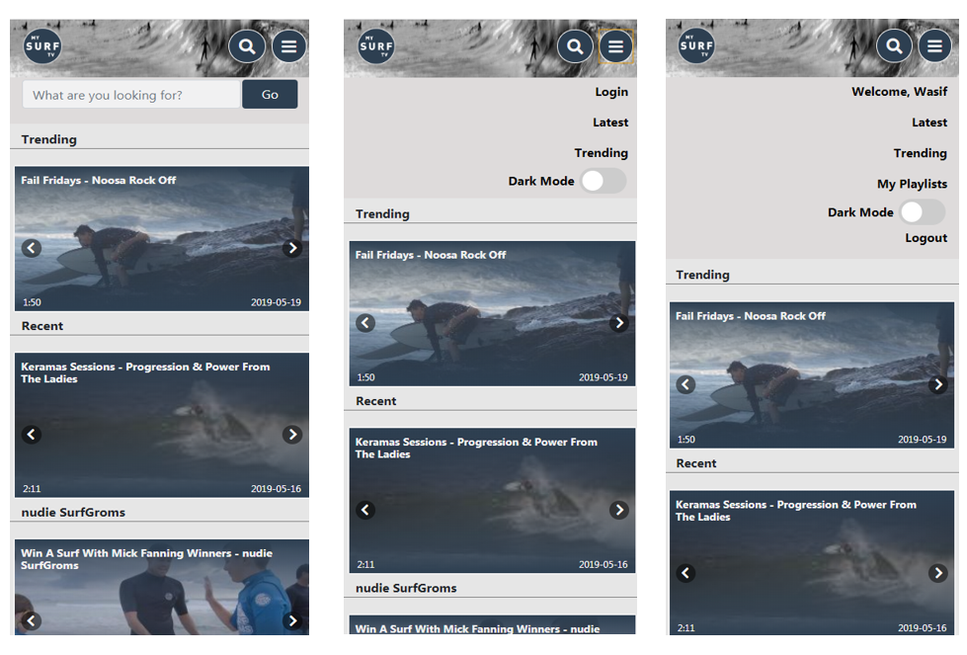

**Figure 2: Search bar and Navigation Bar**

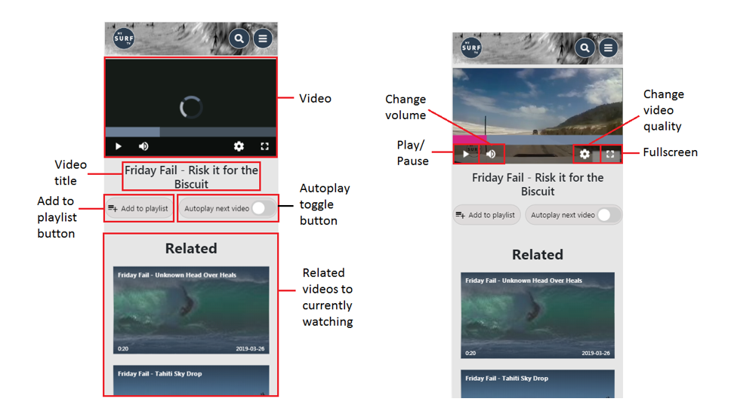

**Figure 3: Watch Video page**

## Website map

This is the mysurf.tv website map, which displays the structure of the mySURF project. (Red boxes can only be accessed by admins)

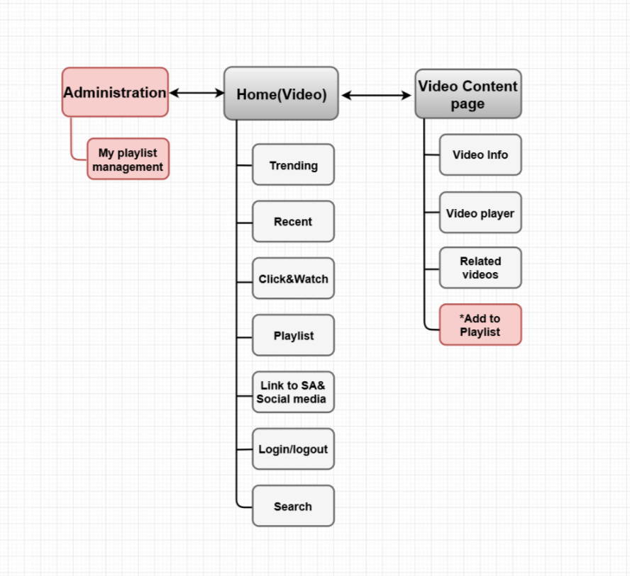

**Figure 4: Website Map**

# Operation manual

## Roles and user accounts

mySURF.TV divides app users into admin and users. A key reason for an admin role is for video and playlist management. A user account is not necessary to use the app, they can search/browse videos they like or directly play a video within an existing admin playlist. If a user wishes to save a video to their own playlist, they must login.

## Login

If a user has an existing login, they may login via the “Login” link in the navigation bar. (Highlighted in red) An admin may also login through here.

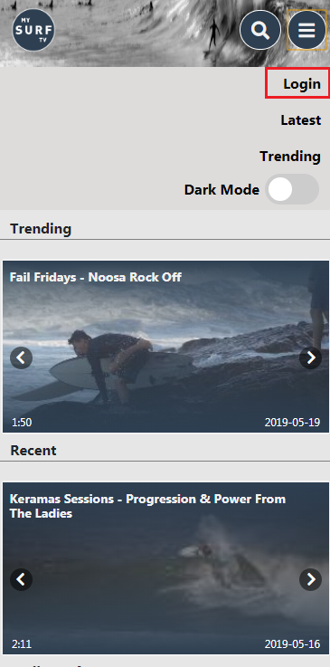

The following page will display, where a valid email and password must match to verify the user/admin account. There is also a “remember me” checkbox, which saves the user’s email. Next to the login button is a “Forgot your password” link which sends a verification email to the user’s email requesting to change the password immediately. If a user does not have an account refer to 3.3. Register.

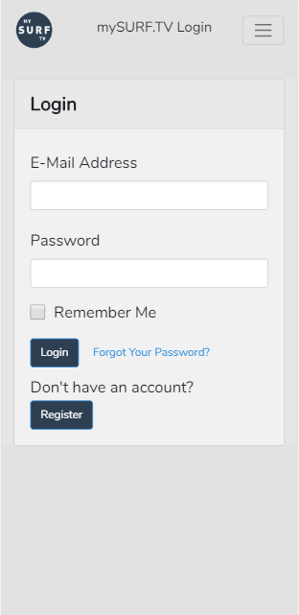

## Register

There are two ways to register a new user (highlighted in red):

1. Through the “Register” link in the collapsed navigation bar
2. “Register” button underneath “Don’t have an account?”

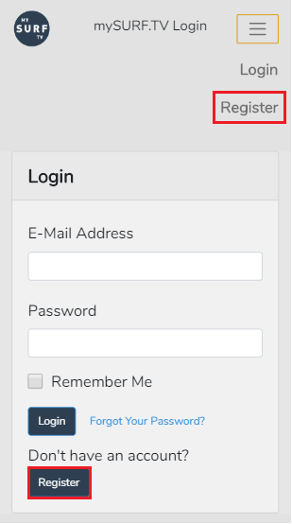

Once a user has clicked on either one they will be redirected to the register page as shown below.

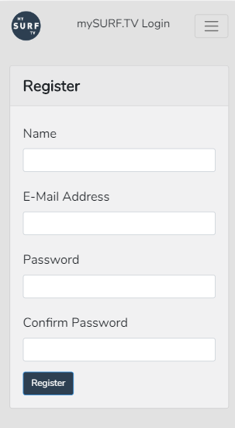

A user may then enter their name, email, password & confirm password before clicking the register button to confirm registration of their account.

## Video play

Users can click any videos thumbnail in the app to go to video play page. The video player provides pause/play, volume change, full screen and video quality change (at the bottom of the player).

mySURF also has an “autoplay next video” toggleable button underneath the video player to reduce users’ interaction when they are watching, allowing videos to continuously play. User’s may also add the video they are watching to their own playlist but must be logged in to perform this action.

The navigation bar and social links will remain at the top and bottom of video play page respectively.

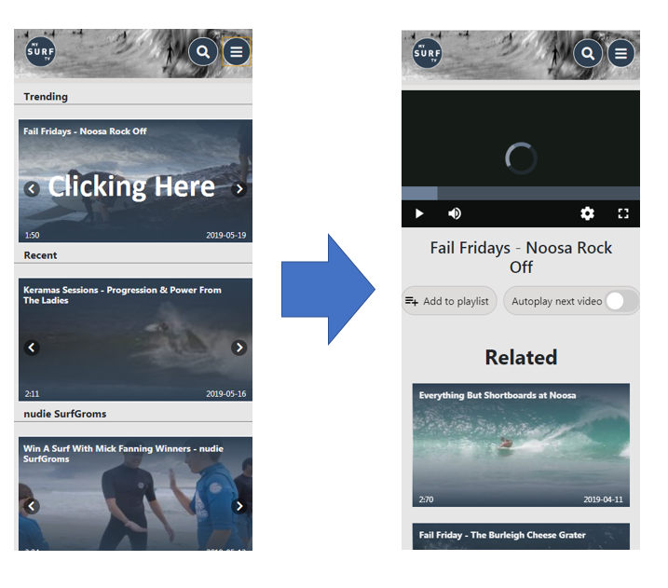

## Search

The search function is in the navigation bar and can be accessed by pressing the search icon button as shown below (highlighted red).

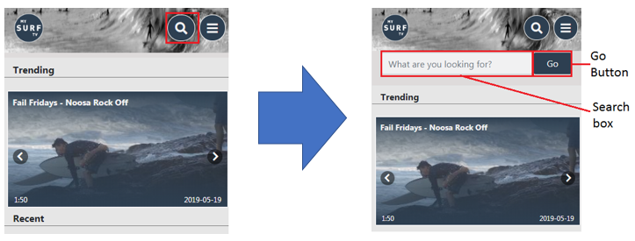

This is keyword searching, it will retrieve videos that containing the keywords you enter in the Search field. The results will be sorted by relevance.

## Videos & related videos system

mySURF will fetch videos from the Brightcove CDN and deliver them to viewers on the mySURF.TV web app. The platform will employ an endlessly generated video feed so that viewers will have a ready stream of content to watch. Related videos will show on the video play page underneath the video, it searches Brightcove videos by tags that the videos have in common.

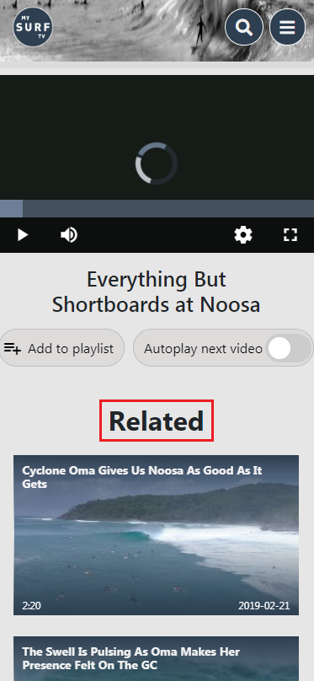

## Admin Playlists

Admin playlists provide users alternative video lists rather than search or choosing videos one by one. The playlists are displayed on the front page upon loading the app. The playlists can only be created by an admin account.

**Create playlist:**

Admin accounts can create a new playlist through /playlists. By clicking the “New Playlist” button, an admin is redirected to a form where they must enter the playlist name, playlist ID and what order number they want the playlist to display in.

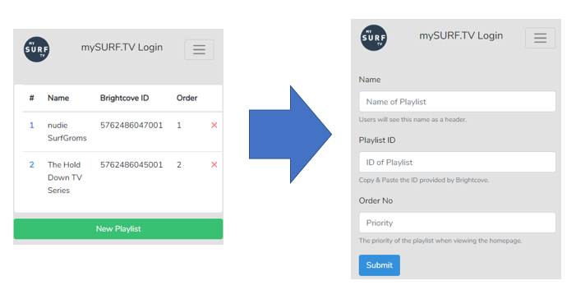

**Delete playlist:**

All admin playlists are displayed on the playlist page, each line is a playlist, there is a delete button (red cross) at the end of each line, the admin can click on this button to delete the selected playlist.

**Update playlist:**

There is a serial number at the start of each line, admin can click the number to modify the playlist details such as name, ID and order.

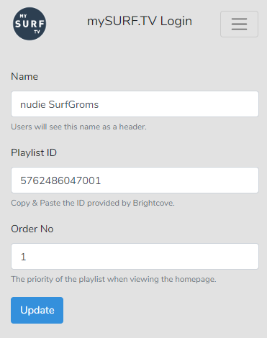

## User Playlists

Users can create their own playlists where they can add any videos they want. These playlists can be accessed through “My Playlists” within the navigation bar.

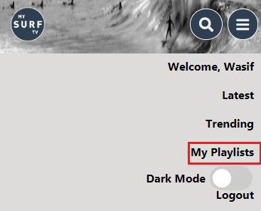

Here you can access the user’s playlists as shown below. A user may delete and add playlists through the respective buttons on this page.

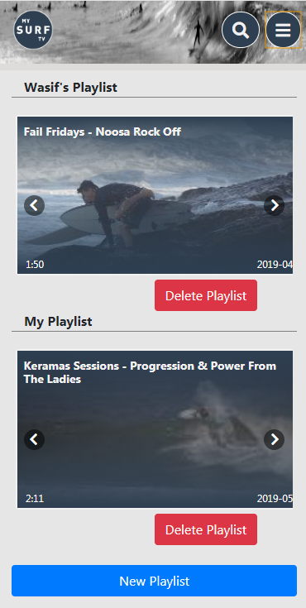

**Create playlist:**

Once a user has clicked the “New Playlist” button they will be prompted to enter a name for the playlist they are creating as shown below.

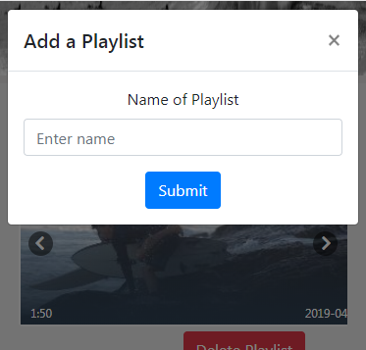

**Delete playlist:**

Using the “Delete Playlist” button a user may remove a playlist entirely from their account.

## Social links

At the bottom of website is a join us area, it offers three external links, which redirects the user to surfing Australia's Facebook, Instagram and Surfing Australia website respectively. The social media pages showcase the latest developments in surfing Australia. Surfing Australia will attract users to learn more about surfing-related content

