How to Setup a Very Simple Web Server
This is a tutorial for Windows.

Step 1
Download Ubuntu from the Microsoft Store.

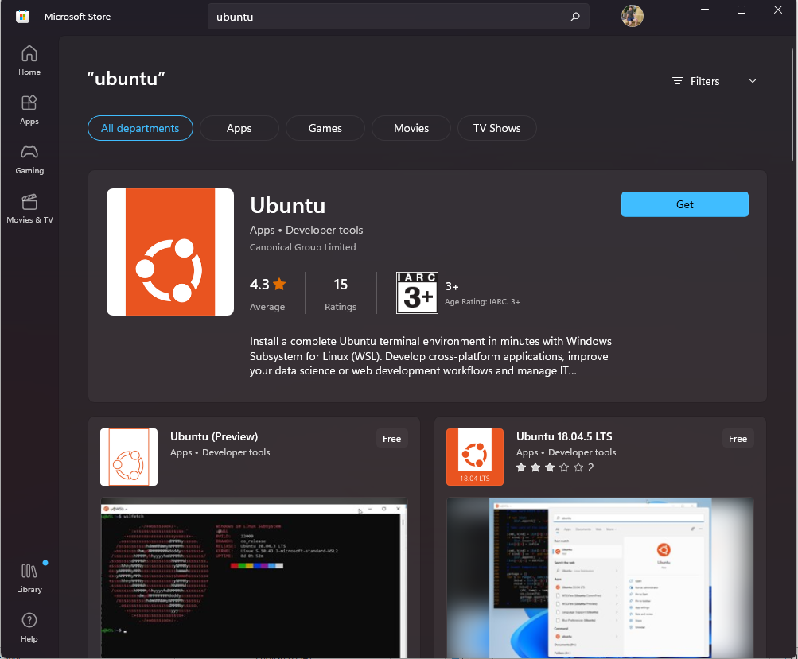
Step 2
Open it. It should look like a terminal.
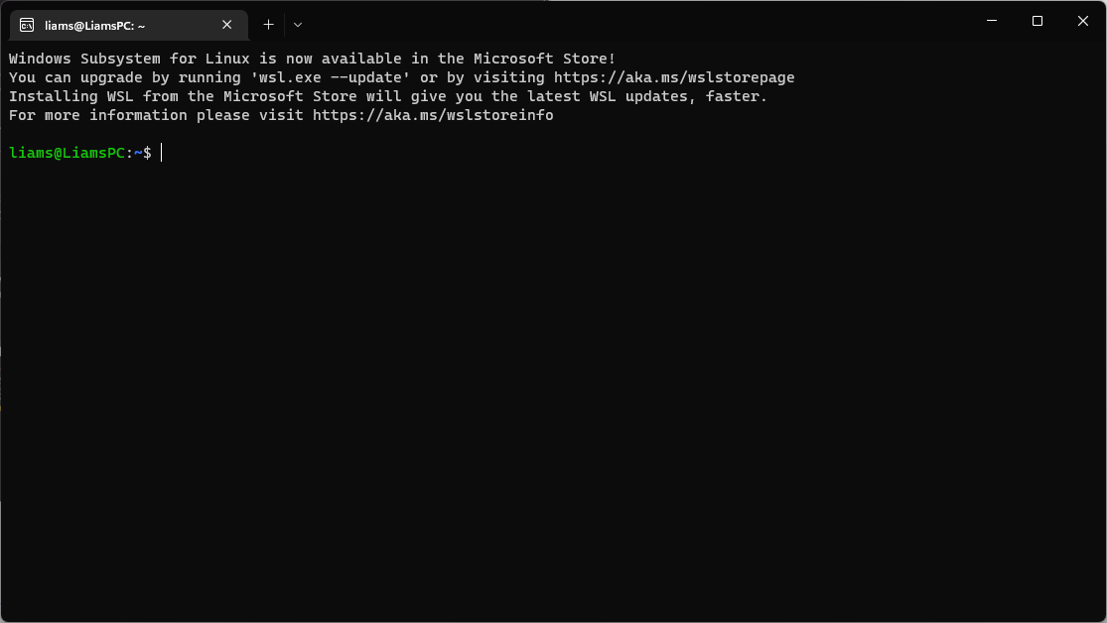
You might be asked to create a password. Once you are done, type in sudo apt install php and then type in your password if asked.

Step 3
Navigate to the directory (folder) the website is in with the cd command. If my website was in C:\Users\name\Documents\website then I would type cd /mnt/c/Users/name/Documents/website. It is important that you use forward slashes and put /mnt/ before the drive name and do not use a colon.

Step 4
Once you are in the folder the website is in (it should have an index.html file; this is the homepage.) type in sudo php -S localhost:80. You may be asked to put in your password again. This will start a PHP webserver in whichever folder you’re in. Now you can go into your browser, and if you type localhost into the address bar, then you should see the website.
If you want to stop the webserver from running, just close the Ubuntu terminal window, or if you want to use it further, press CTRL + C to kill the server.

This is not a very good guide and if something didn’t work then find a solution online.

