|  |
| --- |
| Find Me – Emergency Location Application |
| A Dissertation Presented  By  Liam Upstone-Smith  21017958  May 2024  Software Engineering for Business - 6F3B  University of the West of England |

## **Table of Contents**

**Table of Contents** 2

**Glossary** 3

**1.0 Introduction** 4

**2.0 Method** 5

**2.1 Risks** 5

**2.2 Suitable tools and methodologies** 6

**2.3 Ethics** 6

**2.4 Version Control Strategy** 7

**3.0 Research** 9

**3.1 Secondary Research** 9

**Crime Prevention** 9

**Natural Disasters** 10

**Global Positioning System** 11

**3.2 Technology selection** 12

**4.0 Requirements** 12

**4.1 Use-Cases** 12

**4.2 Functional Requirements** 14

**4.3 Non-Functional Requirements** 14

**4.4 Quality Assurance** 15

**5.0 Design** 15

**5.1 Software Architecture** 15

**5.2 UML Diagrams** 15

**5.3 Wireframes** 15

**6.0 Results** 16

**7.0 Conclusion** 16

**8.0 References** 17

* ADD SPACING AROUND BIG HEADERS
* DEBOLD SUB SUB HEADERS (CRIME PREVENTION)

## **Glossary**

|  |  |
| --- | --- |
| **Abbreviation** | **Explanation** |
| **XP** | *Extreme Programming* |
| **WIP** | *Work in Progress* |
| **SVN** | *Subversion* |
| **USAR** | *Urban Search and Rescue* |
| **UWB** | *Ultra-Wide Band* |
| **GPS** | *Global Positioning System* |
| **IDE** | *Integrated Development Environment* |
| **UX** | *User Experience* |
| **SMS** | *Short Message Service* |

## **1.0 Introduction**

In an increasingly interconnected world, the ubiquity of mobile technology has opened new avenues for enhancing personal safety and emergency responsiveness. This dissertation introduces an app designed to leverage the pervasive nature of smartphones to provide a critical lifeline during emergencies. There were 9,080 offences of rape reported to the metropolitan police in FY2022/2023 (Metropolitan police, 2023) as well as in 2022/23 there were 1,122 child abduction offences and 7,420 kidnapping offences reported by the police (Statista Research Department, 2023).

The application “Find Me,” facilitates users in critical situations to transmit their geographic coordinates to a preselected cohort of contacts, thereby enabling their discovery and provision of assistance. The primary objective of “Find Me” is to contribute to the deterrence of criminal activities and to offer support to individuals who might be impacted by natural disasters. In the aftermath of seismic events, for instance, an individual entrapped beneath debris may transmit their precise location to family and friends, potential enhancing the efficiency of rescue operations and augment ting the likelihood of survival.

Moreover, the “Find Me” application possesses utility in routine scenarios, such as instances where an individual may require assistance in locating a companion amidst unfamiliar surroundings. Despite the existence of analogous applications, like What3Words, which endeavours to partition the globe into tracts measuring three meters squared, each assigned a triad of words for identification purposes, there are inherent design flaws that impede their precision. Specifically, What3Words’ methodology of nomenclature has been critiqued for its propensity to engender confusion, with words that are phonetically similar yet semantically distinct—such as “band” and “banned,” “bare” and “bear,” “beat” and “beet”—leading to potential miscommunication and inaccuracies in location-sharing, particularly in situations where precise location data is of critical importance (Why What3Words is not suitable for safety critical applications, 2021).

Expanding on the day-to-day applications of “Find Me,” the app serves as a versatile tool for individuals to share their whereabouts with ease, whether they are meeting friends in a crowded festival, navigating through a complex urban environment, or ensuring family members can track their journey when traveling alone late at night. The app’s design circumvents the aforementioned issues by employing a more robust and user-friendly interface, which not only enhances the accuracy of location sharing but also ensures that users can rely on it for everyday conveniences and safety assurances. The integration of real-time location updates and the ability to share these updates with a trusted network of contacts makes “Find Me” an indispensable asset for modern, mobile individuals seeking to maintain connections and safety in a fast-paced world.

## **2.0 Method**

### **2.1 Risks**

In the context of project management, a risk mitigation plan is an essential component that serves as a strategic tool to identify, assess, and prioritize potential risks, with the aim of reducing the probability of their occurrence and minimizing their impact should they materialize. A risk mitigation plan necessitates a thorough analysis of the project’s scope and environment, allowing for the early identification of potential risks. This proactive approach enables project managers to foresee challenges and prepare strategies to address them effectively. By anticipating potential setbacks, a risk mitigation plan ensures that resources are allocated efficiently. It allows for the judicious use of time, budget, and human resources, thereby optimizing the overall resource management of the project. A well-structured risk mitigation plan enhances the confidence of stakeholders in the project’s success. It demonstrates a commitment to due diligence and conveys a message of preparedness, which can be pivotal in securing stakeholder support. Many projects operate within regulatory frameworks that mandate the implementation of risk management processes (European Commission, 2024). A risk mitigation plan ensures compliance with these regulations and helps avoid legal and financial penalties associated with non-compliance. It is imperative that risks are taken seriously and are accepted as part of the development cycle. The acceptance of risk necessitates vigilant monitoring to detect any alterations in the impact or probability of occurrence. It is imperative to continuously evaluate the risk, based on the risk to reward ratio, and determine whether the retention of risk remains the most judicious course of action. This assessment ensures that the decision to accept risk is aligned with the strategic objectives and my capacity to absorb potential losses [4 practical risk mitigation strategies for your business, 2023].

In my risk mitigation plan, as shown in DIAGRAM NUMBER, I have evaluated and rated each risk on the basis of its impact to the overall project, as well as the probability of the risk occurring. The assessment of risks I quantified on a numerical scale ranging from 1 to 10, with 10 denoting the highest likelihood potential impact on the project. For user convenience, a color-coding system has been employed. Furthermore, each identified risk is accompanied by a concise contingency plan, which, upon the occurrence of the respective risk, can be executed to either mitigate or avert the resultant consequences.

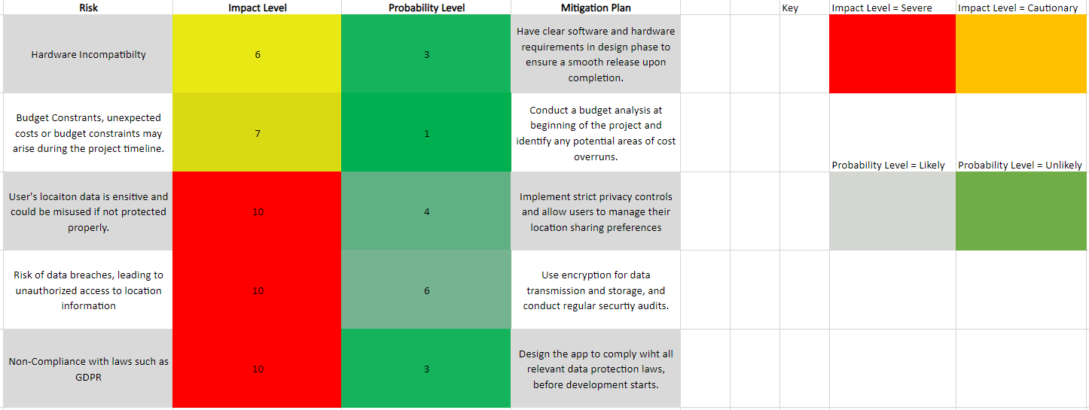

*DIAGRAM NUMBER: Risk Mitigation Plan*

### **2.2 Suitable tools and methodologies**

#### **Extreme Programming**

Extreme Programming (XP) is a software development methodology that emphasizes adaptability, collaboration, and quality. It was conceived to address the specific needs of software development conducted under stringent timelines, evolving requirements, and the imperative for high-quality output [Extreme Programming, 2024]. XP is a subset of the Agile Methodology and is characterized by its own set of practices and values.

Iterative Development is a core practice of XP, it states that software is developed in short cycles, allowing for frequent feedback and course corrections. I implemented this practice by breaking down the project into small, manageable iterations, settings goals for each cycle and evaluating progress at the end.

Another practice of XP is Pair Programming, this requires two programmers to work jointly on the same code. One person is writing the code, and the other is critiquing and suggesting improvements [Extreme Programming: Values, Principles, and Practices, 2021]. This makes the person writing the code to be more aware of each decision they make, due to being watched, this also allows for a second pair of eyes to catch any mistakes. While traditional pair programming wasn’t possible, as this is a solo project, I simulated the review process by regularly reviewing my code with a critical eye, as if another programmer were present.

While XP is typically a team-based methodology, its principles and practices can be effectively adapted for solo projects. The focus on testing, iteration, and continuous improvement is beneficial regardless of the team size. By implementing XP practices, I was able to maintain a disciplined approach to development, resulting in a robust and flexible codebase.

#### **Kanban**

Kanban is a lean and agile project management methodology that originated from the Japanese automotive industry and has since been adapted to software development and other knowledge work domains [What is Kanban? Free Kanban template, with examples, 2024]. It is designed to help teams work more efficiently by visualizing their workflow, limiting work in progress (WIP), and maximizing flow. The Kanban system is often embodied in a kanban board, a visual tool that allows team members to see the status of each piece of work at any given time.

Kanban uses cards or other visual signals to represent work items. I created a personal digital Kanban board with columns for “To Do,” “In Progress,” and “Done” to track my tasks. In addition, I set a limit of 3 tasks on the number of tasks in the “In Progress” column to ensure focus and prevent multitasking. I also implemented a color-coded system for each card. The colour represents several categories, for example: Research, Development, and design. This allows for a more efficient visualization of the different areas in the development lifecycle.

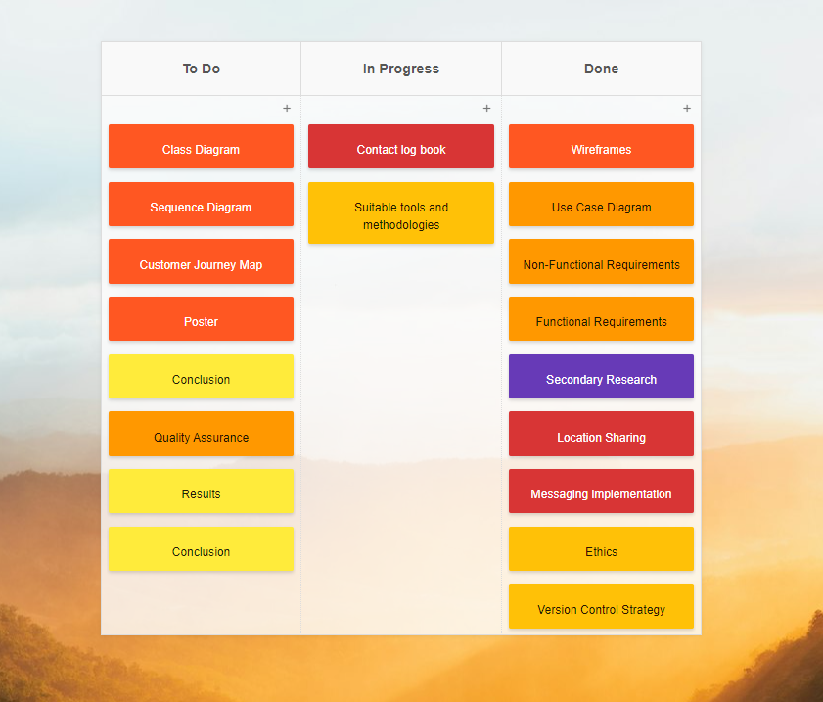

*FIGURE NUMBER: Kanban Board*

### **2.3 Ethics**

In the process of designing an emergency application that sends location details of a user to specific contacts when activated, a number of ethical considerations need to be taken into account. The primary concern here is ethics and as such, the issue is not just any privacy — it’s the user’s right to privacy. In order for users to give consent easily, they have to understand every detail regarding sharing their location data; this means that the app should clearly specify how and when location data will be shared through user-agreeable methods. Users should have the ability to choose whether or not they want to share their location with others (opt-in or opt-out) and control over who is included in their contact list. Security measures should also be prioritized due to the sensitivity of location information: unauthorized access can easily lead to breaches. This implies that apart from security protocols including encryption plus secure transmission methods, we need regular audits for security updates in place as well.

It is also necessary that the app maintains very high levels of precision and reliability. Error messages with false information or not being able to send geolocation data during real emergencies could have serious consequences. Therefore, comprehensive verification and quality assurance processes are ethical duties— they guarantee that the app's performance matches the seriousness of its critical task. These steps are vital: establishing trust and reliability in applications that take a lead role in emergency response situations is key to winning stakeholder confidence.

Software development isn't just about codes and programs. It's about the ethical responsibility that all those involved in creating an application have towards its functions and impact on society. We need clear protocols and a sense of responsibility— failure or misuses must be addressed with justice. Both developers and distributors should be held accountable through means that are not only transparent but fair, too; this is how we take care of the end-users' interests.

### **2.4 Version Control Strategy**

Version control, also known as source control. Is the practice of tracking and managing changes to software code. It is a fundamental tool in software development that allows individual developers and teams to work concurrently on code without the risk of conflicting changes. The primary objective of version control is to facilitate a detailed record of every modification made to the codebase. This historical perspective enables developers to understand the evolution of the software project, revert to previous states if necessary, and analyse the reasons behind each change.

There are two main types of version control systems: centralised and distributed. Centralised version control systems, such as Subversion (SVN), rely on a single server to store all versions of a project’s files [Centralized vs Distributed Version Control: Which One Should We Choose? 2023]. In contract, distributed version control systems, like Git, allow multiple copies of the entire codebase to exist on different developers’ machines, providing a more robust and flexible approach to version management [What is version control: centralized vs. DVCS, 2012].

In the course of this project’s development, diligent efforts have been made to utilize GitHub for robust version control measures. GitHub serves as a pivotal tool that enables the examination, revision, and distribution of any version of the project documentation, as and when required. This capability is of paramount importance for ensuring the integrity of the project’s historical record. The platform’s utility in this regard underscores its role in facilitating a systematic and transparent tracking of the project’s progression, thereby contributing to the reliability and reproducibility of the developmental process [Adapted from “Git vs GitHub – What is Version Control and How Does it Work?” 2020].

The selection of GitHub as the version control strategy was predicated on its compatibility and versatility, which rendered it an apparent choice. Nevertheless, despite its widespread popularity, GitHub is characterized by a steep learning curve. This aspect poses challenges for novice users in fully leveraging its capabilities. The complexities become particularly salient during self-directed learning endeavours. In the absence of structured guidance, individuals may experience a sense of disorientation and uncertainty regarding the initiation of their GitHub journey.

*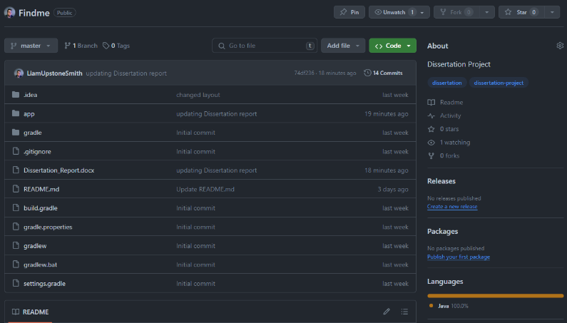DIAGRAM NUMBER: shows I have been routinely uploading and updating the files on the project’s repository on GitHub.*

*DIAGRAM NUMER: shows the number of times I have committed to the project’s repository, as well as the number of lines of code added and deleted.*

UPDATE THESE PICTURES

## **3.0 Research**

### **3.1 Secondary Research**

#### **Crime Prevention**

The perception of safety during nocturnal hours is a critical issue that significantly impacts the behaviour and well-being of individuals. This discomfort and fear experienced by a considerable segment of the population, particularly women, when walking alone at night, are substantiated by research findings. A survey conducted by the European Social Survey and reported by City, University of London, disclosed that 32% of British women feel unsafe walking alone at night, in stark contrast to 13% of men (Fitzgerald, 2021). This disparity is not isolated to the UK but is a recurring pattern across Europe, highlighting a widespread gender-based discrepancy in perceived safety. In the UK, the occurrence of kidnappings and stranger rape cases, although representing a small fraction of the overall crime statistics, remains a significant concern. The Office for National Statistics reported that 2.3% of adults aged 16 and over were victims of sexual assault (including attempts) in the year ending March 2022, translating to approximately 1.1 million adults. This statistic encompasses 798,000 women and 275,000 men (Office for National Statistics, 2023). Moreover, Rape Crisis England & Wales documented that 67,938 rapes were recorded by the police between October 2022 and September 2023, with charges being brought in merely 2.4% of cases (Rape Crisis England & Wales). These figures not only reflect the prevalence of such heinous crimes but also highlights the necessity of implementing effective measures to prevent them.

Despite the substantial number of reported assaults, it is posited that numerous incidents remain unreported to law enforcement agencies. This underreporting may stem from a variety of factors, with a lack of sufficient evidence being a primary consideration. Nevertheless, the introduction of the “Find Me” application may afford victims an additional proactive means to facilitate the apprehension and subsequent prosecution of their assailants. The data from the European Social Survey further elucidates the gender divide in safety perceptions, revealing that in all 29 countries included in the survey, men reported feeling safer than women while walking alone after dark (Fitzgerald, 2021). This consistent trend across different nations indicates a fundamental issue with the freedom of movement for women at night and calls for a deeper examination of societal norms and safety measures.

The Statistics provided by the Office for National Statistics and Rape Crisis England & Wales serve as a stark reminder of the prevalence of sexual assault and the challenged faced in bringing perpetrators to justice. The low percentage of charges brought against recorded rapes highlights systemic issues within the criminal justice process and the need for reform to ensure that victims receive the justice they deserve. The perception of safety while walking at night is a multifaceted issue that affects a significant portion of the population. The gender disparities in perceived safety, the prevalence of sexual assault, and the difficulties in securing convictions for such crimes emphasize the urgency for societal and systemic changes to enhance safety and justice for all individuals.

#### **Natural Disasters**

During Seismic events and other natural disasters, the rapid onset of chaos and destruction can lead to situations where individuals become trapped in collapsed structures or isolated areas. The disarray caused by such events often disrupts communication infrastructure, making it challenging to ascertain the location of those in need of rescue. The collapse of buildings and other structures during earthquakes can result in individuals being trapped, often without immediate access to essential resources like food, water, or medical assistance. The likelihood of survival for these individuals diminishes over time, making the rapid location and extraction of trapped individuals a critical aspect of disaster response efforts (Macintyre et al., 2006). A major challenge in locating trapped victims is the disruption of communication networks, which are crucial for coordinating rescue operations and enabling victims to signal for help. Moreover, the destruction of infrastructure can severely limit the accessibility of affected areas, further complicating rescue efforts (Ko et al., 2023). Urban Search and Rescue (USAR) units are strategically mobilized to regions recently afflicted by seismic disturbances. Contemporary technological progress has facilitated the augmentation of these teams with sophisticated equipment, including acoustic and seismic detection devices, Ultra-Wide Band (UWB) rescue radar systems, and canines proficient in olfactory search techniques to locate individuals by scent [How Search and Rescue Teams Find Survivors After Earthquakes, 2023]. The unpredictability of natural disasters necessitates a proactive and adaptable approach to disaster management. While technology has significantly improved the ability to locate and rescue trapped individuals, the importance of disaster preparedness and the development of resilient infrastructure cannot be overstated (Statcheropoulos et al., 2014, p.66).

In the context of disaster response, the prompt deployment of emergency teams to search for and rescue trapped victims is commendable. However, the criticality of time in such scenarios necessitates a more efficient approach to locating victims. The integration of technology that enables victims to emit a location signal would significantly enhance the effectiveness of rescue operations. This proactive measure would not only expedite the location process but also optimize the allocation of search resources, The concept of a victim-operated beacon system introduces a paradigm shift from a solely reactive emergency response to a more dynamic and interactive model. It embodies the principle of self-advocacy in crisis situations, allowing victims to actively contribute to their own rescue efforts. From a critical standpoint, the implementation of such a system raises questions about accessibility and equity. Ensuring that all individuals, regardless of socioeconomic status, have access to beacon technology is paramount. It is projected that in 2024, the global smartphone user base will have expanded to encompass approximately 7.1 billion individuals [How Many People Own Smartphones? 2024]. Based on this, to allow the emergency signal technology to be robust, universally accessible, and intuitive to ensure widespread adoption, an app that facilitated this technology would ensure the most coverage across the world. The app should function across diverse devices, support multiple languages, and be sensitive to cultural nuances. Addressing the digital divide is essential for equitable access. Collaborative efforts are needed to integrate this technology into existing emergency infrastructure, making it a reliable tool for individuals worldwide to signal for help. Thereby democratizing access to life-saving assistance during emergencies.

#### **Global Positioning System**

The Global Positioning System (GPS) is a satellite-based navigation system that provides location and time information in all weather conditions, anywhere on or near the Earth. It is maintained by the United States government and is freely accessible to anyone with a GPS receiver. GPS operates on the principle of trilateration. For this, a GPS receiver measures the distances to satellites using the travel time of radio signals [How GPS Receivers Work – Trilateration vs Triangulation, 2024]. To calculate precise locations, the receiver must be able to access signals from at least 3 satellites [GPS – Who, What, Where?]. The system consists of a constellation of at least 24 satellites in medium Earth orbit. These satellites are positioned in such a way that at any given time, a receiver on Earth has line-of-sight to at least 4 satellites. Each satellite transmits coded signals at precise intervals [Space Segment, 2022]. In conclusion, GPS is a testament to human ingenuity and cooperation. It exemplifies how technology can transcend boundaries to become an indispensable part of daily life, enhancing safety, efficiency, and our understanding of the world.

### **3.2 Technology selection**

Android Studio is an Integrated Development Environment (IDE) tailored for Android application development. It is built upon IntelliJ IDEA, providing a comprehensive toolset for developers to create Android apps. This IDE includes a variety of tools that facilitate the development process, such as a code editor, debugger, and performance profilers. Android Studio is designed to support the entire application development lifecycle, which encompasses writing code, managing resources, debugging, testing, and deployment. The code editor in Android Studio offers syntax highlighting, code completion, and refactoring capabilities. It supports programming languages like Kotlin, Java, and C++, which are prevalent in Android app development (JetBrains). However, due to my experience, especially during my time at university, I have chosen to use Java as the primary programming language of this project. Android Studio employs Gradle as its build automation system, which automates tasks such as compiling the application and managing dependencies (Gradle Inc.). The IDE includes a versatile emulator that simulates various Android devices, allowing developers to test their application across different configurations without the need for physical devices (Google, 2023).

## **4.0 Requirements**

### **4.1 Use-Cases**

A use case diagram is a graphical representation that outlines the functional requirements of a system, particularly in the context of software development. It serves to depict the interactions between users, referred to as actors, and the system itself, to achieve specific goals or tasks. The primary purpose of a use case diagram is to provide a high-level view of the systems functionality and the roles of various actors without delving into the internal workings of the system [What is the Use Case Diagram? Definition, Uses, Examples, and UML Use Case Diagram, 2024].

In DIAGRAM NUMBER there are 2 actors, User and Emergency Contact. The user represents anyone who uses the app, and the Emergency Contact is who the “SOS” location alert is being sent to.

The user has access to ‘Manage Contact List’, which allows them to see their current list of contacts that will be sent the emergency alert message, if the “SOS” button is pressed. The ‘Manage Contact List’ has 3 generalisation relationships: ‘Add Contact’, ‘Edit Contact’, and ‘Remove Contact’ [Relationships in use-case diagrams, 2021]. This relationship is used because ‘Manage Contact List’ is the parent use case and is required for the other 3 use cases (child use cases) to function. The ‘Press Emergency Button’ use case has an inclusive relationship with ‘Send Location’. This is because sending the users location to the emergency contact, requires the activation of the emergency button. ‘Send Location’ has an inclusive relationship with ‘Manage Contact List’ as the app must know who to send the alert to, before sending it. ‘Send Location’ also has an inclusive relationship with ‘Send Message’ and ‘Receive Alert’, this is because they all depend on each other to function correctly. The ‘Emergency Contact’ only has access to one use case, since their only interaction with the app is receiving an emergency alert of the user’s location.

A possible interaction a user may have with the app, starts with them going to ‘Manage Contact list’ and ‘Add Contact’, this allows them to add a phone number and name of their chosen emergency contact. Then when they’re in an emergency situation they activate the “SOS” Button, leading us to ‘Press Emergency Button’ use case that will then make use of ‘Send location’ and ‘Send message’ to send the emergency message to the list of chosen contacts. The Emergency contact then receives the message.

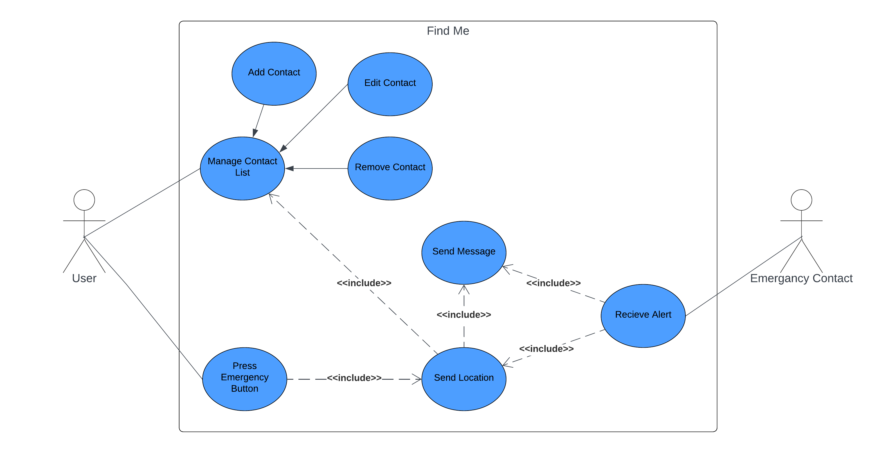

*DIAGRAM NUMBER: Use Case Diagram*

### **4.2 Functional Requirements**

|  |  |  |
| --- | --- | --- |
| Functional Requirement No. | Functional Requirement | Description |
| FR1 | Emergency Alert Activation | A simple and convenient method for users to activate the emergency alert, such as a button or voice command. |
| FR2 | Location Services | The app must access real-time location data of the user’s device. |
| FR3 | Privacy Settings | Users must have control over their privacy settings, deciding when and to whom their location is shared. |
| FR4 | Contact Management | Users should be able to add, edit, and remove contacts from their emergency list. |
| FR5 | Accessibility Features | The app should be accessible, with features like large buttons, voice commands, and compatibility with screen readers. |

### **4.3 Non-Functional Requirements**

|  |  |  |
| --- | --- | --- |
| Non-Functional Requirement No. | Non-Functional Requirement | Description |
| NFR1 | Performance | The app should have a fast response time, especially for sending location alerts, with minimal latency. |
| NFR2 | Reliability | The app must function correctly and consistently, delivering accurate location data without fail. |
| NFR3 | Security | The app must ensure the confidentiality and integrity of user data, employing strong encryption for data transmission. |
| NFR4 | Maintainability | The app should be easy to maintain and update, with clear documentation for future enhancements and bug fixes. |

### **4.4 Quality Assurance**

ISO/IEC 9126

## **5.0 Design**

### **5.1 Software Architecture**

### **5.2 UML Diagrams**

### **5.3 Wireframes**

Wireframes are a key tool used in software design, serving as a blueprint that guides the development of the application. Wireframes strip away visual design to concentrate on the app’s functionality. This helps to focus on creating a logical flow and intuitive interface, which are essential for a successful app [The Role of Wireframes in App Development, 2023]. By focusing on the layout and interaction without the distraction of visual design elements, wireframes allow designers to prioritize the user experience (UX). They enable you to map out the user journey, identify potential usability issues, and refine the app’s navigation to enhance the overall user experience [What are wireframes and why they help with web and app design? 2024].

In my wireframes, as shown in DIAGRAM NUMBER, I have made a clear layout for the “Home Page”, “Contacts Page”, and the “Add Contact Page”. In the “Home Page” there is a title as well as 3 buttons, that are the SOS emergency button, button to go to contacts page, and button to go to settings. The “Contacts Page” shows cards that will be filled with the all the selected contact’s name and phone numbers. As well there is a add button in the top right corner, that leads to the “Add Contact Page”. In the “Add Contact Page” there is simply 3 text fields for the user to fill in, giving the first name, last name, and phone number of the contact the user wishes to add. The “Add Contact” button at the bottom of the screen, saves the details provided and adds them to the list of people that will be contacted if the “SOS” button (on the homepage) is pressed.

*DIAGRAM NUMBER: Wireframe for Home page, Contacts page, and Add Contact page.*

## **6.0 Results**

the following figures walkthrough a possible use case of the “Find Me” application. The figures show examples of both Android and IOS Short Message Service (SMS) messages being received by an emergency contact.

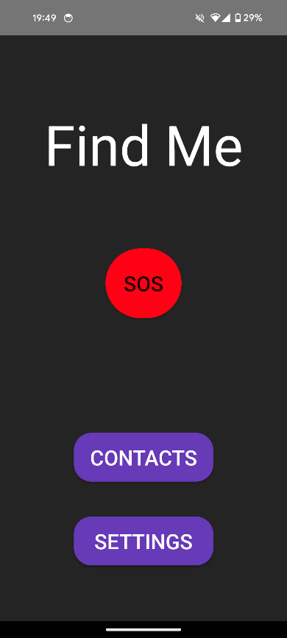

FIGURE NUMBER shows the homepage of the app on an Android Google Pixel 8. In the centre of the screen is the red “SOS” button, which once pressed sends the SMS message to the list of contacts.

FIGURE NUMBER: “Find Me” app home page.

FIGURE NUMBER shows the activation of the button, resulting in the display of the “Toast” (at bottom of screen), this states that the “SMS sent successfully!”.

*FIGURE NUMBER: successful message sent Toast.*

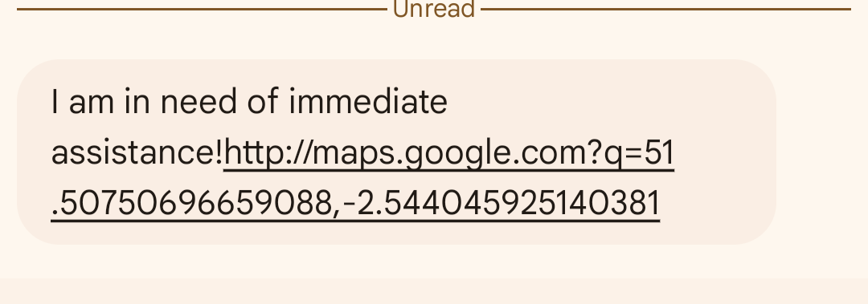

FIGURE NUMBER shows the message sent to a contact, on Android SMS messaging.

*FIGURE NUMBER: Message received on android.*

FIGURE NUMBER shows the message sent to a contact, on IOS SMS messaging.

*FIGURE NUMBER: Message received on IOS.*

### **6.1 Traceability Matrix**

I have created a traceability matrix that clearly displays different test cases, the specific part of the software it is testing, the status of the test, as well as any notes regarding the results of the test. A traceability matrix, often referred to as a requirement traceability matrix (RTM, is a document that connects requirements throughout the validation process. It serves as a guide to ensure that all requirements defined for a system are tested in the test protocols. The matrix is bidirectional, allowing for full traceability and providing a clear visualization of the progress of the project.

The primary purpose of a traceability Matrix is to:

* Validate that all requirements are covered by test cases.
* Track the status of requirements throughout the project lifecycle.
* Identify any changes to requirements and ensure that all stakeholders are informed of these changes.
* Detect any gaps between the requirements and the deliverables.

The use of a traceability matrix particularly critical in complex projects where numerous tests are required to validate a variety of requirements. It is an essential tool for project managers, quality assurance teams, and stakeholders to ensure that the final product meets the initial specifications and to facilitate communication regarding the project’s progress and quality [What Are Requirements Traceability Matrix: With Examples, 2023].

*FIGURE NUMBER : Requirement Traceability Matix*

## **7.0 Conclusion**

* Insightful and critical reflection on the development process, including lessons learned.
* 300-600 words

## **8.0 References**

4 Practical risk mitigation strategies for your business (2023) *MondayBlog.com* [online]. 22 November. Available from: <https://monday.com/blog/project-management/risk-mitigation/> [Accessed 30 April 2024].

Centralized vs Distributed Version Control: Which One Should We Choose? (2023) *GeeksforGeeks.com* [online]. 22 February. Available from: <https://www.geeksforgeeks.org/centralized-vs-distributed-version-control-which-one-should-we-choose/> [Accessed 30 April 2024].

Extreme Programming. (2024) *Wikipedia.org* [online]. 30 January. Available from: <https://en.wikipedia.org/wiki/Extreme_programming> [Accessed 07 May 2024].

Fitzgerald, R. (2021) Survey Shows 32% of British women don’t feel safe walking alone at night – compared to just 13% of men. *The Conversation* [online]. 18 March. Available from: <https://theconversation.com/survey-shows-32-of-british-women-dont-feel-safe-walking-alone-at-night-compared-to-just-13-of-men-157446> [Accessed 29 April 2024].

Git vs GitHub – What is Version Control and How Does it Work? (2020) *FreeCodeCampe.org* [online]. 19 August. Available from: <https://www.freecodecamp.org/news/git-and-github-overview/> [Accessed 23 April 2024].

Google (2023) *Android Developers*. Available from: <https://developer.android.com/studio/run/emulator> [Accessed 06 May 2024].

GPS – Who, What, Where? (No Date) *Actisense.com* [online]. Available from: <https://actisense.com/news/gps/#:~:text=A%20minimum%20of%203%20Satellites,only%20measures%20distance%2C%20not%20angles.&text=Trilateration%20works%20by%20using%20the,the%20distance%20from%20each%20satellite>. [Accessed 06 May 2024].

Gradle inc. (No Date) *Gradle Build Tool.* Available from: <https://gradle.org/#close-notification> [Accessed 06 May 2024].

How GPS Receivers Work – Trilateration vs Triangulation. (2024) *GISGeography.com* [online]. 13 March. Available from: <https://gisgeography.com/trilateration-triangulation-gps/> [Accessed 06 May 2024].

How Many People Own Smartphones? (2024) *WhatsTheBigData.com* [online]. 31 January. Available from: <https://whatsthebigdata.com/smartphone-stats/> [Accessed 29 April 2024].

How Search And Rescue Teams Find Survivors After Earthquakes. (2023) *FireBuyer.com* [online]. 02 March. Available from: <https://firebuyer.com/how-search-and-rescue-teams-find-survivors-after-earthquakes/#:~:text=When%20the%20UWB%20radar%20sensor,very%20quickly%20in%20real%20time> [Accessed 29 April 2024].

JetBrains (No Date) *JetBrains.com.* Available from: <https://www.jetbrains.com/idea/> [Accessed 06 May 2024].

Ko, Y.Y., Tsai, C.C., Chu, M.C., Hwang, Y,W., Ge, L. (2023) Failure of engineering structures and associated geotechnical problems during the 2022Ml 6.8 Chihshang earthquake, Taiwan. *Natural Hazards* [online] 118, pp. 55-94. [Accessed 29 April 2024].

Macintyre, A.G., Barbera, J.A. and Smith, E.R. (2006) *Surviving Collapsed Structure Entrapment after Earthquakes: A “Time-to-Rescue” Analysis* [online]. Cambridge: Cambridge University Press. [Accessed 29 April 2024].

Metropolitan Police. (2023) *End of Year 2022/23 TNO crime Dashboard* [online]. London: Metropolitan Police. Available from: https://www.met.police.uk/sd/stats-and-data/met/year-end-crime-statistics-22-23/ [Accessed 23 April 2024].

Office for National Statistics. (2023) *Sexual offences in England and Wales overview: year ending March 2022* [online]. London: Office for National Statistics. Available from: <https://www.ons.gov.uk/peoplepopulationandcommunity/crimeandjustice/bulletins/sexualoffencesinenglandandwalesoverview/march2022> [Accessed 29 April 2024].

Rape Crisis England & Wales (no date) *Rape and sexual assault statistics*. Available from: <https://rapecrisis.org.uk/get-informed/statistics-sexual-violence/> [Accessed 29 April 2024].

Relationships in use-case diagrams. (2021) *IBM.com* [online]. 04 March. Available from: <https://www.ibm.com/docs/en/rational-soft-arch/9.6.1?topic=diagrams-relationships-in-use-case> [Accessed 27 April 2024].

Space Segment (2022) *GPS.Gov* [online]. 28 June. Available from: <https://www.gps.gov/systems/gps/space/> [Accessed 06 May 2024].

Statcheropoulos, M., Agapiou, A., Pallis, G.C., Mikedi, K., Karma, S., Vamvakari, J., Dandoulaki, M., Andritsos, F., and Paul Thomas., C. L. (2014) Factors that affect rescue time in urban search and rescue (USAR) operations. *Natural Hazards* [online]. 75, pp. 57-69 [Accessed 29 April 2024].

Statista Research Department (2023) *Number of Child abduction offences in England and Wales 2002-2023*. Available from: <https://www.statista.com/statistics/303536/child-abduction-in-england-and-wales-uk/> [Accessed 23 April 2024].

The European Parliament and the Council of the European Union (2022) *Digital Operational Resilience Act (DORA)* [online]. Luxembourg: The publications Office of the European Union. (2022/2554) Available from: <https://eur-lex.europa.eu/legal-content/EN/TXT/PDF/?uri=CELEX:32022R2554&from=FR> [Accessed 30 April 2024].

The Role of Wireframes in App Development. (2023) *DailyUI.com* [online]. 23 October. Available from: <https://blog.dailyui.com/the-role-of-wireframes-in-app-development/> [Accessed 27 April 2024].

What Are Requirements Traceability Matrix: With Examples. (2023) *LambdaTest.com* [online]. 10 July. Available from: <https://www.lambdatest.com/learning-hub/requirements-traceability-matrix> [Accessed 07 May 2024].

What are wireframes and why they help web and app design? (2024) *HyperPixel.co.uk* [online]. 19 February. Available from: <https://hyperpixel.co.uk/insights/what-are-wireframes-and-why-they-help-with-web-and-app-design/> [Accessed 27 April 2024]

What is Kanban? Free Kanban template, with examples. (2024) *Asana.com* [online]. 19 January. Available from: <https://asana.com/resources/what-is-kanban> [Accessed 07 May 2024].

What is the Use Case Diagram? Definition, Uses, Examples, and UML Use Case Diagram. (2024) *IdeaScale.com* [online]. 11 April. Available from: <https://ideascale.com/blog/what-is-the-use-case-diagram/> [Accessed 27 April 2024].

What is version control: centralized vs. DVCS (2012) *Atlassian.com* [online]. 14 February. Available from: <https://www.atlassian.com/blog/software-teams/version-control-centralized-dvcs> [Accessed 30 April 2024].

Why What3Words is not suitable for safety critical applications (2021) Cybergibbons.com [online]. 29 April. Available from: https://cybergibbons.com/security-2/why-what3words-is-not-suitable-for-safety-critical-applications/ [Accessed 30 April 2024].