This manuscript has been authored by UT-Battelle, LLC, under contract DE-AC05-00OR22725 with the US Department of Energy (DOE). The United States Government retains and the publisher, by accepting the article for publication, acknowledges that the United States Government retains a nonexclusive, paid-up, irrevocable, worldwide license to publish or reproduce the published form of this manuscript, or allow others to do so, for the United States Government purposes. The Department of Energy will provide public access to these results of federally sponsored research in accordance with the DOE Public Access Plan (http://energy.gov/downloads/doe-public-access-plan).
Rapid Mode Shape Mapping in Dynamic AFM Realized Using Active Learning
[Author list placeholder], Liam Collins1*
1 Center for Nanophase Materials Sciences, Oak Ridge National Laboratory, Oak Ridge, Tennessee 37831, USA.
email: collinslf@ornl.gov

Abstract
The spatial shape of a vibrating AFM cantilever — its mode shape — decides what a dynamic AFM measurement actually reports. In contact resonance AFM (CR-AFM) the mode shape links the measured resonance to tip–sample stiffness, and in piezoresponse force microscopy (PFM) it sets the detection positions where electrostatic artifacts vanish. Mapping the mode shape directly, by stepping the detection laser along the cantilever and sweeping the drive frequency at each position, is powerful but slow, and it must be repeated whenever the probe, load, or contact changes. Here we show that this map is highly compressible: because the underlying cantilever physics has only a handful of unknown parameters, the full position–frequency response — spanning several contact resonances and their antiresonance branches — can be recovered from a small number of laser positions chosen by an active learning loop. An information-based rule chooses each successive detection position, and we develop two complementary reconstructions of the map that differ in how much physics they assume. A physics-informed reconstruction fits the few parameters of a fast Euler–Bernoulli forward model; in simulation it recovers the full map and localizes the displacement null spot (D-NS) and electrostatic blind spot (D-ESBS) from three to four positions, and it returns the physical parameters themselves. Because beam theory does not exactly describe real probes, a Gaussian-process discrepancy term keeps this accurate under realistic model error, holding the operating points to 0.1–0.3 µm from six to eight positions. A model-light reconstruction instead assumes only that the mode shape is smooth in space, fitting the map as a low-rank object with no assumption about the frequency response, so sharp resonance and antiresonance features are preserved and model error is impossible; it needs a few more positions but is the safe choice on real data. On measured data — a Multi75E-G probe on periodically poled lithium niobate — it reconstructs the full contact-resonance mode shape from six detection positions and recovers the D-NS to within the resolution of a thirty-position reference sweep. Both reconstructions cut the measurement burden five- to ten-fold below exhaustive sweeping, with calibrated uncertainty throughout. The approach applies to any dynamic AFM mode where the cantilever shape carries the signal — contact resonance nanomechanics, electrochemical strain microscopy, and quantitative PFM alike.

Introduction
Most dynamic AFM measurements treat the cantilever as a simple harmonic oscillator described by a resonance frequency, amplitude, and quality factor. In reality the cantilever is an extended beam, and the quantity a detector reports depends on where along the beam the motion is sensed. This spatial dependence — the mode shape — is not a nuisance detail. In contact resonance AFM it encodes the tip–sample contact stiffness and damping that underpin nanomechanical property mapping [1-3]. In piezoresponse force microscopy it determines how localized electromechanical motion and long-range electrostatic forces mix into the detected signal [4-6], and it defines special detection positions — resonance null spots and electrostatic blind spots — where parts of that mixture are suppressed [5, 7-9].
Recent work has shown that these operating points are dynamic: they move with applied load, contact stiffness, and probe geometry, and they differ from probe to probe even within a single commercial batch [9]. The practical consequence is that the mode shape map — the response measured as a function of detection position x and drive frequency f — must be characterized per probe and per measurement condition. The direct way to obtain it is to automate the detection laser: park the spot at a position, sweep the frequency through the contact resonance, move to the next position, and repeat [5, 9, 10]. This works, but a dense sweep takes tens of positions, each with its own frequency sweep and settling time, and the result is stale as soon as the contact changes. For measurements that need the operating points tracked across a load series, a bias series, or during a long imaging session, exhaustive sweeping is the bottleneck.
The key observation of this paper is that the mode shape map is far more redundant than a generic image. For a given probe, essentially the entire (x, f) map is fixed by a small number of physical unknowns: the normal and lateral contact stiffness, the contact damping, the ratio of electrostatic to electromechanical drive, and an overall detection gain. A beam model with those parameters can generate the whole map in milliseconds. Measuring the map point by point therefore wastes almost every measurement: the information content is a few numbers, not a few thousand pixels. This is precisely the setting where active learning and Bayesian experimental design pay off [11-13]: use a physical model to decide which few measurements pin down the unknowns, and let the model fill in everything else.
Here we develop and validate such a scheme in simulation, structured so that it transfers directly to the instrument. Each 'measurement' is one laser position yielding a full frequency sweep — matching the real cost structure, where moving and settling the detection spot is the slow step. A Bayesian posterior over the parameters of a two-segment Euler–Bernoulli contact resonance model [9, 14] is updated after every position, and the next position is chosen to be maximally informative. Because beam theory is known not to reproduce real probes quantitatively near the tip [9], we also confront the scheme with data generated by a structurally different model, and show that a two-part defense — a Gaussian-process discrepancy term [15] plus model-free extraction of the operating points from the corrected maps — preserves accuracy when the physics model is wrong in realistic ways. Pushing this logic to its limit, we then show that the map can be reconstructed with essentially no physical assumption at all, as a low-rank spatial object; this model-light reconstruction sacrifices some efficiency but is immune to model error, and it is what we use for the experimental demonstration. The two reconstructions are the assume-more and assume-less ends of a single idea — the map is low-dimensional, and one can exploit that either through a specific model or through its rank — and we make the trade-off between them explicit so that either can be chosen deliberately. While we frame the problem for quantitative interferometric PFM, where the displacement null spot (D-NS) and displacement electrostatic blind spot (D-ESBS) must be located to micrometer precision [5, 9], the same loop applies unchanged to CR-AFM nanomechanics, electrochemical strain microscopy, and any other mode where the answer depends on knowing how the lever moves.

Results and Discussion
A physics-informed active learning loop
The framework has three parts. First, a forward model: a two-segment Euler–Bernoulli description of the tilted cantilever with finite tip height, an interior tip contact with a free overhang beyond it, elastic tip–cone compliance, and two excitation pathways — a localized electromechanical drive at the tip and a distributed electrostatic force along the lever [9, 14]. Five parameters are treated as unknown: contact stiffness, tip-cone stiffness, contact quality factor, the electrostatic-to-piezo drive ratio, and the detection gain. One evaluation of the model produces the complete complex response map for both excitation pathways in about two milliseconds, fast enough to sit inside an inference loop.
Second, an inference engine. At each visited position the instrument (here, a virtual instrument with realistic noise: a constant displacement noise floor, a multiplicative gain error, and a 4 µm detection-spot footprint) returns the complex spectrum for both domain orientations of a periodically poled sample. Measuring both domain signs matters: the piezoresponse flips sign between domains while the electrostatic background does not, so the pair separates the two pathways — the same reason position sweeps in experiments use PPLN [5, 9]. Fitting sharply resonant complex spectra is notoriously prone to local minima, so the posterior is built in stages: a global coarse scan over the mechanical parameters scored on log-amplitude (which is insensitive to phase decorrelation), a refinement in log-amplitude space, and a final polish on the full complex residuals with a noise model containing both additive and fractional terms. A Laplace approximation around the optimum provides the posterior, and a reduced chi-squared statistic guards the fit: if an incremental update degrades, the loop rescans globally, and if no parameter set can explain the data, the statistic says so — which becomes important below.
Third, an acquisition rule for choosing the next position. Given the current posterior, the loop scores every candidate laser position by how much it is expected to teach. We test six position-selection strategies in total. Three are physics-informed acquisition rules that use the posterior: (i) expected information gain about the parameters (D-optimal design [13]); (ii) integrated predictive variance of the reconstructed map; and (iii) a goal-oriented rule that targets the variance of the derived D-NS and D-ESBS positions. The other three are model-agnostic baselines: (iv) random selection, (v) equally spaced positions, and (vi) a physics-free Gaussian-process learner that interpolates the map directly rather than through the beam model. Figure 1 shows the loop in action for a well-specified case using the expected-information rule (i): after a three-position seed design, it concentrates its choices in the near-tip and overhang region — recovering, without being told, the manuscript-level observation that this is where the operating-point physics lives [9] — and both the full map and the two operating points converge after three to four positions in total.
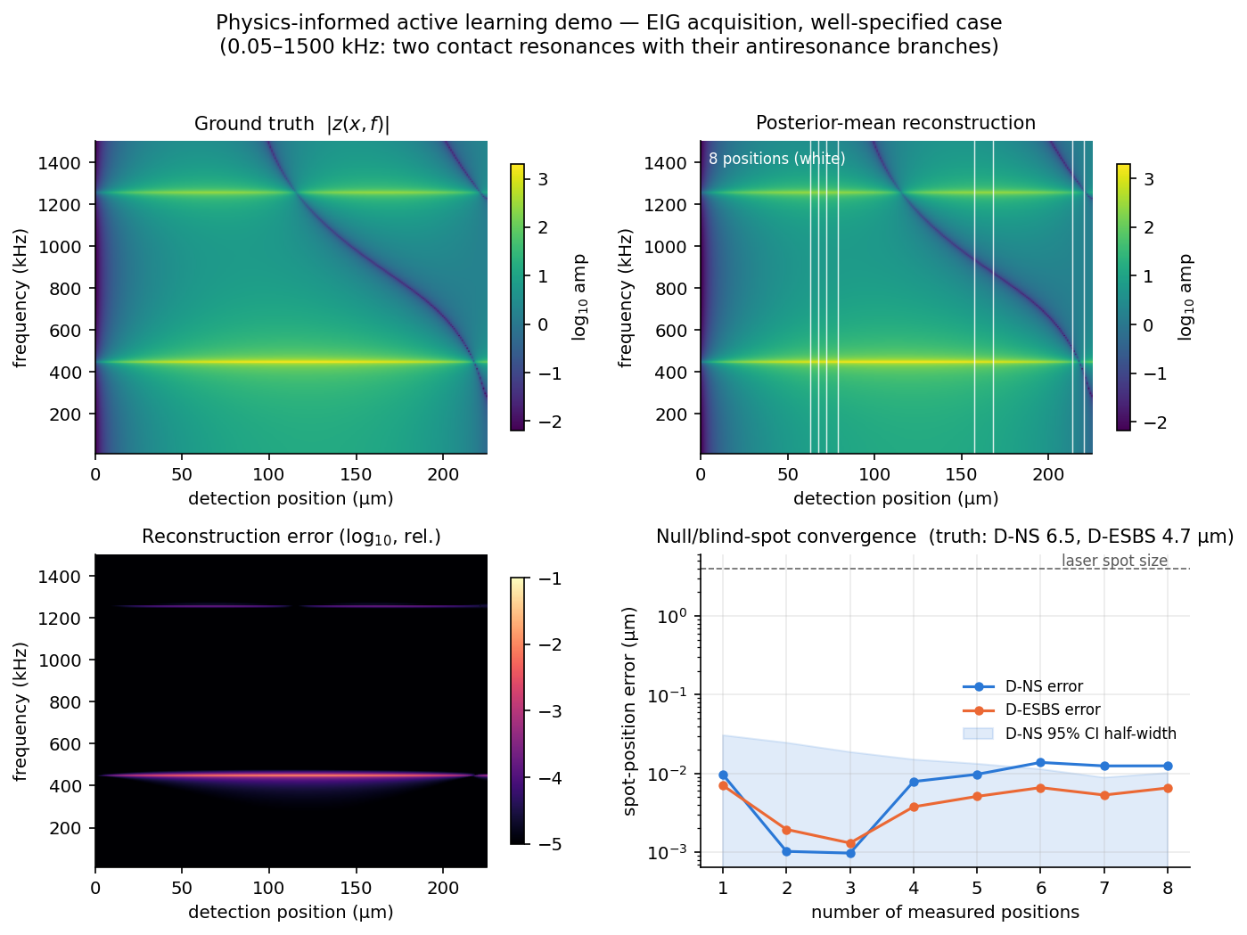
Figure 1. Physics-informed active learning demonstration (simulation, well-specified case), computed over 0.05–1500 kHz so the map spans two contact resonances (near 450 and 1260 kHz) and their position-dependent antiresonance branches. Top: ground-truth response map |z(x, f)| and the posterior-mean reconstruction after eight measured positions (white lines; three seed positions plus positions chosen by expected information gain). Bottom left: reconstruction error. Bottom right: convergence of the D-NS and D-ESBS position estimates with the number of measured positions; the dashed line marks the 4 µm detection-spot size.
How few positions are enough?
Figure 2 benchmarks all six position-selection strategies — the three physics-informed acquisition rules (expected information gain, integrated predictive variance, spot-targeted) and the three baselines (random, equispaced, physics-free Gaussian process) — across three scenarios: well-specified physics, four-times-higher noise, and parametric model mismatch (data generated with perturbed probe geometry unknown to the inference), with each curve the median over repeated runs with random ground truths. Three conclusions stand out. First, the physics is the whole game: every physics-informed strategy reconstructs the map to a fraction of a percent and localizes both spots far below the detection-spot size with three to four positions, while the physics-free Gaussian process stalls at several percent map error and cannot produce spot estimates at all at these sampling densities. Second, detector noise is nearly irrelevant — quadrupling the noise floor barely moves the curves, because the model constrains the map far more strongly than the noise corrupts it. Third, the choice among physics-informed acquisition rules is a second-order effect in simulation, though expected information gain and the spot-targeted rule retain a roughly two-fold advantage over random and equispaced sampling under model mismatch. Against the tens of positions per condition used in exhaustive sweeps [9], the practical saving is roughly an order of magnitude — and the loop provides live uncertainty estimates, so it can stop itself as soon as the spot confidence intervals fall below a chosen tolerance.
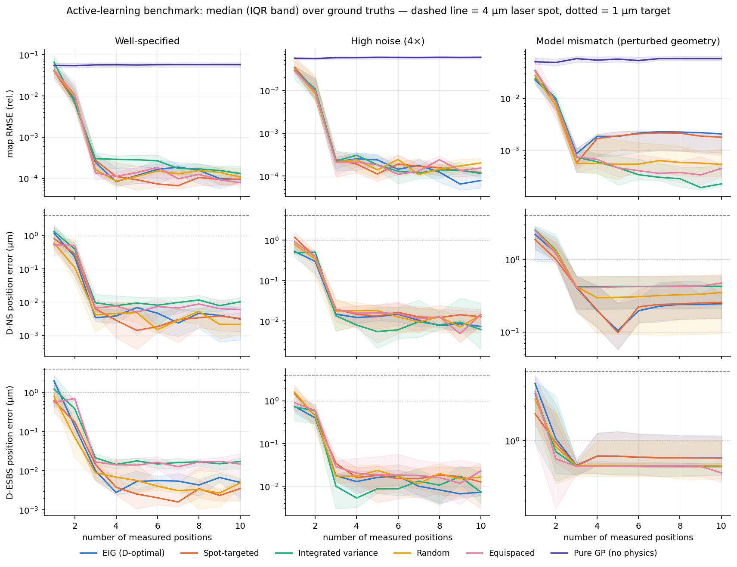
Figure 2. Simulation benchmark. Map reconstruction error (top), D-NS position error (middle), and D-ESBS position error (bottom) versus the number of measured positions, for the six position-selection strategies — three physics-informed acquisition rules (expected information gain / D-optimal, integrated predictive variance, spot-targeted) and three baselines (random, equispaced, physics-free Gaussian process) — in three scenarios: well-specified model, four-fold noise, and parametric geometry mismatch. Lines are medians over repeated runs (shaded: interquartile range). Dashed and dotted lines mark the 4 µm detection-spot size and a 1 µm target.
When the model is wrong: hybrid correction and model-free extraction
Beam theory does not quantitatively reproduce real probes: three-dimensional tip compliance, distributed electrostatic loading of the tip cone, and friction produce near-tip behavior that one-dimensional models miss, with micrometer-scale consequences for the operating points [9]. A physics-informed loop must therefore survive a wrong model, not just noisy data. To test this we generated data from a deliberately different 'pseudo-FEM' model containing physics outside the inference family — a rotational constraint at the tip contact, an extra concentrated electrostatic load on the tip cone, frequency-dependent damping, and a detection-sensitivity ripple. As expected, no parameter set fits such data (the chi-squared guard flags the misfit), and the best-fit beam model carries a systematic bias of about one micrometer in the spot positions that more data cannot remove: the pure-physics error curves in Figure 3 go flat at the bias.
Two additions remove the plateau. The first is a discrepancy term in the spirit of Kennedy and O'Hagan [15]: the residual spectra between the measurements and the best-fit beam model are interpolated across position by a Gaussian process whose prior variance grows toward the tip, encoding where beam-model error is known to concentrate. The corrected map is the beam-model prediction plus this learned correction. The second is a change of role for the model in the final answer: rather than reading the operating points off the fitted parameters, they are extracted directly from the corrected maps. The two domain spectra separate the channels without any model — their difference is the piezoresponse channel and their sum the electrostatic channel — and each operating point is located as a signed zero crossing of the phase-rotated profile, which survives the finite detection-spot blur that destroys amplitude minima. The physics model is thereby demoted from oracle to guide: it decides where to measure and provides the baseline map, but the operating points are effectively measured, not modeled. With this hybrid scheme the D-ESBS error drops from a 1 µm plateau to below 0.1 µm and the D-NS error continues to improve with each position, reaching 0.03–0.3 µm — using six to eight positions in total.
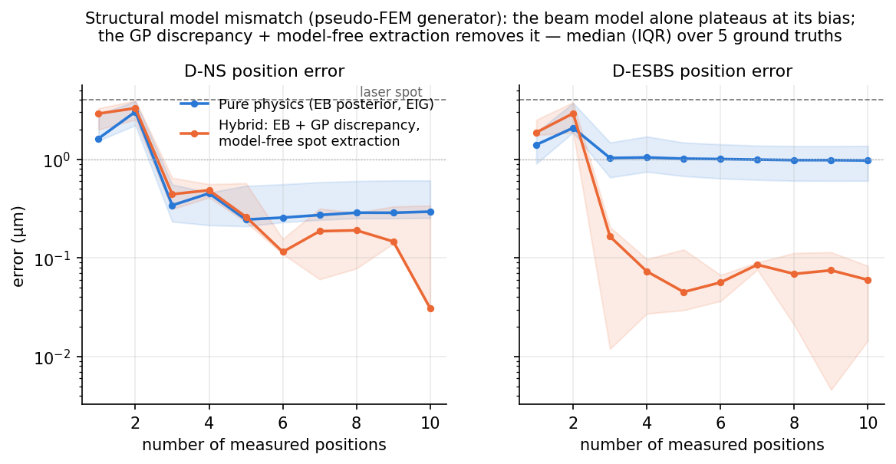
Figure 3. Robustness to structural model error. Data are generated by a model containing physics the inference model cannot represent (rotational apex constraint, cone-concentrated electrostatic load, frequency-dependent damping, sensitivity ripple). The pure-physics loop (blue) plateaus at its systematic bias; the hybrid scheme (orange) — beam model plus Gaussian-process discrepancy, with operating points extracted model-free from the corrected maps — removes the plateau. Medians (interquartile range) over five ground truths with randomized perturbation strengths.
Experimental demonstration
On a real probe, beam theory is only approximate — the very near-tip effect that motivated the discrepancy correction above. For the experimental demonstration we therefore use the reconstruction that assumes the least about the model: the model-light, low-rank method (Methods), which fits the mode shape as a smooth low-rank spatial object and makes no assumption about the frequency response, so it cannot be biased by a wrong model and preserves the sharp spectral features exactly.
We tested this on measured data: a platinum-coated BudgetSensors Multi75E-G probe in contact with periodically poled lithium niobate at 1000 nN, with the interferometric detection spot stepped through thirty positions over a ~30 µm span near the free end and a full frequency sweep (254–449 kHz) recorded at each. Figure 4a shows the resulting map. It has exactly the structure predicted by the models: a position-independent contact-resonance branch near 358 kHz and an antiresonance branch that sweeps diagonally downward with position; where the two cross, the on-resonance amplitude vanishes and the phase reverses, marking the displacement null spot at 17.2 µm into the scan.
A singular-value decomposition of this map shows it is highly compressible — four spatial components already capture 99.8% of its energy — confirming the low-dimensional structure the whole method relies on. Figure 4b shows the mode shape reconstructed from only six detection positions selected by the D-optimal rule (Methods), and Figure 4c the associated uncertainty. Both branches are recovered sharply, with a held-out reconstruction error of 1.6% on the twenty-four positions the algorithm never visited (Fig. 4d compares measured and reconstructed spectra at three held-out positions; the resonance peak and the deep antiresonance notch are both reproduced, and the ±2σ bands cover the measured curves). Figure 4e shows the reconstruction error as a function of the number of measured positions: D-optimal selection and a simple equispaced design both converge by about six positions, whereas random selection is erratic because clustered positions leave the spatial fit poorly conditioned — position selection matters. The recovered null spot (Fig. 4f) is 17.3 ± 0.5 µm, agreeing with the thirty-position reference of 17.2 µm while using roughly five times fewer measurements. The uncertainty is largest along the narrow resonance line, which is genuinely under-sampled in frequency by this dataset — the method reports that honestly rather than hiding it.
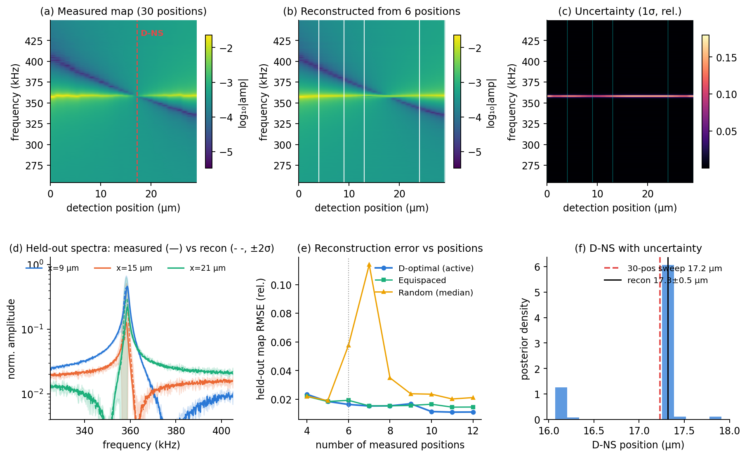
Figure 4. Experimental demonstration on a Multi75E-G probe / PPLN at 1000 nN (IDS detection). (a) Measured position–frequency amplitude map over thirty detection positions; the resonance and antiresonance branches cross at the displacement null spot (D-NS, dashed line). (b) Mode shape reconstructed from six positions (white lines) selected by D-optimal design. (c) Pointwise reconstruction uncertainty (1σ, relative). (d) Measured (solid) versus reconstructed (dashed, ±2σ band) spectra at three held-out positions, showing the sharp resonance and antiresonance are preserved. (e) Held-out reconstruction error versus number of measured positions for D-optimal, equispaced, and random selection. (f) Posterior distribution of the recovered D-NS position; the reconstruction (17.3 ± 0.5 µm) matches the thirty-position reference (17.2 µm).
Two reconstructions of one low-dimensional map
Figures 1–4 span a spectrum of modeling assumptions applied to the same underlying fact — that the position–frequency map is low-dimensional. It is worth making the trade-off between the two ends of this spectrum explicit, because it determines which reconstruction to use in a given experiment. The physics-informed reconstruction (Figs. 1, 2) assumes a specific beam model; the model-light low-rank reconstruction (Fig. 4) assumes only that the mode shape is smooth along the lever; the discrepancy-corrected hybrid (Fig. 3) sits between them, keeping the beam model but learning a correction to it.
The two ends differ sharply in efficiency, for a concrete reason. The low-rank reconstruction must determine the spatial structure from the data: at each frequency it fits as many spatial coefficients as the map has significant components, so it cannot succeed with fewer detection positions than the map's spatial rank, plus a margin for conditioning. The physics-informed reconstruction never spends a measurement discovering spatial structure, because the mode shapes are known analytically from the beam model; all that remains unknown is a handful of global parameters, and a single full spectrum already supplies hundreds of complex points that constrain them. Its position budget is therefore set by parameter identifiability — two or three positions suffice to break the residual degeneracies — and does not grow as the map becomes spatially richer with additional resonances. On the same simulated broad-band map, at matched position counts the physics-informed reconstruction is one to two orders of magnitude more accurate (Table 1).
Detection positions | Physics-informed | Model-light (low-rank)
3 | 0.03 % | 4.3 %
4 | 0.01 % | 1.3 %
5 | 0.01 % | 0.9 %
6 | 0.02 % | 0.3 %
Table 1. Relative map-reconstruction error (RMSE) versus number of measured detection positions, for the two reconstructions on the same simulated broad-band map (0.05–1500 kHz, well-specified case). The physics-informed budget is set by the five model parameters; the model-light budget is set by the map's spatial rank, so it needs more positions to reach comparable accuracy.
The physics-informed reconstruction is also more informative, in three concrete senses. It returns the physical parameters themselves — the contact stiffness that CR-AFM converts to elastic modulus, and the electrostatic-to-electromechanical drive ratio that quantifies PFM crosstalk — whereas the low-rank map reports where the operating points are but not the contact mechanics that place them there. Being generative, it can extrapolate to conditions and positions that were not, or cannot be, measured — for example a displacement null lying beyond the physical tip, as observed for stiffer probes [9] — while the low-rank reconstruction only interpolates within the measured span and condition. And its residual is a built-in test of model adequacy: the same reduced-chi-squared that flags the structural-mismatch case in Fig. 3 tells the operator when the beam model has stopped being trustworthy, information the low-rank method cannot provide.
Every one of these advantages, however, is contingent on the model being correct — and on a real probe it is not exactly correct. The efficiency and the physical parameters are then partly purchased at the cost of a systematic bias, unless the discrepancy term is included, whereas the low-rank reconstruction is immune to model error by construction. The practical rule that follows is simple: use the physics-informed reconstruction in simulation, for well-characterized probes, or whenever the physical parameters or extrapolation are themselves the goal; use the model-light reconstruction on real data when robustness and faithful spectra matter more than the last factor of two in positions — which is exactly why it underlies the experimental demonstration above.

Conclusions
Mode shape maps in dynamic AFM are expensive to measure but cheap to describe. Because the map is low-dimensional, an active learning loop recovers the full position–frequency response and localizes the PFM operating points from five- to ten-fold fewer detection positions than exhaustive sweeping, with calibrated uncertainty throughout. That low-dimensionality can be exploited along a spectrum of modeling assumptions. At one end, a physics-informed reconstruction fits a beam model and is the most efficient and most informative — it needs the fewest positions, returns the contact stiffness and drive ratio directly, and can predict conditions and positions it never measured — but it is only as good as the model. At the other end, a model-light low-rank reconstruction assumes only spatial smoothness; it needs a few more positions and yields no physical parameters, but it preserves sharp spectral features exactly and cannot be biased by model error, making it the natural choice on real probes. A Gaussian-process discrepancy term bridges the two, retaining most of the physics-informed efficiency while tolerating the near-tip effects beam theory misses. Nothing in the loop is specific to PFM: the same machinery applies wherever cantilever dynamics carry the signal — contact resonance nanomechanics, electrochemical strain microscopy — and the per-probe, per-condition recalibration that currently makes quantitative operation tedious becomes fast enough to repeat whenever the contact changes.

Methods
Forward model
The cantilever is modeled with an assumed-modes (modal) implementation of the Euler–Bernoulli contact resonance problem, using the first twelve clamped-free eigenmodes of the full lever. The tip contacts the sample at an interior point set back from the free end, so the distal overhang with its true free end is contained in the basis automatically, equivalent to a two-segment solution [9, 14]. The contact comprises normal and lateral springs with dashpots, with the lateral spring acting through the tip height and in series with a tip-cone compliance; cantilever tilt couples displacement and slope at the contact. Two drives are computed simultaneously: a localized electromechanical excitation applied through the contact springs and a distributed electrostatic load proportional to the inverse square of the local tip–sample gap along the lever, with a reduced effective width over the tapered overhang. The frequency response is obtained by solving the complex modal system (twelve to fourteen modes, chosen to span the bandwidth of interest) over the frequency grid in a single batched operation, a few milliseconds for a map of a few hundred frequencies by a few hundred positions; the demonstration of Fig. 1 spans 0.05–1500 kHz, over which the map contains two contact resonances. Five parameters are inferred (log contact stiffness, log cone stiffness, log quality factor, log drive ratio, log gain); geometry is fixed at values representative of a BudgetSensors Multi75E-G probe. The framework accepts any forward model exposing the same interface, including the two-segment analytical solver of ref. [9].
Virtual experiment
A measurement at position x returns the complex spectra of both domain orientations with additive complex noise at a constant displacement noise floor (8% of the quasistatic signal, matching typical interferometric floors of ~1 pm against ~12 pm signals), 2% multiplicative gain noise, and a 4 µm full-width Gaussian detection-spot footprint applied along the position axis. For structural-mismatch studies the data are generated by a modified model containing a rotational apex constraint, an additional concentrated electrostatic load at the tip, frequency-dependent contact damping, and a smooth detection-sensitivity ripple, none of which the inference model can represent.
Inference and acquisition
The posterior over the five parameters is obtained by staged optimization: a global grid over the three mechanical parameters with the two amplitude parameters profiled out, scored on log-amplitude residuals; log-amplitude least-squares refinement of the best candidates; and a final complex-residual polish under a noise model with additive and 3% fractional components, followed by a Laplace approximation. Later steps warm-start from the previous posterior, with a reduced chi-squared guard that triggers a global rescan. Acquisition scores are computed from the Laplace posterior: expected information gain as the log-determinant of the posterior information update (D-optimality), integrated predictive variance from pushed-forward posterior samples, and a spot-targeted score propagating parameter uncertainty to the derived operating-point positions. The hybrid scheme fits a Gaussian process across position to the per-frequency complex residuals (per-frequency normalization; prior standard deviation growing toward the tip), forms corrected maps, and extracts D-NS and D-ESBS as signed zero crossings of the phase-rotated piezoresponse channel at contact resonance and electrostatic channel in the quasistatic band, respectively, using the domain sum and difference to separate channels.
Mode-shape reconstruction from few positions
For the experimental data we reconstruct the full map with a model-light method that makes no assumption about the shape of the frequency response, complementary to the physics-informed parameter inference validated in simulation. It rests on the same principle — that the map is low-dimensional — but exploits it in a form suited to real spectra. The modal picture writes the response as a separable sum, z(x, f) = Σ φ_n(x) a_n(f), of a few smooth spatial mode shapes φ_n(x) times complex frequency responses a_n(f); equivalently, the position–frequency matrix is low rank. We therefore represent the spatial dependence with a small basis of smooth functions (here Chebyshev polynomials of degree up to four over the measured span) and, independently at each frequency, fit the complex basis coefficients to the spectra measured at the selected positions by linear least squares. The full map at every position is then the basis times these coefficients. Because each frequency is treated separately and the measured spectra themselves supply all frequency information, no smoothing is applied along the frequency axis: the sharp resonance peak and the position-dependent antiresonance notch are preserved exactly, and the only assumption is that the response varies smoothly along the cantilever, which is physically guaranteed by the mode shapes. Detection positions are chosen by a D-optimal rule: starting from the two ends of the accessible range, positions are added greedily to maximize the determinant of the spatial-basis information matrix, which is equivalent to minimizing the reconstruction variance. Uncertainty has two contributions combined in quadrature — the per-frequency residual between the fit and the measured spectra (largest at the narrow resonance, which is under-sampled), and the spatial leverage of the least-squares estimate (which grows in the gaps between measured positions). The displacement null spot is identified as the position where the antiresonance branch crosses the resonance branch, and its confidence interval is obtained by bootstrapping the reconstruction over the estimated measurement noise. The number of spatial components needed is confirmed by a singular-value decomposition of the densely sampled reference map.
Experimental methods
Measurements used a Vero AFM (Oxford Instruments Asylum Research) equipped with a quadrature phase differential interferometer; the interferometric detection-spot position was translated along the cantilever under software control through the AEcroscopy platform [10]. The demonstration in Fig. 4 used a platinum-coated BudgetSensors Multi75E-G probe (nominal free resonance 75 kHz, spring constant 3 N/m) in contact with periodically poled lithium niobate at an applied load of 1000 nN. At each of thirty detection positions spanning approximately 30 µm near the cantilever free end, an electrically driven frequency sweep through the first contact resonance (254–449 kHz, 992 points) was recorded as amplitude and phase, giving the complex spectra used above. The thirty-position sweep serves as the dense reference against which the few-position reconstructions are compared; in routine operation only the actively selected positions would be measured.

Acknowledgements
This research was conducted at the Center for Nanophase Materials Sciences, which is a DOE Office of Science User Facility.

References
1. Rabe, U. & Arnold, W. Acoustic microscopy by atomic force microscopy. Applied Physics Letters 64, 1493–1495 (1994).
2. Rabe, U. et al. Quantitative determination of contact stiffness using atomic force acoustic microscopy. Ultrasonics 38, 430–437 (2000).
3. Killgore, J. P. et al. Viscoelastic property mapping with contact resonance force microscopy. Langmuir 27, 13983–13987 (2011).
4. Jesse, S., Baddorf, A. P. & Kalinin, S. V. Dynamic behaviour in piezoresponse force microscopy. Nanotechnology 17, 1615–1628 (2006).
5. Labuda, A. & Proksch, R. Quantitative measurements of electromechanical response with a combined optical beam and interferometric atomic force microscope. Applied Physics Letters 106, 253103 (2015).
6. Collins, L., Liu, Y., Ovchinnikova, O. S. & Proksch, R. Quantitative electromechanical atomic force microscopy. ACS Nano 13, 8055–8066 (2019).
7. Killgore, J. P., Robins, L. & Collins, L. Electrostatically-blind quantitative piezoresponse force microscopy free of distributed-force artifacts. Nanoscale Advances 4, 2036–2045 (2022).
8. Proksch, R., Wagner, R. & Lefever, J. Accurate vertical nanoelectromechanical measurements. Journal of Applied Physics 135, 165103 (2024).
9. Checa, M. et al. Dynamics of null and electrostatic blind spots for quantitative PFM. (companion manuscript / in preparation).
10. Liu, Y. et al. AEcroscopy: a software–hardware framework empowering microscopy toward automated and autonomous experimentation. Small Methods 8, 2301740 (2024).
11. Kalinin, S. V. et al. Automated and autonomous experiments in electron and scanning probe microscopy. ACS Nano 15, 12604–12627 (2021).
12. Ziatdinov, M., Liu, Y., Kelley, K., Vasudevan, R. & Kalinin, S. V. Bayesian active learning for scanning probe microscopy: from Gaussian processes to hypothesis learning. ACS Nano 16, 13492–13512 (2022).
13. Chaloner, K. & Verdinelli, I. Bayesian experimental design: a review. Statistical Science 10, 273–304 (1995).
14. Bradler, S., Kachel, S. R., Schirmeisen, A. & Roling, B. A theoretical model for the cantilever motion in contact-resonance atomic force microscopy and its application to phase calibration in piezoresponse force and electrochemical strain microscopy. Journal of Applied Physics 120, 165107 (2016).
15. Kennedy, M. C. & O'Hagan, A. Bayesian calibration of computer models. Journal of the Royal Statistical Society: Series B 63, 425–464 (2001).

