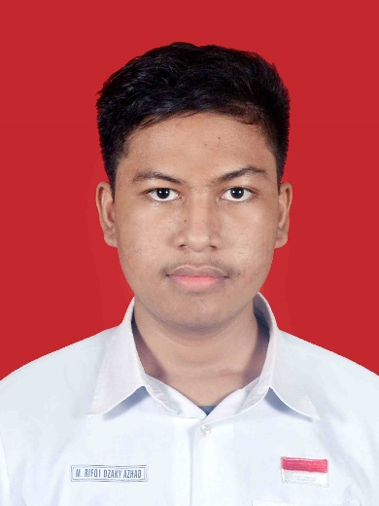
9M. Rifqi Dzaky Azhad
An Undergraduate who’s currently majoring in Informatics, interested in subjects related to math and computation. Now studying and learning to be proficient at using popular programming languages and relevant skills to improve technical capabilities. The area of interest involves the utilization of Machine Learning, with a particular focus on patterns prediction and data optimization.
Age | 19 y.o.
Place of Birth | Jember, East Java
Present Whereabouts | Bandung, West Java

Contact and Personal Information

rifqiazhad21@gmail.com

www.linkedin.com/in/rifqiazhad0210
+62 85336559198
Program and Workshop
Global Competencies Academy (GCA) Participant
A program to prepare undergraduate and graduate students for studying abroad. This includes training to make necessary documents such as CV and Motivation Letter, training participants to improve their English proficiency tests scores, and exercising communication skills so that participants can be fluent at speaking in English.
Institut Teknologi Sepuluh Nopember
August 2022 – December 2022
Organization and Committee
The Importance of Computational Thinking Workshop for Teachers in Indonesia
As a Registration and Publication Committee, contributed to the success of the workshop aimed at assisting teachers in learning Computational Thinking for effective integration into their school curricula. Responsibilities included designing participant name tags and collaborating with other committees to run a successful workshop.
Telkom University
17 October and 20 October, 2023
Bebras Challenge Workshop 2023
Served as the Registration Committee, successfully integrating workshop that facilitated students in learning and applying Computational Thinking and preparing them for the upcoming Bebras Challenge Competition. Duties involved overseeing 200+ registrants from across Bandung, in which the workshop was held onsite at Telkom University, also preparing and designing the registration form, managing the Excel file, organizing registrant data pre-workshop, and finalizing documents post-workshop.
Telkom University
25 October – 30 October, 2023
Bebras Challenge Competition 2023
As a Registration Committee, successfully held this competition which the participants compete to enhance their skills in Computational Thinking and Informatic. Responsibilities included processed over a thousand participants application data, managed participants data excel files by cleaning and organizing, uploaded and oversees participants information on the registration website, also provided essential information and guidance to participants.
Telkom University
1 November – 11 November, 2023

Competition
Participant in the Provincial Level of the Kompetisi Sains Nasional (KSN) in the Field of Astronomy
Held by Pusat Prestasi Nasional Kementrian Pendidikan dan Kebudayaan
16 June 2021
Language Proficiency

Bahasa Indonesia
Native Language
English
TEFL Score (English Proficiency test held by the GCA program, 2022): 560
EPrT Score (English Proficiency test held by Telkom University, 2023): 577
Education

Telkom University
Majored in the bachelor’s degree of Informatics.
03 May 2023 – Present | Bandung, Indonesia
SMA Negeri 2 Jember
Focused on STEM majors.
15 June 2019 - 5 May 2022 | Jember, Indonesia

Relevant Skills

Programming
Go
Proficient in GO, able to finish class and personal projects using GO programming language.

MATLAB
Using MATLAB to finish a project to visualize Fourier transformation of a DC circuit and have completed other projects.

Microsoft Office
Word dan PowerPoint
Proficient in using Word and PowerPoint. Successfully completed class tasks using various features in Microsoft Office software, received positive feedback from teachers and classmates.
Excel
Handled input, cleaning, sorting, and descriptive analysis of diverse data. Excel proficiency demonstrated through experiences as registration committee.

