Dataset
- Nama Dataset: ChestMNIST
- Sumber: https://github.com/MedMNIST/MedMNIST
- Total data: 112,120
- Split: Using original dataset split (Training / Validation / Test; 78,468 / 11,219 / 22,433)
Initial Observation
- Image size: 224*224 (Image square shaped)
- Image channels: 1(has one channel, grayscale)
- Per-image pixel statistics: Not normalized
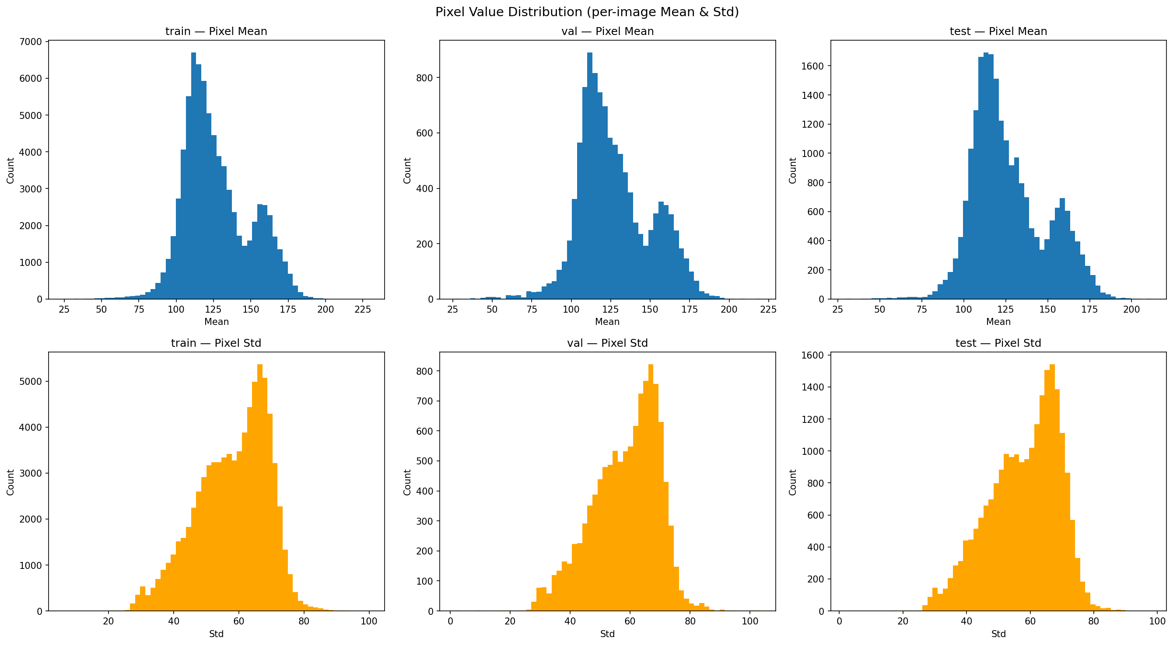
- Duplication: 25 Duplicate Group
Preprocessing
- Per-image pixel statistics: Normalized mean to (0.485, 0.456, 0.406) and std to (0.229, 0.224, 0.225)
- Handle Duplication: 26 Images Removed (Using md5 hash to find exact matching images). Priority rule: train > val > test. Within same split: keep lower filename index. Cross-split duplicates: image is retained in the higher-priority split only.

EDA
- Label Distribution per-Split: Imbalance label trhough out all the splits
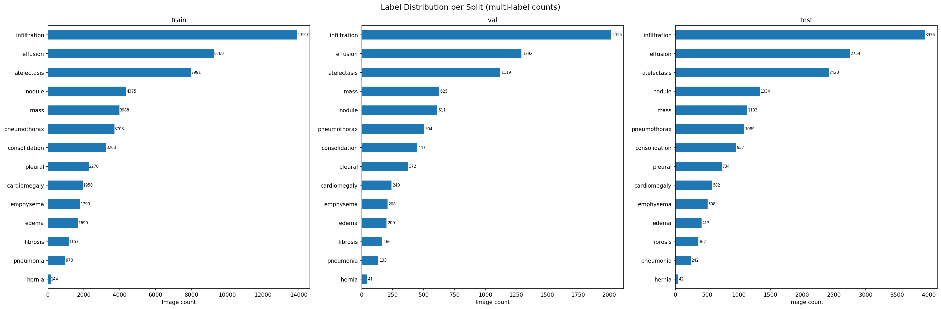
- Label Count Distribution: Train dataset contains data with the most label (9 labels).
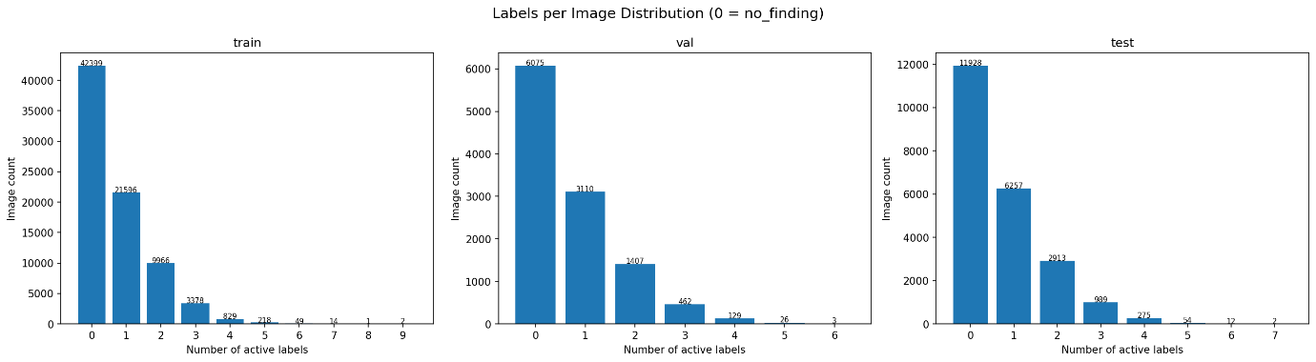
Augmentation
Dataset on the train split are augmented with: horizontal flip, random rotation (-10 to 10 degrees), gaussian blur, contrast and brightness change. Performed on low-label images to help balance dataset label distribution. Test and val split are not augmented to prevent inflated model performance.
Model
- efficientnetv3,
- mobilenetv2,
- convnextv2,

