

CAB230 CLIENT SPECIFICATION

Liam Wrigley – n9448381



# Introduction

Implemented:

* Made with react
* Ability to search all endpoints
* Login with successful error handling as well as saving auth token to local storage
* Logout button that will remove the auth token
* Register with proper error handling
  + Without auth token will be redirected to login page
* Table view with sortable headings
* Ability to sort by offence, area, age, gender, year and month
* Map view showing a heatmap of occurrences which is also sortable.
* Using HTTPS

Not Implemented:

* Graphing was not implemented
* Reset button for search not implemented

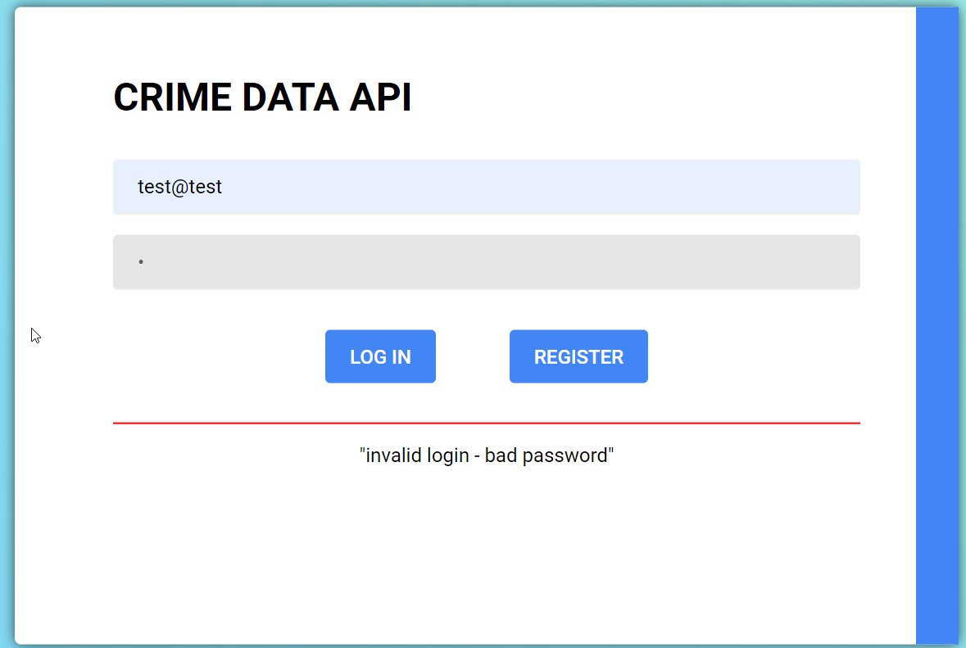

Figure Incorrect password

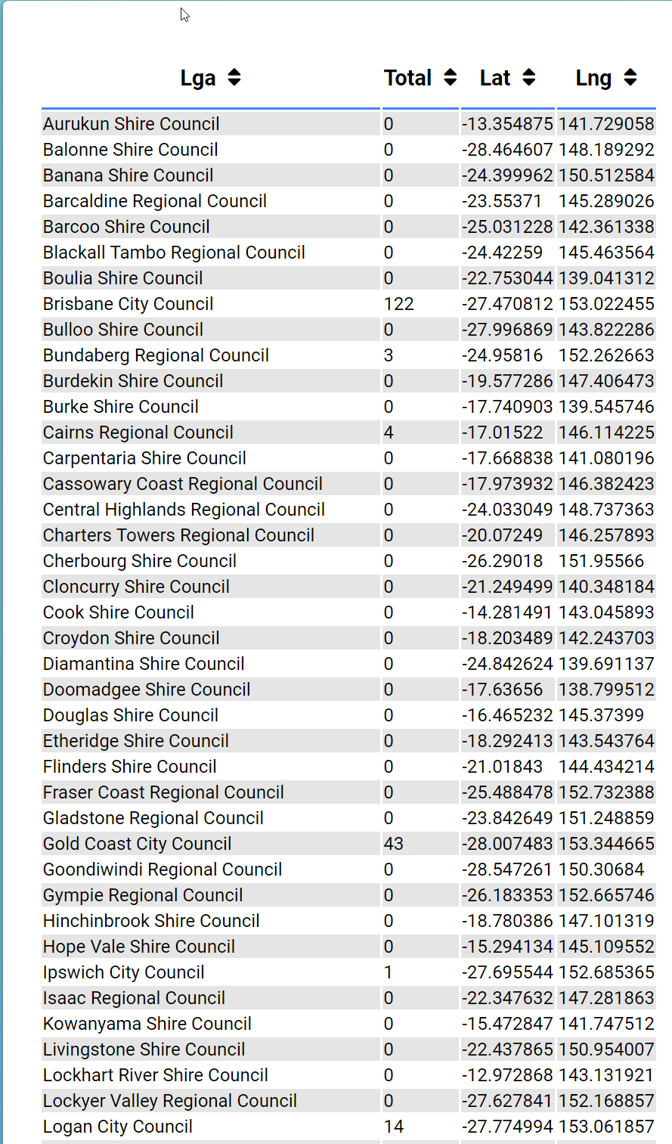

Figure Table view

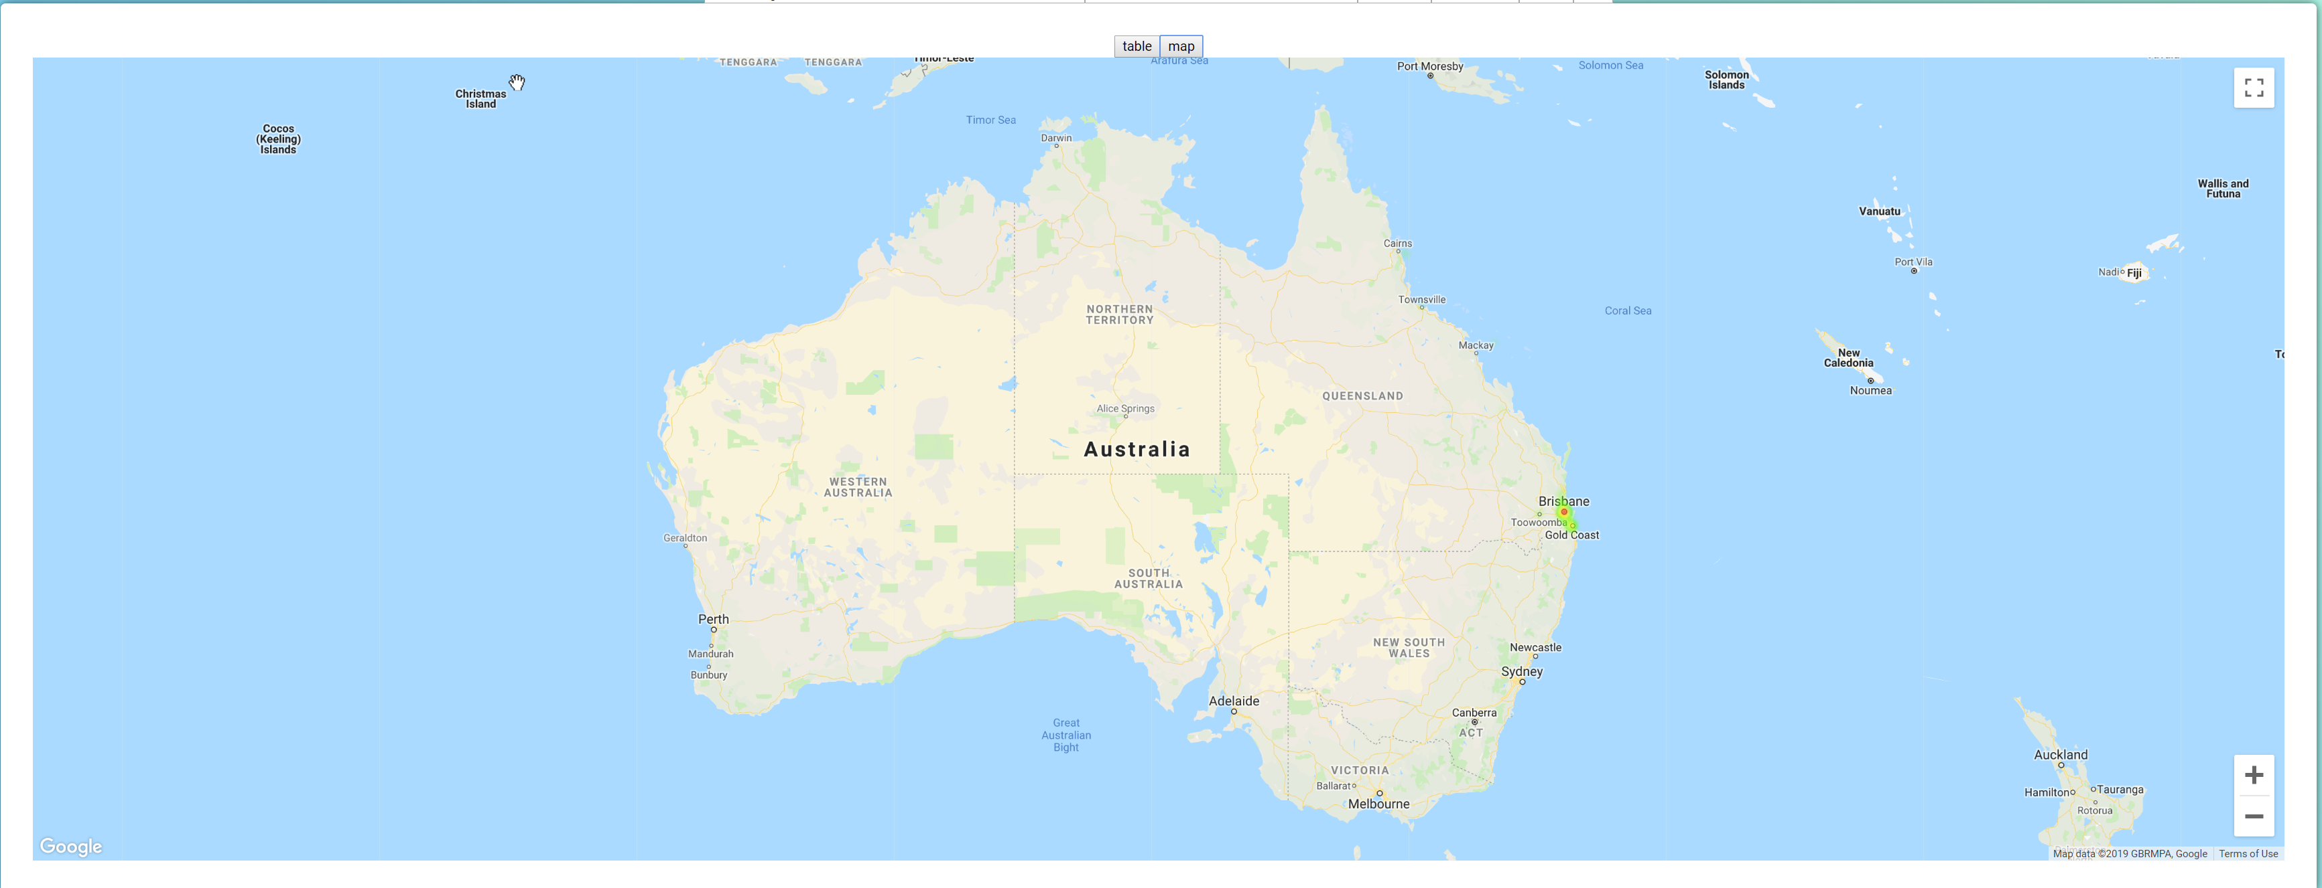

Figure Map view

# Technical description

The graphing was achieved using ‘google-map-react’ and uses the same data flow that the table view uses. The table is created using the package ‘react-smart-data-table’ and all data will update any time a dropdown value changes.

Figure 4 UseEffect to update any time a query part changes

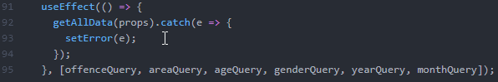

The data is updated using a large string of variables that are updated any time a dropdown is changed.

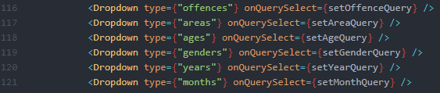

Figure Dropdown components in use

The dropdown component was created to dynamically create dropdowns of data that is fetched from within the component via the passed variable “type” seen in figure 5. The dropdowns each have an onchange event that will return current value encoded.

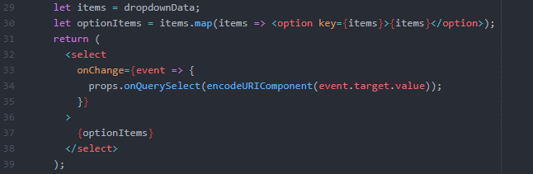

Figure Creation of dropdown HTML

There is no graphing functionality for the data due to time constraints.

# Testing and limitations – test plan, results, compromises.

**Login:**

|  |  |  |
| --- | --- | --- |
| INPUT | RESULT | EXPECTED |
| No email | "invalid login - you need to supply both an email and password" | "invalid login - you need to supply both an email and password" |
| No pass | "invalid login - you need to supply both an email and password" | "invalid login - you need to supply both an email and password" |
| Unregistered email | "oh no! It looks like that user doesn't exist..." | "oh no! It looks like that user doesn't exist..." |
| Wrong password | "invalid login - bad password" | "invalid login - bad password" |
| Successful | Redirect to data | Redirect to Data |

**Register:**

|  |  |  |
| --- | --- | --- |
| INPUT | RESULT | EXPECTED |
| NO Email | It looks like that email is already registered | "error creating new user - you need to supply both an email and password" |
| No Password | It looks like that email is already registered | "error creating new user - you need to supply both an email and password" |
| Unique email and password | "yay! you've successfully registered your user account :)" | Successfully Registered!  Please log in |

# References

Packages used:

* react-smart-data-table – used for creating and showing tables
* google-map-react – used for mapping data on heatmap with Google API

# Appendix: brief user guide

“npm install” to redownload all packages

“npm start” to start client.