Planet Y

Games Design Document

Table of contents

Game outline 4

Story summary 4

Game play 4

Character and controls 5

Main gameplay concepts 6

Game world 7

Game experience 8

Gameplay mechanics and enemies 9

Mechanics 9

Hazards and enemies 9

Items/Abilities 11

Combat 11

Mobility 12

Ultimate 12

Bonus material 13

Unlockable content 13

Beat chart 13

Planet Y

Will be available on Steam distribution platform Windows, Linux and steamOS.

Aimed at ages 13 years +

With a Teen ESRB rating

Release date TBD Est: ( Q2 2016)

# Game outline

## Story summary

The player takes the role of humanity’s bravest explorer who’s about to go on their most dangerous expedition yet, to the mysterious world known as Planet Y from where no other explorer has returned. Because of this fact the player decide to build the most advanced rover they can and, much to the dismay of the chief engineer, jokingly name it Rov-E. The ship then heads to Planet Y and deploys Rov-E and this is where the game begins.

The setting is the distant future where technology has advanced to a point where space travel is easy, and humanity is in a golden age of space exploration. Where the whole world waits to see who will be the first to tame the notoriously deadly Planet Y, and claim untold fame and riches. It is because of this setting that the character decides to undertake this journey in the first place.

There are three characters of importance: the player whose dialogues are generally light hearted and humorous, the chief engineer Swann who takes a more serious tone during the conversations between and during levels, and the on-board AI on Rov-E who is very literal and almost sarcastic in its responses. All of these will frequently talk to each other during the game, developing a relationship with a light hearted personality conflict which the player will get to see humorously evolving.

The story behind the game is told through the dialogue between the characters both during and in between levels. The levels are strung together with the remnants of the previous expeditions that will be found on the levels and determine where the game next takes the player.

## Game play

The player will progress through the game by completing levels, these levels start to finish will take around 5 minutes to complete if they do it in one go and will have anywhere from 1-3 checkpoints to ensure it doesn’t take too long. There will be 10 levels per stage, and 6 stages of increasing difficulty. Levels will be completed by getting to the exit portal and activating all of the beacons along the way (there will typically be 3 beacons per level).

The challenges the players will face will be in the form of enemies - each with different attacks, movements and looks depending on the stage. Some of these enemies will be on set routes and act more as obstacles than some of the other enemies which will go after the player if they’re in range or even fire projectiles at the player or passively. The players will overcome these challenges by killing them by getting to their weak spot, or by using an ability to dodge or kill them from afar. The other challenge the user will face is the environments of which there are 6. For example in the first stage there will be gravity alterations around the levels which could cause them to walk on the ceiling, be prevented from jumping high or causing them to float off if they do jump. Although these will not kill them directly they will cause the player to unexpectedly go towards enemies or other static obstacles that will kill them.

The player will progress though the stages by completing every level on them and moving onto the next. While completing the levels they will unlock items and abilities they can use on other levels. These will be permanent and the player can’t accidentally not get them on a level. There will be 3 different types and the player can mix and match them. The ones the player unlocks will get progressively stronger throughout the stages but they will not necessarily be useful for combating the environment the player is in, leading to the user making tactical decisions on what to take. As they progress more options open up to them on how they can complete a level.

# Character and controls

The player is the captain who is directly controlling the rover which is essentially the player. The backstory of these characters will not be made too in depth as the story is not a critical part of this game and what little there is, is covered in the story section of this document. The rover will have a model that will look something like *(fig1.1)* only cartoon like and highly stylised. The other vocal characters in this game will only be seen in the form of text appearing at the bottom of the screen with an image of their face to the side of it *(fig1.2)*, they will not have models because they will not take part in the gameplay.

Fig1.1

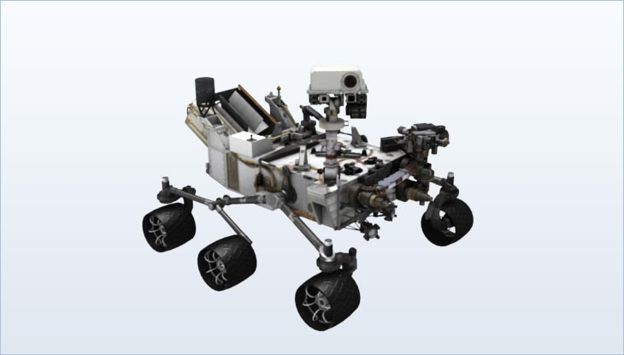

*Image from:* [*mars.jpl.nasa.gov*](http://mars.jpl.nasa.gov/msl/mission/rover/)

Fig1.2

*Game screen*

Swann

The captain

*dialogue*

*Portrait*

*Portrait*

There are various activities the player can do. At the start it will be very basic simple movement left to right with jumping, like all typical platformers. As the game progresses more options become available and the player gets more control over their character using the 3 abilities the player can have at any one time. The control scheme will be very familiar to players as it doesn’t differ from the standard control scheme for platformers *(fig1.3)*.

Fig1.3

Q: Movement ability key

E: Combat ability key

R: ultimate ability

A: Left

D: Right

Space: Jump

W: Ascend grapple (if in use)

S: Descend grapple (if in use)

Esc: Menu

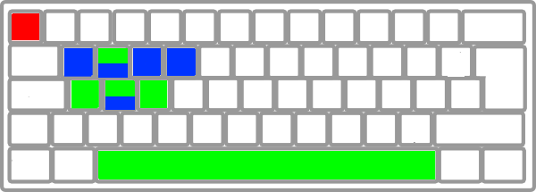

*Original Image from:* [*www.clker.com*](http://www.clker.com/clipart-28897.html) *edited using adobe fireworks cs4*

# Main gameplay concepts

Fig2.1

Planet Y

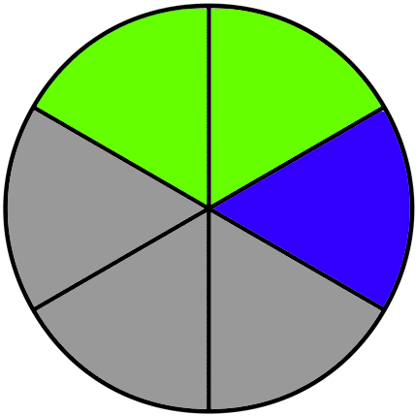

Stage 3

Level 5

As you can see from (*fig2.1)* there will be 6 areas each comprised of 10 levels. The sequence of play will be presented in the form of this screen, which the player will see when they play or continue the game. Unlike some platformers the player will not be able to skip ahead once they have a certain amount of levels completed in one area, the player will have to complete them all for them to advance to the next level. Each level can only be played once the player has completed the one before it.

Green zones represent levels that can be revisited and played again, blue represents the current selected level and grey represents unavailable levels because they have not been unlocked yet. The final product will have an image of the planet cut into 6 pieces with the pieces becoming revealed as the player unlocks them, this is just an approximation of the UI.

The first level of each stage will be a sort of tutorial, it won’t directly tell the player what the environmental challenge is on this stage but it will be much easier than the rest and will use hints such as the environmental clues in *(fig2.2)* so the player knows roughly what to expect. These levels will also be more heavily narrated than the rest so the player feels the story has progressed more by getting to the next stage. The next levels will then get increasingly harder until level 10 where it will get extremely challenging. The final stage will be comprised of a mix of the challenging environments of the previous 5 making it considerably harder than the rest.

Fig2.2

*An enemy being flipped upside down by gravity flipping*

*An enemy being dragged downwards by an extreme example of gravity changing*

*An enemy floating off showing that gravity is weaker in that area*

# Game world

The game world is Planet Y. As mentioned previously the 6 stages of the game all take place on this planet, each taking up roughly a 1/6th of what we see of its surface. It is a world of hugely varying terrain from environment to environment. The player will find a vast array of different plant life and landscapes in the background of the levels with different terrain for them to walk on as well. The animal life (enemies) will also change in appearance from environment to environment, although they will still have the same functionality as the enemies of that type had in the previous environments only the “skin” would have changed.

The locations fit into the story as the first one is the last known location of the previous exploration team. Their mission logs and notes cause the player to travel to the next location in order to find out more about what happened to them, reclaiming their equipment in the process (ie items and abilities).

# Game experience

When the player first starts the game there will be a brief loading screen followed by an animation of the character dropping into the level. After that animation has completed, control of the character is released and white text will appear on the screen telling the player the stage and the level *(fig3.1)*. The music played during this will be unnerving and instil a sense of wonder and trepidation. As the player progresses through the level, that mood will change as the characters narrate and the music changes to more typical platformer music - an up - beat electronic song that is reasonably simple. This is what will happen every time the user enters a new environment.

Fig 3.1

*Level*

*Player *

Level and stage popup

For normal levels there will be the same animation and white text introduction but the music will start off as the normal platformer music. The first time They discover remnants of the previous expeditions on the level, the music will change to a more sombre and mysterious tone and the screen will zoom in on what has been discovered. This will likely be a small building where upon entering the walls will become transparent enters and the camera pans closer. *(Fig 3.2).*

Fig 3.2

*entrance/exit to scene *

*item/ ability *

*Player *

Swann

The captain

*dialogue*

*Portrait*

*Portrait*

In general, the game’s music and environment will try to be upbeat and happy. This is to create comedic contrast to the extreme difficulty of the game as it is designed to be frustrating due to the mechanics of the game’s environments and at best unreasonably cruel level design which in general will cause the player to have to replay specific parts of the level many times before reaching another checkpoint and having to do it over again. This is one of the reasons the camera and mood changes for the discoveries, to make it extremely rewarding to the player for their hard work getting there. It’s these discoveries that give them new items and abilities as well.

# Gameplay mechanics and enemies

## Mechanics

The basic movement mechanics of the game with no items/abilities will be relatively simple, the player will be able to move left and right on the ground and alter their left/right trajectory while falling or jumping using the same controls, and the jumping will work as follows. They can jump, then jump again once they are in the air. The height of the jump will depend on how long they hold down space (i.e. tapping it for a light jump, pressing it for a high one). The player will only be able to jump again once they land, but this also includes grabbing onto a wall by sliding they character against it. Once this happens the players jumps will reset and their character will slowly slide down the wall.

The basic combat mechanics with no items/abilities will be that all small and light enemies will have to be jumped on top of to be killed and will kill the player if one of their projectiles hit them or if the player contacts it from the side. Once the player jumps onto an enemy the enemy dies and the player is given a small boost upwards (not unlike Mario). For other enemies the player will have to navigate to its weak spot. This will be made obvious in its colour scheme but this scheme will vary from area to area. Typically the weak spot is the same colour as the weaker enemy’s entire body with its strong points a very neutral tone. Once the player comes into contact with its weak spot there will be a small animation of the character drilling it that will last about a second and then controls will be released again. During the animation jump the character is moving with the enemy its attacking automatically. There will also be stationary enemies that cannot be killed unless an ability is used. There is no health for the players’ character, they get hit once they die and respawn. The same applies to enemies, no enemies require two hits to kill but they will respawn when the player does.

When the player dies there will be no load screen, just a quick sound effect and then the player reappears with simple mechanical activation sound effect, either at the start of the level, or at the most recent beacon they have activated (if they have reached one). The reasoning behind this is that they will be dying very frequently and having a load time or an animation will make the game much less fun.

## Hazards and enemies

There will be several types of enemies that all behave differently. There are 5 archetypes; small, flying, large, large flying and stationary *(fig 4.1.)* Each of these architypes will have two variants one that’s melee that in general will dash/fly quickly towards the player with the intent of touching the player (which kills the player) or a ranged variant that will fire a variety of projectiles at the player. The small ones fire small slow moving blobs in a flat, straight line from them to the left or right of them. The flying enemies can fire in 180 degrees in the direction they are facing and the large enemies (both grounded and flying) will fire heavier versions of projectiles that follow the same rules. Like the heavy ground enemies will fire a laser type projectile which will change in theme throughout the stages but will act the same way, and the flying type will fire multiple projectiles at once in a shotgun like arc. While the stationary enemy will field all of these types of projectile depending on the type which will be discernible from its model and can fire in 360 degrees.

Fig 4.1

Stationary

Large

Large flying

Small flying

Small

*Red is an example weak spot, black is lethal if it contacts the player and the arrow is the direction the player must take to kill the enemy (without abilities)*

There will also be the typical hazards from a platformer such as spikes, mines, water and other liquids that kill the player if they fall in as well as seemingly bottomless pits that kill the player if they fall down them. These will be avoided using skill, or other routes but the main way they will be tackled is using items and abilities.

The main mechanic of the game is the environmental challenge in each stage that will have the largest effect on the gameplay these are.

* **Gravity distortions:** These will be in the first 10 levels, and will have two main affects. Firstly it will be able to flip gravity so that the player is flipped upside down and is now waling on the platforms above them. When this happens they will be playing as if the camera is flipped upside down as in the controls will be inverted (ie left is right). The second threat this challenge poses to the player is gravity suddenly increasing or decreasing sending the player unwittingly plummeting to their death or floating off into an enemy.
* **Micro black holes:** These environmental challenges will be on levels 11 to 20. Like the previous one their threats are invisible - the player will suddenly start to move slowly in one direction gradually speeding up as they get closer. If they are sucked in close enough it becomes visible and will kill the player if they contact it. But they will also have another affect that will assist them in the platforming challenges for example they can use one to give them extra lift to make a difficult jump.
* **Electrical storms:** This challenge is quite simple and will be on levels 21 to 30. It will alter their controls at the start of each level, rebinding keys to the other controls so for example jump can be replaced with the left key but they player will not have to search their entire keyboard for the controls it will only change the controls to keys that are already used for something. Not only this but it will also periodically disable items so for example if they grapple to something and then the storm flares up the grapple will fail and the player will fall.
* **Phasing terrain:** This challenge will be on levels 31-40 and will kill the player by making terrain disappear and new terrain appear seemingly randomly. This will be used to make difficult platforming sections where the player must jump at the right time and also used to make traps such as simple pitfalls or terrain opening up and releasing enemies and so on.
* **Rapid mutation:** This challenge will be on levels 41 to 50 and will have two main affects. Firstly plants that are normally in the background may mutate into enemies or spike traps and be brought onto the stage to pose a threat. There will also be lots more enemies on this area as one of the effects of this environment is that enemies can’t be killed as after a few moments they get back up. Enemies may also mutate into other types of enemies to lay traps.

The final levels 51-60 will be made of a combination of two or more of these environments per level.

## Items/Abilities

There are many items/abilities in this game that are unlocked as the player progress through the game and are the main driving factor behind the player’s progression and the main source of enjoyment while playing. They will fit into 3 main categories

### Combat

* **Blaster:** The blaster will be available from very early on in the game and will have 10 charges per level. It will be able to fire either directly to the left or right of the player depending on where they are facing.
* **Sniper:** The sniper will have the same projectile as the blaster except it can be fired in the direction of the mouse pointer. Upon pressing and holding the combat ability key the character will be immobilised and a reticule will appear on the mouse to show which direction the projectile will be fired in. To balance this there are only 6 uses of this item.
* **Grenade launcher:** The grenade launcher will be the first weapon that will allow the user to fire indirectly at an enemy, it will work in a similar manner to the sniper when the button is pressed the player is immobilised and the flight path of the grenade is displayed. The grenade can bounce 3 times before it explodes and it will explode immediately on contact with an enemy. It will have 4 uses per level.
* **Mines:** Mines will detonate and explode when an enemy comes into contact with them, they are dropped at the players feet when they press the combat ability key and are incapable of damaging the player even if they explode in close proximity due to an enemy. There will be 8 to use per level.
* **Laser:** The laser will only have 3 uses per level and will be aimed the same way as the sniper, except its projectile is capable of firing through terrain and penetrating through multiple enemies. Its reach will not be that of the entire level as it will only affect what is on screen.

The combat abilities will each have their own relevant sound effect when fired, this sound effect will be loud and dominating in comparison to the others, this is to give the user the feeling that they did something major as they only have limited access to them during levels and will have a short cool down between shots.

There will be no way to replenish ammo during a level, if the player dies they will have whatever ammo they had when they reached the last checkpoint or when the player started the level .

### Mobility

* **Boost:** When boost is activated using the mobility ability key it will increase the players speed for 3 seconds and then have a cooldown of 15 seconds before it can be used again. There will be a sound effect of an engine revving and an animation of fire coming off the back of the character. Controls and jumping will be the same during this.
* **Grapple:** When grapple is activatedthe player will have a reticule appear over their mouse and there will be a mechanical whirring noise to signify that they are able to use the grapple. When they use it by pressing left mouse a rope will attach itself to the selected surface. The character will keep any momentum it had if it was mid-air and the controls will change so that left and right movement swings it left and right and the otherwise unused up and down keys (W and S) will change its length. Once attached the user can let go of the ability key and the jump key will be used to let go of the rope. This ability will have a 30 second cooldown.
* **Triple jump:** Triple jump will work just as you expect, it has no cooldowns or limits on its use and it will work the same way as the double jump (see mechanics page for further details).
* **Teleport (blink):** when the ability movement key is pressed a reticule with the outline of the player character will appear on the mouse with a potential range half the length of the screen. When pressed their will be an electrical zapping sound and the player will instantly appear at the intended destination and all momentum and speed will be lost. There will be a 45 second cooldown on this ability.

Unlike the combat abilities there is not a limited amount of uses per level but instead there are cooldowns, if the player presses the key while the cooldown is not yet finished nothing will happen.

### Ultimate

* **Invincibility:** Once the ultimate ability key is pressed the player will become immune for 5 seconds and a shield will appear around the player character. An electrical humming sound effect will play for its duration, the only way they can die in this state is by falling into a bottomless pit. This will enable them to walk on spikes and other hazardous materials and also swim through liquid that otherwise kills them, enemies are also unable to damage them in this stage. This can only be used once per level.
* **Time shift:** If they have this ability equipped when they die they can opt to use the ultimate ability key and rewind to wherever the character was 3 seconds before they died. In this time enemies could be brought back to life and beacons de-activated. The entire level will go back, there will also be a grey filter put on the screen as well as a video rewind sound affect being played. If the player does not want to do this they can press any other key and immediately respawn. They can also use it while alive and the same things will take place. This can only be used once per level.
* **Flight:** the flight ability will work differently to the rest, instead of a cooldown or ammo, it will have fuel that will drain with each use meaning it can be used many times in a level if it’s only for short amounts of time. It will start at %100, it will not grant perfect flight (as in the player won’t immediately stop mid-air and move left, right up and down at will) it will instead allow them to slow their descent and boost themselves upwards. There will be a fiery jetpack sound effect while it’s used and an electrical warning sound when it runs out. The fuels will allow the player to fly for about 15 seconds per level and once the fuel is out it’s out.

## Bonus material

### Unlockable content

There are two types of unlockable content in this game that will incite players to return. The first is the items and abilities that are unlocked as the player progresses that have already been discussed in detail. The second is hard-mode, once the player has completed the game once they will unlock this mode where they can play the game again only the levels are made much harder, by redesigning the original levels to be much more challenging. The level will be recognisable but include challenges that the player would usually face in the later levels (or new ones). There will be no new items or abilities but they will all be unlocked from the start. The player will still have to play the levels again in order - they cannot skip just because they have done them before on normal mode.

It is unlikely that there will be DLC for this game as it’s probably more efficient to just make a sequel than a level pack.

# Beat chart