Professional High School

**FIRST QUARTER**

**ICT 9 Seatwork 1 – HTML Lists (20points)**

NAME: _________________________________________________________________________ SCORE: _______________

GRADE AND SECTION: _________________________ DATE: __________________

**DIRECTIONS:**

1. Create a list of characters from Noli Me Tangere in your webpage.
2. Insert the following information:

* Names
* Description

1. Save your files following the format:

* **CAMPUS_ICT9Section_Q1SW1_LastName_FirstName** (docx or pdf)
* **CAMPUS_ICT9Section_Q1SW1_LastName_FirstName.html**

1. Create a folder and rename it to **Q1SW1_LastName.** Move your files into the folder.
2. Compress **Q1Seatwork1_LastName** folder. Submit the compressed file through the OB Platform.

|  |
| --- |
| **CRITERIA** |
|  |
| ***Text Tags – 5pts*** |
| * Opening and closing tags * Text formatting tags |
| ***Content (List) – 10 pts*** |
| * Used proper HTML list * Designed the webpage * Proper layout of texts |
|  |
|  |
|  |
| ***Execution of Instructions – 5 pts*** |
| * All the instructions were followed * Saved with a correct filename and format * Submitted on time and to the correct platform |

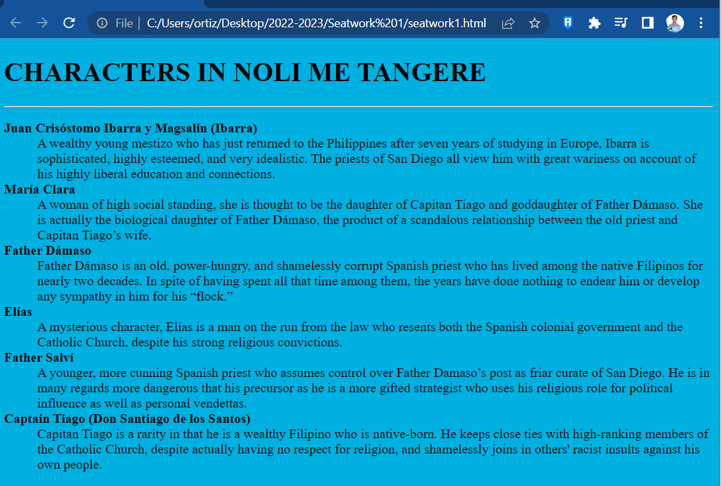SAMPLE OUTPUT:

**CODES (insert screen captures of your codes)**

**OUTPUT (insert screen captures of your output from the browser)**