PROJECT REPORT: TEST ENGINEERING

Course: CEN315 – Introduction 2 Test Engineering
Project Name: Gym Booking System API
Date: December 23, 2025

NAME: Hamdo Dahir
SURNAME: SABAN
STUDENT NUMBER: 2022555059

Project Summary and Architectural Approach
This project involves a back-end system for a Gym Booking Application, developed using .NET 8. The primary goal was to apply advanced test engineering methodologies to ensure the reliability, performance, and maintainability of the software.

Architectural Overview
The system follows an N-Tier Architecture to separate concerns:
- Domain/Models: Core entities and request/response models.
- Service Layer: Contains the business logic, pricing algorithms, and reservation rules.
- Infrastructure/Repository: Handles data persistence and external integrations.
- API Layer: RESTful endpoints for client communication.

Test Levels and Techniques Applied
We implemented a multi-layered testing strategy to cover different aspects of the application.

Decision Table
To optimize the test suite, we used Decision Tables for complex pricing logic.
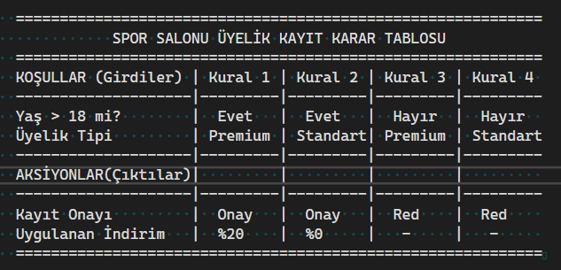

Pairwise
Pairwise Testing for member/class combinations. This approach ensured maximum coverage with a minimum number of test cases.

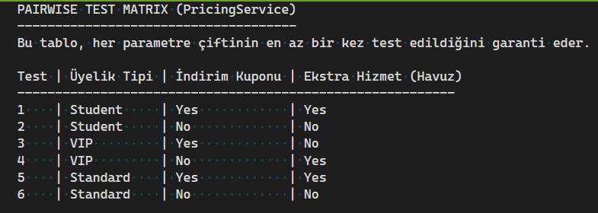

Behavior-Driven Development (BDD)
Using SpecFlow (Gherkin), we translated business requirements into human-readable test scenarios. This bridged the gap between technical implementation and business expectations.
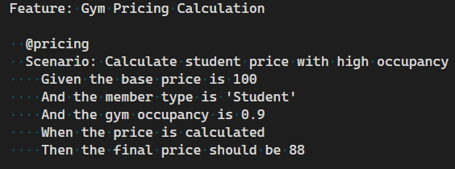

Unit and Integration Testing
Unit Tests: Isolated testing of individual methods using xUnit and Moq.
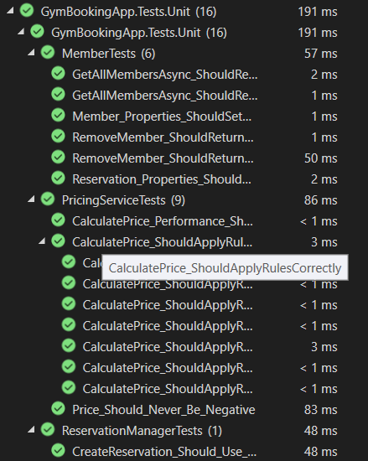
Integration Tests: Verified the interaction between the API, Services, and Repositories within a Docker environment.
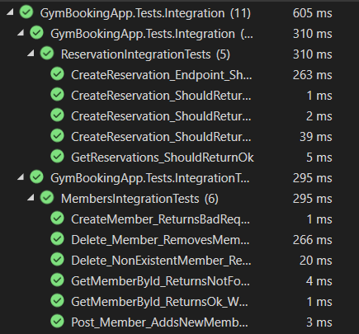

Mutation Testing (Stryker.NET)
We applied Mutation Testing to measure the "intelligence" of our tests. By intentionally injecting faults (mutants) into the code, we verified if our test suite could detect and "kill" these errors.
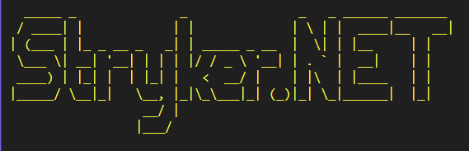
Code Coverage
The project achieved an overall code coverage of 94.1%, ensuring that almost all execution paths are verified by tests.
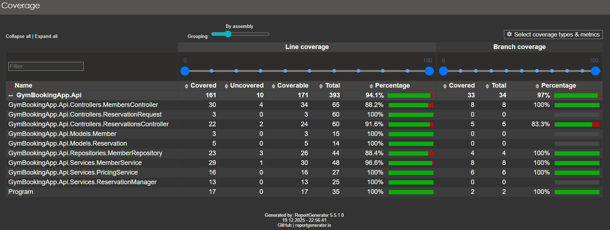
Mutation Score
Focused Score (Services): 84.21%.
Analysis: The high score in the Service layer proves that the core business logic is robustly protected against logic errors.
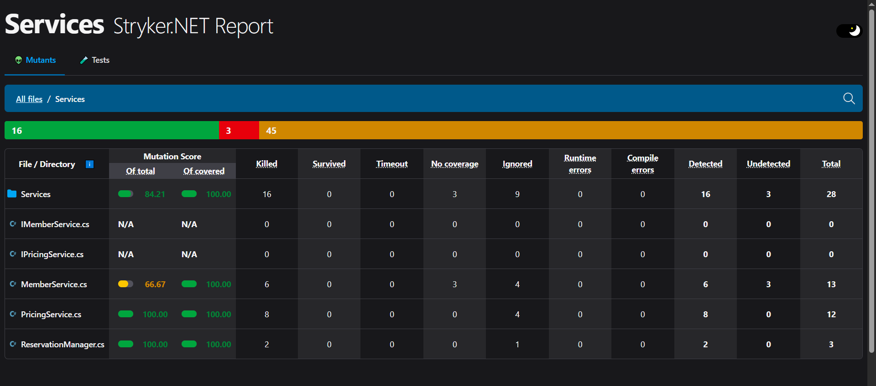
Performance Benchmarks
Using automated tools, the API was tested under load:
Concurrent Requests: 100.
Total Duration: 2231 ms.
Average Latency: 22.3 ms per request.
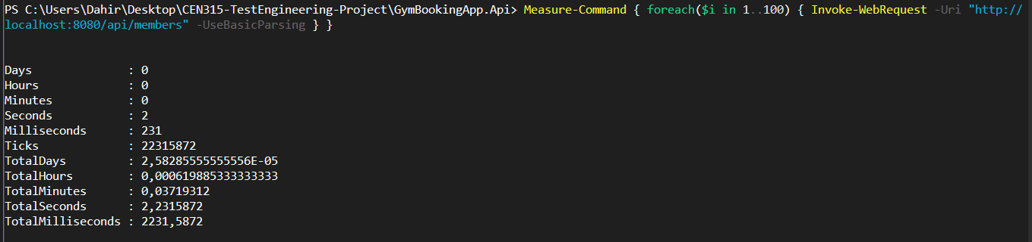

CI/CD and Security
CI/CD Pipeline: Integrated with GitHub Actions. Every code change triggers an automated build and test run, ensuring no regressions are introduced.
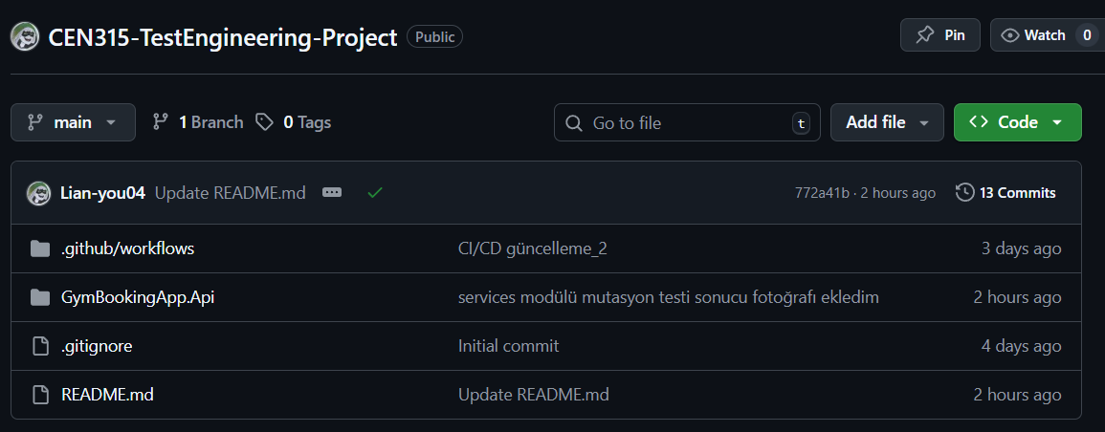
Containerization: The entire environment is containerized via Docker, providing consistency across different development and production environments.
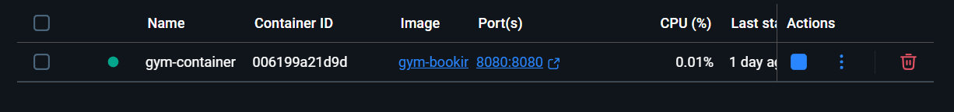

Overall Reflection
What was done well:
Logic Protection: Successfully achieved a %100 mutation score in critical services like PricingService.
Automation: Established a fully automated pipeline where testing and deployment are seamless.

Future Improvements:
Expanding Mutation Scope: While the Service layer is highly secure, future iterations will include unit tests for Controllers to raise the overall project mutation score above its current 25.00%.
Security Scanning: Adding Static Application Security Testing (SAST) tools to the CI/CD pipeline.

