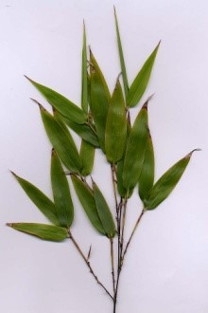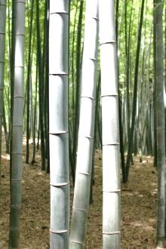

**Beautiful Bamboo**

Bamboo has long been woven into the cultures of many countries, where it has historically been used for everything from food and fodder to musical instruments and construction material. For centuries, millions of people have depended on this plant, which is known as “friend of the people” in China, and “wood of the poor” in India. But the demand for bamboo has been increasing in other parts of the world as well, especially as it relates to furniture, accent pieces, and flooring. More and more, people are seeing the value and beauty of using bamboo in their homes to achieve modern-day fashion with an ethnic flavor. Entire books have been written on the subject, including *Big Bad Bamboo* and *Bamboo, Family Style*.

There are many different sizes and varieties of bamboo. It is both tropical and subtropical, growing in climates as diverse as jungles and mountainsides. Actually giant, woody grasses, it is very adaptable, with some species deciduous and others evergreen. Although there isn't yet a complete knowledge about this plant, there are believed to be between 1100 and 1500 different species of bamboo. The color range is from light green leaves and culms (stems) to dark, rich shades of green or some combination thereof.

Because they are so easy to grow in such a variety of climates, there is a plant available for just about anyone who wishes to grow one in the backyard. Some dwarf species include chimonobambusa marmorea, indocalamus tessellatus, and pleioblastus chino vaginatus. Also suitable for the personal garden are those categorized as mid size. Examples of these types of plants are bambusa glaucophylla and otatea acuminata aztectorum. Plant starts and seeds are easier to find than ever, being available at nurseries and through mail order.

Choosing bamboo as part of home or garden design makes sense on many levels. Not only does it have an appealing look, but it supports the environment as well as the countries that produce it.