实验四：适配器模式

(1) 类适配器(classAdapter)

1.1 UML图
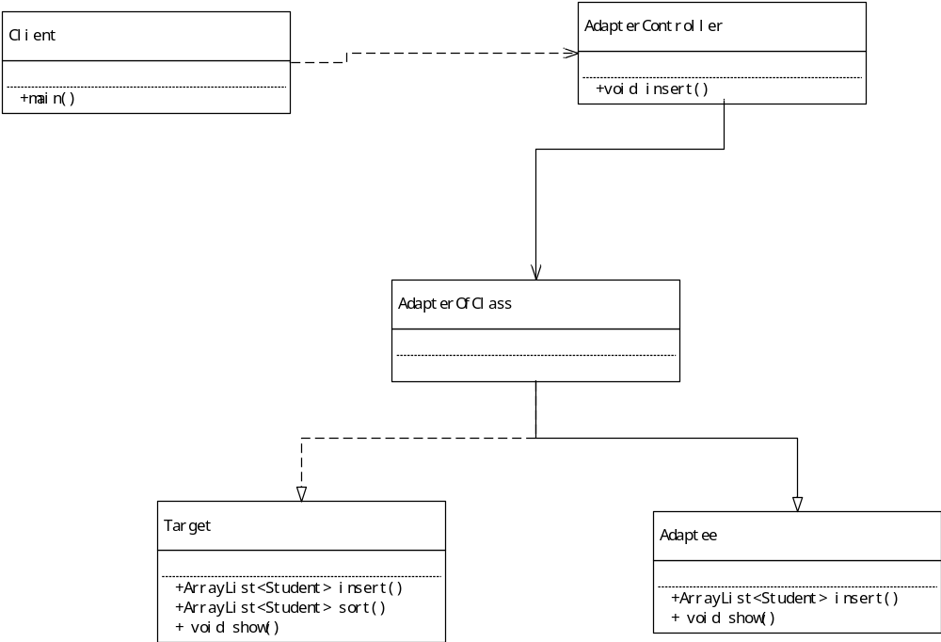

1.2 代码
package cn.edu.scau.cmi.lianzongsheng.adapter;

import java.util.ArrayList;

import javafx.scene.control.TextArea;

public class Adaptee {
public ArrayList<Student> insert(int stuid,String name){
Student stu =new Student(stuid, name);
Student.stuList.add(stu);
return Student.stuList;
}
public void show(ArrayList<Student> stuList,TextArea infolist) {
infolist.clear();
for(int i=0;i<stuList.size();i++) {
String info = "学号："+stuList.get(i).stuID+" 姓名："+stuList.get(i).name+"\n";
infolist.appendText(info);

}
}

}

package cn.edu.scau.cmi.lianzongsheng.adapter;

import java.util.ArrayList;

import javafx.scene.control.TextArea;

public interface Target {
public ArrayList<Student> insert(int stuid,String name);
public ArrayList<Student> sort( ArrayList<Student> stuList);
public void show(ArrayList<Student> stuList,TextArea infolist);
}
package cn.edu.scau.cmi.lianzongsheng.adapter;

import java.util.ArrayList;

public class AdapterOfClass extends Adaptee implements Target {

@Override
public ArrayList<Student> sort(ArrayList<Student> stuList) {

return SortUtil.sortList(stuList);
}

}

1.3 实现效果
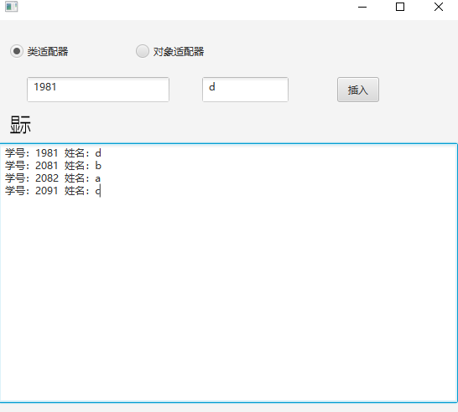

(2) 对象适配器(objectAdapter)

2.1 UML图

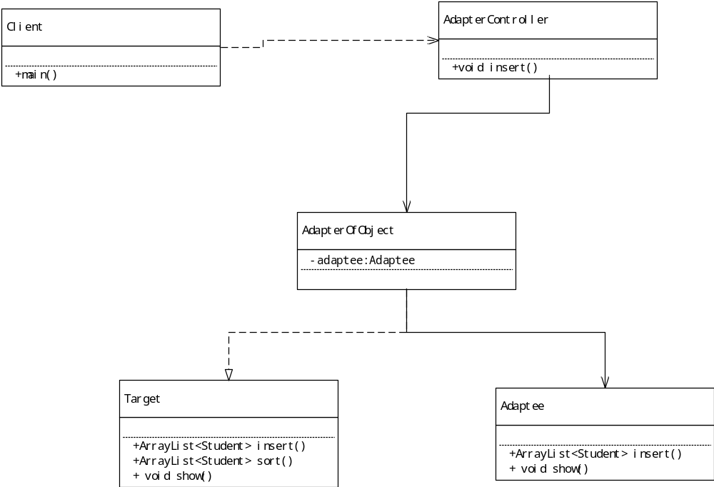

2.2 代码
package cn.edu.scau.cmi.lianzongsheng.adapter;

import java.util.ArrayList;

import javafx.scene.control.TextArea;

public class AdapterOfObject implements Target{
private Adaptee adaptee=new Adaptee();

@Override
public ArrayList<Student> insert(int stuid, String name) {

return adaptee.insert(stuid, name);
}

@Override
public ArrayList<Student> sort(ArrayList<Student> stuList) {
return SortUtil.sortList(stuList);
}

@Override
public void show(ArrayList<Student> stuList, TextArea infolist) {
stuList = sort(stuList);
adaptee.show(stuList, infolist);

}

}

2.3 实验效果
