实验七：Spring基本使用

毕业答辩，zhangsan是liang老师的学生。使用Spring管理这两个对象，客户端输出学生的姓名和这个学生的导师的姓名。
Spring的配置文件
<?xml version="1.0" encoding="UTF-8"?>
<beans xmlns="http://www.springframework.org/schema/beans"
xmlns:xsi="http://www.w3.org/2001/XMLSchema-instance"
xsi:schemaLocation="http://www.springframework.org/schema/beans http://www.springframework.org/schema/beans/spring-beans.xsd">
<bean id = "student1" class="cn.edu.scau.cmi.chenkairong.ioc.domain.Student">
<property name="name" value="陈同学"></property>
<property name="gendar" value="男"></property>
</bean>
<bean id = "teacher1" class="cn.edu.scau.cmi.chenkairong.ioc.domain.Teacher">
<property name="name" value="梁老师"></property>
<property name="gendar" value="男"></property>
</bean>
</beans>

客户端获取zhangsan对象的核心方法
ApplicationContext applicationContext = new ClassPathXmlApplicationContext("applicationContext.xml");
Teacher teacher = (Teacher)applicationContext.getBean("teacher1");

实现效果
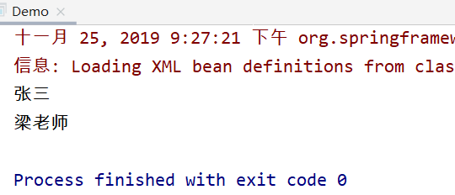

在第六个实验的基础上（Hibernate+DAO），DAO对象使用Spring管理。其他要求按照默认要求。
Spring配置文件
<?xml version="1.0" encoding="UTF-8"?>
<beans xmlns="http://www.springframework.org/schema/beans"
xmlns:xsi="http://www.w3.org/2001/XMLSchema-instance" xmlns:p="http://www.springframework.org/schema/p"
xmlns:context="http://www.springframework.org/schema/context"
xmlns:mvc="http://www.springframework.org/schema/mvc"
xsi:schemaLocation="http://www.springframework.org/schema/beans
http://www.springframework.org/schema/beans/spring-beans-3.1.xsd
http://www.springframework.org/schema/context
http://www.springframework.org/schema/context/spring-context-3.1.xsd
http://www.springframework.org/schema/mvc
http://www.springframework.org/schema/mvc/spring-mvc-4.0.xsd">
<!-- 自动扫描所有的包，加载装配所有的实体类bean -->
<context:component-scan base-package="cn.edu.scau.cmi.chenkairong.mybatisdemo"/>
<!-- 配置数据源 -->
<bean id="dataSource" class="org.springframework.jdbc.datasource.DriverManagerDataSource">
<property name="driverClassName" value="com.mysql.jdbc.Driver"/>
<property name="url" value="jdbc:mysql://localhost:3306/mybatisdemo?characterEncoding=UTF-8"/>
<property name="username" value="root"/>
<property name="password" value="123456"/>
</bean>
<!-- sqlSessionFactory -->
<bean id="sqlSessionFactory" class="org.mybatis.spring.SqlSessionFactoryBean">
<!-- 加载 mapper.xml的配置文件 -->
<property name="mapperLocations" value="cn/edu/scau/cmi/chenkairong/mybatisdemo/mapper/*.xml"/>
<!-- 添加所需的数据源 -->
<property name="dataSource" ref="dataSource"/>
</bean>
<!-- 扫描Dao包，加载接口映射类 -->
<bean class="org.mybatis.spring.mapper.MapperScannerConfigurer">
<property name="basePackage" value="cn.edu.scau.cmi.chenkairong.mybatisdemo.dao"/>
<property name="sqlSessionFactoryBeanName" value="sqlSessionFactory"/>
</bean>
<!-- (事务管理)transaction manager -->
<bean id="transactionManager"
class="org.springframework.jdbc.datasource.DataSourceTransactionManager">
<property name="dataSource" ref="dataSource"/>
</bean>
</beans>

DAO的获取核心代码
public class AppContext {
private static ApplicationContext appContext;
static {
appContext = new ClassPathXmlApplicationContext("apptionContext.xml");
}
public static <T>T getBean(Class<T> t){
return appContext.getBean(t);
}
}

studentDao student_insert = AppContext.getBean(studentDao.class);
student_insert.add(student);

实现效果
