实验五：组合模式

(1) 安全组合模式

1.1 UML图
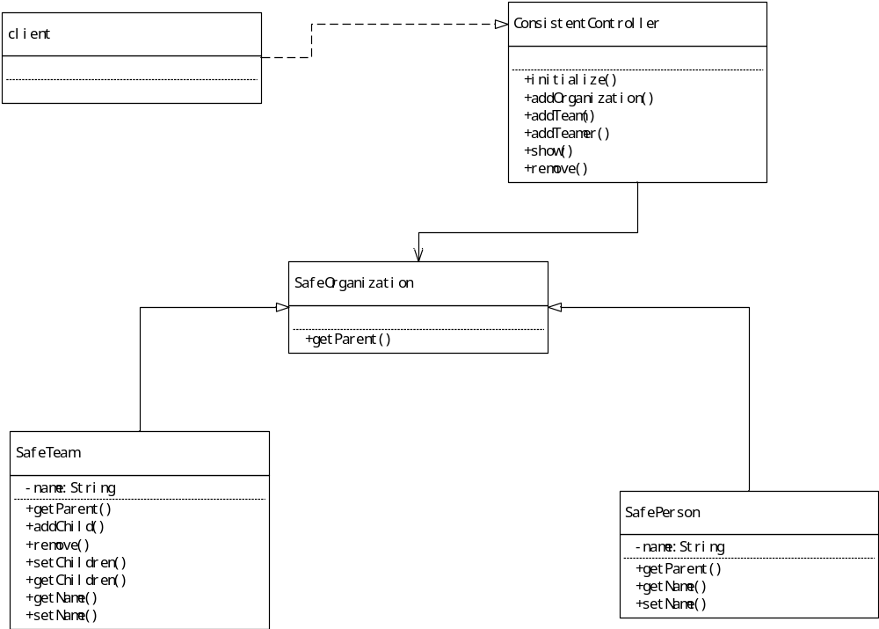

1.2 代码
package cn.edu.scau.cmi.lianzongsheng.composite.safe;

public abstract class SafeOrganization {
SafeOrganization getParent() {
return null;
}

}
package cn.edu.scau.cmi.lianzongsheng.composite.safe;

import java.util.HashSet;

public class SafeTeam extends SafeOrganization {
private String name;
private HashSet<SafeOrganization> children = new HashSet<>();
@Override
SafeOrganization getParent() {
// TODO Auto-generated method stub
return super.getParent();
}
public SafeOrganization addChild(SafeOrganization child) {
this.children.add(child);
return this;

}
public SafeOrganization remove(SafeOrganization child) {
children.remove(child);
return this;
}

public String getName() {
return name;
}
public void setName(String name) {
this.name = name;
}
public HashSet<SafeOrganization> getChildren() {
return children;
}
public void setChildren(HashSet<SafeOrganization> children) {
this.children = children;
}
}

package cn.edu.scau.cmi.lianzongsheng.composite.safe;

public class SafePerson extends SafeOrganization {
private String name;
@Override
SafeOrganization getParent() {
// TODO Auto-generated method stub
return this.getParent();
}
public String getName() {
return name;
}
public void setName(String name) {
this.name = name;
}

}

1.3 效果
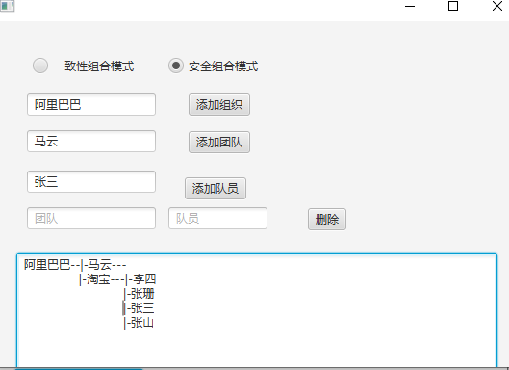

(2) 一致性组合模式

2.1 UML图

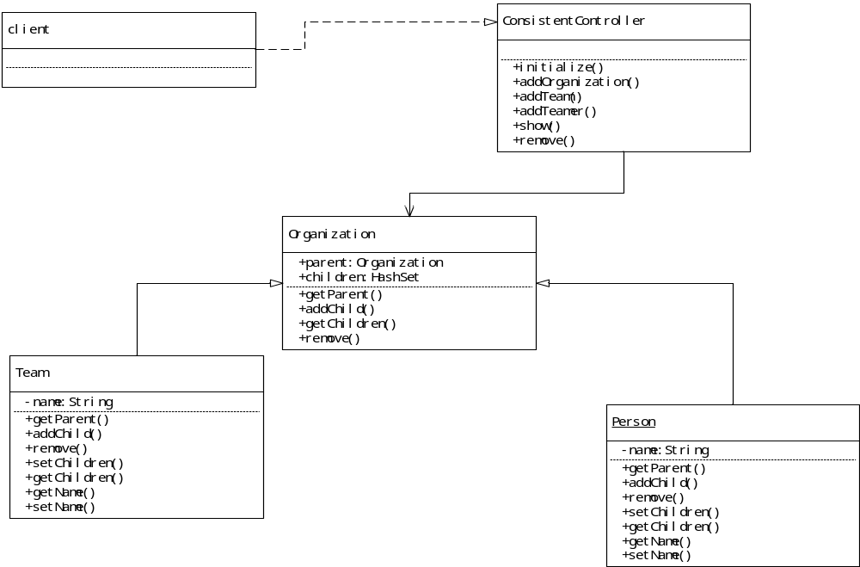

2.2 代码
package cn.edu.scau.cmi.lianzongsheng.composite.consistent;
import java.util.HashSet;
public abstract class Organization {
Organization parent = null;
HashSet<Organization> children = new HashSet<>();
abstract Organization getParent();
abstract Organization addChild(Organization child);
abstract HashSet<Organization> getChildren();
abstract Organization removeChild(Organization child);
}
package cn.edu.scau.cmi.lianzongsheng.composite.consistent;

import java.util.HashSet;
public class Team extends Organization{
private String teamName =null;
@Override
Organization getParent() {
return this.parent;
}
@Override
Organization addChild(Organization child) {
this.children.add(child);
return this;
}
@Override
HashSet<Organization> getChildren() {
// TODO Auto-generated method stub
return this.children;
}
public void setTeamName(String teamname) {
this.teamName =teamname;

}
public String getTeamName() {
return this.teamName;
}

@Override
Organization removeChild(Organization child) {
// TODO Auto-generated method stub
children.remove(child);
return this;
}
}
package cn.edu.scau.cmi.lianzongsheng.composite.consistent;

import java.util.HashSet;

public class Person extends Organization{
private String name;
@Override
Organization getParent() {
// TODO Auto-generated method stub
return this.parent;
}
@Override
Organization addChild(Organization child) {
// TODO Auto-generated method stub
return null;
}

@Override
HashSet<Organization> getChildren() {
// TODO Auto-generated method stub
return null;
}

public String getName() {
return name;
}

public void setName(String name) {
this.name = name;
}
@Override
Organization removeChild(Organization child) {
// TODO Auto-generated method stub
return null;
}
}

2.3 实验效果
