HW5-577

LianZuo

2023-12-04

1. Name the variables that are discrete, continuous, and categorical.

discrete variables: cyl, carb, gear

continuous variables: pmg, disp, hp, drat, wt, qsec

categorical variables: vs, am

2a. We may consider 2 factors in our study.

(ev.mtcars <- eigen(cor(mtcars))$values)

[1] 6.60840025 2.65046789 0.62719727 0.26959744 0.22345110 0.21159612  
 [7] 0.13526199 0.12290143 0.07704665 0.05203544 0.02204441

mean(ev.mtcars)

[1] 1

which(ev.mtcars>mean(ev.mtcars))

[1] 1 2

2b. We see that a sharp fall occurs at the second eigenvalue and afterwards the line has a very small slope and becomes flatter.

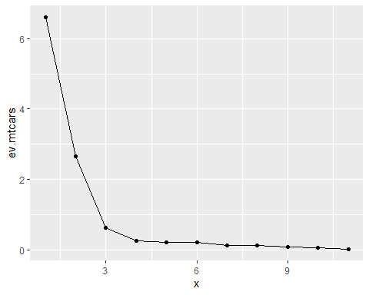

1. Since p-value is 0.205, The chi square statistic is 30.53 on 25 degrees of freedom. We conclude that 3 factors considered are sufficient to fit.
2. Variables mpg, cyl, disp, drat, wt,am and gear can be associated with Factor 1.

Variables cyl, hp, qsec and vs can be described by Factor 2.

Factor 3 can be considered as a measure of carb variable.

1. The estimated error variances associated with drat and am variables is 0.2899972 and 0.2083812 .

mtcars.fac.vm$uniquenesses[c(5,9)]

drat am   
 0.2899972 0.2083812

$4.38={0.643}^{2}+{\left(-0.618\right)}^{2}+{\left(-0.719\right)}^{2}+{\left(-0.291\right)}^{2}+{0.804}^{2}+{\left(-0.778\right)}^{2}+{\left(-0.177\right)}^{2}+{0.295}^{2}+{0.880}^{2}+{0.908}^{2}+{0.114}^{2}$

Show the calculation of how the sum of squared loadings for factor 1 is 4.38.

loads <- mtcars.fac.vm$loadings  
 apply(loads^2,2,sum)[1]

Factor1   
 4.380409

1. The variance among the observed variables is explained by factor 2 is 3.520 .
2. Show the calculation how the proportion of variance explained by factor 2 is found to be 0.320.

round(apply(loads^2,2,sum)[2]/11,2)

Factor2   
 0.32

1. The gear variable that is highly correlated with factor 1 and its correlation value is 0.908 .
2. The qsec variable that is highly correlated with factor 2 and its correlation value is as -0.946 .
3. The variance in variable hp is explained by all the factors in the model is 0.8732196 , we call this variance as communality or the common variance.

communality <- apply(loads^2,1,sum)  
 communality[4]

hp   
 0.8732196