

PRESS RELEASE | FOR IMMEDIATE RELEASE  November 20, 2013  Phone Office: +374-10-248411  Email: info@instigatemobile.com  www.instigatemobile.com

SIM CARD CHANGE NOTIFIER: Instigate Mobile Introduces New App
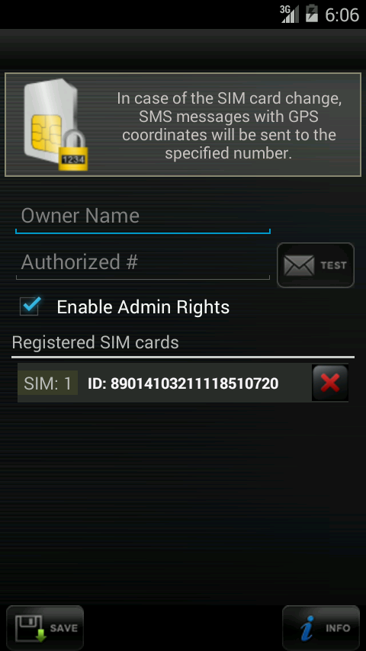
The set up page of the Application | Yerevan, Armenia -Instigate Mobile is pleased to announce the release of its new mobile application “Sim Card Change Notifier” for use with the Android operating systems. The free app, now available for download on Google Play, gives you opportunity to know about the coordinates of the sneak-thief of your mobile phone.  Unlike similar apps, the free Sim Card Change Notifier mobile app provides instantly updated coordinations of the sneak-thief. It sends information to the trusted number once in 2 hours. And what is most important, the icon of the application is hidden from the view which gives opportunity to stay concealed.  The app is working on SIM card change basis. After installing the app and filling the necessary information the application is activated and the icon of the application disappears from owner menu. The application can be called back by dealing the special number indicated in INFO section. After each time the phone is rebooted the application searches the active SIM number and if the number does not coincide with the registered one it starts sending SMS from the none registered number, and if it is possible sends SMS with the mobile phone current GPS coordinations.  The application also gives opportunity not only remotely register SMS number but also block the device.  In Future Instigate Mobile is planning to add new extra features to the application.

# # #

Instigate Mobile is a spin-off from Armenia based company Instigate CJSC focusing on software services and solutions for Mobile and Web technologies.
Instigate Mobile expertise in services and development for Mobile and Web applications is well known and cover many areas such as Database management systems, data warehousing; Customized software development; Information Systems; Outsourcing; IT engineering solutions; Internet applications; Industrial automation; Business process automation; iOS and Android application projecting and implantation; Multimedia applications.

