

SimCardChangeNotifier : Android application
Functional Specification
Code | 1120
Version | 1.0
Last modified | 12:51:28 PM
Number of pages | 4

Table of Contents
1.Introduction 3
1.1.Document identifier 3
1.2.References 3
1.3.Definitions of terms and acronyms 3
1.4.Requirements Overview 3
1.5.Application Overview 3
1.6.Schedule Requirements 3
2.Android 3
2.1.Main menu 3

Introduction

Document identifier
This document describes the features and use cases for “SimCardChangeNotifier” Android application developed by Instigate Mobile for Android devices.
“SimCardChangeNotifier” purpose is to help people to find lost Android devices.

References

Definitions of terms and acronyms
- Android is a mobile operating system developed by Google and is based upon the Linux Kernel and GNU software. It was initially developed by Android Inc. (a firm purchased by Google). Android OS smartphones ranked first among all smartphone OS handsets sold in the U.S. In the second quarter of 2010, at 33%. BlackBerry OS is second at 28%, and iOS is ranked third with 22%. In 2012 World-Wide Smartphone 66% Sales with Android operating system.
http://en.wikipedia.org/wiki/Mobile_operating_system

Requirements Overview
The Android application should support Android OS 2.2 and higher versions.
The Android application supports only portrait mode.

Application Overview
This section describes the proposed implementation of the application and its features.
The typical usage scenario is:
- After launching the application user can add Phone owner name
- After launching the application shows serial number of current SIM card
- User can change SIM card and after lunching application again new serial number will be added
- User can add phone number to which the SMS notification will be sent after changing the SIM card
- User can Test the SMS sending
- User can change sending SMS notification time
- User can add SIM cards after saving the application by replying from desired phone SMS notification with the following text sccn.add.currentSIM
- After saving the application user can block device with custom password by replying from desired phone SMS notification with the following text sccn.block.device
- User can Save the Phone number and after saving the application will be hidden from Applications menu
- For changing configuration user can get back hidden application by dialing following number ###741147

Schedule Requirements
TODO

Android

Main menu
Application icon should be in the front of view.
Application purpose short description should be shown.
After clicking on Help button user should be able to see the popup with information of the application.
After clicking on Settings button user should be able to change SMS notification sending time
User should add the name of the phone owner.
User should add Phone number to which SMS notification will be sent.
After adding phone number user can test SMS sending feature.
For remote blocking device with setting password user must allow “Admin Rights” permission for application
User should Save the Phone owner name and Phone number. After Saving application should be closed and hidden from application list.

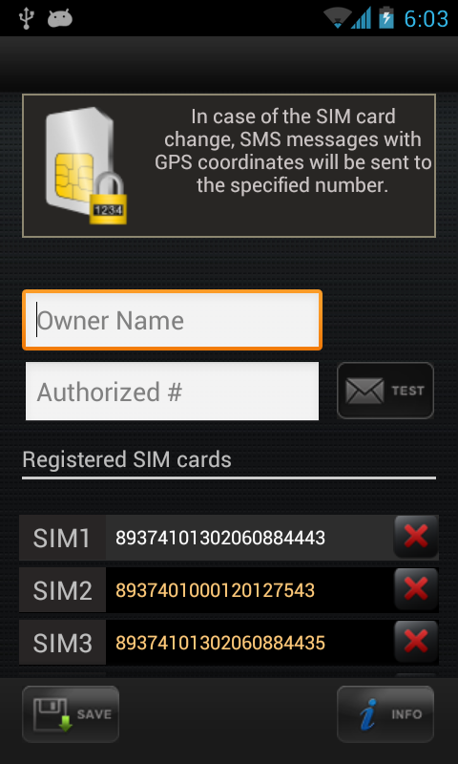Illustration 1: Main menu

