
Product Requirements for Phone Guard Application
Sim Card Change Notifier
Code | 1121
Version | 0.01
Last modified | 29-Nov-13
Number of pages | 6

Document History
Date | Description | Author(s)
09-Sep-10 | Version 0.01: Created the initial version of the problem statement of Phone Guard Application | Vahe Kocharyan
09-Sep-10 | Reviewed | Susanna
16-Nov-10 | Updated description of free 1.0 version. | Artyom Karhanyan
29-NOV-13 | Updated description of 3.1.0 version. | Vram Voskanyan

Table of Contents
1. Introduction 4
1.1. Document identifier 4
1.2. Definitions of terms and acronyms 4
2. Requirements 4
2.1. Overview of the Requirements 4
2.2. Functional Requirements for Free Version (v.1.0) 4
2.3. Functional Requirements for PRO Version (v.2.0) 5
2.4. Platform requirements 5
2.5. Verification Requirements 5
3. Current Status 5
3.1. Dependencies, Assumptions, Risks 5
3.2. Schedule and Effort Estimations 5

Introduction

Document identifier
This is a product requirements document for mobile application which can help to find lost mobile devices.

Definitions of terms and acronyms
- Android is a mobile operating system developed by Google and is based upon the Linux Kernel and GNU software. It was initially developed by Android Inc. (a firm purchased by Google). Android OS smartphones ranked first among all smartphone OS handsets sold in the U.S. In the second quarter of 2010, at 33%. BlackBerry OS is second at 28%, and iOS is ranked third with 22%. In 2012 World-Wide Smartphone 66% Sales with Android operating system.
http://en.wikipedia.org/wiki/Mobile_operating_system

Requirements

Overview of the Requirements
There is need to develop an application which will help to find mobile device in case it has been lost and SIM card has been changed. The phone owner should be able to register a number in the application to which a notification (SMS) will be sent in case if SIM card of the phone is changed.
The application allow to register multiple SIM cards and remote control via SMS.

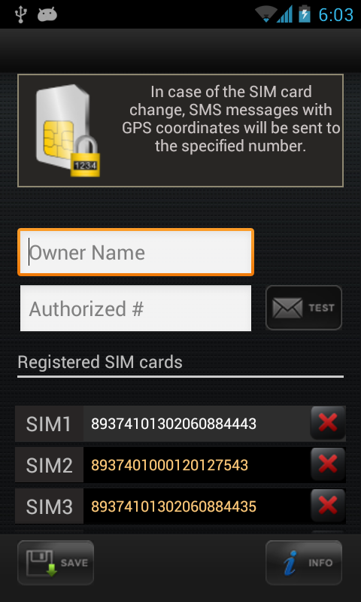

Functional Requirements for Version (v.3.1.0)
Installation
- Installation of the application must be started by downloading it from the Android Market.
- After launching the application, the user is asked to activate the “Admin rights permission” needed for remote device blocking by SMS.
- As input the name of the owner and the desired (trusted) phone number should be filled.
- Testing functionality should be supported to test whether the trusted number is entered correctly, i.e. the test SMS should be sent to the specified number to check it's correctness and to inform owner of the phone number that his number is included in one's SIM Card Change Notifier program.
- After changing SIM card and lunching the application new serial number of SIM card should be visible
- Current SIM card serial number should be highlighted
- After saving, the application should be closed and hidden from device's applications menu.
- After the application is saved and hidden from the device's applications menu, the user can restore the application by dialing the following number: ###741147
Change of SIM card
- After SIM card changing and rebooting device, the background service of the application should do the following two steps.
  - If SIM card has been changed with unregistered one:
    - SMS notification with custom password (for blocking the device) is sent to the specified number
    - If user would like to add changed SIM card as desired SIM, he should reply to the SMS with the following text: sccn.add.currentSIM
    - After new SIM card serial number is registered, confirmation SMS should be sent to the trusted number
    - If user would like to block the device by setting custom password, he should reply to the notification SMS with the following text: sccn.block.device
    - After the device is blocked, confirmation SMS is sent to the trusted number.
    - (Only for test) If user forget new custom password or would like to change password, he should reply to the notification SMS with the following text: sccn.unlock.device
new password: sccn123
  - After sending the first notification SMS, the GPS service must be activated, and SMS notification with Address and Google Maps URL should be sent to the specified number.
Implementation requirements
  - Add FlightPath analytics.(In progress)
  - Add Google analytics.
Uninstall of the application
- Uninstallation should be done from the application's market (must be certified).

Platform requirements
SIM Card Change Notifier should be developed for the following platforms:
- Android 2.2.x

Current Status
Now we don't supported dual SIM functionality, because Android does not support multiple SIM cards. Dual SIM device manufacturers implemented that functionality with private API.
Detail you can read here.
http://developer.samsung.com/forum/board/thread/view.do?boardName=GeneralB&messageId=154434&startPage=86&curPage=88

Dependencies, Assumptions, Risks
- For particular platforms SIM card APIs are not supported.
- For particular platforms background work is not supported.
Risks of delays from schedule are:
- Changing problem statement during development.
- Switching to more high priority tasks.
- Employees are not familiar with needed development environments.

Schedule and Effort Estimations
Schedule is located in the following path:
svn://urmia/repository/instigate/rnd/mobile/schedule

