

SIM Card Change Notifier
User Guide

Version 3.2.0
Last modified on 2015-Oct-28
Number of pages 8
Table of Contents
1. Introduction 3
1.1. Document identifier 3
1.2. Definition 3
2. General Information 3
2.1. Application Overview 3
2.2. System Overview 3
2.3. User access Level 4
3. Getting Started 4
3.1. Installation/ Download 4
3.2. Application User Interface 4
4. Application Usage 6
4.1. Test SMS 8
4.2. Register multiple SIM cards 8
4.3. Change configuration 8
4.4. Register SIM card remotely 8
4.5. Block the device remotely 8
4.6. Reset the “Show Number” remotely 8
4.7. Uninstall the application 8

Introduction

Document identifier
This document is a user guide for Sim Card Change Notifier application

Definition
“SMS Notification” - SMS containing information about SIM card change.
“Email Notification” - Mail containing information about SIM card change.
“Owner Name” - The name of phone on which the application is installed.
“Registered SIM cards” - The list in which the registered SIM cards' serial numbers are shown.
“Trusted Number” - The phone number which will receive SMS from application in case of SIM card change. It is possible to remotely block the device and register new inserted unregistered SIM card only from this number.
“Show Number” - Dialing this number will show application in phone application list. By default it is ###7226.
“Your Email” - The email address which will receive notification emails in case of sim card change.
”Register Command” - User can send SMS from “Trusted Number” to register newly inserted unregistered SIM card. “Register Command” text is “sccn_add_current_sim ”.
“Block Command” - Sending SMS from “Trusted Number” with this command will block the phone. “Block Command” text is “sccn_block_device”.
“Reset Show Number Command” - Sending SMS from “Trusted Number” with this command will reset the “Show Number” to its default: ###7226. “Reset Show Number Command” text is “sccn_reset_show_number”.
“Location Sending Interval” - User periodically receives SMS with location coordinates with this time interval.

General Information
General Information section explains in general terms the application and the purpose for which it is intended.

Application Overview
Sim Card Change Notifier is a free SIM Card monitoring application. The application enables mobile phone users to monitor any unwanted/unexpected changes of the SIM card. It sends SMS messages to the predefined/trusted phone number and email messages to predefined email address, when a non-authorized SIM card is installed in the mobile phone.
Each time when a non-authorized SIM card is detected the application sends “SMS Notification” and “Email Notifications”. The application also provides remote control features, such as remotely block the phone or authorize a newly installed non-authorized SIM card.
The application allows to have up to 3 authorized SIM cards.
When location is available, SMS message containing phone's coordinates and address will be sent to the “Trusted Number”.
When application is configured and saved, it becomes hidden from the phones application menu. The application can be shown by dialing “ Show Number”. By default it is ###7226.

System Overview
The application operates on mobile devices running Android operating system.
The application is compatible with Android 2.2 (API Level 8) and higher versions. The application requires:
- Device ID & Call information permissions to read SIM card information.
- SMS/Email sending/receiving permissions to send/monitor SMS messages.
- Internal GPS receiver to obtain location coordinates and include them in sent SMS.
- Administrative permissions to Block the device remotely.
The application becomes functional when it is configured and saved.
NOTES:
- The application works only on GSM phones with SIM cards.
- Depending on device settings, GPS availability, and GSM provider settings, GPS coordinates and SIM card's number may not be available in the sent SMS.
- The application is optimized for dual SIM card mobile phones.

User access Level
Everyone can install and use this application on their mobile devices if the device meets the minimum system requirements.

Getting Started
Getting Started section explains how to get Sim Card Change Notifier and install it on the device. This section is the brief description of application menu.

Installation/ Download
You can download and install the latest version from Google Play Store.
https://play.google.com/store/apps/details?id=instigate.simCardChangeNotifier

Application User Interface
The application has very simple and intuitive user interface.
The application has 3 main views: Home view, Settings menu, About/Info Section.
When the user clicks the Save button, the owner of the trusted number will receive SMS notification with “Show number” and the user will be asked to activate administrator permissions. This is required to allow application to change/set the screen-lock password when receiving SMS with “Block Command”.
When the user saves the configuration without activating administrator permissions, the owner of the “Trusted Number” can not remotely block the device by sending SMS message with “Block Command”.

Home View
Home view is the main view of the application.
It consists of configuration view and tool bar located at the bottom of the screen. See Illustration 1.
You specify mobile phone “Owner Name”, “Trusted Number” (to which SMS will be send) and “Your Email” (to which “Email Notification” will be send) in this view.
Registered/Authorized SIM card information (SIM card ID) is filled automatically by the application if a SIM card is installed.
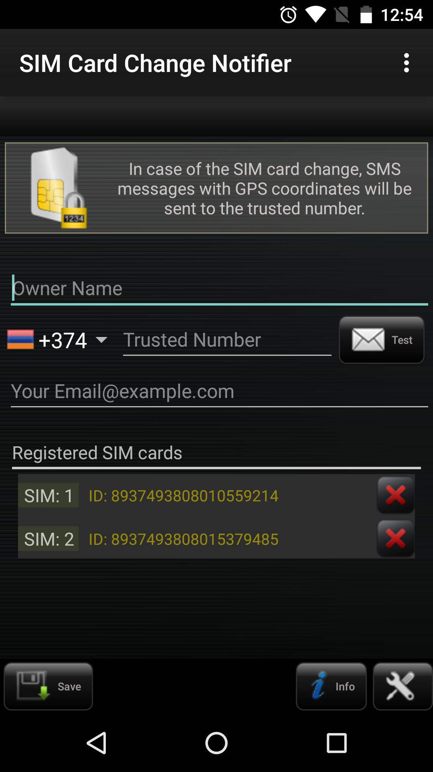Illustration 1
You can test SMS sending functionality by pressing Test button (next to the “Trusted Number”).
Toolbar has 3 buttons:
- Save button– saves the current configuration and the app becomes hidden from device application menu. You can reactivate the application by dialing the number that you set in preferences (By default ###7226, see Illustration 6) and update the configuration. The owner of the trusted number will receive SMS notification with “Show Number”, when the user clicks the Save button.
- Info – opens info/about section, which describes general application information . For more details see Info Section.
- Settings – opens settings menu. For more details see Settings.

Settings
In this screen user can configure the application's settings (see Illustration 2). Here can be configured:
- Interval of sending SMS with GPS coordinates. When unregistered SIM card is inserted in the device and device location is available, with this interval of time the application will send SMS with location of the device to the “Trusted Number”.
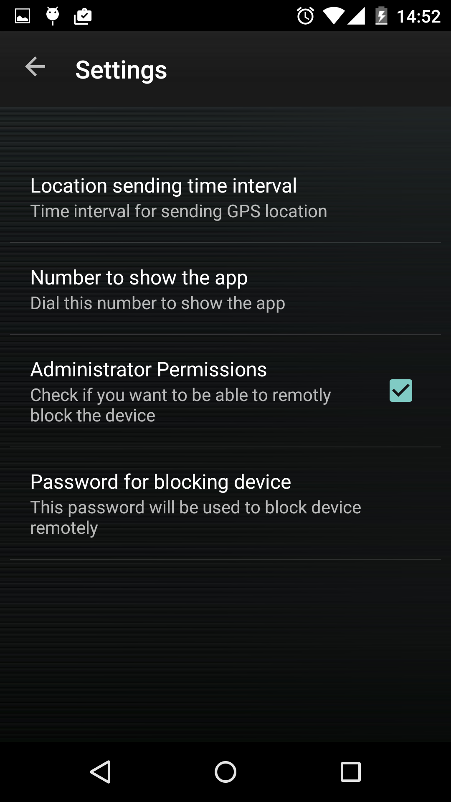Illustration 2
- Number that will be used to show application. After dialing this number the application will be shown in application list. By default it is ###7226.
- Device Administrator permissions activation /deactivation(block device feature will work only with activated permissions).
- Password for blocking device. This password will be used to block device by setting new password, when application will receive block SMS command from the “Trusted Number”. See detailed instruction in section “Configure the application.“.

About Section
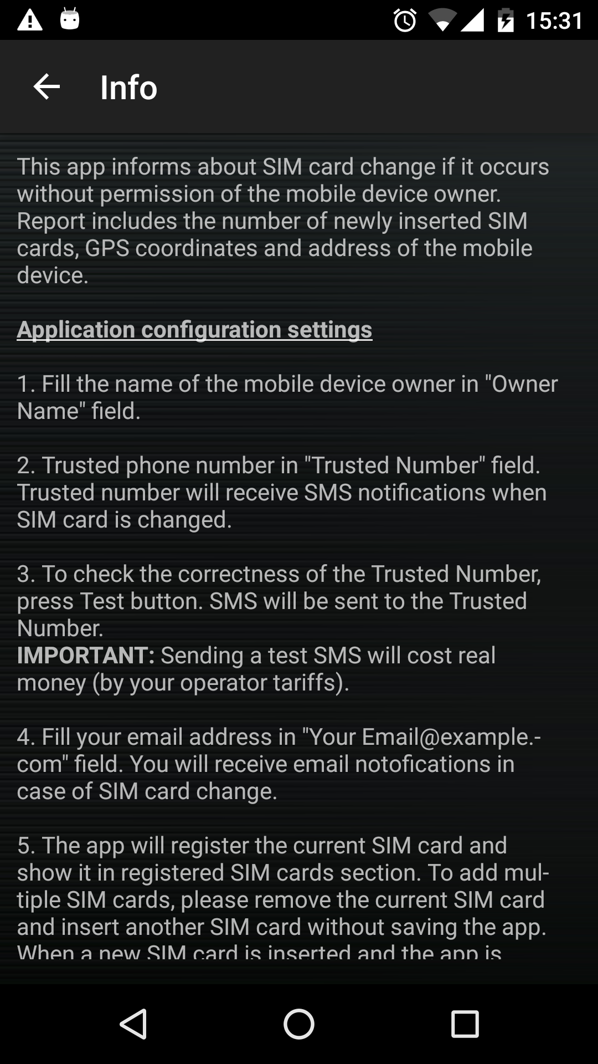Illustration 4
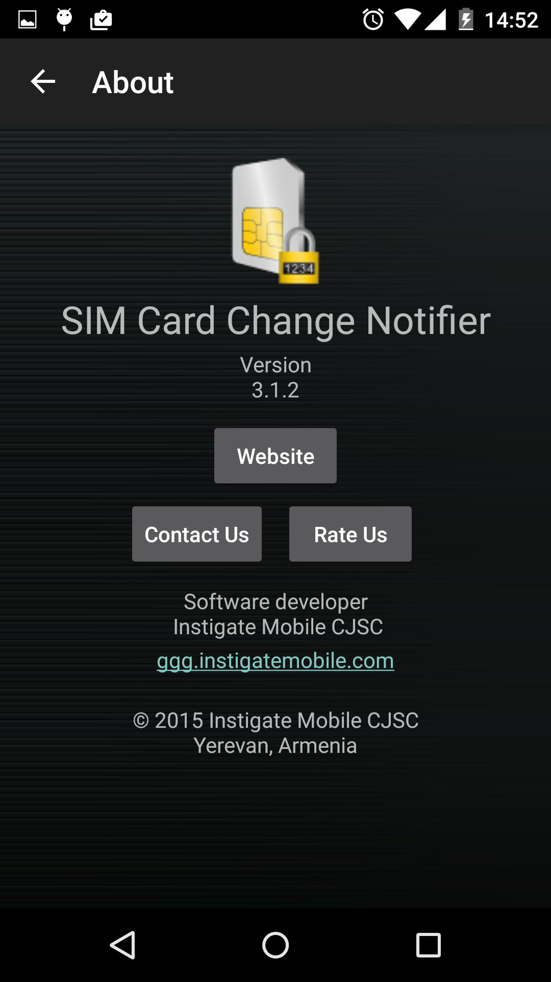Illustration 3
This section is presented the information about the application See Illustration 3.
You can visit the application's official website by pressing the “Website” button. “Rate Us” will bring you to our page on Play Store to rate this application. You can wrute us by pressing on “Contact Us” button.

Info Section
This section describes the main functionality of the application and its usage. See Illustration 4.

Application Usage
This application notifies about SIM card change if it happens without permission of the mobile device owner.
When a new unregistered SIM card is inserted into the phone the “Trusted Number” will receive SMS notification.
“SMS Notification” includes the number of newly inserted SIM card, GPS coordinates (if available) and Address of the mobile device (if available).
By default the application sends SMS with mobile device location every 2 hours to track the phone if “Location Sending Interval” is not set manually.
When the owner of the “Trusted Number” receives SMS notifications, he/she can always include the newly inserted SIM card in the registered list by replying with ”Register Command” SMS message or remotely block the device by setting password, if replying with “Block Command” SMS message.
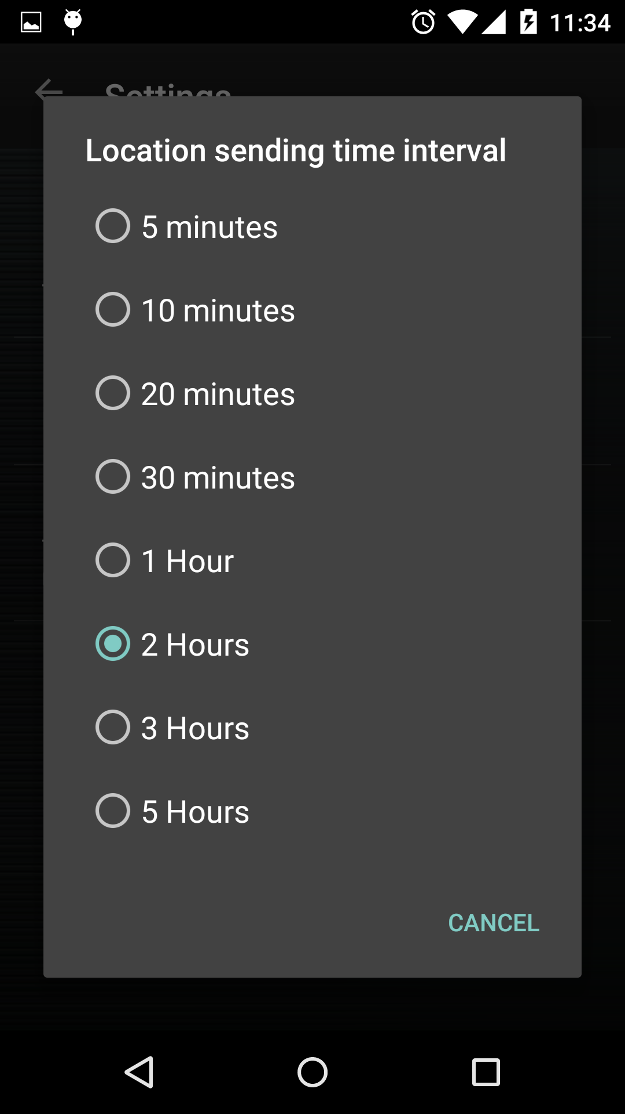Illustration 5
Configure the application.
Fill the name of the mobile device owner in “Owner Name” field, choose your country from the list(please select 'Other' if country is not found) and filed trusted phone number in “Trusted Number” field. “Trusted Number” will receive SMS notifications when SIM card is changed.
Now you can press “Settings” button to enter settings menu. Settings menu allows you to configure the following settings:

Location Sending Interval
If GPS is enabled and unregistered SIM card is installed, the application sends SMS with GPS location coordinates. This setting sets interval between sending SMS with GPS coordinates of device. By default the application keeps sending SMS notifications with GPS coordinates every 2 hours to track the phone. See Illustration 5.

Number for showing app
When the user dials this number the application will be shown. You will need to show application to make changes in configurations. By default number is ###7226. User can see this number in settings (See Illustration 6) and in notification dialog when he/she presses the “Save” button. Also, the owner of the trusted number will receive SMS notification with “Show Number”. User can reset the “Show Number” to its default. The application will reset the “Show Number” after receiving SMS with “Reset Show Number Command” from trusted number.
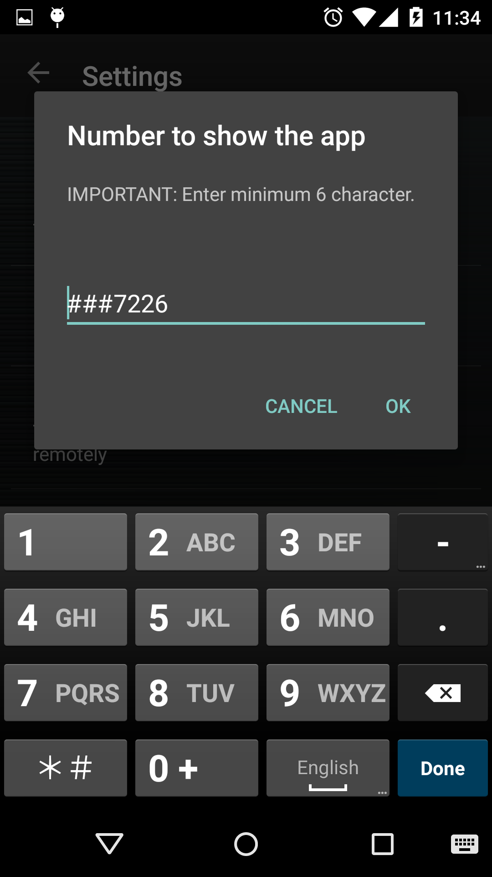Illustration 6

Administrator permissions
You can activate the application device administrator permissions by checking this property. Remotely Block the device feature will work only with activated permissions.

Password for blocking device
This is password with which the device will be blocked when application receives SMS with “Block Command”. By default the application generates random password, e.g agD24 see Illustration 7. The password will be included in “SMS Notification” and in SMS which informs that the device was blocked successfully. Now you can go back to main screen and press “Save” button to save configurations and hide the application.
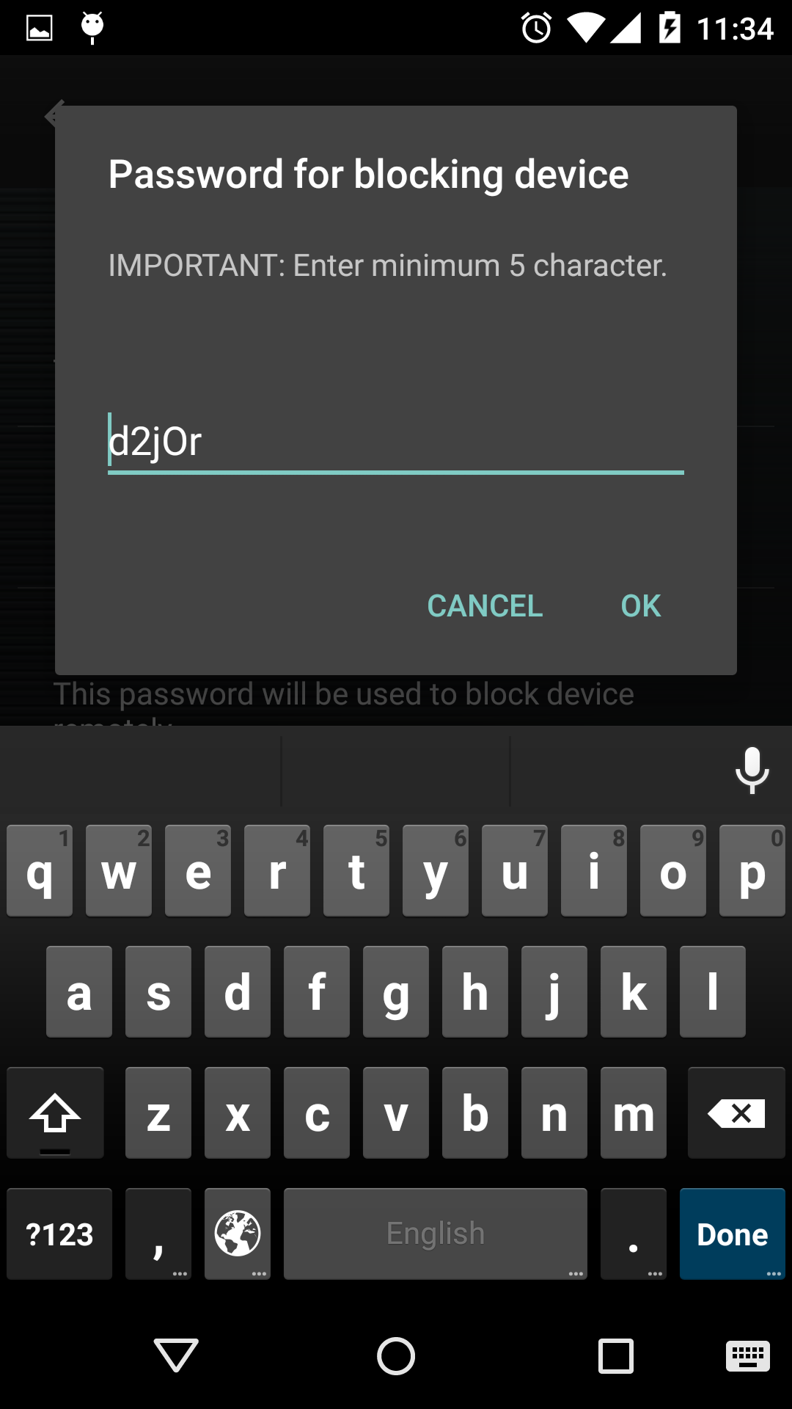Illustration 7

Test SMS
To check the correctness of the “Trusted Number”, press Test button.
SMS will be sent to the “Trusted Number” to check the entered number.
Note: Sending a test SMS will cost real money (by your operator tariffs).

Register multiple SIM cards
To add multiple SIM cards, please insert or activate another SIM card without saving the application. If application is already saved, show it by dialing ”Show Number”.
When a new SIM card is inserted or activated and the application is reopened, new SIM card appears in Registered SIM cards table with white colored label.
Note: If there are multiple SIM cards in mobile device, the application recognizes only one SIM card. The user must take out all inserted SIM cards from the device and insert only the SIM card which must be registered. (See more in the video).
If you want to use application on a device with dual SIM support, you must follow the below mentioned steps:
- Remove the 2nd SIM card and leave only one SIM card.
- Install application and open it. You will see one SIM card in “Registered SIM cards” list.
- Close the application.
- Remove the 1st SIM card from device.
- Insert the 2nd SIM card.
- Open application. You will see two SIM cards in “Registered SIM cards” list. The serial number of last inserted SIM card will be displayed in white color.
- Now you can insert the 2nd SIM card.

Change configuration
To change the configuration, please dial the “Show Number”.

Register SIM card remotely
The owner of “Trusted Number”, receiving SMS notifications, can always include the newly added SIM card into registered list by replying with “Register Command” (see in definitions) SMS message.

Block the device remotely
The owner of the “Trusted Number”, receiving “SMS Notification”, can remotely block the device by replying with “Block Command” SMS. Application will block device by setting a new password. After processing “Block Command” the application will send the operation result (succeed or failed). If succeeded, SMS will contain “Block Password”.

Reset the “Show Number” remotely
The owner of the “Trusted Number”, can remotely reset the “Show Number” by sending SMS with “Reset Show Number Command”.

Uninstall the application
After dialing the “Show Number”, the application will be shown. If you have checked the “Administrator Permissions in the Settings section, you need to uncheck it before uninstalling( see Illustration 2). Then you can uninstall the application in regular way.

